

UNITY AGENT QUICK USER GUIDE
CONTENTS

1 Initial Setup 3
1.1 Call Center Login Details 4
2 Unity Agent Interface Overview 5
3 Main Interface Elements 6
3.1 ACD State Buttons 6
3.2 Call Control 6
3.3 Active Call Window 6
3.4 Contacts [Busy Lamp Field] 6
3.5 Call Logs 6
3.6 Abandoned Calls 6
3.7 Voicemail 7
4 Call Center Agent Functionality 7
4.1 Changing ACD State 7
4.1.1 Only Show One ACD Button 7
4.1.2 Assigning Unavailable Codes 8
4.1.3 Force Disposition Code 8
4.2 Using Personal Wallboard 8
4.2.1 Configuring Statistics Columns in Personal Wallboard 9
4.2.2 Customizing Statistics Label 9
4.2.3 Configuring Alert Thresholds in Personal Wallboard 9
4.3 Joining & Leaving Queues 10
4.4 Standard Escalation 10
4.5 Emergency Escalation 10
4.6 Escalation via Active Call Window 11
4.7 Personal Statistical Report 11
5 Call Control 11
5.1 Making a Call 12
5.1.1 Using the Dial Window 12
5.1.2 Using the Contacts Panel 12
5.2 Answer a Call 12
5.3 End a Call 12
5.3.1 Redial 12
5.4 Send Call to Voicemail 12
5.5.1 Announced Transfer 13
5.5.1.1 Warm Transfer 13
5.5.2 Blind Transfer 13
5.5.2.1 Using Contacts Panel Drag and Drop 13
5.5.2.2 Using Transfer Button 13
5.5.2.3 Using Right Click 14
5.6 Call Hold/Retrieve 14
5.6.1 Placing a Call on Hold 14
5.6.2 Retrieving a Held Call 14
5.7 Conference Calling 14
5.8 Starting a Conference Call 14
5.9 Call Recording 15
6 Active Call Window 15
6.1 Window Layout 15
6.2 Calls In Queue 15
7 Drag and Drop 16
8 Contacts Panel [Busy Lamp Field] 16
8.1 Contact Panel Display Options 16
8.1.1 Details View 16
8.1.2 List View 16
8.1.3 Small Icon View 17
8.1.4 Tile View 17
8.2 User Icons 17
8.2.2 Instant Messaging Availability 17
8.3 Managing Monitored Users in the Contacts Panel 17
8.4 Park Call on Extension 17
8.5 Retrieving Parked Calls 18
8.6 Camp Call on Extension 18
9 Instant Messaging 18
9.1 Docking the IM Window 18
9.2 Undocking and Redocking IM sessions 19
9.3 Sending an Instant Message 19
9.4 Adding Participants to an Existing IM Session 19
9.5 Logging IM Sessions 19
10 Personal Directory 19
10.1 Add New Entry 20
10.2 Edit Entry 20
10.3 Remove Entry 21
10.4 Dialling Directory Entry 21
10.5 Import Personal Directory 21
10.6 Export Personal Directory 21
11 Contact Search Directories 22
12 Call Logs 22
13 My Status 23
13.1 Call Forward Always 23
13.2 Remote Office 24
13.3 Connect to a Device [Hoteling Guest] 24

1 Initial Setup

Unity Agent
Full call control, directory integration and service configuration [as outlined in the Unity Desktop user guide], plus:
- Agent state [available, unavailable, wrap-up]
- Joining & leaving call centers
- Statistics for all queues that the agent is a member of [the agent’s own stats and summary queue stats such as calls in queue]
- Callback abandoned calls. Call center abandoned call remote numbers can be assigned by Unity Supervisor for Unity Agent to click-to-dial and marked as Processed.
- Unity Connect API – integration with third party database applications

The first time Unity is started you will be prompted to enter the configuration details, as shown below. Unity can then retain the connection and authentication details for later use. The Login ID and Password will be assigned from your Service Provider.
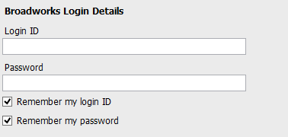
Next you will be prompted for the server address for your Service Provider. If this field is already populated do not change it. In most cases you can leave the Server Port as 2208
Leave the Unity Server Connection Details as those prefilled.

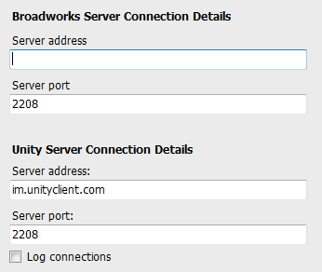

Restart Unity Agent to begin.
1.1 Call Center Login Details
Once Unity has been restarted it will connect to the host BroadWorks system and populate all the Call Center Instance IDs for the call centers that the agent is a member of as shown below.
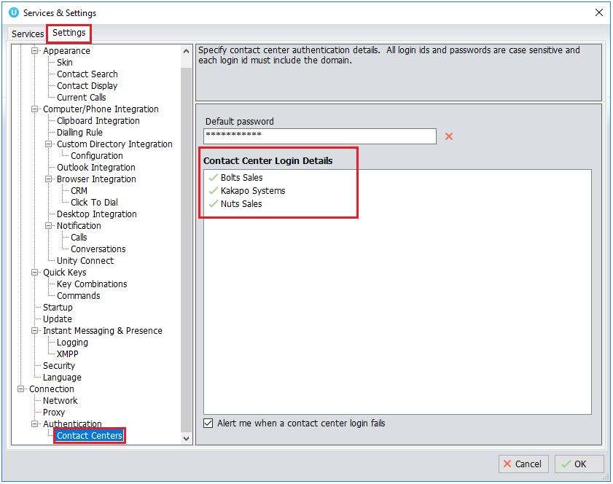

2 Unity Agent Interface Overview

Unity is split into six functional areas; ACD Buttons, Call Control buttons, Personal Wallboard, Active Call Window, Contacts [Busy Lamp Field and Instant Messages]. Contacts is a tab that can be toggled to display Call Logs, Abandoned Calls and the Voicemail tab.

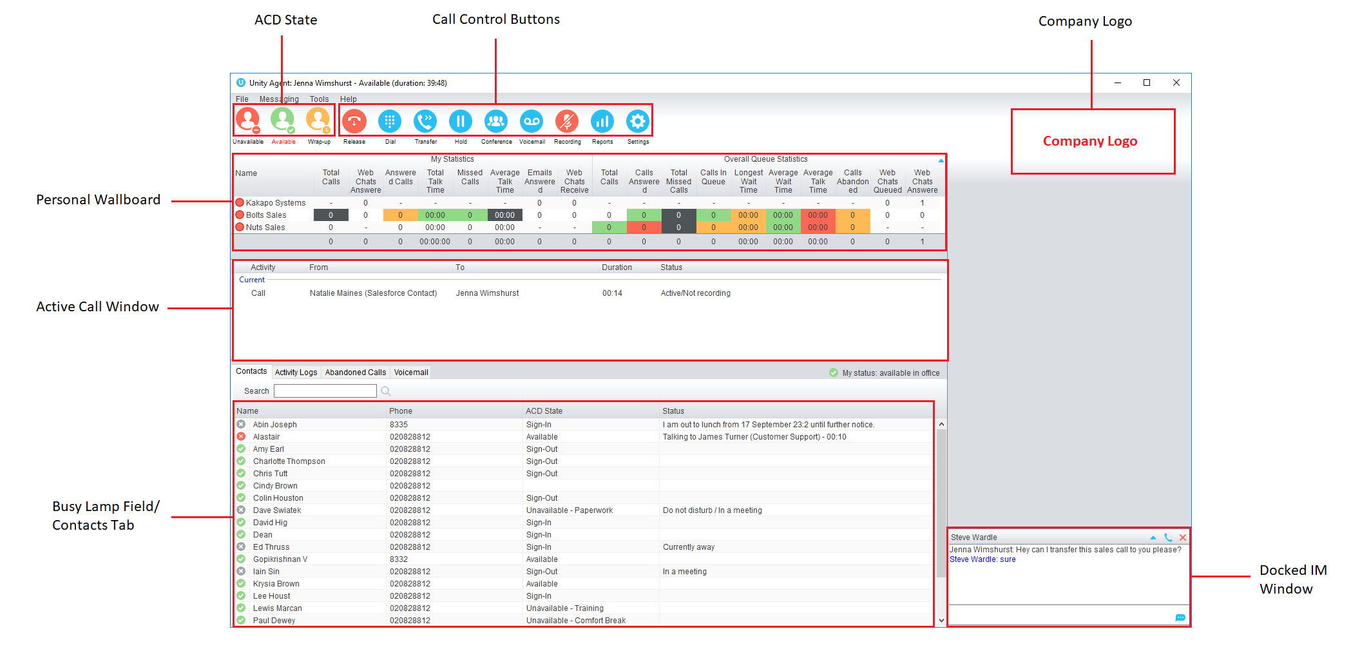
3 Main Interface Elements
3.1 ACD State Buttons
ACD State buttons for setting the agent’s availability to the call center. When clicking “Unavailable” the user will be presented a list of unavailable codes as configured in BroadWorks.
3.2 Call Control
Call Control buttons provide quick access to common telephone handling commands. Only services that are assigned to the user are displayed.
3.3 Active Call Window
This provides a list of all current calls and their state. For example, Ringing, Active or On Hold. The duration of the call is also displayed.
3.4 Contacts [Busy Lamp Field]
This panel will display up to 30 monitored users, displaying their Do Not Disturb [grey], Available [green], Engaged [red] or Ringing [orange] state as icons.
3.5 Call Logs
Toggling the bottom Contacts panel to Call Logs will display Missed Calls, Received Calls and Dialled Calls.
3.6 Abandoned Calls
A supervisor can assign abandoned calls to the agent for a callback. These will be listed in the “Abandoned Calls” tab. Double click these calls to make the outbound call. If the agent is a member of BroadSoft premium call center using DNIS, then Unity will automatically change the outbound CLI to be that of the DNIS queue. Right click the call to mark as processed and remove from the agent list.

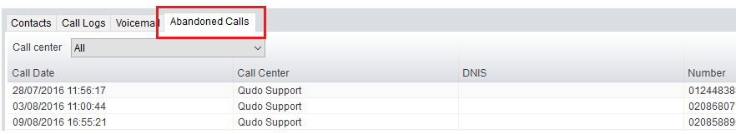

3.7 Voicemail
Clicking into the Voicemail tab will display a list of voice messages with the most recent at the top.

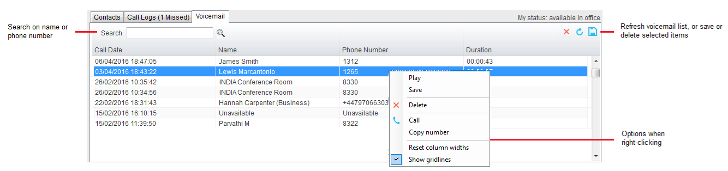

4 Call Center Agent Functionality

Inbound ACD calls will display the call center name, as configured in BroadWorks, in the “To” field. The “From” field will display the incoming CallerID [if not withheld] or the name of the caller if that can be matched from the Directory. Answer the call by lifting the IP phone handset, clicking Answer/Release call control button or double clicking the call in the Active Call Window.
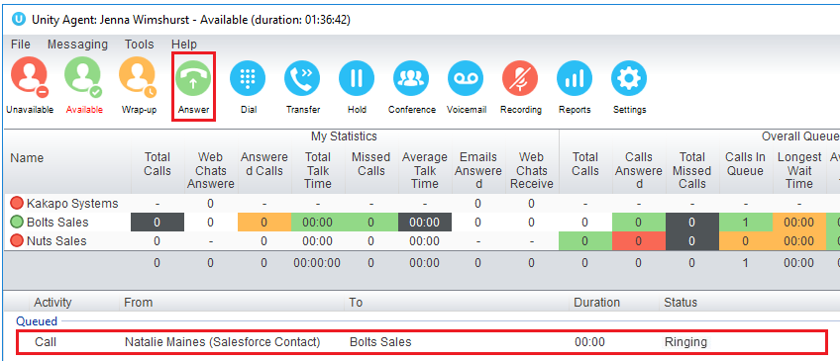
Hang up the IP phone handset or click Release  to end the call.
4.1 Changing ACD State
Clicking Unavailable, Available or Wrap-Up will change your availability for all queues you are a member of.

4.1.1 Only Show One ACD Button
Unity Agent can optionally be configured in Settings > Incoming Calls > Call Center > Agent > ACD State to only display one ACD button, which will be the currently selected state.
4.1.2 Assigning Unavailable Codes
When the agent selects unavailable, any unavailable codes that have been configured in BroadWorks will appear.
Unavailable Code assignment with one ACD button:

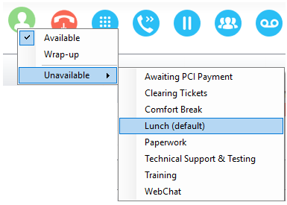
4.1.3 Force Disposition Code
To assign a Disposition Code the agent right clicks in the Active Call Window. Unity can force the agent to enter a disposition code by setting their ACD state post-call to Wrap-Up ACD state.

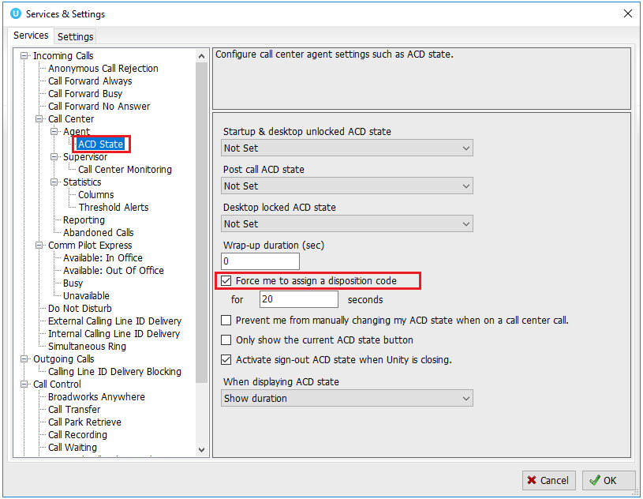

4.2 Using Personal Wallboard
The Personal Wallboard will show current performance metrics for the call centers the agent is assigned to. The stats are broken down by “My Statistics” which shows the agent’s individual performance and “Overall Queue Statistics” which will show the current conditions across the entire call center[s].
4.2.1 Configuring Statistics Columns in Personal Wallboard
The statistics shown in “My Statistics” and “Overall Queue Statistics” panels of the Personal Wallboard are configurable in Settings > Services > Call Center > Statistics > Columnns.

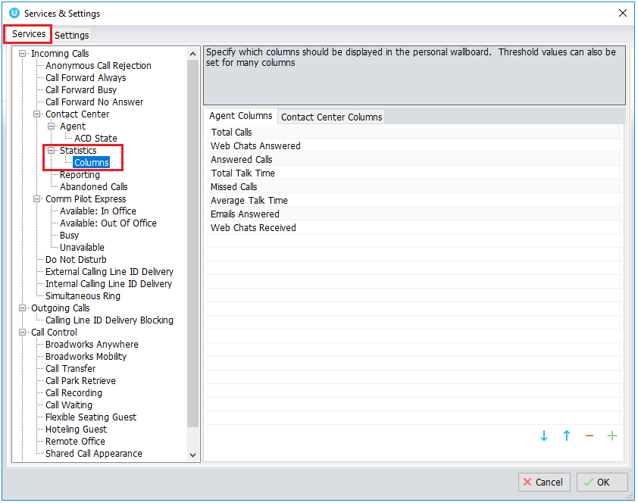
4.2.2 Customizing Statistics Label
Double click any statistic as displayed in the list above. From the below field you are able to customize the statistic label as required.

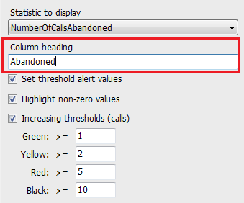
4.2.3 Configuring Alert Thresholds in Personal Wallboard
Double click any Statistic in Settings > Services > Call center > Statistics > Columns and tick “Set threshold alert values”. This will display a table where corresponding values can be configured that will progressively change the statistic background colour greed, yellow, red and black.

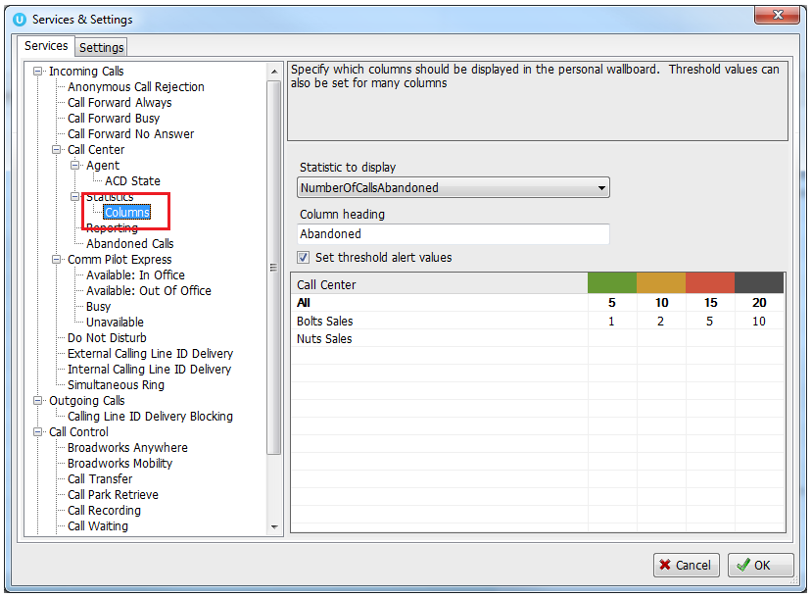

Double click an entry in the list to set overall threshold values or those for a specific call center.

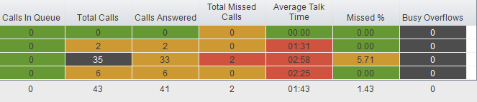
4.3 Joining & Leaving Queues
Right click any queue in the Personal Wallboard to toggle between Join and Leave queue. Queues that you are joined to have a green icon next to them. This is only available if the Agent is allowed to join or leave a call center queue.

4.4 Standard Escalation
Standard escalation is used when the agent needs to be given information or instruction from the supervisor without conferencing in the remote party. Typically, the agent will release the call to the supervisor and replay the information to the remote party.
4.5 Emergency Escalation
Emergency escalation is used to immediately conference a supervisor into the call with the remote party, therefore it relies on either the 3-Way or N-Way Calling user service being assigned to the agent. When performing an emergency escalation, Unity will place any active calls on hold then dial the selected supervisor, or the first supervisor that is available.

4.6 Escalation via Active Call Window
To perform escalation, the agent right-clicks the call in the active call window, then either chooses the supervisor to escalate the call to:
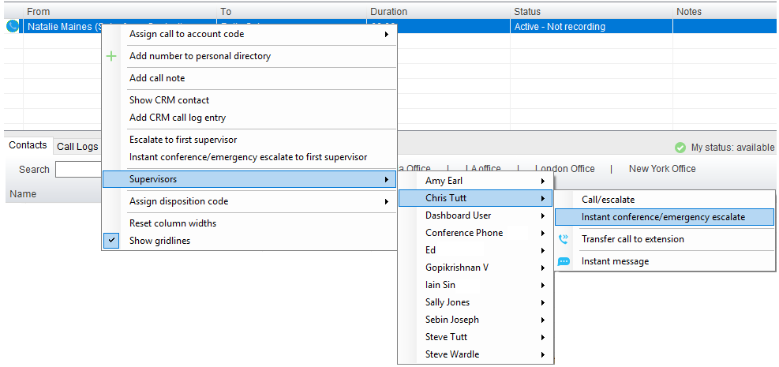

Or escalates the call to the first available supervisor.

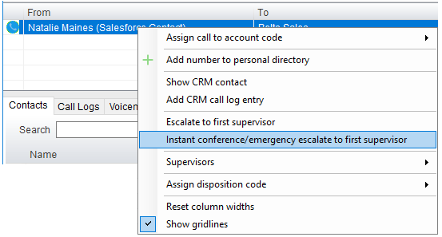
4.7 Personal Statistical Report
To access the reports, click the Reports button  or select Tools > Call Centers > Report Viewer from the menu. Specify the reporting period, click Tools > Call Centre > Report Viewer.

5 Call Control

All calls are managed through the call control buttons at the top of the application. These buttons will change depending on the state of the selected call, or the only call if there is only one call in the Active Call Window. For example, the Answer/Release   and Hold/Retrieve  buttons toggle as only one of these options will be valid at any time.
5.1 Making a Call
5.1.1 Using the Dial Window
Click the Dial button  to bring up the Dial dialogue box, as shown below. Using the computer keypad enter the desired number and press Enter or click OK to make the call.
5.1.2 Using the Contacts Panel
Double click a user icon or right click and select “Call extension”
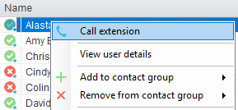
5.2 Answer a Call
When Unity displays an inbound call, click the Answer icon or double click the call in the Active Call Window to answer the call.
5.3 End a Call
Click the Release button to end the currently selected call. If there are multiple calls in the Active Call Window, make sure you select the right call before clicking Release.
5.3.1 Redial
You can also right-click the Dial button to see a list of the last 10 dialled numbers. Simply click on an entry to dial the party, as shown below.

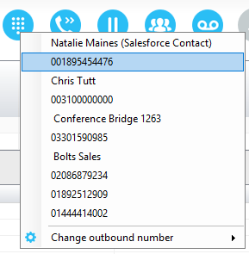
5.4 Send Call to Voicemail
To send an inbound caller directly to your voicemail click the Voicemail button .
5.5.1 Announced Transfer
Receive and answer an inbound call. Make a new call to the desired destination extension or number as described Make a Call above. This will automatically place the first caller on Hold and will open a new call in the Active Call Window. Once the called party answers, click Transfer  and select the context menu option to transfer both calling parties together.

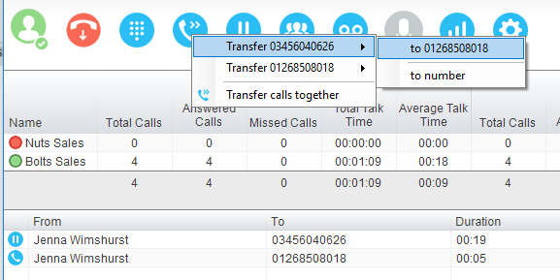

5.5.1.1 Warm Transfer
Unity Agent allows you to warm transfer a call by right clicking the user you want to transfer the call to and selecting “warm transfer” from the context menu. This will then put the original caller on hold and dial the selected number. When ready, click the transfer button in the call center control options panel and the two calls will be transferred.
5.5.2 Blind Transfer
5.5.2.1 Using Contacts Panel Drag and Drop
Unity Agent can be configured to automatically blind transfer a call by dragging the call from the Active Call Window and dropping it on a user icon or number icon in the Contacts panel, or dropping it onto a call center queue [if agent is configured as an agent with call center queues].
5.5.2.2 Using Transfer Button
Once on a call click the Transfer call control button . In the Transfer window enter the destination and click OK.

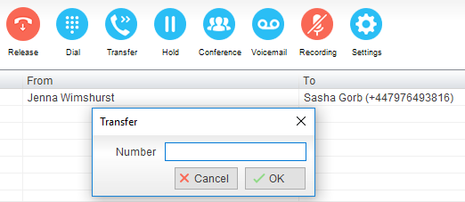
5.5.2.3 Using Right Click
While on an active call right click the recipient icon or number in the Contacts panel or Search. Select “Transfer call to extension” to blind transfer the call.
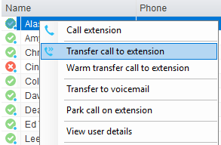
5.6 Call Hold/Retrieve
The Hold/Retrieve function toggles depending on the status of the currently selected call. Hold is only available for an active call while Retrieve is only a valid option for a call currently on Hold.
5.6.1 Placing a Call on Hold
To place a current active call on Hold, press the red Hold button. The call status will now show as on hold in the Active Call Window and there will be an On Hold icon alongside the call.
5.6.2 Retrieving a Held Call
Click the held call in the Active Call Window to select it. Click the Retrieve button  to take the call off hold, you can also double click the call to retrieve it.
5.7 Conference Calling
A conference call can be established with any combination of internal and external numbers. The total number of parties that can be supported is determined by service assignment. The Three-Way Calling user service supports conference calls with two other parties only while the N-Way Calling user service supports conference calls with more participants.
5.8 Starting a Conference Call
You can select two calls in the Active Call Window and click this button to quickly conference everyone together. Once in a conference you can easily select other calls and add them to it, but you must start with a conference with two other calls first. You can use the hold and retrieve buttons to hold the whole conference, and use the release button to drop a caller out of the conference. Please note this feature depends on service assignment so may not always be available.
5.9 Call Recording
You can use this button to manage call recording in two ways. You can right-click on the button to select how to record calls.

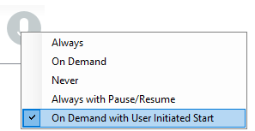

Or left click to start, stop, pause or resume recording the selected call. The button will change to show if the selected call is currently being recorded, or if recording is paused or stopped.
Depending on the call recording option selected you may see a menu when clicking this button, as below.

6 Active Call Window

The Active Call Window gives visual representation of the status of all calls the user receives or is currently managing.
6.1 Window Layout

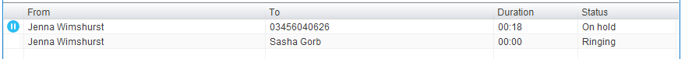

From – This field will display the incoming CallerID or the name
To – This field displays the name of the user, hunt group or call center
Duration – This displays the total time elapsed since the call was first answered.
Status – This shows the Ringing/Active, on On Hold and recording status of each call.
6.2 Calls In Queue
Agents can optionally see all calls in queue for the Call Centers they are joined to, as shown below. This is configured in Settings>Agent>Display queued call center calls in the list.
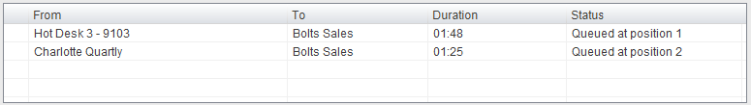
7 Drag and Drop

Drag & drop is an important feature of Unity, it means that in order to perform an action on a call you can simply drag it on top of something. For example if you want to blind transfer a call to a user then this can be done by simply searching for that user, then dragging the call and dropping it on that user in the contacts list. You may see some options here depending on what was configured in settings, or Unity can automatically blind transfer the call. Similarly if you want to perform an announced transfer then simple drag one call on top of the other in the Active Call Window, the calls will be transferred together and be removed from the list.

You can also drag other objects into this list to make a call, for example drag a user from the contacts list into the Active Call Window to call that internal user’s extension or external contact’s number.
8 Contacts Panel [Busy Lamp Field]

The Contacts tab gives a visual indication of the status of users [within the group/enterprise] that are currently being monitoring. A maximum of 30 users can be displayed. Double clicking a monitored user will call them and right clicking will bring up a dynamic options menu.
8.1 Contact Panel Display Options
There are three different views available, as outlined below. Right-click anywhere in the Contacts panel and select Appearance list to change the view.
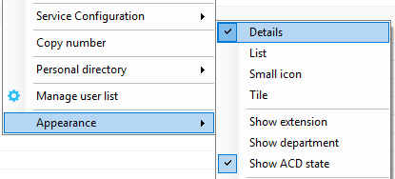
8.1.1 Details View
This view provides by far the greatest amount of detail, but requires more space [although the list can be shortened in which case scrollbars will automatically appear]. This is the recommended view for Agents as it shows the ACD state of up to 30 monitored Agents.
8.1.2 List View
This option will display all users in a list.
8.1.3 Small Icon View
This view combines a simplified look and space reduction.
8.1.4 Tile View
This view is similar to Icon view but uses more white space to provide a cleaner look.
8.2 User Icons
There are four main user icons states shown in the Contacts panel, regardless of the view chosen.
 | Available | The monitored user extension is on hook
 | Ringing | The monitored user extension is ringing
 | Engaged | The user is on the phone
 | Do Not Disturb | The user has selected DND or Unavailable profile

8.2.2 Instant Messaging Availability
Regardless of a user’s Available/Ringing/Engaged/DND state, if they currently have any version of Unity open they will be available for instant messaging. This is shown by the blue dot at bottom right of the user icon.
8.3 Managing Monitored Users in the Contacts Panel
The Contacts panel will display 30 users. In the Contacts panel right click anywhere and click “Manage user list”. This will allow you to choose which users to display.

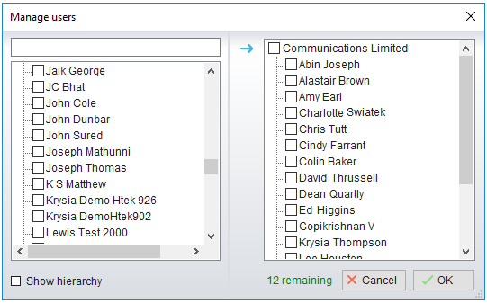
8.4 Park Call on Extension
Will park the call on the monitored user’s extension park slot.
8.5 Retrieving Parked Calls
Once a call has been parked onto a user’s extension, their Unity will display a Pickup Call Icon and a toast pop up window will appear. In order for the user to retrieve the parked call they simply need to click either the Pickup Call Icon or the toast pop up. If the call is not retrieved it will be redirected back to the original user who parked the call.
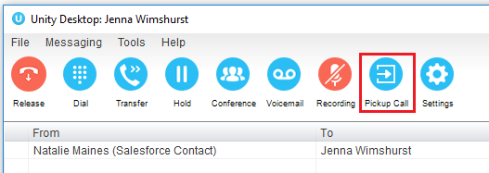
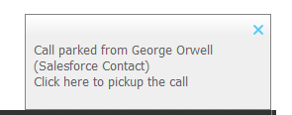
8.6 Camp Call on Extension
Will camp the call onto the engaged monitored user. When the user goes back on-hook the camped call will be delivered and their phone will start ringing.

9 Instant Messaging

Instant messages can be sent and received between any Unity app [Reception, Desktop, Agent, or Supervisor]. Messages sent to offline user [those that do not have an instance of Unity open] can be stored and delivered when the recipient next opens Unity.
9.1 Docking the IM Window
Instant Messages can be displayed in the Docked IM Window or as separate dialogue boxes for each individual IM thread. If the docked window is used IMs can be initiated via drag and drop and new IM windows will not pop over other applications.
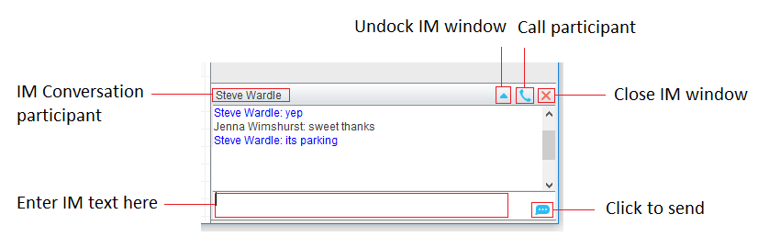
9.2 Undocking and Redocking IM sessions
You can undock an IM message by clicking the “Expand conversation to separate window” button. The IM session will now be a standalone window.

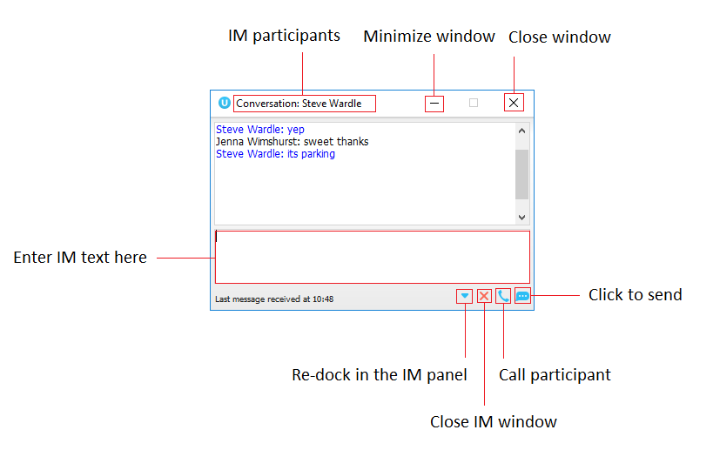
9.3 Sending an Instant Message
Send an instant message either by right clicking a user icon in Contacts panel or Search and selecting “Instant Message” from the drop list, or by dragging a user icon into the docked IM panel.
9.4 Adding Participants to an Existing IM Session
When an IM conversation is in the Docked IM panel you can drag a user icon from the Contacts Panel or Search and drop them on the IM window to add them to the conversation.
9.5 Logging IM Sessions
You will find the Instant Messaging and presence logging options in the Settings tab. Here you
will be able to configure how IMs are saved, what file type they are (CSV or HTML) and where
they are saved.
10 Personal Directory

Personal Directory – Right click in Contacts
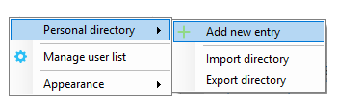
Personal Directory – Right click on monitored user
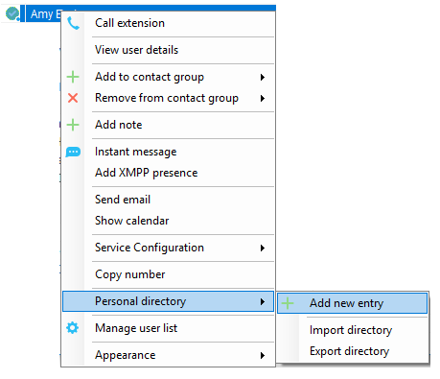
10.1 Add New Entry
Enter the Name and Number and click Ok
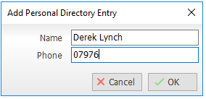

If the number specified is already in the Directory the user will be alerted as below.
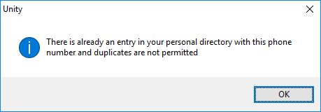
10.2 Edit Entry
Use the Search field in Contacts to locate the entry. You can search by either Name or Number. Right click the Entry and select “Edit”.
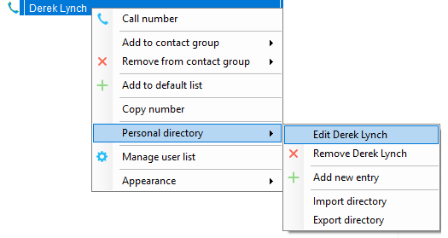
10.3 Remove Entry
Use the Search field in Contacts to locate the entry. You can search by either Name or Number. Right click the Entry and select “Remove”.

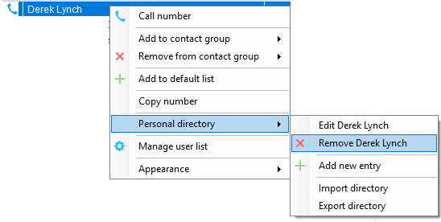
10.4 Dialling Directory Entry
Locate the entry either on the Contacts panel or Search. Drag the entry into the Active Call Window or double click to make a call, or right click the entry and click “Call number”.
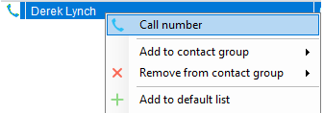

10.5 Import Personal Directory
Agent will allow the user to import a .csv file of directory entries, provided they are in “name, number” format. Right click in the Contacts panel, select “Personal directory > “Import” and then browse to the location of the csv.
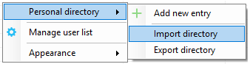
10.6 Export Personal Directory
To export Personal Directory entries right click in Contacts and select Personal directory > “export”. You will be prompted to save the file locally.
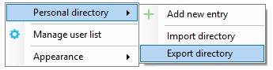
11 Contact Search Directories

The Contact Search field combines all BroadWorks and Outlook Contacts directories to create a central search repository. The BroadWorks directories include the Common Phone List [system speed dials], the receptions user’s own Personal Directory entries, and the Group Directory which includes all the other users in the group as well as hunt groups, auto attendants and call centers. Unity can also integrate with third party LDAP [including Microsoft Active Directory] and SQL directories.

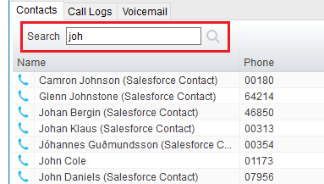

Right click in the search box to select a directory, then click the search button to clear it and see the default list of monitored users.
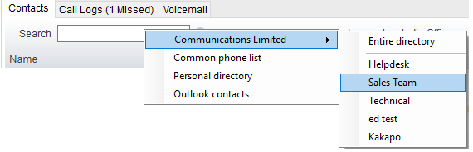

Search results will display each number for a contact as a separate line. Drag or double click the entry to make a call or right click to select a call action from the context menu.
icons represent external numbers or system resources such as hunt groups for which presence information cannot be displayed.
12 Call Logs

The Call Logs tab displays Missed, Received and Dialled Calls with a date and time stamp showing the most recent call at the top. Up to 20 numbers are listed unless the Enhanced Call logs service is assigned to the Agent user in BroadWorks. Calls to the Agent user DID as well as hunt group and call center calls that have reached the Agent user are shown.
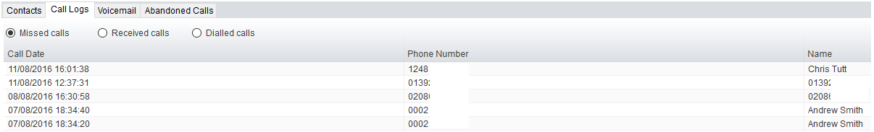

Drag or double click an entry to make a call to that number. Call logs can be exported as a csv file, either individually or together, but clicked the Export button.

13 My Status
The “My Status” link provides an indication of the current status of the user as well as quick access to key services that are regularly modified.
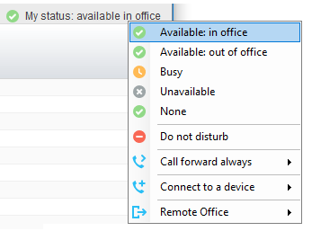

CommPilot profiles are also used to convey presence information to other users within the group or enterprise.
13.1 Call Forward Always
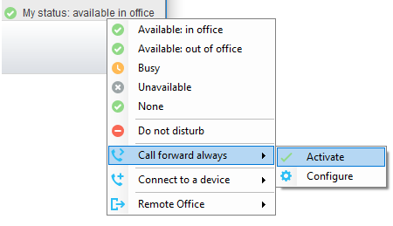
13.2 Remote Office
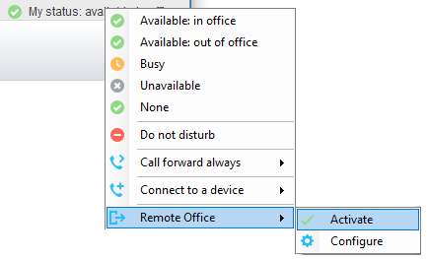
13.3 Connect to a Device
The user can easily select the device to connect to through the My Status link, as shown below.

