
UNITY DESKTOP QUICK HELP GUIDE
CONTENTS

1 Introducing Unity 3
2 Initial Setup 4
3 Unity Desktop Interface Overview 5
4 Main Interface Elements 6
4.1 Call Control 6
4.2 Active Call Window 6
4.3 Contacts [Busy Lamp Field] 7
4.4 Call Logs 7
4.5 Voicemail 7
5 Call Control 8
5.1 Making a Call 8
5.1.1 Using the Dial Window 8
5.1.2 Dialling from the clipboard 8
5.2 Answer a Call 8
5.3 End a Call 8
5.3.1 Redial 8
5.4 Send Call to Voicemail 8
5.5.1 Announced Transfer 9
5.5.1.1 Warm Transfer 9
5.5.2 Blind Transfer 9
5.5.2.1 Using Contacts Panel Drag and Drop 9
5.5.2.2 Using Transfer Button 9
5.5.2.3 Using Right Click 10
5.6 Call Hold/Retrieve 10
5.6.1 Placing a Call on Hold 10
5.6.2 Retrieving a Held Call 10
5.7 Conference Calling 10
5.8 Starting a Conference Call 10
5.9 Call Recording 11
6 Active Call WIndow 11
7 Drag and Drop 11
8 Contacts Panel [Busy Lamp Field] 12
8.1 Contact Panel Display Options 12
8.1.1 Details View 12
8.1.2 List View 12
8.1.3 Small Icon View 12
8.1.4 Tile View 12
8.2 User Icons 13
8.2.1 Instant Messaging Availability 13
8.3 Managing Monitored Users in the Contacts Panel 13
8.4 Park Call on Extension 13
8.5 Retrieving Parked Calls 13
8.6 Camp Call on Extension 14
8.7 Barge into This Call 14
9 Instant Messaging 15
9.1 Docking the IM Window 15
9.2 Undocking and Redocking IM sessions 15
9.3 Sending an Instant Message 16
9.4 Adding Participants to an Existing IM Session 16
9.5 Logging IM Sessions 16
10 Personal Directory 16
10.1 Add New Entry 17
10.2 Edit Entry 17
10.3 Remove Entry 17
10.4 Dialling Directory Entry 18
10.5 Import Personal Directory 18
10.6 Export Personal Directory 18
11 Contact Search Directories 18
12 Call Logs 19
13 My Status 20
13.1 Call Forward Always 20
13.2 Remote Office 21
13.3 Connect to a Device 21

1 Introducing Unity

Unity is a Microsoft® Windows® based application that enhances the Hosted PBX solution to provide call control, directory integration, instant messaging and service configuration. Featuring an intuitive icon based interface, Unity provides point and click call control within the familiar desktop environment. Unity improves workgroup collaboration by bringing users closer to each other and simplifying internal and external communication.
Features provided;
- Call control
- Directory Search
- User Status [Busy Lamp Field]
- Displays 30 users
- User service configuration
- Outlook Contacts click to dial
- Call pick up
- Call Recording Control
- Meet me Conferencing Moderator Dial in
- Hoteling [hot desking] logon/logoff
- VoiceMail tab playback, save, delete voice messages
- Browser click to dial [from Chrome, Edge, Firefox]
- User Status [Busy Lamp Field]
- Displays 30 users
- Instant Messaging
- Third party database [SQL, LDAP, Active Directory] integration within Directories
- Unity Connect API integration with third party database applications

The below services are supported:
Service | Description
Anonymous Call Rejection | Prevent a caller from contacting you if they have explicitly hidden their phone number
Call Forward Always | Automatically forward all incoming calls to a number
Call Forward Busy | Automatically forward all incoming calls to a number when the user is on the phone
Call Forward No Answer | Automatically forward all incoming calls to a number when the call hasn’t been answered after a certain number of rings
Call Recording | Record incoming and outgoing calls, refer to section 5.8 for more information
CommPilot Express | Use pre-configured routing profiles to handle incoming calls based on the current state of the user
Do Not Disturb | Block all incoming calls and reroute to voicemail if available
Simultaneous Ring | Automatically ring another number when an incoming call is received, the call can then be answered through that number or the primary phone
Calling Line ID Delivery Blocking | Hide your phone number when making outgoing calls
BroadSoft Anywhere | Connect mobile or fixed-line devices to the VoIP account, and switch calls between them
Call Transfer | Transfer calls to internal or external numbers
Call Waiting | Answer an incoming call when already on a call
Call Park Retrieve | Retrieve a call that has been parked for a specific user
Directed Call Pickup With Barge-In | Automatically join another users call
Hoteling Guest | Associate the VoIP account to another device so that it is treated as the primary device. Used in a hot-desking environment.
Remote Office | Associate a mobile device to the VoIP account to make or receive calls
Shared Call Appearance | Control multiple devices for the same VoIP account
Voice Messaging User | Provide voicemail for unanswered incoming calls
External and Internal Calling Line ID Delivery | Provides Calling Line ID information of an incoming call from outside the group

2 Initial Setup

When Unity is first started you will be prompted to authenticate on the VoIP platform, which requires a login ID [including domain] and password. Please consult your service provider if you don’t have these details.

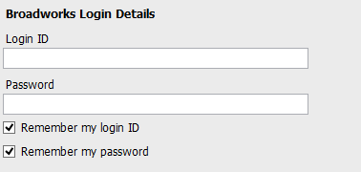

Now select Connection > Network from the list on the left to confirm the connectivity details, as below.

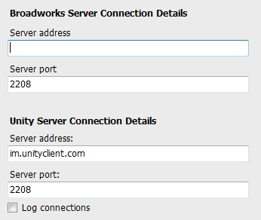

Enter the Broadsoft Server Connection as specified by your Service Provider. In some cases, this will already be supplied in which case it does not need to be changed.

3 Unity Desktop Interface Overview

Unity is split into three functional areas; Call Control buttons, Active Call Window and Contacts [Busy Lamp Field and Instant Messages]. The contacts tab can be toggled to display Call Logs and the Voicemail tab.
The Active Call Window will display the status of all current calls for the logged in user, which are controlled using the Call Control buttons. These call control buttons will change based on the status of the call.
The Busy Lamp Field list will automatically populate with 30 random users in your group or enterprise when Unity first starts.

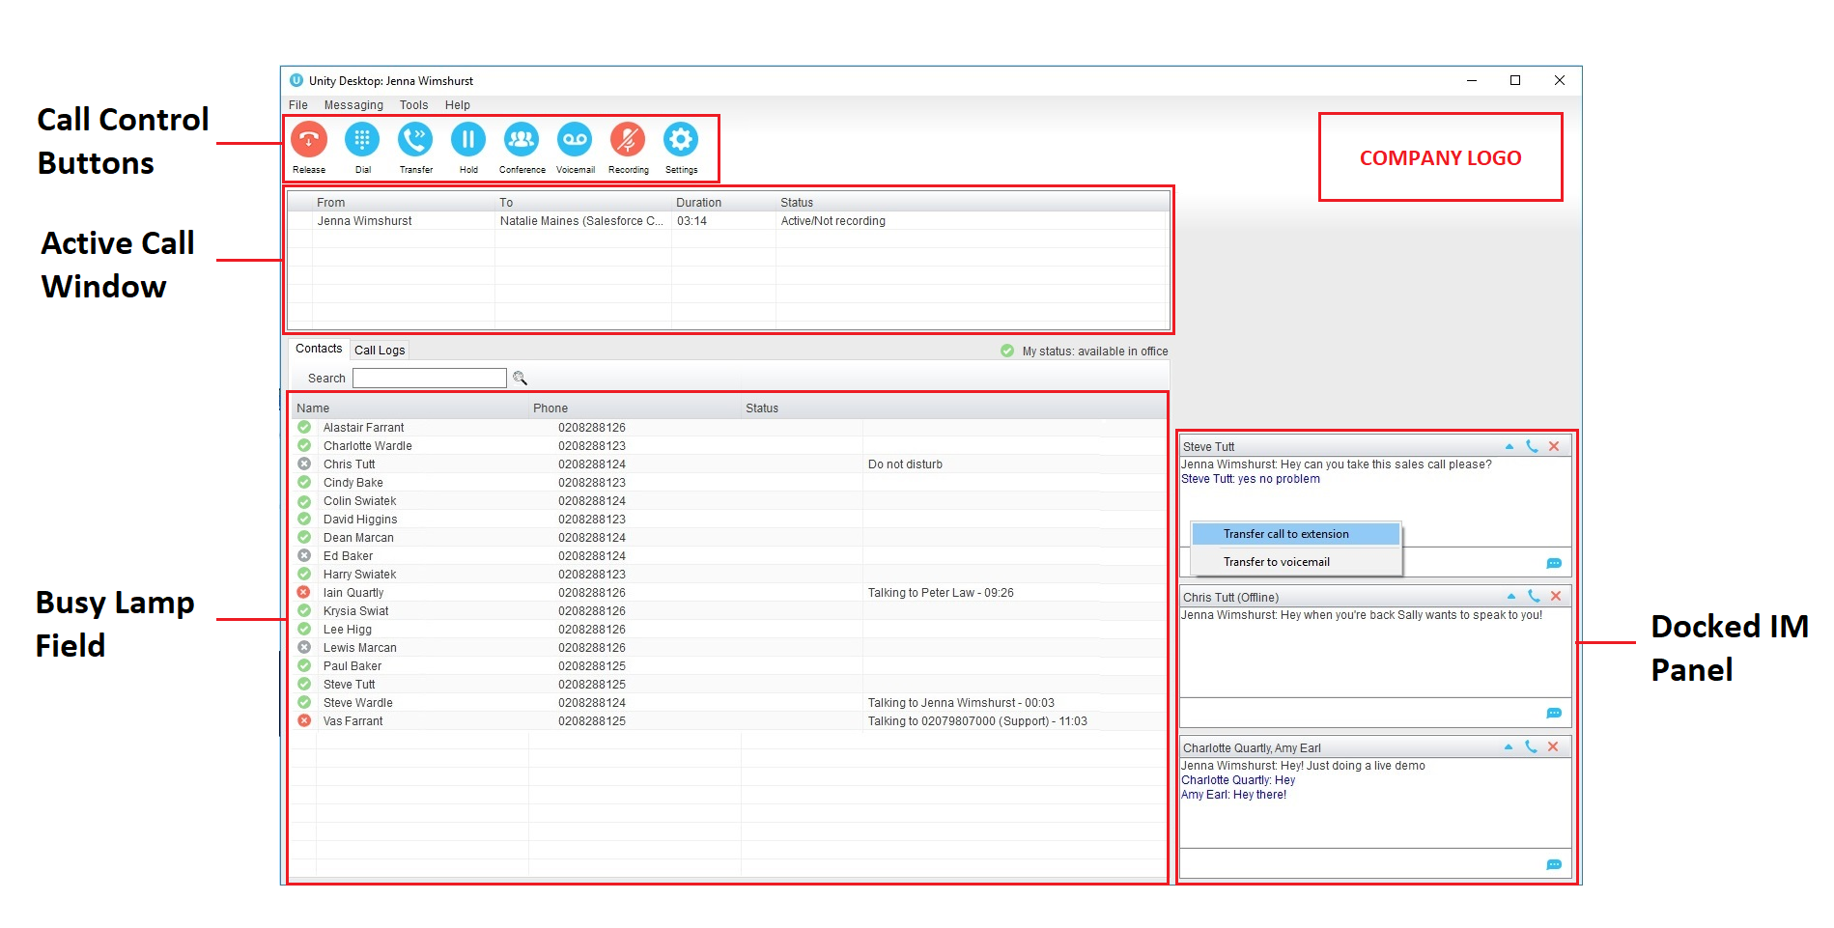

4 Main Interface Elements
4.1 Call Control
Call Control buttons provide quick access to common telephone handling commands. Only services that are assigned to the user are displayed.
4.2 Active Call Window
This provides a list of all current calls and their state. For example, Ringing, Active or On Hold. The duration of the call is also displayed.
4.3 Contacts [Busy Lamp Field]
This panel will display up to 30 monitored users, displaying their Do Not Disturb [grey], Available [green], Engaged [red] or Ringing [orange] state as icons.
4.4 Call Logs
Toggling the bottom Contacts panel to Call Logs will display Missed Calls, Received Calls and Dialled Calls. Missed Calls will include both direct inward DID calls and Hunt Group calls.
4.5 Voicemail
Clicking into the Voicemail tab will display a list of voice messages with the most recent at the top. Double click an entry to play through the PC’s default media player.

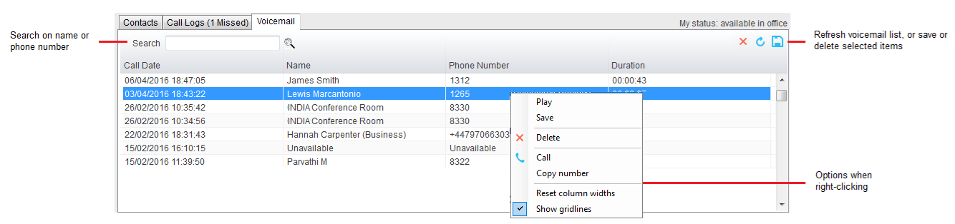

In order for the Voicemail tab to appear, Desktop must be configured for “Use unified messaging” and “Show visual voicemail tab” in Voicemail settings as below.
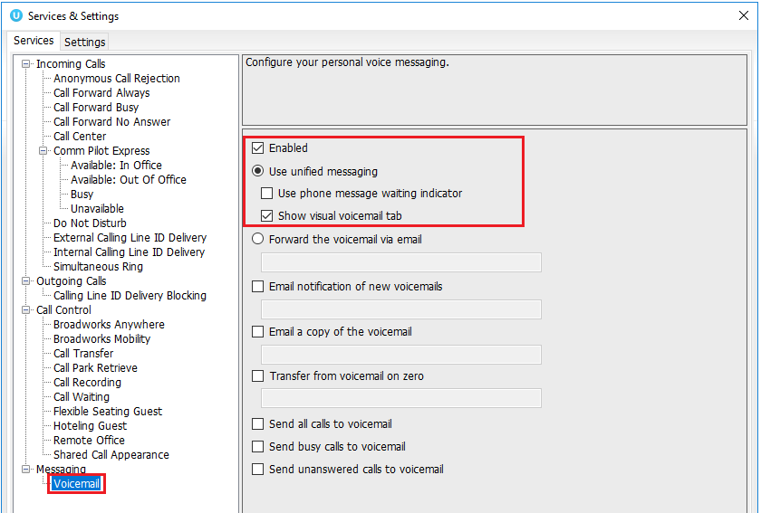
5 Call Control

All calls are managed through the call control buttons at the top of the application. These buttons will change depending on the state of the selected call, or the only call if there is only one call in the Active Call Window. For example, the Answer/Release   and Hold/Retrieve  buttons toggle as only one of these options will be valid at any time.
5.1 Making a Call
5.1.1 Using the Dial Window
Click the Dial button  to bring up the Dial dialogue box, as shown below. Using the computer keypad enter the desired number and press Enter or click OK to make the call.
5.1.2 Dialling from the clipboard
Any number that is copied to the Windows clipboard, (highlight the telephone number, right click, then clicking copy) this will cause a popup toast above the system tray with the option to call the number. Click the toast notification to make the call.
5.2 Answer a Call
When Unity displays an inbound call, click the Answer icon or double click the call in the Active Call Window to answer the call.
5.3 End a Call
Click the Release button to end the currently selected call. If there are multiple calls in the Active Call Window, make sure you select the right call before clicking Release.
5.3.1 Redial
You can also right-click the Dial button to see a list of the last 10 dialled numbers.
5.4 Send Call to Voicemail
To send an inbound caller directly to your voicemail click the Voicemail button .
5.5.1 Announced Transfer
Receive and answer an inbound call. Make a new call to the desired destination extension or number as described Make a Call above. This will automatically place the first caller on Hold and will open a new call in the Active Call Window. Once the called party answers, click Transfer  and select the context menu option to transfer both calling parties together.

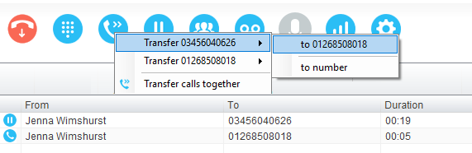

5.5.1.1 Warm Transfer
Unity Desktop allows you to warm transfer a call by right clicking the user you want to transfer the call to and selecting “warm transfer” from the context menu. This will then put the original caller on hold and dial the selected number. When ready, click the transfer button in the call center control options panel and the two calls will be transferred.
5.5.2 Blind Transfer
5.5.2.1 Using Contacts Panel Drag and Drop
Unity Desktop can be configured to automatically blind transfer a call by dragging the call from the Active Call Window and dropping it on a user icon or number icon in the Contacts panel.
5.5.2.2 Using Transfer Button
Once on a call click the Transfer call control button . In the Transfer window enter the destination and click OK.

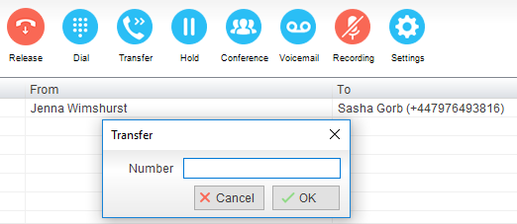
5.5.2.3 Using Right Click
While on an active call right click the recipient icon or number in the Contacts panel or Search. Select “Transfer call to extension” to blind transfer the call.
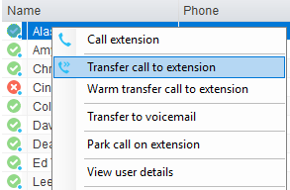
5.6 Call Hold/Retrieve
The Hold/Retrieve function toggles depending on the status of the currently selected call. Hold is only available for an active call while Retrieve is only a valid option for a call currently on Hold.
5.6.1 Placing a Call on Hold
To place a current active call on Hold, press the red Hold button. The call status will now show as on hold in the Active Call Window and there will be an On Hold icon alongside the call.
5.6.2 Retrieving a Held Call
Click the held call in the Active Call Window to select it. Click the Retrieve button to take the call off hold, you can also double click the call to retrieve it.
5.7 Conference Calling
A conference call can be established with any combination of internal and external numbers. The total number of parties that can be supported is determined by service assignment. The Three-Way Calling user service supports conference calls with two other parties only while the N-Way Calling user service supports conference calls with more participants.
5.8 Starting a Conference Call
You can select two calls in the Active Call Window and click this button to quickly conference everyone together. Once in a conference you can easily select other calls and add them to it, but you must start with a conference with two other calls first. You can use the hold and retrieve buttons to hold the whole conference, and use the release button to drop a caller out of the conference. Please note this feature depends on service assignment so may not always be available.
5.9 Call Recording
You can use this button to manage call recording in two ways. You can right-click on the button to select how to record calls.

6 Active Call WIndow

The Active Call Window gives visual representation of the status of all calls the user receives or is currently managing.

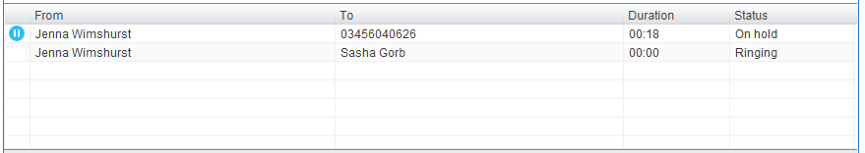

From – This field will display the incoming CallerID or the name
To – This field displays the name of the user or hunt group
Duration – This displays the total time elapsed since the call was first answered
Status – This shows the Ringing/Active, on On Hold and recording status of each call

7 Drag and Drop

Drag and drop is an important feature of Unity, it means that in order to perform an action on a call you can simply drag it on top of something. For example, if you want to blind transfer a call to a user then this can be done by simply searching for that user, then dragging the call and dropping it on that user in the contacts list. You may see some options here depending on what was configured in settings, or Unity can automatically blind transfer the call. Similarly, if you want to perform an announced transfer then simple drag one call on top of the other in the Active Call Window, the calls will be transferred together and be removed from the list.

You can also drag other objects into this list to make a call, for example drag a user from the contacts list into the Active Call Window to call that internal user’s extension or external contact’s number.

8 Contacts Panel [Busy Lamp Field]

The Contacts tab gives a visual indication of the status of users [within the group/enterprise] that are currently being monitoring. A maximum of 30 users can be displayed. Double clicking a monitored user will call them and right clicking will bring up a dynamic options menu.
8.1 Contact Panel Display Options
There are three different views available, as outlined below. Right-click anywhere in the Contacts panel and select Appearance list to change the view.
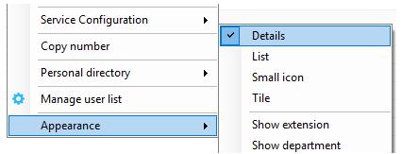
8.1.1 Details View
This view provides by far the greatest amount of detail, but requires more space [although the list can be shortened in which case scrollbars will automatically appear]. This is the recommended view for users as it shows the ACD state of up to 30 monitored users.
8.1.2 List View
This option will display all users in a list.
8.1.3 Small Icon View
This view combines a simplified look and space reduction.
8.1.4 Tile View
This view is similar to Icon view but uses more white space to provide a cleaner look.
8.2 User Icons
There are four main user icons states shown in the Contacts panel, regardless of the view chosen.
 | Available | The monitored user extension is on hook
 | Ringing | The monitored user extension is ringing
 | Engaged | The user is on the phone
 | Do Not Disturb | The user has selected DND or Unavailable profile

8.2.1 Instant Messaging Availability
Regardless of a user’s Available/Ringing/Engaged/DND state, if they currently have any version of Unity open they will be available for instant messaging. This is shown by a small blue dot at bottom right of the user icon.
8.3 Managing Monitored Users in the Contacts Panel
The Contacts panel will display 30 users. In the Contacts panel right click anywhere and click “Manage user list”. This will allow you to choose which users to display.

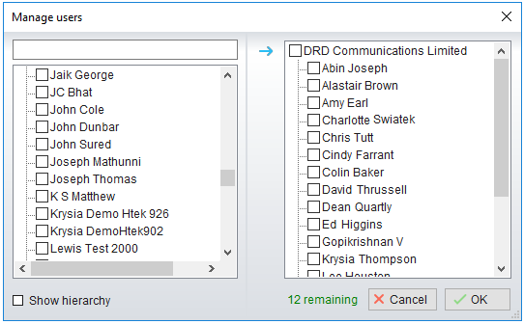
8.4 Park Call on Extension
Will park the call on the monitored user’s extension park slot.
8.5 Retrieving Parked Calls
Once a call has been parked onto a user’s extension, their Unity will display a Pickup Call Icon and a toast pop up window will appear. In order for the user to retrieve the parked call they simply need to click either the Pickup Call Icon or the toast pop up. If the call is not retrieved it will be redirected back to the original user who parked the call.

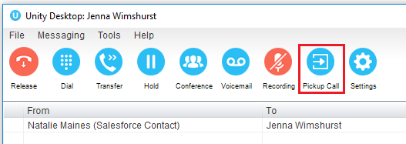
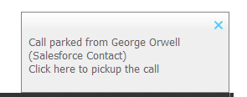
8.6 Camp Call on Extension
Will camp the call onto the engaged monitored user. When the user goes back on-hook the camped call will be delivered and their phone will start ringing.

8.7 Barge into This Call
Makes an immediate three-way conference call with the Desktop user, the monitored user and the third party the monitored user is talking toWhen attempting to barge into a call, if the phone plays a “number doesn’t exist” tone then this means the monitored user cannot be barged into.

Please note that when leaving a call that you barged into, you must transfer the call parties together in order to leave the conference without ending the original call.
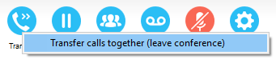

9 Instant Messaging

Instant messages can be sent and received between any Unity app [Reception, Desktop, Agent, or Supervisor]. Messages sent to offline user [those that do not have an instance of Unity open] can be stored and delivered when the recipient next opens Unity.
9.1 Docking the IM Window
Instant Messages can be displayed in the Docked IM Window or as separate dialogue boxes for each individual IM thread. If the docked window is used IMs can be initiated via drag and drop and new IM windows will not pop over other applications.
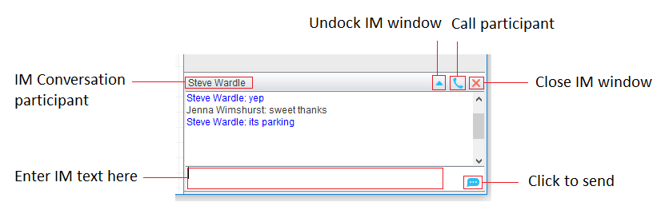
9.2 Undocking and Redocking IM sessions
You can undock an IM message by clicking the “Expand conversation to separate window” button. The IM session will now be a standalone window.

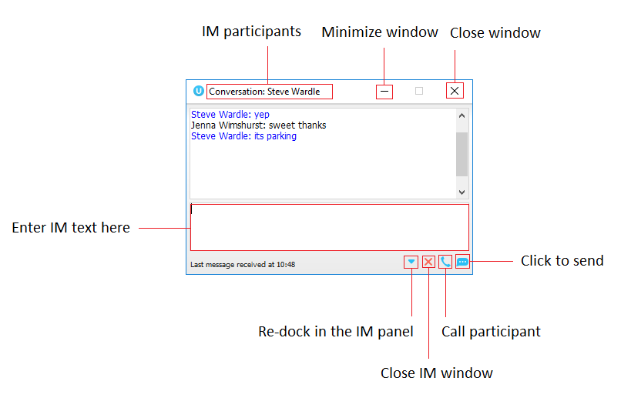
9.3 Sending an Instant Message
Send an instant message either by right clicking a user icon in Contacts panel or Search and selecting “Instant Message” from the drop list, or by dragging a user icon into the docked IM panel.
9.4 Adding Participants to an Existing IM Session
When an IM conversation is in the Docked IM panel you can drag a user icon from the Contacts Panel or Search and drop them on the IM window to add them to the conversation.

9.5 Logging IM Sessions
You will find the Instant Messaging and presence logging options in the Settings tab. Here you
will be able to configure how IMs are saved, what file type they are (CSV or HTML) and where
they are saved.

10 Personal Directory

Personal Directory – Right click in Contacts
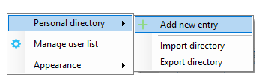

Personal Directory – Right click on monitored user
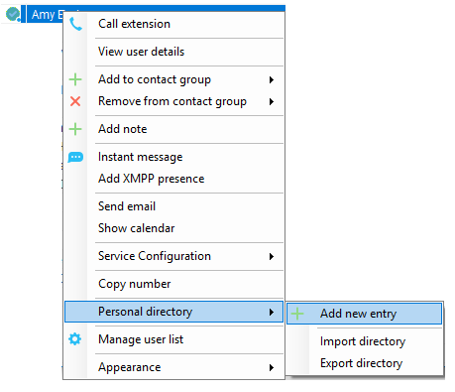
10.1 Add New Entry
Enter the Name and Number and click Ok
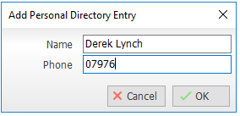

If the number specified is already in the Directory the user will be alerted as below.

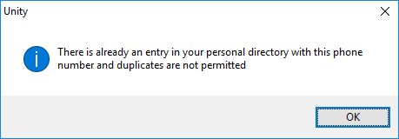
10.2 Edit Entry
Use the Search field in Contacts to locate the entry. You can search by either Name or Number. Right click the Entry and select “Edit”.
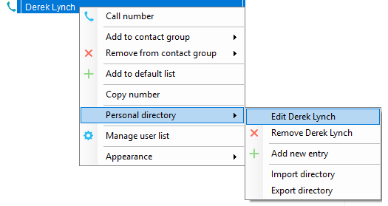
10.3 Remove Entry
Use the Search field in Contacts to locate the entry. You can search by either Name or Number. Right click the Entry and select “Remove”.
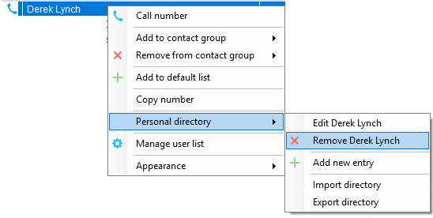
10.4 Dialling Directory Entry
Locate the entry either on the Contacts panel or Search. Drag the entry into the Active Call Window or double click to make a call, or right click the entry and click “Call number”.

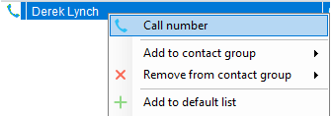
10.5 Import Personal Directory
Desktop will allow the user to import a .csv file of directory entries, provided they are in “name, number” format. Right click in the Contacts panel, select “Personal directory > “Import” and then browse to the location of the csv.
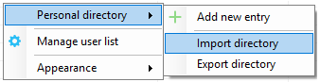
10.6 Export Personal Directory
To export Personal Directory entries right click in Contacts and select Personal directory > “export”. You will be prompted to save the file locally. The format is csv and the default file name is PersonalDirectory.csv
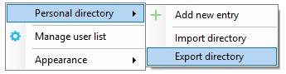
11 Contact Search Directories

The Contact Search field combines all BroadWorks and Outlook Contacts directories to create a central search repository. The BroadWorks directories include the Common Phone List [system speed dials], the receptions user’s own Personal Directory entries, and the Group Directory which includes all the other users in the group as well as hunt groups. Unity can also integrate with third party LDAP [including Microsoft Active Directory] and SQL directories.

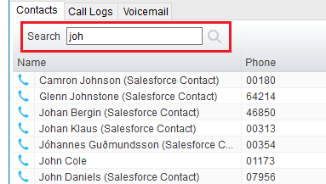

Search results will display each number for a contact as a separate line. Drag or double click the entry to make a call or right click to select a call action from the context menu.
Right click in the search box to select a directory, then click the search button to clear it and see the default list of monitored users.
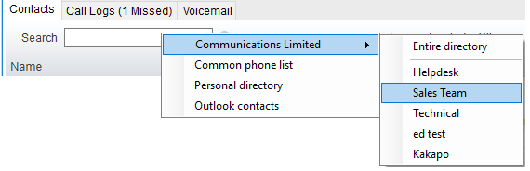

icons represent external numbers or system resources such as hunt groups for which presence information cannot be displayed.

12 Call Logs

The Call Logs tab displays Missed, Received and Dialled Calls in chronological order [although the sort order can be changed by clicking on the column header]. The Call logs tab will show the number of missed calls since Unity was last used, as well as any missed calls received while Unity is running, as shown below.

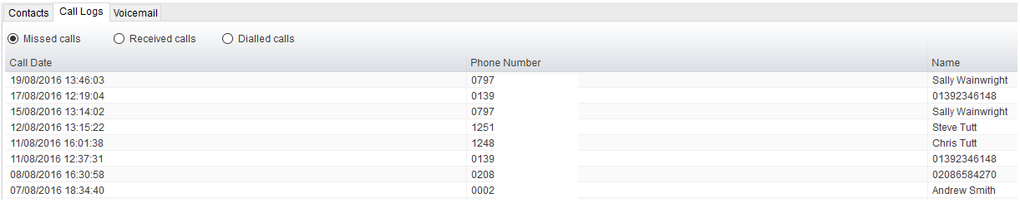

Drag or double click an entry to make a call to that number. Call logs can be exported as a csv file, either individually or together, but clicked the Export button.

13 My Status

The “My Status” link provides an indication of the current status of the user as well as quick access to key services that are regularly modified.
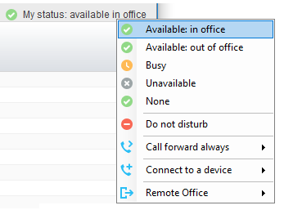
CommPilot profiles are also used to convey presence information to other users within the group or enterprise.
13.1 Call Forward Always
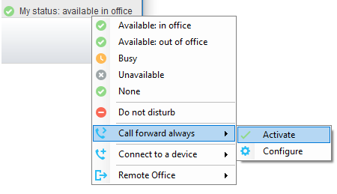
13.2 Remote Office
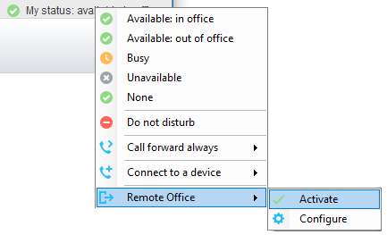
13.3 Connect to a Device
The user can easily select the device to connect to through the My Status link, as shown below.

