

Unity Reception Quick User Guide

Contents
1 About Unity Reception 2
1.1 Getting Started 3
2 Getting Around 4
2.1 Call Control Buttons 5
2.1.1 Answer 5
2.1.2 Release 5
2.1.3 Dial 5
2.1.4 Transfer 6
2.1.5 Hold/Retrieve 6
2.1.6 Conference 6
2.1.7 Recording 7
2.1.8 Announce 7
2.1.9 Call Park Retrieve 7
2.1.10 Reports 8
2.1.11 Settings 8
2.2 Active Call Window 8
2.2.1 Drag & Drop 8
2.2.2 Previously Transferred 9
2.2.3 Adding a Note 9
2.2.4 Show Parked & Camped Calls 9
2.2.5 Configuration 10
2.3 Contacts List 11
2.3.1 Performing Call Actions 12
2.3.2 Add a Note 12
2.3.3 Hold & Link 13
2.3.4 Contact Groups 14
2.3.5 Calendar Integration 15
2.3.6 Remote Service Configuration 16
2.3.7 Configuration 17
2.4 Call Logs 18
2.5 Visual Voicemail 19
3 Instant Message 19
3.1 Start IM Conversation 20
3.2 Add a Participant 21
3.3 Transfer Call to a Participant 21
3.4 Configuration 22
4 Quick Access Service Configuration 22
4.1 CommPilot Express Profiles 23
4.2 Do Not Disturb 23
4.3 Call Forward Always 23
4.4 Connect to a Device 24
4.5 Remote Office 24

1 About Unity Reception

Standard vs Enterprise Features
Unity is available in Standard and Enterprise variants. The features available are as follows:
Unity Reception Standard
Features provided;
- 50 user fixed busy lamp field (BLF)
- Drag and drop call control [to make a call, release, IM, transfer, park etc]
- BroadWorks call center agent functionality for join/leave queue and changing ACD state
- Hold & Link User - Custom tagging of held calls [ie holding for Andrew Smith]
- Outlook Calendar integration to display the required users calendar events
- Visibility of the party the inbound caller was previously transferred to
- Ability to listen to, save and delete voicemails
- Add notes for inbound calls and all group or enterprise users
- XMPP support for IM&P with UC-One
Unity Reception Enterprise
All Unity Reception Standard features but also including;
- Unlimited dynamic busy lamp field [displays hook status of all matched users on contact search]
- Remote service configuration for all BroadWorks group and enterprise users
- Contact Groups

Unity Reception is specifically designed for busy front desk call handling environments, or for those users who manage a large number of concurrent calls or require visibility of all users in the business.

This document provides a quick overview of key functionality, aimed specifically at the receptionist. For a more in-depth description of the Unity client please refer to the full user guide.

1.1 Getting Started
When Unity is first started you will be prompted to authenticate on the VoIP platform, which requires a login ID [including domain] and password. Please consult your service provider if you don’t have these details.

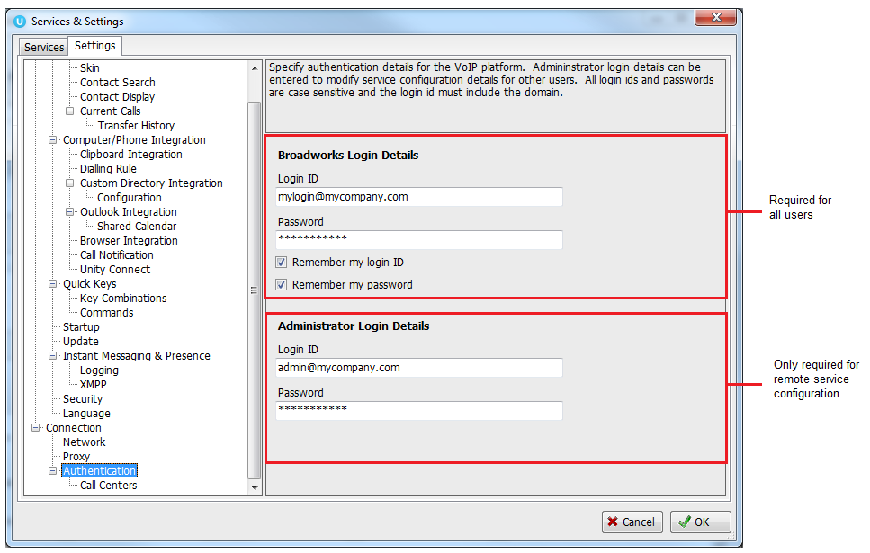

You can see above there are two areas where login details can be entered, please make sure you enter your login details in the top half, the administrator login details are only required for remote service configuration, which is outlined in 2.3.6.

You may also be asked to enter your VoIP server connection details. If so they can be obtained from your service provider but please don’t change any other settings.

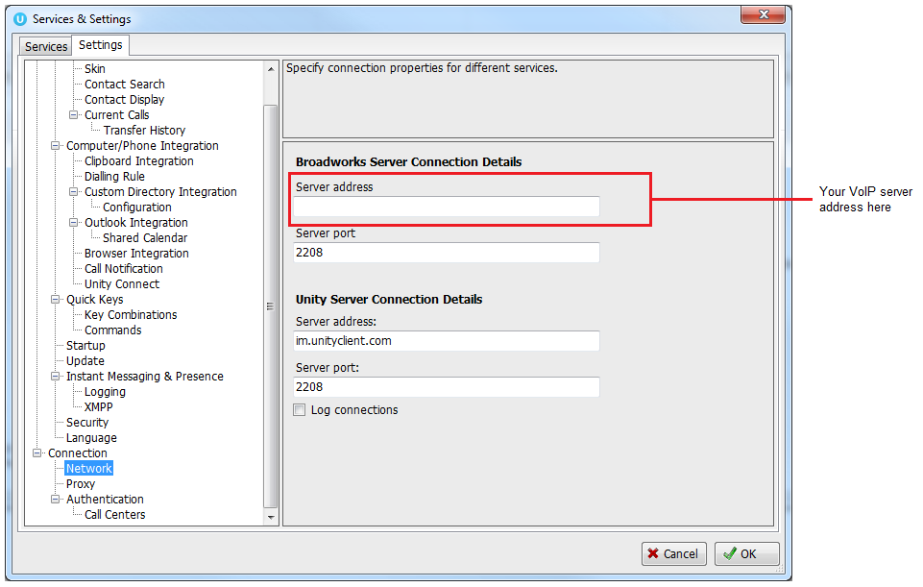

If the login details are incorrect you will be prompted to re-enter them, if problems persist please consult your VoIP service provider.

2 Getting Around

Unity provides key features such as drag & drop and context menus to allow you to quickly manage calls and colleagues in the business. Almost all actions can be performed by either dragging something over something else, or right-clicking the mouse.

Unity is split into three main areas; call control buttons, call window and contacts list. Call logs and voicemails can be seen in different tabs. Unity Reception can also act as an agent in a call centre environment. In this case Unity will also display ACD state buttons and the Personal Wallboard, which shows current call center conditions. Please speak to your service provider if you need more information about call centers and ACD states.

Unity also offers a docked Instant Message (IM) panel which makes it easy to connect instant messages, calls and colleagues. For example, you can drag a colleague from the contacts list into the docked IM panel to send them an instant message, then drag a call into the IM window to transfer a call.
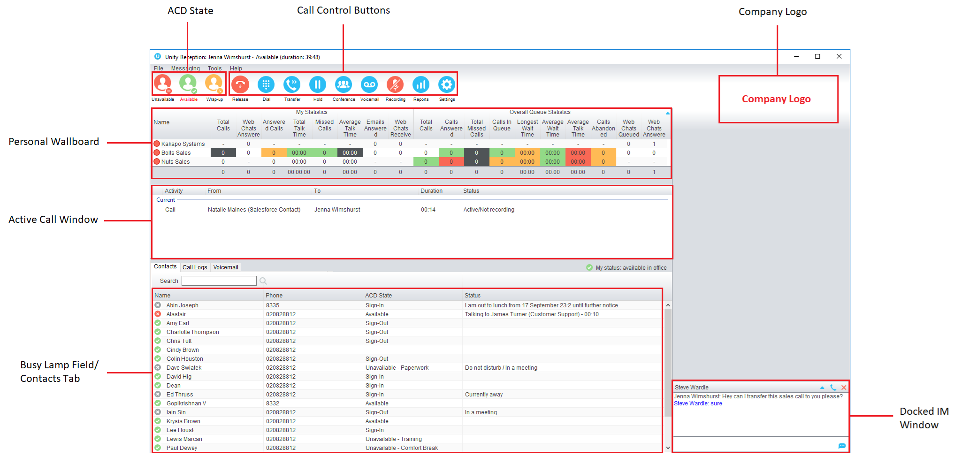

2.1 Call Control Buttons
All calls are managed through the call control buttons at the top of the application. These buttons will change depending on the state of the selected call, or the only call if there is only one call in the Active Call Window. For example, the Answer/Release   and Hold/Retrieve  buttons toggle as only one of these options will be valid at any time.

2.1.1 Answer
This will answer an inbound call that is not yet answered, it will only be shown in this scenario.

2.1.2 Release
This will end the selected call, regardless of the current state.

2.1.3 Dial
Use this button to dial a number from the Dial window.

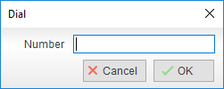

You can also right-click this button to quickly dial one of the ten last called numbers.
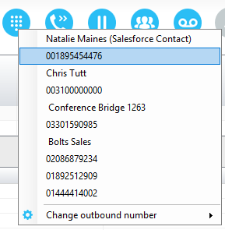

2.1.4 Transfer
Use this button to blind transfer a selected call to a number.

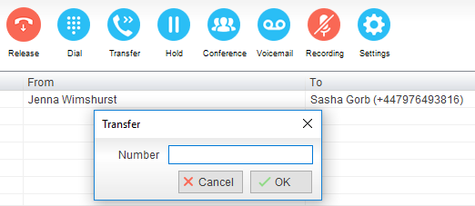

If there are multiple calls you can use the context menu to transfer them together (announced transfer) or to transfer to another number.
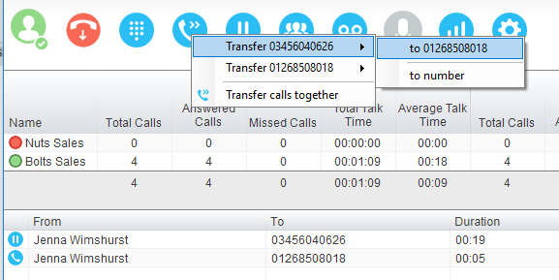

2.1.5 Hold/Retrieve
This will place a call on hold if active, or take it off hold. These buttons change depending on the state of the selected call.

2.1.6 Conference
You can select two calls in the Active Call Window and click this button to quickly conference everyone together. Once in a conference you can easily select other calls and add them to it, but you must start with a conference with two other calls first. You can use the hold and retrieve buttons to hold the whole conference, and use the release button to drop a caller out of the conference. Please note this feature depends on service assignment so may not always be available.

2.1.7 Recording
You can use this button to manage call recording in two ways. You can right-click on the button to select how to record calls. The recording status for the current call is shown in the status section in the Active Call Window.
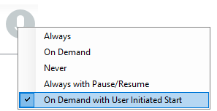

Or left click to start, stop, pause or resume recording the selected call. The button will change to show if the selected call is currently being recorded, or if recording is paused or stopped.

2.1.8 Announce
This button will only be displayed if you are a member of a paging group, meaning you can call an extension and talk through other colleague’s phones at the same time, this is often used to make announcements. If you are part of a paging group then you can use this button to call that extension, if you are a member of multiple paging groups then you can select the paging group to call through a menu.

2.1.9 Call Park Retrieve
This button will only appear when there is a call parked on your extension. You can hover the mouse over the button to see who is parked, or click to immediately retrieve the parked call. Any active calls will be put on hold.
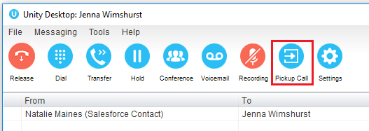

Please note that a “toast” notification will also be displayed, as below
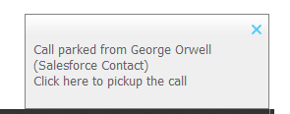
2.1.10 Reports
If you are a call center agent then you can use the Unity Report Viewer to generate reports on your call center performance, please talk to your service provider for more information.

2.1.11 Settings
This is how you access service configuration and Unity settings.

2.2 Active Call Window

The Active Call Window will display all calls that are related to you, either people that have called you or that you have called. You can see who the call is from and to, how long it has been in progress and the current status [including the recording state].

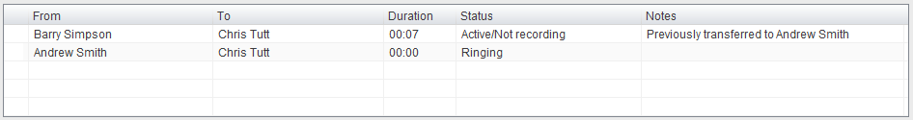

The status can be “Ringing”, “Active”, “On Hold”, “Parked for…” or “Camped for…”. You will also see status icons when the call is on hold or part of a conference.

Receptionists can optionally see all calls in queue for the Call Centers they are joined to, as shown below. This is configured in Settings>Agent>Display queued call center calls in the list.

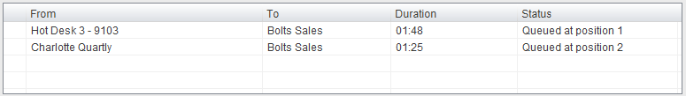

2.2.1 Drag & Drop
Drag & drop is an important feature of Unity, it means that in order to perform an action on a call you can simply drag it on top of something. For example if you want to blind transfer a call to a user then this can be done by simply searching for that user, then dragging the call and dropping it on that user in the contacts list. You may see some options here depending on what was configured in settings, or Unity can automatically blind transfer the call. Similarly if you want to perform an announced transfer then simple drag one call on top of the other in the Active Call Window, the calls will be transferred together and be removed from the list.

You can also drag other objects into this list to make a call, for example drag a user from the contacts list into the Active Call Window to call that internal user’s extension or external contact’s number.

2.2.2 Previously Transferred
When a call is received Unity Reception will automatically tell you who the caller was last transferred, if available.

This information is updated whenever you transfer a call and is shared between Unity Reception clients meaning if the call was transferred by another receptionist last week, today when that same person calls in today and can’t remember who they spoke to, you have that information. Transferred call history is stored for 28 days by default, but can be increased or reduced in Settings.

2.2.3 Adding a Note
You can add notes to the call by right-clicking and selecting add note, as below. Please note that notes are shared between all receptionists using Unity, so if the call is transferred away, then is transferred back and answered by another receptionist, they will see the note that you added. You can see below that previous transfer history and notes and combined in the same column.

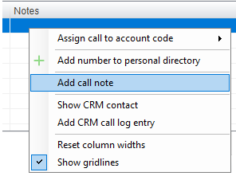

2.2.4 Show Parked & Camped Calls
When a call is camped for a colleague that is on the phone or is parked against their extension, you can configure Unity to keep that call in the Current Call Window.

You can double-click the call to retrieve it, or after a certain amount of time it will automatically be redirected to you. This can be configured in Settings, as outlined below.

2.2.5 Configuration
The Active Call Window can be configured through settings, as shown below

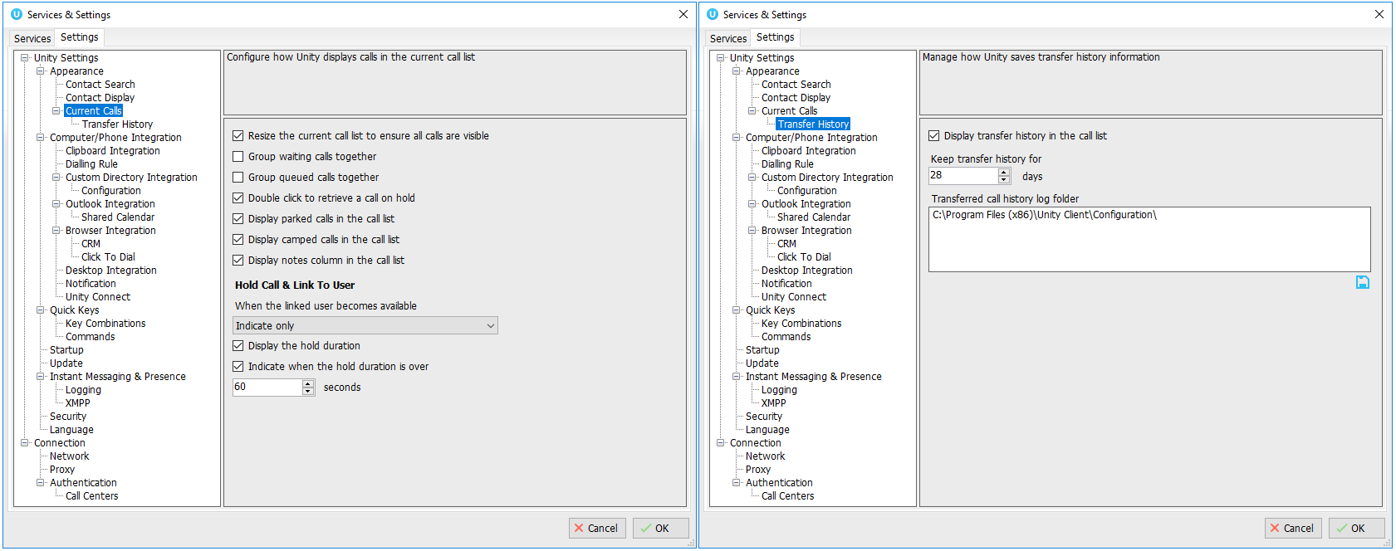

Resize the Current Call List: If set then the Active Call Window will automatically resize to ensure all calls are visible, up until there are 10 calls in the list at which point scrollbars will be used.

Grouping Calls: Unity can group waiting [including held, parked, camped and linked] calls together, as shown below.

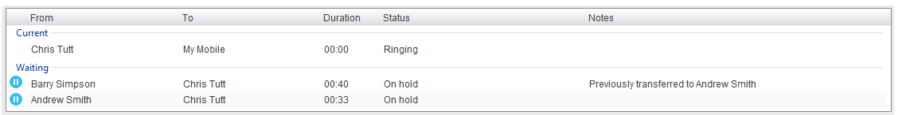

Double Click to Retrieve: When this setting is enabled, you can double-click on a held call in the Active Call Window to immediately place any active calls on hold and retrieve the selected one.
Display Parked & Camped Calls: When activated, Unity will retain all parked and camped calls in the Active Call Window.

Display Notes: This setting allows notes to be displayed against calls in the Active Call Window, if this setting is disabled the Notes column will not be displayed.

When Linked User Becomes Available: When using the Hold & Link feature [as outlined in section 2.3.3] Unity can either alert the receptionist that the monitored user is now available, prompt to transfer or automatically transfer.

Transfer History: Transfer history is only available if the Notes field is being displayed. You can configure Unity to store transfer history information for a defined duration and can specify where the history should be stored if sharing information between Unity Reception clients.

2.3 Contacts List
The Contacts list gives access to everyone in your business, as well as all contacts in your shared business directory, personal directory, speed dials, Outlook folders and any other third-party database that may be available. When you search for a contact Unity will search all directories and automatically start monitoring anyone within the business to see if they are on the phone or currently unavailable.

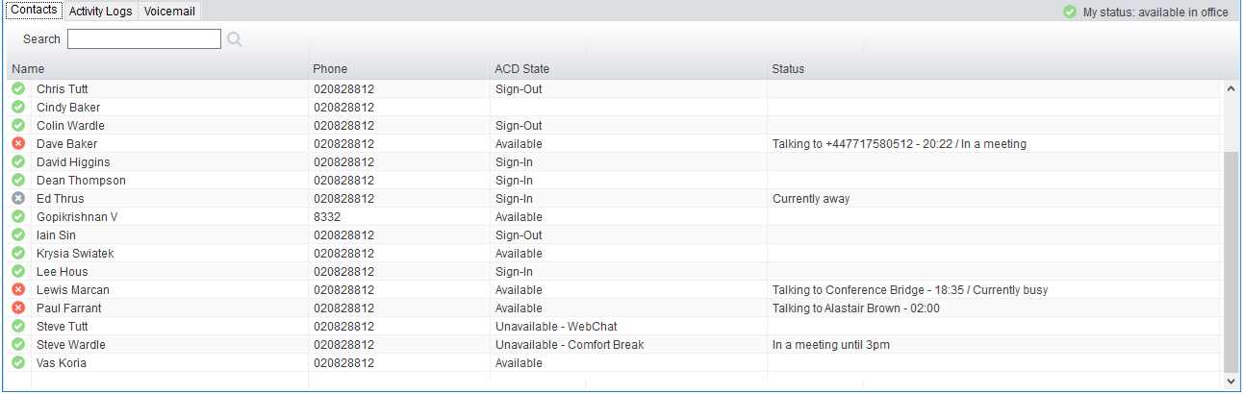

When not showing search results, the Contacts list can include up to 50 internal users and any number of external contacts in a “default list”. Unity will monitor the internal users and indicate when they are on the phone, when they are in Do Not Disturb (DND) or another unavailable status [as outlined in section 4], or when they have entered any presence information. All this information combines to give you a snap-shot of that user, so that if a call comes in for them you can process it accordingly [by sending to voicemail, transferring to mobile etc]. It also means you can easily drag calls onto these contacts to blind transfer, park on extension etc.

 | Available | The monitored user extension is on hook
 | Ringing | The monitored user extension is ringing
 | Engaged | The user is on the phone
 | Do Not Disturb | The user has selected DND or Unavailable profile

If the user is using Unity then you can be sure that if you send an instant message they will receive it immediately, if they are offline then they won’t receive the IM until they next log into Unity.
To change the list of internal users to include in the default Contacts list, simply right-click anywhere and select Manage users, as below

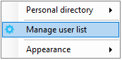

You can then select which internal users to include in the default Contacts list by moving them from the left list into the right, you can use the search feature to quickly search for users.
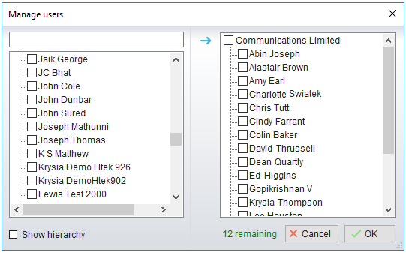

2.3.1 Performing Call Actions
In order to perform a call action against a contact in the Contacts list, simply select it and right-click. You will be presented with a context menu that dynamically displays various options based on the current state of the call and of the contact you selected. Options include transfer to extension, mobile or voicemail, camp and park the call on the user’s extension or instant message.

2.3.2 Add a Note
As with calls in the Active Call Window, you can manually add notes for an internal user that are shared between Unity Reception clients. These notes can be added, edited and removed by right-clicking the contact in the list. Depending on the view, the notes could be displayed in the status column or as a tool-tip.

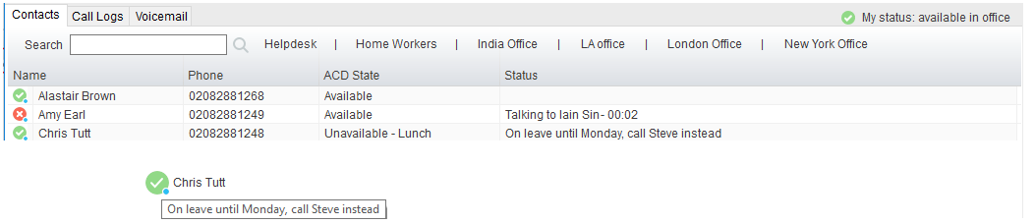

2.3.3 Hold & Link
Hold & Link is a unique feature in Unity Reception that allows you to link a call in the Active Call List with a monitored/internal user in the Contacts list, thereby giving visibility of who the caller is holding for and if they are currently on the phone, all from within the Active Call Window.

In the below scenario a call has come in from Barry Simpson who wants to talk to Andrew Smith, but he is currently on the phone. Right-click Andrew from the Contacts list [or drag the call over Andrew] and select “Hold call and link to user” and shown below.

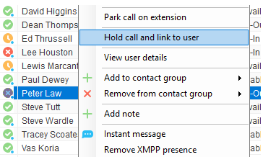
The call will be placed on hold so you can continue to take other calls. The call holding for Andrew will be shown as below. At any time you can double click the call [or select the call in the list and click the Retrieve button] to ask Barry if he is happy to continue holding.

Once Andrew becomes available Unity will change the text in the Active Call Window to indicate that he is now available.

You can then drag the call over Andrew in the Contacts list to transfer, or right-click the call and select “Transfer call to extension”

The hold duration and behaviour of Hold Call and Link to User is configurable and can be found in Settings>Current Calls, as shown below.
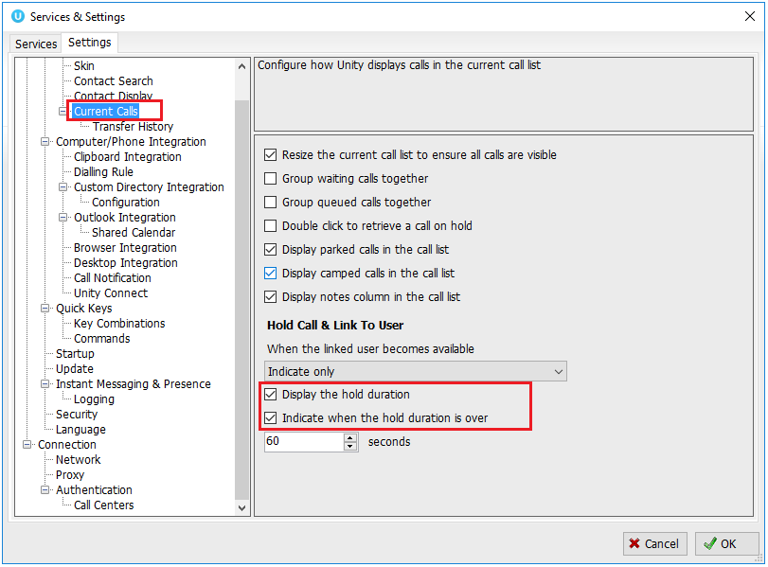

2.3.4 Contact Groups
A contact group is a grouping of internal and external users, very much like the default contact list but defined by a name. They are typically used to quickly group users by department or role, so that you can quickly find all users in a specific department simply by clicking the contact group.

To create a contact group, select the user(s) from the Contacts list that you want to include in the contact group, then right-click and select the menu option as below.

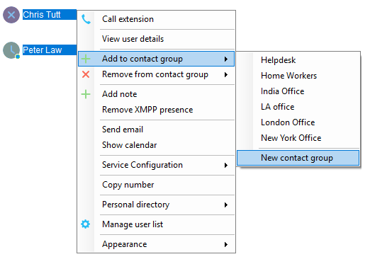

You will then be prompted to enter a contact group name

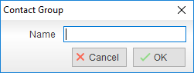

And the contact group will be displayed in the Contacts tab
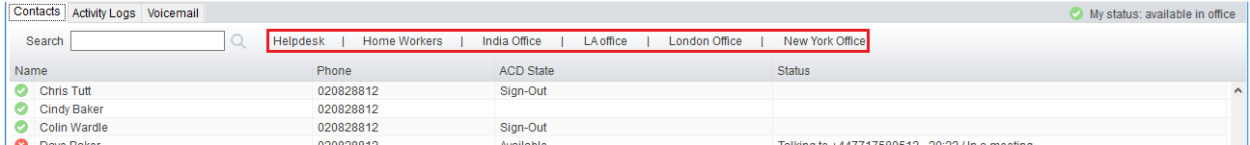

Click on any contact group to quickly see all internal users within that group, along with their phone status and any other information (DND, entered notes etc). Up to 50 internal users can be added to each contact group.

You can easily add other users to an existing contact group by right clicking as shown below
You can also remove one or more contacts from a contact group by selecting “Remove from contact group” from the menu option shown above, and can delete the entire contact group by right-clicking it and selecting “Delete contact group”

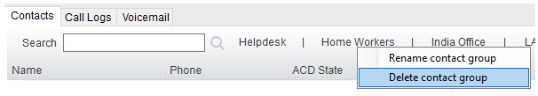

Right click in the search box to list all directories, then click the search button to clear it and see your default monitored users.
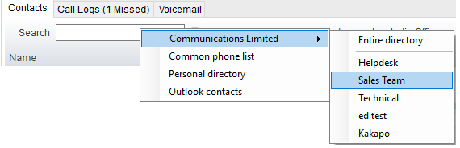

2.3.5 Calendar Integration
Unity can integrate with Outlook to show the shared calendar for internal users, provided calendar sharing is enabled and appropriate permissions are granted. Right-click the selected user from within Contacts and select “Show calendar”, this option will only be available if the email address has been entered in the VoIP platform for the monitored user.

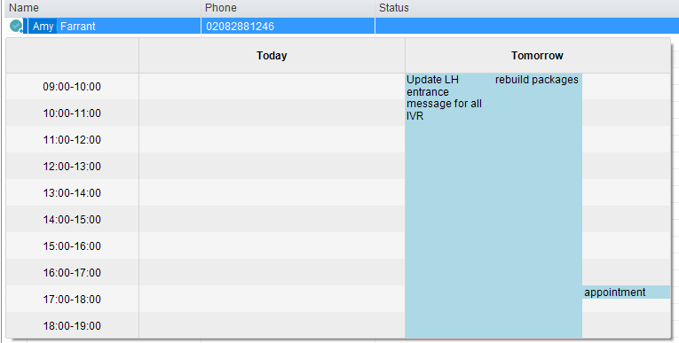

Unity requires “full details” access to read the shared calendar, we recommend that the Reviewer permission level be set to all calendars that Unity needs to display.
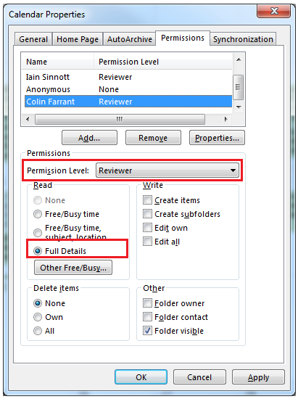

2.3.6 Remote Service Configuration
If group/enterprise administrator login details have been entered [as outlined in section 1.1] then you can change certain service configuration details for internal users, specifically being able to activate or deactivate Do Not Disturb (DND), forward all calls to a number, or change the routing/presence details for a user [for example by moving them into the Unavailable or Busy profile].

If Unity is configured for remote service configuration then when you right-click an internal user from the Contacts list you will see the below menu options, which may change depending on which services are assigned to the user and if their mobile number has been entered.

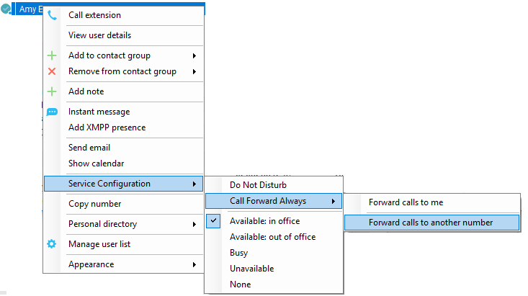

2.3.7 Configuration
The Contacts list can be configured through Settings, as shown below

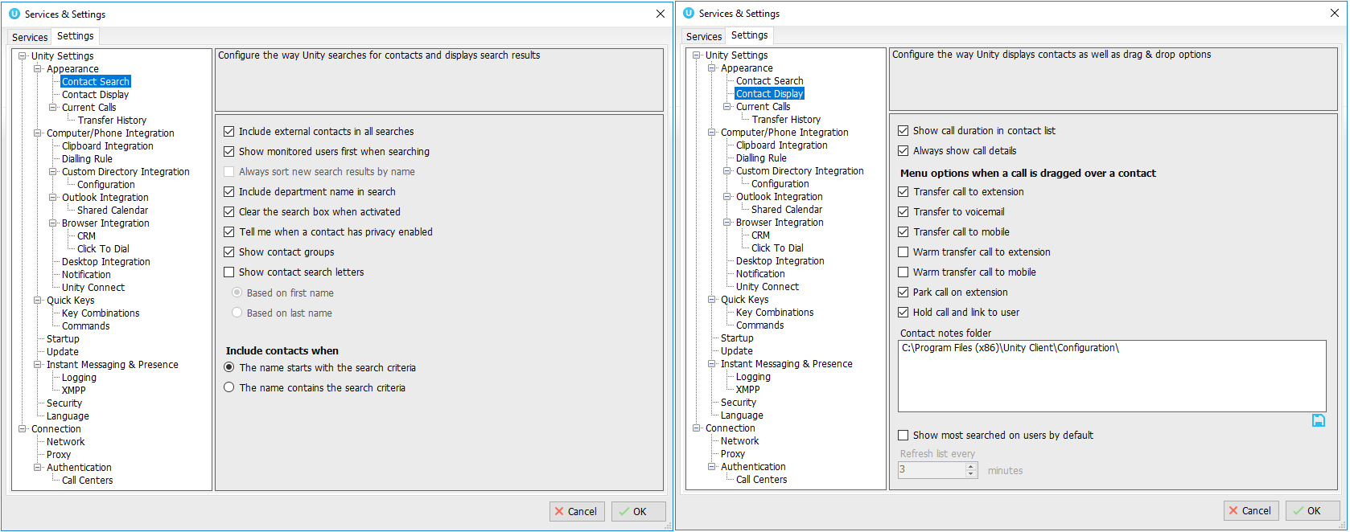

Include External Contacts in all Searches: When checked Unity will always search all directories every time a search is performed, which is one second after the last key was pressed. If the user is a slow typist this could result in many searches, so if there is a large external directory [for example an Outlook folder with several thousand records or a slow-performing SQL database] then Unity performance may be impacted. Turning this setting off means that by default only the group/enterprise directory is searched, other directories will only be searched if the user presses enter or clicks the search image.

Show Monitored Users First When Searching: When this setting is turned on Unity will always display monitored users first in alphabetical order, then external contact is monitored order. Otherwise internal and external contacts will be shown together in alphabetical order.
Always Sort New Search Results by Name: This setting can only be modified if the “Show Monitored Users First When Searching” setting is not active. If active then search results will always be displayed in alphabetical order based on the name of the contact, otherwise the same sorting used in the default list [which could be based on any column in the Contacts list] will be used when searching.

Include Department Name in Search: If activated then Unity will include any internal users where the department name matches the search criteria, for example the receptionist could type “sales” to quickly see a list of all sales people. In a nested department environment only the bottom-most department will be considered.

Clear the Search Box When Activated: If activated then whenever the user clicks into the search box the current search criteria will be removed and the default list will be shown.

Show Contact Groups/Show Search Letters: As outlined in section 8.4, contact groups provide a fast way to access pre-configured groups of internal and external contacts.

Including Contacts in Search Results: When searching Unity can be configured to only include contacts in the search results if the name starts with the search criteria or contains the search criteria. When configured to search based on the contact name containing the search criteria, it will be possible to search on first or last name, but the search results will be less refined (there will often be more entries in the search results).

Show Call Duration: Unity can be configure to include the call duration when showing a monitored user on the phone. The default option is to show the call duration, this would likely only be deactivated for privacy reasons.

Menu Options on Drag & Drop: You can select what options Unity displays or performs when a call is dragged over a contact in the Contacts list. If multiple options are selected then a menu will be displayed, otherwise if only one option is selected then Unity will perform this action every time, assuming the option is available based on the state of the call and contact.

2.4 Call Logs
Unity will display your 20 last received, missed and called numbers. This may be more depending on service assignment. You can right-click or drag a call log into the Active Call Window to call the person back. Unity will show the number of missed calls since last used, or since started. 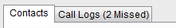
2.5 Visual Voicemail

You can manage your voicemail box directly from within Unity to listen to, save and delete voicemails.

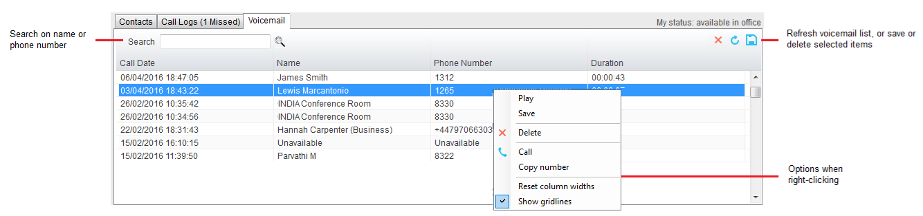

This feature is only available if the Voice Messaging User service is assigned and active, and the voicemail tab is configured to be displayed, as below
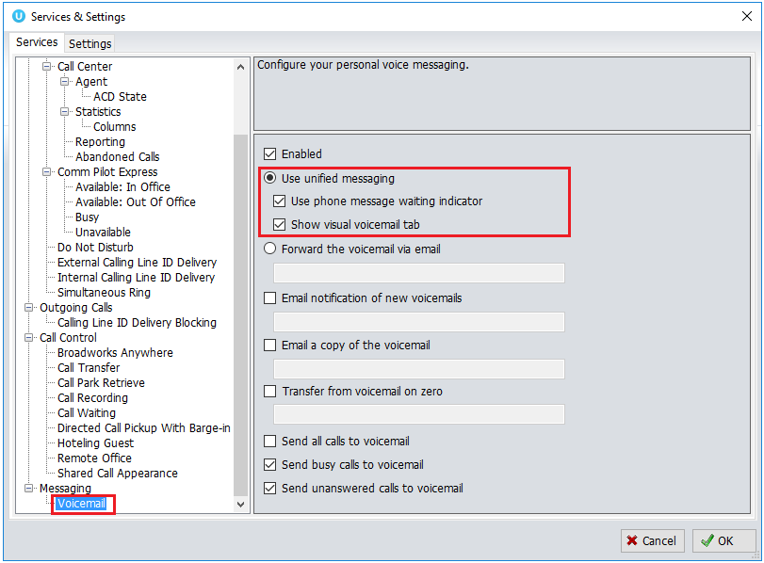

3 Instant Message

Instant Messaging (IM) is an integral part of Unity as it provides another communication channel in addition to the phone. Unity offers a docked IM panel which displays all IM conversations with internal users, this is the best configuration for a receptionist because everything is within a single Unity display and there are no other windows popping over the top.

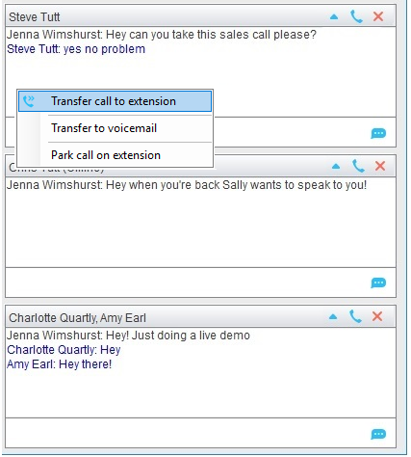

An “online” user is one that is currently running an instance of Unity, and therefore available to send an online message to. These users are indicated with a small envelope on their user icon which is shown for all states, as shown in section 2.3 above. If a user is offline they are still available to be sent an instant message, but they will not receive it until they next start Unity, therefore this is an excellent tool for leaving “post-it note” type messages, such as requests to call people back when next available.
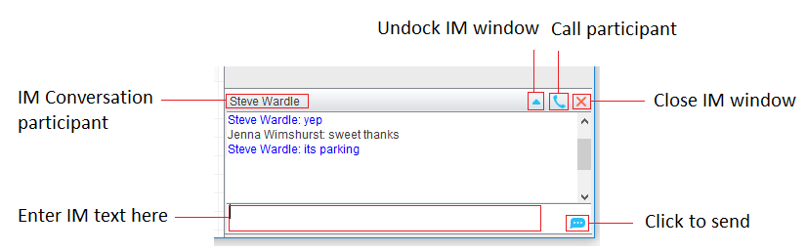

3.1 Start IM Conversation
To send someone an instant message simply right-click them in the Contacts list, or drag them into the docked IM panel [if displayed]. Unity will create a window like the one above that is used to IM that person, you will have one of these for each conversation you have open. Also when people send you an instant message they will appear in this list as well.

You can also start a conversation to multiple parties [called “group chat”] by clicking on Messaging > Start Conversation, as shown below
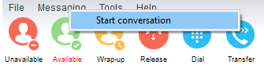
You can then select which users to include in the conversation by moving them into the right list

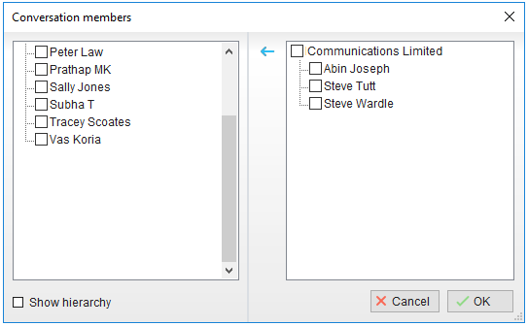

Unity will only show users that are currently online, because group chat is only possible with online users. Therefore if a user goes offline they will automatically be removed from the conversation.

3.2 Add a Participant

You can easily add a participant to an existing IM conversation by dragging the user from the Contacts list over the top of the appropriate window in the docked IM panel, then selecting “Add to the conversation” in the pop-up menu as shown below. You will see all participants of the conversation at the top of the window.
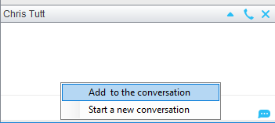

3.3 Transfer Call to a Participant

This is a key feature for a receptionist, it allows you to quickly create an instant message to a user to ask if they’re available, then to drag a call into that IM conversation to blind transfer to that user. If there are multiple participants in the IM conversation then you can select which user to transfer to.
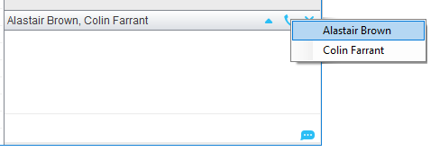
3.4 Configuration

You can undock IM conversations if you want to see them in their own window, which can be configured in Settings. You can also choose to always show the docked IM panel, even when there are no conversations taking place. This may be a good idea as you can always drag users into this panel to quickly send them an instant message.

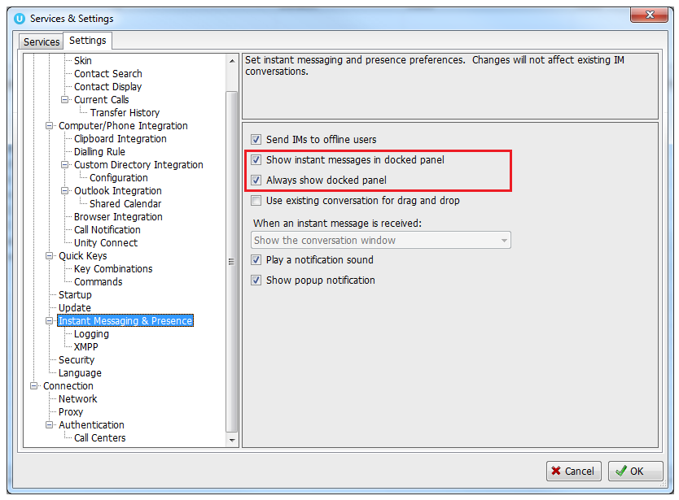

You can also choose if you want to see a “toast” notification in the bottom-right corner, and also if you want to play an announcement sound when a new IM is received and Unity isn’t the active application.

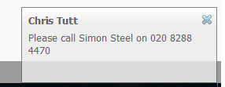

There is a complete overview of instant messaging functionality and configuration in the full Unity user guide.

4 Quick Access Service Configuration

This acts as a “my current state” indicator in Unity, which will tell you if you are currently on Do Not Disturb (DND), have call forwarding activated or are otherwise unavailable.

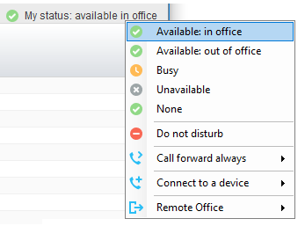

To quickly change your status simply click on the “My Status” link and select an option from the menu, these options depend on service assignment so may not all be present.

You can use the My Status link to change the below services

4.1 CommPilot Express Profiles

These profiles have two important uses; they can be used to setup call routing rules based on if you are in the office, on your mobile or away from your desk. They also tell other people this status, for example if you set your profile to “Unavailable” or “Busy” then other people will see this in their Contacts list, as below. This helps provide more information about where people are and if they are available.

4.2 Do Not Disturb
If this service is activated nobody will be able to call you. The My Status link will turn red to act as a reminder, and other people will see you are on Do Not Disturb in their Contacts list.

4.3 Call Forward Always
If activated all calls to your VoIP number will be forwarded to the number you entered for this service. You can activate, deactivate or configure the service from here, when active the My Status link will turn red to act as a reminder. Other people will also see that you are forwarding all calls to another number in their Contacts list.

4.4 Connect to a Device
This is used to connect to a phone in a hoteling environment. Simply select the device from the list to connect. If you are still connected to a device when you close Unity, you will be asked if you want to stay connected, as below.

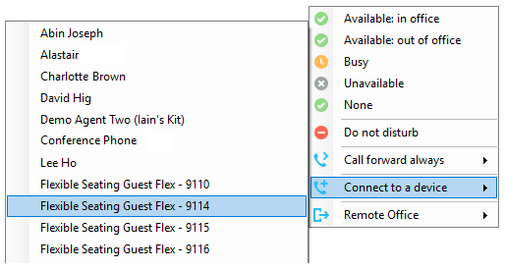

4.5 Remote Office
This service allows you to use a “normal” phone as your VoIP phone, so that all calls to you will be routed to this number, and you can use Unity to make outbound calls whereby this number will ring, then when you answer it the outbound will be setup from that number.

Please speak to your VoIP service provider if you require any further information on any of these services or features.

