
UNITY SUPERVISOR QUICK USER GUIDE
CONTENTS

1 Initial Setup 3
1.1 Call Center Login Details 4
2 Unity Supervisor Interface Overview 5
2.1 ACD State Buttons 6
2.2 Call Control 6
2.3 Active Call Window 6
2.4 Contacts [Busy Lamp Field] 6
2.5 Call Logs 6
2.6 Abandoned Calls 6
2.7 Voicemail 7
2.8 Personal Wallboard 7
2.9 Staffed Ratio 7
3 Call Center Agent Functionality 8
3.1 Changing ACD State 8
3.1.2 Force Disposition Code 8
3.2 Using Personal Wallboard 8
3.2.1 Configuring Statistics Columns in Personal Wallboard 8
3.2.2 Customizing Statistics Label 8
3.3 Joining & Leaving Queues 9
3.4 Receiving ACD Calls 9
3.5 Supervisor Escalation 10
3.6 Standard Escalation 10
3.6.1 Emergency Escalation 10
3.6.2 Escalation via Active Call Window 10
3.6.3 Personal Statistical Reports 10
4 Supervisor Functionality 11
4.1 Remotely Changing Agent State 11
4.2 Remotely Changing Agent State from Personal Wallboard 11
4.3 Threshold Alerts 12
4.3.1 Configuring Thresholds 12
4.4 Silent Monitoring 12
4.5 Configuring Statistics Columns in Personal Wallboard 13
4.6 Adding Agents to Monitored Agents List 13
5 Call Control 14
5.1 Making a Call 14
5.1.1 Using the Dial Window 14
5.1.2 Using Directory Search 14
5.1.3 Dialling from the clipboard 14
5.2 Answer a Call 14
5.3 End a Call 14
5.3.1 Redial 14
5.4 Send Call to Voicemail 14
5.5.1 Announced Transfer 15
5.5.1.1 Warm Transfer 15
5.5.2 Blind Transfer 15
5.5.2.2 Using Transfer Button 15
5.6 Call Hold/Retrieve 15
5.7 Conference Calling 16
5.7.1 Starting a Conference Call 16
5.8 Call Recording 16
6 Active Call Window 16
6.1 Window Layout 16
6.2 Calls In Queue 17
7 Drag and Drop 17
8 Contacts Panel [Busy Lamp Field] 17
8.1 Contact Panel Display Options 18
8.2 User Icons 18
8.2.1 Instant Messaging Availability 18
8.3 Managing Monitored Users in the Contacts Panel 18
8.4 Park Call on Extension 19
8.5 Retrieving Parked Calls 19
8.6 Camp Call on Extension 19
8.7 Barge into This Call 19
9 Instant Messaging 19
9.1 Docking the IM Window 20
9.2 Undocking and Redocking IM sessions 20
9.3 Sending an Instant Message 20
9.4 Adding Participants to an Existing IM Session 20
9.5 Logging IM Sessions 21
10 Personal Directory 21
10.1 Add New Entry 21
10.2 Edit Entry 22
10.3 Remove Entry 22
10.4 Import Personal Directory 22
10.5 Export Personal Directory 22
11 Contact Search Directories 23
12 Call Logs 23
13 My Status 24
13.1 Call Forward Always 24
13.2 Remote Office 25
13.3 Connect to a Device [Hoteling Guest] 25

1 Initial Setup

Unity Supervisor
Full call control, directory integration and service configuration [as outlined in the Unity Desktop user guide], plus:
- Remotely change Supervisors ACD state [available, unavailable, wrap-up]
- Allows the Supervisor to set threshold alerts against real time statistics for call centers
- Callback CallerID capture of abandoned calls. Call center abandoned calls can be assigned to Agents for call back and reporting.
- Unity Connect API – integration with third party database applications.

The first time Unity is started you will be prompted to enter the configuration details, as shown below. Unity can then retain the connection and authentication details for later use. The Login ID and Password will be assigned from your Service Provider.

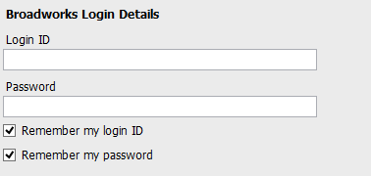

Next you will be prompted for the server address for your Service Provider. If this field is already populated do not change it. In most cases you can leave the Server Port as 2208.
Leave the Unity Server Connection Details as those prefilled.

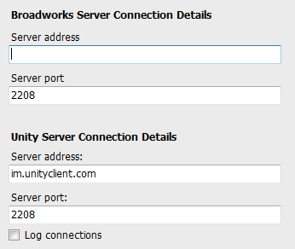

Restart Unity Supervisor to begin.
1.1 Call Center Login Details
Once Unity has been restarted it will connect to the host BroadWorks system and populate all the Call Center Instance IDs for the call centers that the supervisor is a member of as shown below.

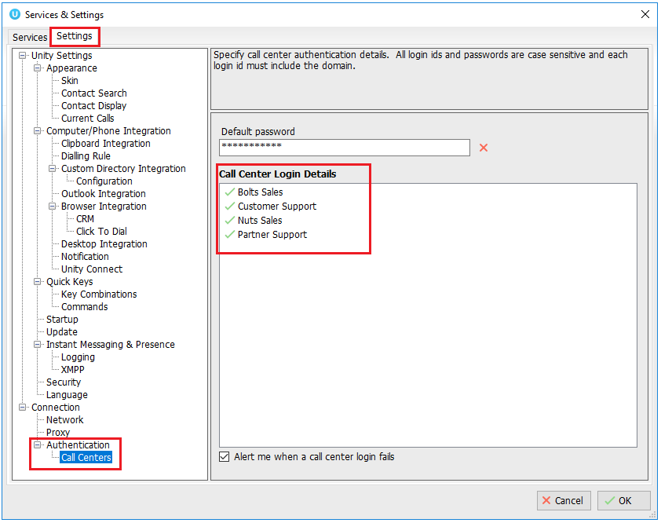

2 Unity Supervisor Interface Overview

Unity is split into six functional areas; ACD Buttons, Call Control buttons, Personal Wallboard, Active Call Window, Contacts [Busy Lamp Field and Instant Messages]. Contacts is a tab that can be toggled to display Call Logs, Abandoned Calls, Agent Activity and the Voicemail tab.

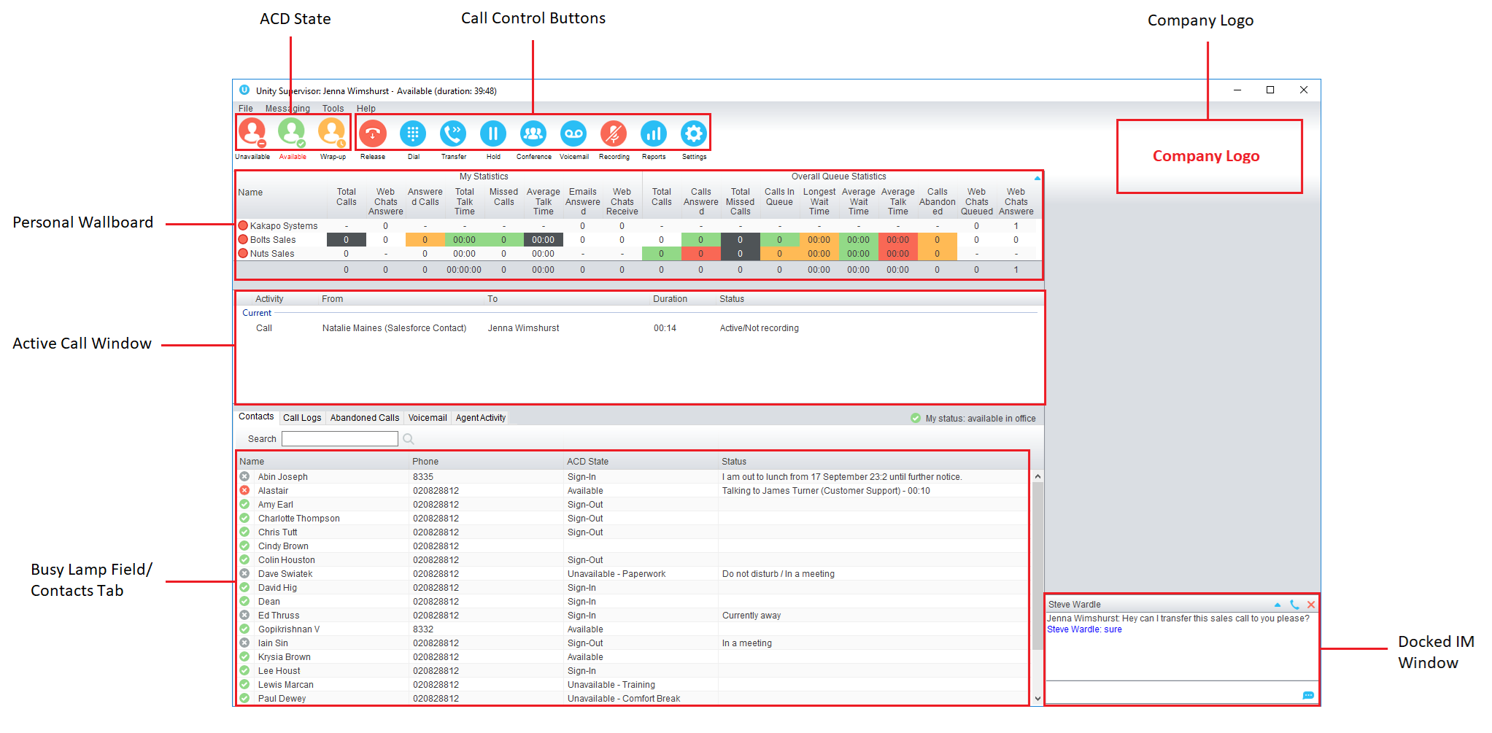
2.1 ACD State Buttons
ACD State buttons for setting the supervisor’s availability to the call center. When clicking “Unavailable” the user will be presented a list of unavailable codes as configured in BroadWorks.

2.2 Call Control
Call Control buttons provide quick access to common telephone handling commands. Only services that are assigned to the user are displayed.

2.3 Active Call Window
This provides a list of all current calls and their state. For example, Ringing, Active or On Hold. The duration of the call is also displayed. This is from the moment the call was first placed and does not reset when a call is Held or Retrieved.
2.4 Contacts [Busy Lamp Field]
This panel will display up to 30 monitored users, displaying their Do Not Disturb [grey], Available [green], Engaged [red] or Ringing [orange] state as icons.
2.5 Call Logs
Toggling the bottom Contacts panel to Call Logs will display Missed Calls, Received Calls and Dialled Calls.
2.6 Abandoned Calls
A Supervisor can assign abandoned calls to an Agent for a call back. These will be listed in the “Abandoned Calls” tab. Right click these calls to assign them to an Agent or double click to make the outbound call.
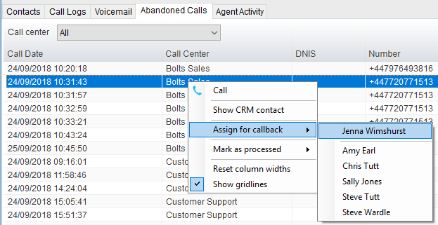

2.7 Voicemail
Clicking into the Voicemail tab will display a list of voice messages with the most recent at the top.
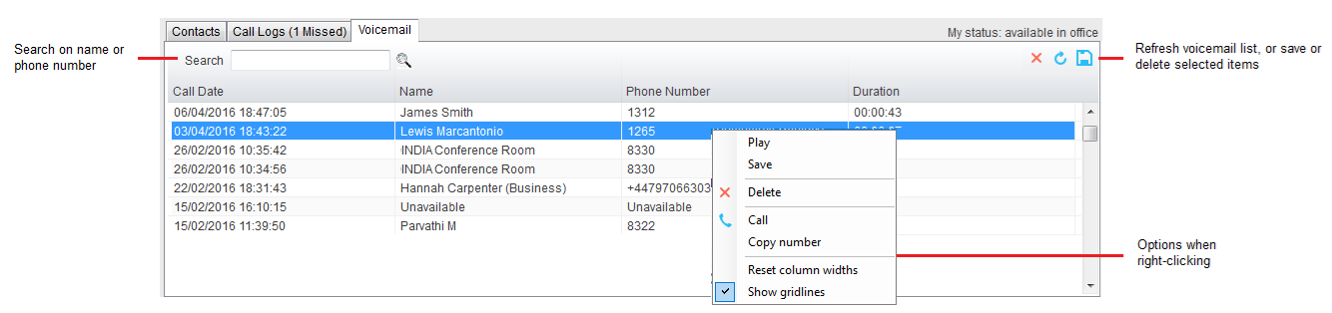

2.8 Personal Wallboard
If the Supervisor is not also an agent for the queue in BWKS, then they will not be able to Join/Leave or take calls for those queues. The Join/Leave status icon will show as grey and there will be no statistics in the “My Statistics” window as below.

When the user is also an agent
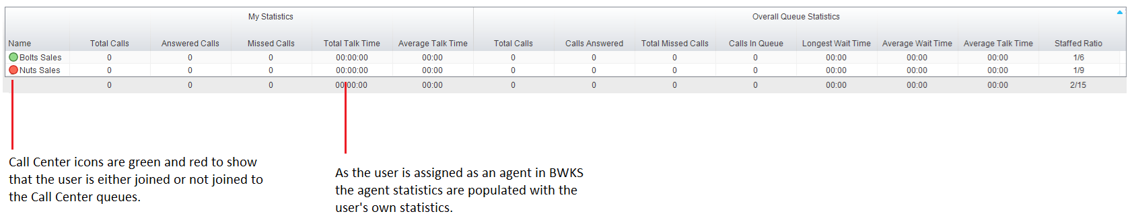

When the user is not an agent
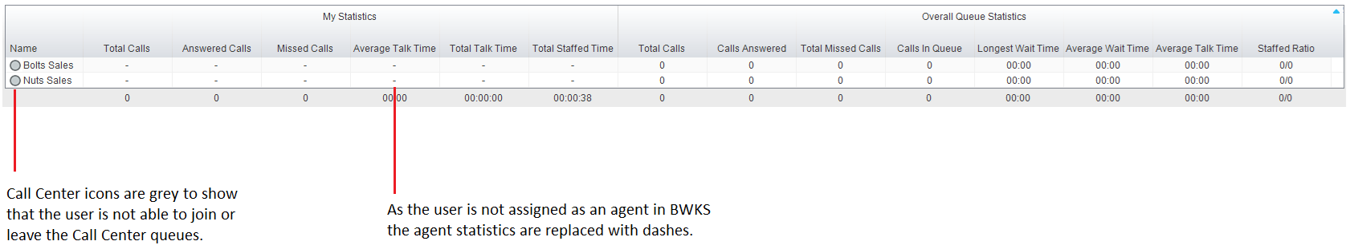

2.9 Staffed Ratio
For each queue, Staffed Ratio shows the total number of Agents that are available to take calls out of the total number of Agents assigned to the queue in BWKS.
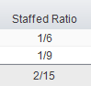

3 Call Center Agent Functionality

Unity Supervisor also allows the user to perform call center agent functionality such as changing ACD state, joining and leaving a queue and taking calls for that queue.
3.1 Changing ACD State
Clicking Unavailable, Available or Wrap-Up will change your availability for all queues you are a member of.

3.1.2 Force Disposition Code
To assign a Disposition Code the supervisor right clicks in the Active Call Window. Unity can force the supervisor to enter a disposition code by setting their ACD state post-call to Wrap-Up ACD state.
3.2 Using Personal Wallboard
The Personal Wallboard will show current performance metrics for the call centers the supervisor is assigned to. The statistics are broken down by “My Statistics” which shows the supervisor’s individual performance and “Overall Queue Statistics” which will show the current conditions across the entire call center[s].
3.2.1 Configuring Statistics Columns in Personal Wallboard
The statistics shown in “My Statistics” and “Overall Queue Statistics” panels of the Personal Wallboard are configurable in Settings > Services > Call Center > Statistics > Columnns.
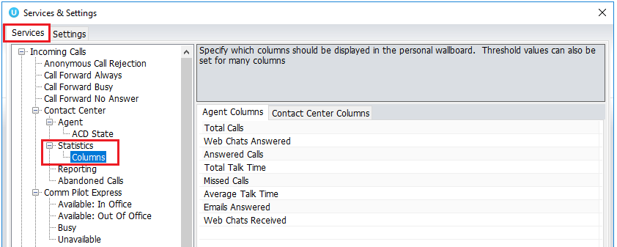
3.2.2 Customizing Statistics Label
Double click any statistic as displayed in the list above. From the below field you are able to customize the statistic label as required.

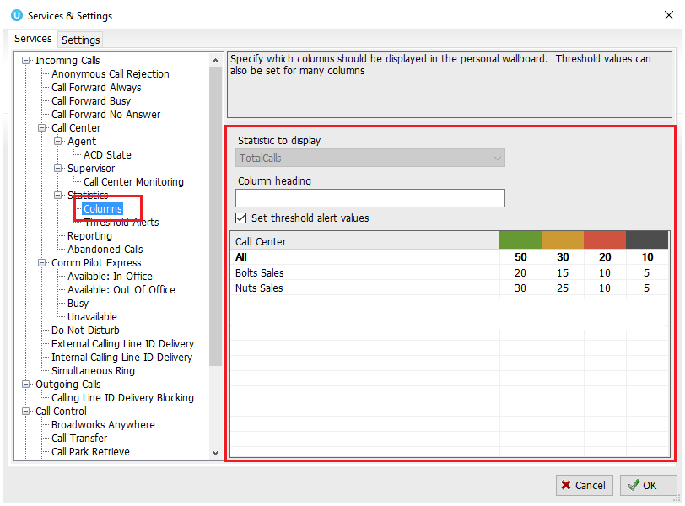

Double click an entry in the list to set overall threshold values or those for a specific call center.
In the example below statistics columns have been added, some have been renamed from the default and threshold alerts have been configured.
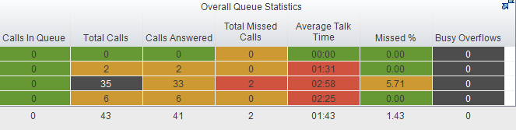
3.3 Joining & Leaving Queues
Right click any queue in the Personal Wallboard to toggle between Join and Leave queue. This is only available if the user is allowed to join and leave call center queues.
3.4 Receiving ACD Calls
Inbound ACD calls will display the call center name in the “To” field. The “From” field will display the incoming CallerID.

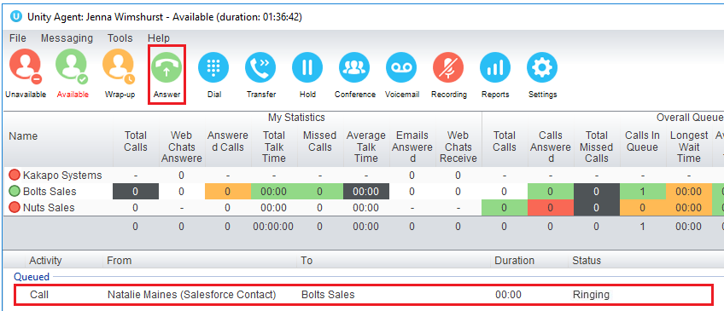
3.5 Supervisor Escalation
Unity Call Center Supervisor facilitates the BroadWorks call center escalation feature by allowing both standard and emergency call escalation. Both types of escalation can only be performed on call center calls and both inbound and outbound [DNIS] calls are supported.
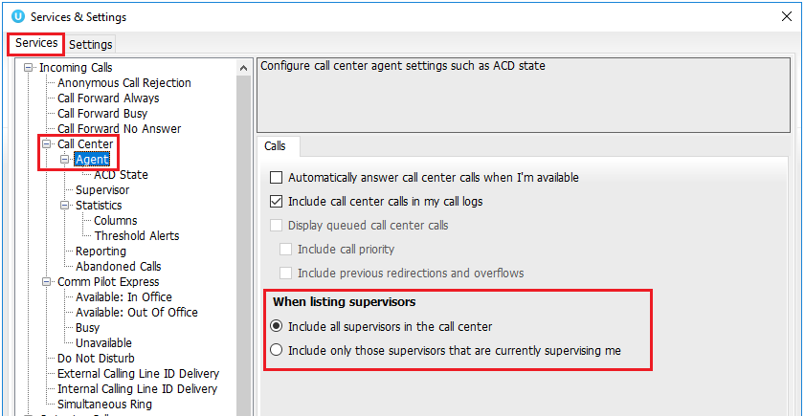
3.6 Standard Escalation
Standard escalation is used when an agent needs to be given information or instruction from the supervisor without conferencing in the remote party.
3.6.1 Emergency Escalation
Emergency escalation is used to immediately conference a supervisor into the call with the remote party, therefore it relies on either the 3-Way or N-Way Calling user service being assigned.
3.6.2 Escalation via Active Call Window
To perform escalation, the agent right-clicks the call in the active call window, then either chooses the supervisor to escalate the call to:
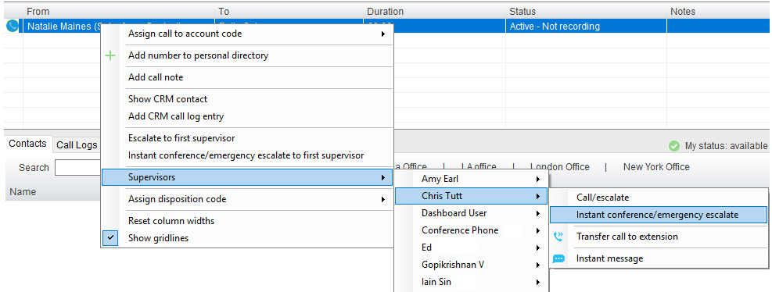
3.6.3 Personal Statistical Reports

Unity Supervisor provides access to the following agent reports. To access these reports, click the Reports button .
4 Supervisor Functionality

4.1 Remotely Changing Agent State
The supervisor can change the Agent’s availability to the call center either from the Personal Wallboard, Tools menu or Agent Activity tab. The supervisor can also specify an Unavailable code when selecting this state and Call or Instant Message the Agent from the drop list.

When providing the option to change a monitored agent’s ACD state or joined status, Unity will show if the agent is currently joined to the queue and what the current ACD state is, as shown below.
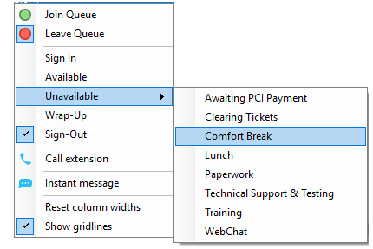

4.2 Remotely Changing Agent State from Personal Wallboard
Right clicking any queue in the Personal Wallboard will present a drop list of options. Hover over “Agents” to see a list of all agents assigned to the selected queue.

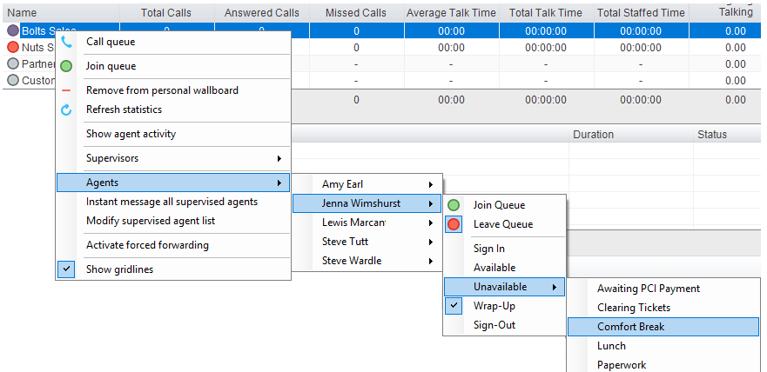

4.3 Threshold Alerts
Thresholds allow the supervisor to configure performance triggers against various parameters for all the queues they are supervising.

4.3.1 Configuring Thresholds
Click Settings [button] > Services [tab] > Statistics> Columns > Call Center Columns – double click the statics (e.g. total calls) to set thresholds.

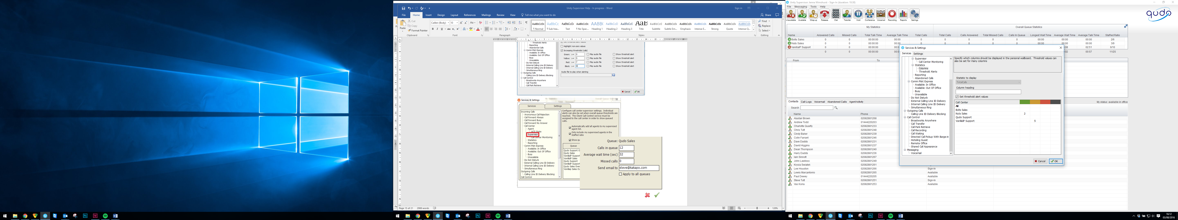

4.4 Silent Monitoring
Allows the supervisor to silently monitor the next call or calls taken by a specified agent. To activate Silent Monitoring, right click the call center queue in Personal Wallboard > select the agent > select Next Call Only or All Calls.
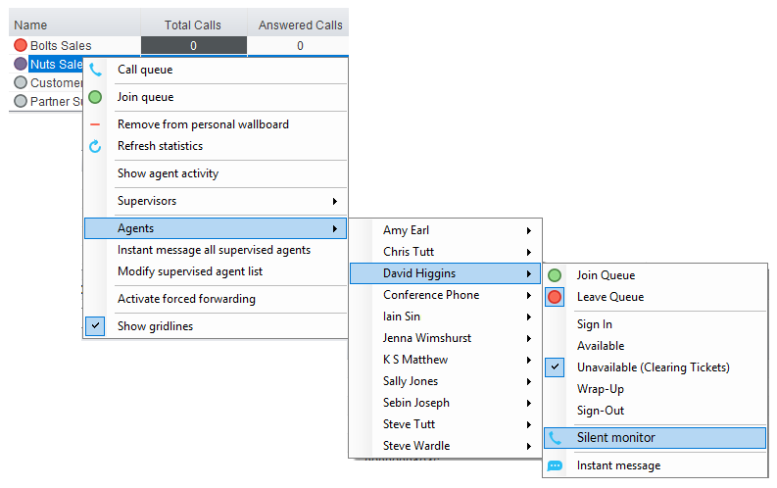

Silent Monitoring Warning Tone
The supervisor can optionally play the agent a tone to alert them that they are being monitored.

4.5 Configuring Statistics Columns in Personal Wallboard
The statistics shown in “My Statistics” and “Overall Queue Statistics” panels of the Personal Wallboard are configurable in Settings > Services > Call Center > Statistics > Columnns.
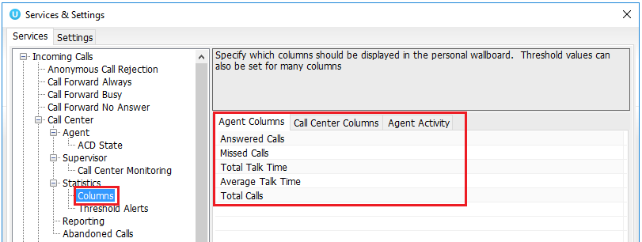

4.6 Adding Agents to Monitored Agents List
To monitor a specific subset of the total agents, go to Settings [button] > Settings [tab] > Supervisor and uncheck “Automatically add all agents to my supervised agent list” and restart Unity.

Right click the call center queue in Personal Wallboard, select “Modify supervised agent list” and add the agents you want to supervise.
5 Call Control
All calls are managed through the call control buttons at the top of the application. These buttons will change depending on the state of the selected call, or the only call if there is only one call in the Active Call Window. For example, the Answer/Release   and Hold/Retrieve  buttons toggle as only one of these options will be valid at any time.
5.1 Making a Call
5.1.1 Using the Dial Window
Click the Dial button  to bring up the Dial dialogue box, as shown below. Using the computer keypad enter the desired number and press Enter or click OK to make the call.
5.1.2 Using Directory Search
Enter the search field in the Contacts panel to dynamically search all internal users and speed dials.
5.1.3 Dialling from the Clipboard
Any number that is copied to the Windows clipboard, (highlight the telephone number, right click, then clicking copy) this will cause a popup toast above the system tray with the option to call the number.
5.2 Answer a Call
When Unity displays an inbound call, click the Answer icon or double click the call in the Active Call Window to answer the call.
5.3 End a Call
Click the Release button to end the currently selected call. If there are multiple calls in the current call list, make sure you select the right call before clicking Release.
5.3.1 Redial
You can also right-click the Dial button to see a list of the last 10 dialled numbers. Simply click on an entry to dial the party, as shown below.
5.4 Send Call to Voicemail
To send an inbound caller directly to your voicemail click the Voicemail button .
5.5.1 Announced Transfer
Receive and answer an inbound call. Make a new call to the desired destination extension or number as described Make a Call above. This will automatically place the first caller on Hold and will open a new call in the Active Call Window. Once the called party answers, click Transfer  and select the context menu option to transfer both calling parties together.

Example – Transfer with two live calls

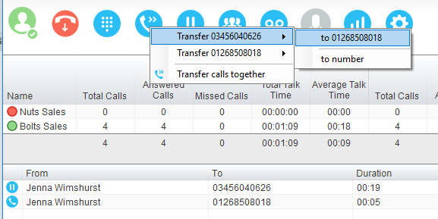
5.5.1.1 Warm Transfer
Unity Supervisor allows you to warm transfer a call by right clicking the user you want to transfer the call to and selecting “warm transfer” from the context menu. This will then put the original caller on hold and dial the selected number. When ready, click the transfer button in the call center control options panel and the two calls will be transferred.
5.5.2 Blind Transfer
Unity Supervisor can be configured to automatically blind transfer a call by dragging the call from the Active Call Window and dropping it on a user icon or number icon in the Contacts panel, or dropping it onto a call center queue.
5.5.2.2 Using Transfer Button
Once on a call click the Transfer call control button . In the Transfer window enter the destination and click OK.
5.6 Call Hold/Retrieve
The Hold/Retrieve function toggles depending on the status of the currently selected call. Hold is only available for an active call while Retrieve is only a valid option for a call currently on Hold.
5.7 Conference Calling
A conference call can be established with any combination of internal and external numbers. The total number of parties that can be supported is determined by service assignment. The Three-Way Calling user service supports conference calls with two other parties only while the N-Way Calling user service supports conference calls with more participants.
5.7.1 Starting a Conference Call
You can select two calls in the Active Call Window and click this button to quickly conference everyone together. Once in a conference you can easily select other calls and add them to it, but you must start with a conference with two other calls first. You can use the hold and retrieve buttons to hold the whole conference, and use the release button to drop a caller out of the conference. Please note this feature depends on service assignment so may not always be available.
5.8 Call Recording
You can use this button to manage call recording in two ways. You can right-click on the button to select how to record calls.

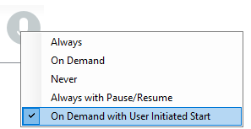

Or left click to start, stop, pause or resume recording the selected call. The button will change to show if the selected call is currently being recorded, or if recording is paused or stopped.
6 Active Call Window

The Active Call Window gives visual representation of the status of all calls the user receives or is currently managing.
6.1 Window Layout

From – This field will display the incoming CallerID or the name
To – This field displays the name of the user, hunt group or call center
Duration – This displays the total time elapsed since the call was first answered
Status – This shows the Ringing/Active, on On Hold and recording status of each call
6.2 Calls In Queue
Supervisors can optionally see all calls in queue for the Call Centers they are joined to, as shown below. This is configured in Settings>Agent>Display queued call center calls in the list.

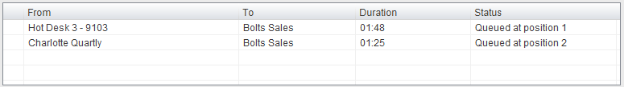

7 Drag and Drop

Drag & drop is an important feature of Unity; it means that in order to perform an action on a call you can simply drag it on top of something. For example if you want to blind transfer a call to a user then this can be done by simply searching for that user, then dragging the call and dropping it on that user in the contacts list. You may see some options here depending on what was configured in settings, or Unity can automatically blind transfer the call.
Similarly if you want to perform an announced transfer then simple drag one call on top of the other in the Active Call Window, the calls will be transferred together and be removed from the list.

You can also drag other objects into this list to make a call, for example drag a user from the contacts list into the Active Call Window to call that internal user’s extension or external contact’s number.
8 Contacts Panel [Busy Lamp Field]

The Contacts tab gives a visual indication of the status of users [within the group/enterprise] that are currently being monitoring. A maximum of 30 users can be displayed. Double clicking a monitored user will call them and right clicking will bring up a dynamic options menu.

8.1 Contact Panel Display Options
There are four different views available, as outlined below. Right-click anywhere in the Contacts panel and select Appearance list to change the view.
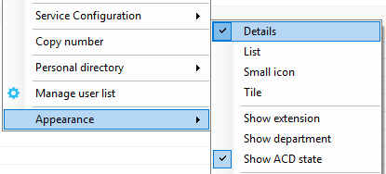
8.2 User Icons
There are four main user icons states shown in the Contacts panel, regardless of the view chosen.

 | Available | The monitored user extension is on hook
 | Ringing | The monitored user extension is ringing
 | Engaged | The user is on the phone
 | Do Not Disturb | The user has selected DND or Unavailable profile

8.2.1 Instant Messaging Availability
Regardless of a user’s Available/Ringing/Engaged/DND state, if they currently have any version of Unity open they will be available for instant messaging. This is shown by the small blue dot bottom right of the user icon.
8.3 Managing Monitored Users in the Contacts Panel
The Contacts panel will display 30 users. In the Contacts panel right click anywhere and click “Manage user list”. This will allow you to choose which users to display.

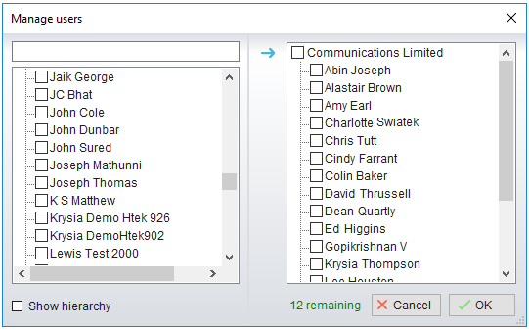
8.4 Park Call on Extension
Will park the call on the monitored user’s extension park slot.
8.5 Retrieving Parked Calls
Once a call has been parked onto a user’s extension, their Unity will display a Pickup Call Icon and a toast pop up window will appear. In order for the user to retrieve the parked call they simply need to click either the Pickup Call Icon or the toast pop up.

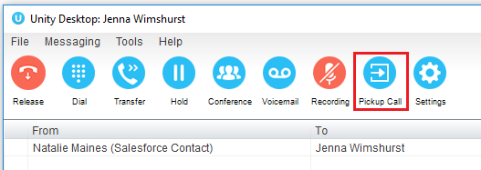
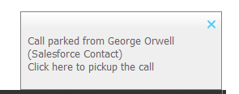
8.6 Camp Call on Extension
Will camp the call onto the engaged monitored user. When the user goes back on-hook the camped call will be delivered and their phone will start ringing.
8.7 Barge into This Call
Makes an immediate three-way conference call with the Supervisor user, the monitored user and the third party the monitored user is talking to. If the phone plays a “number doesn’t exist” tone then this means the monitored user cannot be barged into.

Please note that when leaving a call that you barged into, you must transfer the call parties together in order to leave the conference without ending the original call.
9 Instant Messaging

Instant messages can be sent and received between any Unity app [Reception, Desktop, Agent, or Supervisor]. Messages sent to offline user [those that do not have an instance of Unity open] can be stored and delivered when the recipient next opens Unity.
9.1 Docking the IM Window
Instant Messages can be displayed in the Docked IM Window or as separate dialogue boxes for each individual IM thread. If the docked window is used IMs can be initiated via drag and drop and new IM windows will not pop over other applications.
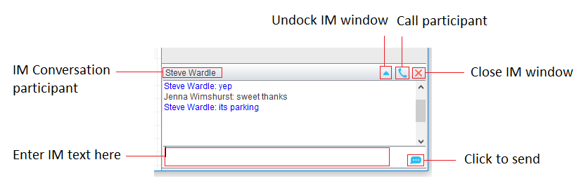
9.2 Undocking and Redocking IM sessions
You can undock an IM message by clicking the “Expand conversation to separate window” button. The IM session will now be a standalone window.

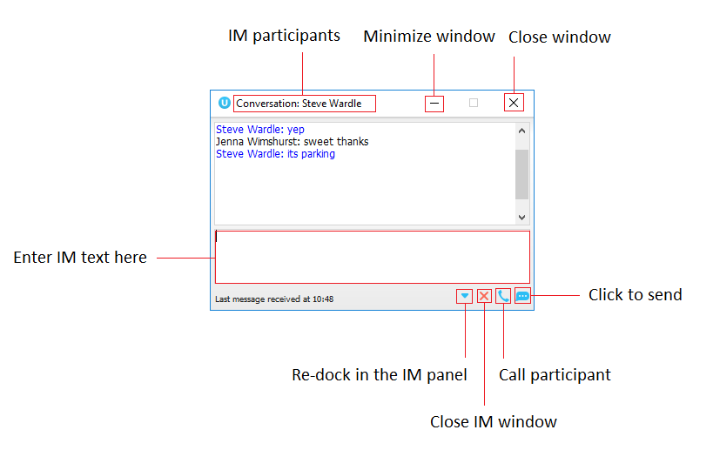
9.3 Sending an Instant Message
Send an instant message either by right clicking a user icon in Contacts panel or Search and selecting “Instant Message” from the drop list, or by dragging a user icon into the docked IM panel.
9.4 Adding Participants to an Existing IM Session
When an IM conversation is in the Docked IM panel you can drag a user icon from the Contacts Panel or Search and drop them on the IM window to add them to the conversation.
9.5 Logging IM Sessions
You will find the Instant Messaging and presence logging options in the Settings tab. Here you
will be able to configure how IMs are saved, what file type they are (CSV or HTML) and where
they are saved.
10 Personal Directory

Personal Directory – Right click in Contacts
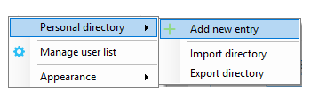

Personal Directory – Right click on monitored user
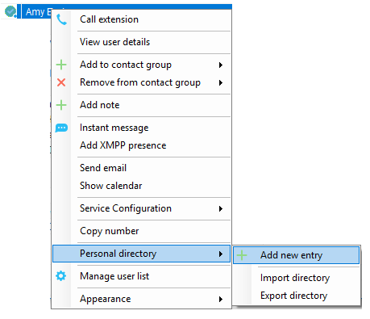
10.1 Add New Entry
Enter the Name and Number and click Ok

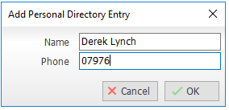

If the number specified is already in the Directory the user will be alerted.
10.2 Edit Entry
Use the Search field in Contacts to locate the entry. You can search by either Name or Number. Right click the Entry and select “Edit”.
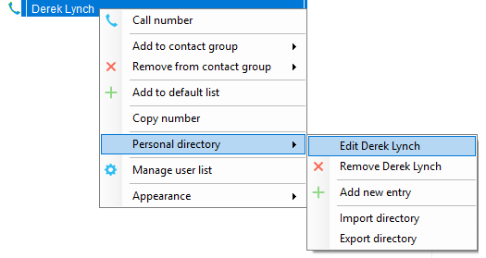
10.3 Remove Entry
Use the Search field in Contacts to locate the entry. You can search by either Name or Number. Right click the Entry and select “Remove”.
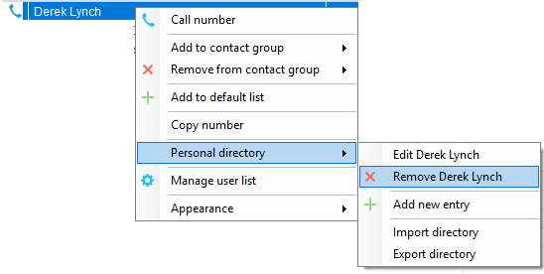
10.4 Import Personal Directory
Supervisor will allow the user to import a .csv file of directory entries, provided they are in “name, number” format. Right click in the Contacts panel, select “Personal directory > “Import” and then browse to the location of the csv.
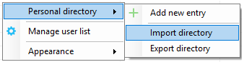
10.5 Export Personal Directory
To export Personal Directory entries right click in Contacts and select Personal directory > “export”.
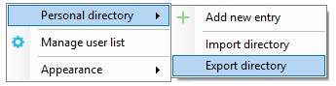
11 Contact Search Directories

The Contact Search field combines all BroadWorks and Outlook Contacts directories to create a central search repository. The BroadWorks directories include the Common Phone List [system speed dials], the receptions user’s own Personal Directory entries, and the Group Directory which includes all the other users in the group as well as hunt groups, auto attendants and call centers. Unity can also integrate with third party LDAP [including Microsoft Active Directory] and SQL directories.
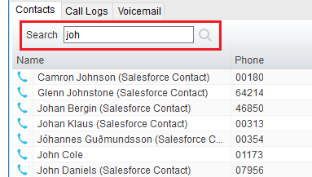
Right click the search box to list all directories, then click the search button to clear it and see your default monitored users.

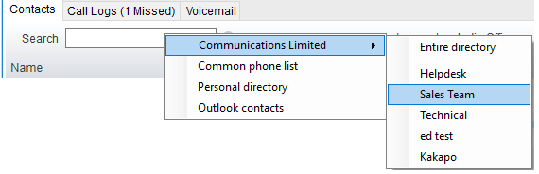

Search results will display each number for a contact as a separate line. Drag or double click the entry to make a call or right click to select a call action from the context menu.
icons represent external numbers or system resources such as hunt groups for which presence information cannot be displayed.
12 Call Logs

The Call Logs tab displays Missed, Received and Dialled Calls with a date and time stamp showing the most recent call at the top. Up to 20 numbers are listed unless the Enhanced Call logs service is assigned to the Supervisor user in BroadWorks. Calls to the Supervisor user DID as well as hunt group and call center calls that have reached the Supervisor user are shown.

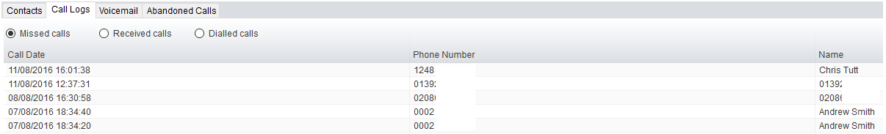

Drag or double click an entry to make a call to that number. Call logs can be exported as a csv file, either individually or together, but clicked the Export button.
13 My Status

The “My Status” link provides an indication of the current status of the user as well as quick access to key services that are regularly modified.
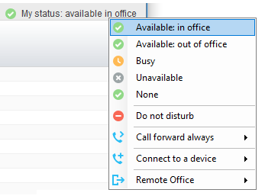

CommPilot profiles are also used to convey presence information to other users within the group or enterprise.
13.1 Call Forward Always
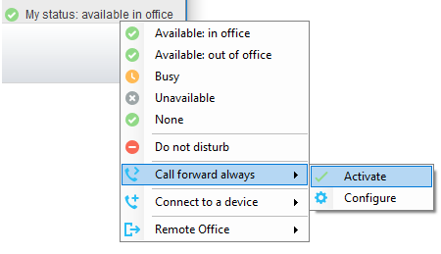
13.2 Remote Office
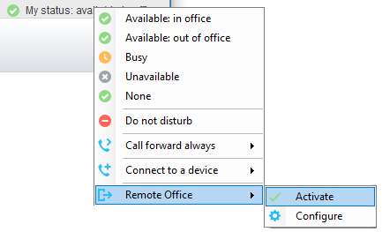
13.3 Connect to a Device
The user can easily select the device to connect to through the My Status link, as shown below.

