

UNITY CONTACT CENTER HELP GUIDE

Contents
1. Unity Contact Center 4
2. Assigning Contact Center Licenses 6
3. Administration 7
3.1 Authorization Requests 7
4. Staff Groups 9
5. Reply Repository 11
6. Resource Repository 12
6.1 Email HTML Resources 13
7. In-Office Profiles 14
8. Holidays 16
9. Availability & ACD State Management 17
9.1 ACD State Change 18
9.1.1 Post-Conversation ACD State 18
9.2 Simultaneous Conversations 19
9.3 Agent Availability Restrictions 20
9.4 Unavailable Restrictions 22
10. Queues 22
10.1 Creating a new Queue 23
10.2 Profile 24
10.3 Media Streams 24
10.4 Supervisors 25
10.5 Availability & ACD State Management 25
10.5 Reply Repository 25
10.6 Resource Repository 26
10.7 Holidays 26
10.8 History Log 26
11. Media Streams 26
11.1 Add Media Stream 27
11.2 Web Chat 28
11.3 Twitter 33
11.3.1 Authenticating Twitter 34
11.3.2 Twitter Settings 35
11.4 Email 35
11.5 Callback 37
11.6 SMS 39
11.7 Profile 41
11.7.1 Deleting a Media Stream 41
11.8 Routing Phases 42
11.8.1 Routing by Department (Web Chat & Callback Only) 45
11.9 Availability & ACD State Management 46
11.10 Reply Repository 46
11.11 Resource Repository 46
11.12 History Log 46
12. Presence-Based Scripting 47
13. End User Experience 48
13.1 New Conversation Alert 49
13.2 Conversation 49
13.2.1 When Showing Unreserved Conversations 50
13.2.2 Transferring & Closing Conversations 51
13.3 Managing Web Chat 52
13.3.1 History 56
13.3.2 CRM Contacts & Leads 56
13.4 Managing Callbacks 57
13.4.1 Reason for call back 58
13.4.2 Agent Notes 59
13.6.3 Schedule Callback 59
13.4.4 Close Callback 59
13.5 Managing Email 60
13.6 Managing Twitter 61
13.7 Managing SMS 63
13.7.1 Delivered/Undelivered receipts 65
13.7.2 Sending attachments 66
13.7.3 Ending an SMS conversation 66
13.8 CRM automatic contact pop 66
13.9 Viewing Historical Conversations 67
14. Desktop Functionality 68
14.1 Joining or Leaving Queues 68
14.2 ACD State Information 68
15. Agent Functionality 69
15.1 Joining or Leaving Queues 69
15.2 Adding/Removing Contact Center Statistics 70
16. Supervisor Functionality 71
16.1 Licensing/Becoming A Supervisor for A Queue 71
16.2 Show Queued and Reserved Conversations 71
16.3 Transferring & Closing Conversations 72
16.4 Silent Monitoring Conversations 73
16.4 Agent Activity Tab 74
16.4.1 Agent Type 75
17. Troubleshooting 76
17.1 Web Chat Hyperlinks 76
17.2 Can’t add Media Streams/Queues 76
17.3 Channel Is No Longer Active Error 77

Unity Contact Center

The Unity Contact Center platform allows VoIP users to manage omni-channel conversations through the Unity client, in addition to normal VoIP related functionality. This is achieved through several Contact Center components which are outlined below. Unity Contact Center functionality does not rely on BroadWorks Call Center services being assigned, or even that a Unity Call Center client be used. Contact Center functionality can be provided through any Unity client, for any channel type.

Queue: A Contact Center Queue is similar to a VoIP Call Center. It is a logical Group of Media Streams that are presented to the Agent as a single entity.

Media Stream: A Media Stream is the channel to the public, it represents a Web Chat or Callback client, an Email address, a Twitter handle or a Facebook login.

Routing Phase: A routing phase is a rule that instructs the Contact Center which users to alert when a new conversation is delivered through a Media Stream. The rule includes the routing profile (longest idle, circular, simultaneous etc) as well as the duration that Agents should be alerted. One or more Routing Phases are associated with a Media Stream, which the Contact Center engine will process in the order specified. This removes the need for a conversation to overflow to other Queues; each conversation is processed entirely from within the same Media Stream.

Staff Group: A Staff Group allows an administrator to assign a single Group of Agents to a routing phase, rather than having to assign multiple users one by one. This greatly reduces administrative overhead in a large Contact Center environment.

The below diagram outlines how these components work together to provide a complete omni-channel queuing and delivery platform.

For example, a visitor to a website starts a Web Chat conversation. The Contact Center platform will first look at the date and time to decide whether to Queue the conversation or to follow “unstaffed” behaviour.

Please note: If there are no Agents joined to the Media Stream then the conversation will be processed as “missed”.

The Contact Center will then look at the first Routing Phase, which is to alert the longest idle Agent based on all Media Streams in that Contact Center Queue. Each Agent should be alerted for ten seconds before moving onto the next Agent, but after trying for 40 seconds the Contact Center should move to the next routing phase. The second routing phase is to alert all joined Agents [that are assigned through a single Staff Group] simultaneously for 60 seconds. If the conversation has not been answered then the “missed” behaviour will alert the visitor that nobody is available for chat right now, an Email will then be sent with the details the visitor entered to a predefined Email address.

Assigning Contact Center Licenses

Please note: Portal User Accounts must have the “Can Assign & Unassign Licenses” setting enabled as this allows users to add and remove licenses to users. It also allows the user to create Media Streams and assign CPaaS numbers to users. (If this permission is not set then the user won’t be able to create Media Streams and assign CPaaS numbers because these are billable actions).

All configuration details for Unity Contact Center are set through the Kakapo Systems portal. To begin, log in to the Kakapo partner portal and select the Contact Center tab at the Group or Reseller level, please note that a Reseller in the portal represents either a Service Provider or Enterprise in BroadWorks.

Important: The Contact Center tab will only be visible if at least one Unity Contact Center license is assigned to a user within that Group and/or enterprise.
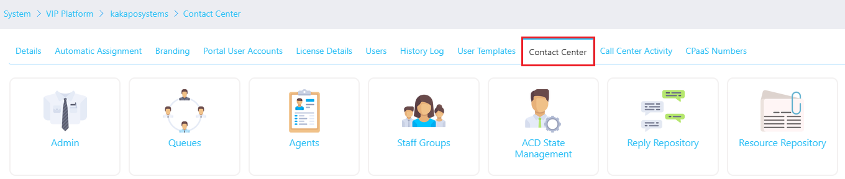

There are two types of Contact Center licenses, “Unity Contact Center Agent” and “Unity Contact Center Supervisor”. They are assigned in the normal way through the License Details tab, as shown below.
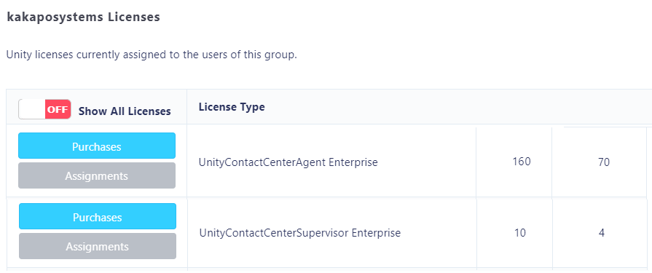
Unlike end-user client licenses, Contact Center Agent and Supervisor licenses are not automatically assigned as trial licenses, they must be explicitly assigned either through the partner portal or API. Please contact Kakapo Systems directly to request evaluation licenses.
Contact Center licenses must be assigned in addition to any client licenses required. For example, if an Agent is using Unity in a BroadWorks Call Center environment, a Unity Agent license must be assigned for the end-user client, then a Unity Contact Center Agent license must be assigned to add Contact Center functionality.

Administration

This section is used for any general administrative tasks that need to be done to the Contact Center environment.
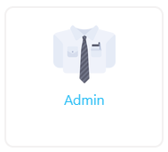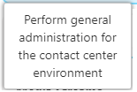

3.1 Authorization Requests
In the administration section users can add an email address which is used to perform authorization requests for Email and Twitter Media Streams.
Please note: Users can add more than one email address, but it is one email per line.

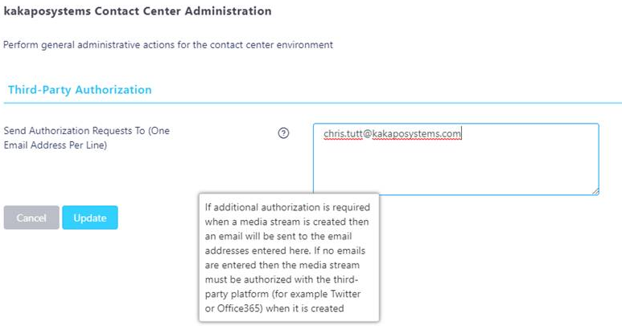
If there is one or more email addresses entered, then when creating Email and Twitter Media Streams you only need to provide a name – you won’t need to provide a Twitter or any email address details (including the email address). Users can set these of course, in which case they will be saved.

The portal will not stop users from creating the Media Stream if these details are missing, instead it will send an email to the email addresses above alerting them that the Media Stream needs to be authorized. They can then click on the link in the email and enter the details required.

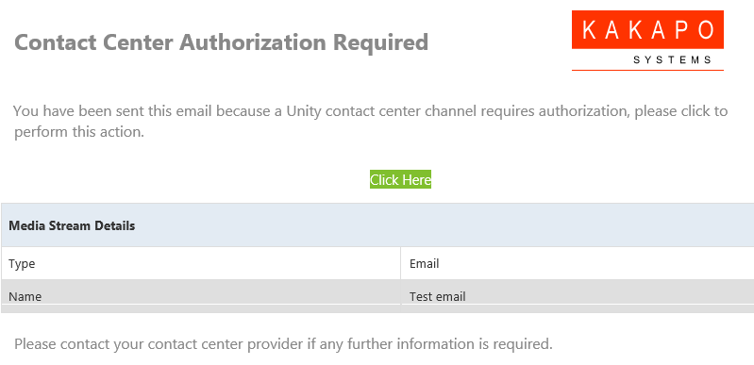
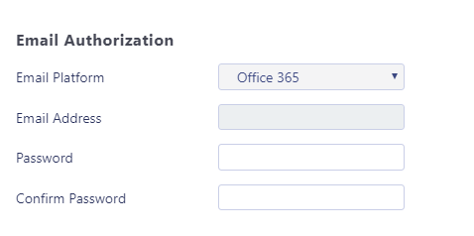
Any previously saved details from when the Media Stream was created will be displayed. If it’s a Twitter Media Stream and the handle was specified when it was created, then this page will redirect the user directly to Twitter to perform OAuth authorization.

If there are no authorization email addresses entered, then the portal will not allow the Media Stream to be created without all details being set.

Staff Groups

A staff Group is a logical Group of users that allows an administrator to manage a single entity in a routing phase, rather than having to assign multiple users one by one.

Staff Groups can be configured to automatically add any new users, thereby providing a “catch all” Group which may be used as the final routing phase for a Media Stream.

Please note: You can only create staff Groups at the Group or enterprise level, staff Groups created at these levels will be available to Queues and Media Streams. A staff Group created at the Group level will only be available for use within that Group, whereas staff Groups created at the Reseller level will be available for both enterprise and Group Queues.

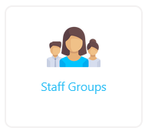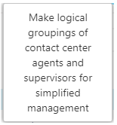

Select staff Groups from the Contact Center menu to see all existing staff Groups (including any created at a higher level) and to create a new Group.

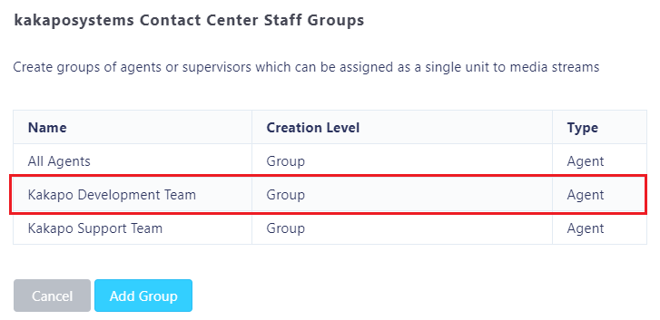
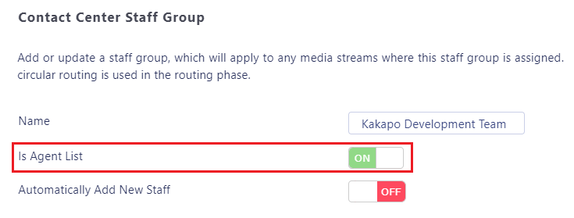
Enter a name for the staff Group and specify if the Group is for Agents or Supervisors, a staff Group cannot comprise both Agents and Supervisors together and the “Is Agent List” setting cannot be changed once the staff Group has been created.

Changing this setting will automatically repopulate the list with users that have either the “Unity Contact Center Agent” or “Unity Contact Center Supervisor” license assigned. To search for a user simply type the name or login ID in the search box or scroll through the list. To add users to the Group select them and click “Add”. All users in the right-hand box have already been added to the staff Group. To remove a user from the staff Group simply select them from the right-hand box and click remove.

You can move Agents up and down the list, which will dictate the order in which these Agents are alerted if this staff Group is added to a routing profile with circular routing.

To automatically add new staff members to the staff Group simply switch the “Automatically Add New Staff” toggle.

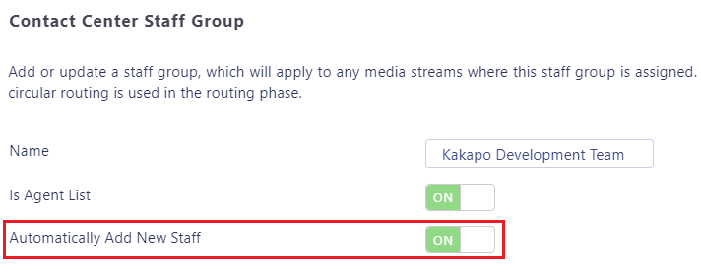

If this switch is toggled then every time a Contact Center Agent or Supervisor license is assigned to a new user it will add them into the applicable staff Group automatically.

Reply Repository

Create canned replies for users to easily send common responses to customer queries. These are available at the Reseller, Group, Queue and Media Stream level. All replies configured at the parent level will be available for all the lower levels. For example, a reply created at the Queue level will be available for all Media Streams of that Queue.

The reply repository can be found in the main Contact Center menu for all relevant levels, as shown below.
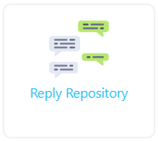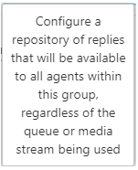

The list will show all existing canned replies, including the level at which they were added.
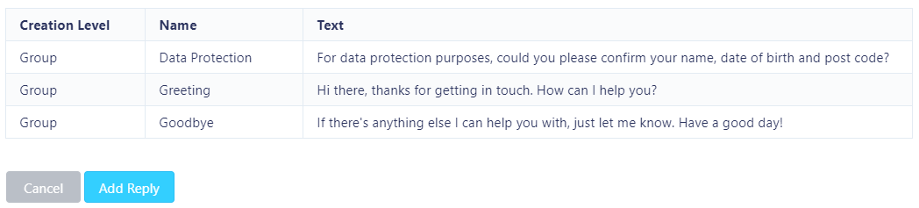

When adding a reply at the Reseller, Group or Queue levels you must specify which types of media channel it applies to. Some canned replies such as “please give me a minute to look into that” would not be applicable to an Email conversation, while three paragraphs of text would not be relevant in a Twitter conversation. Setting the channel types that the canned reply is available for will ensure that users will only see those canned replies when replying to those type of conversation. A canned reply can be available to multiple channel types.
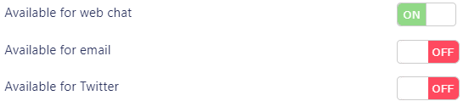
Once you have selected the applicable Media Streams, give the reply a reference name and enter the reply text. Unity client will search on both the name and reply text when the Agent enters search criteria, so rather than having to include reply text the Agent can simply type “bye” to see all available farewell replies.
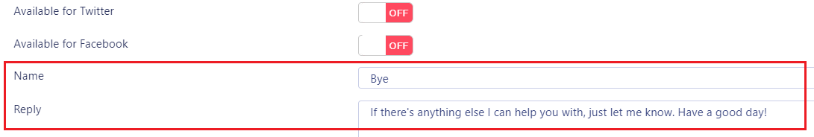

Resource Repository

The resource repository is similar to the reply repository outlined above, in that it allows Agents to quickly access a range of resources when replying to a conversation, which can easily be passed to the remote party either as a hyperlink (Web Chat, Twitter, or Facebook) or an Email attachment.

As with canned replies, all resources created at the parent level will be available for all the lower levels. For example, a resource created at the Group level will be available for all Queues of that Group.

The resource repository can be found in the main Contact Center menu for all relevant levels, as shown below.
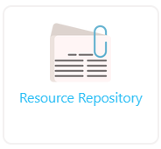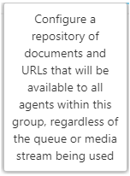
The list will show all existing resources, including the level at which they were added.
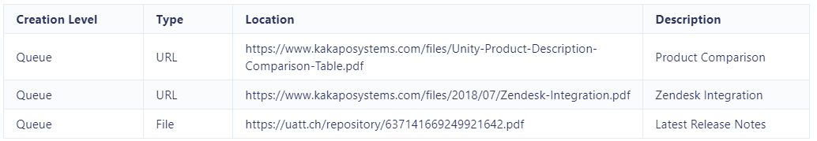
You can add a resource as a URL or file upload. If uploading a file, the portal will save the file with a randomly generated filename, but it will ensure the actual name of the file that was uploaded is used in the hyperlink or Email attachment.
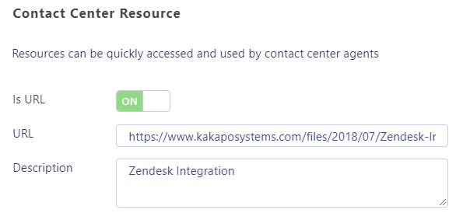

Add a short description about the resource [which will be used when searching for resources within the Unity client, as outlined below] and then select “Add Resource”.
To delete a resource simply view it from the resource repository list and click Delete.

6.1 Email HTML Resources
You can also add HTML replies to the Email Media Streams reply repository. You can only do this at the Media Stream level.
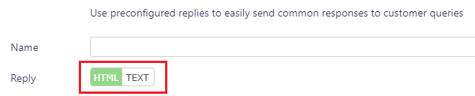
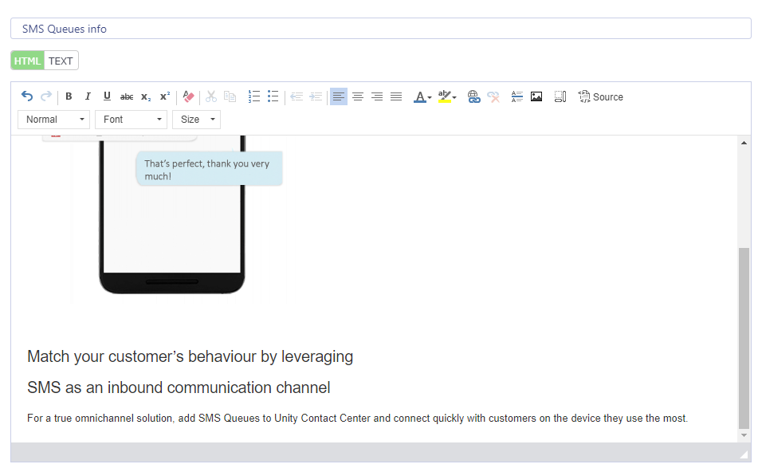

In-Office Profiles

Easily create profiles for the times that various Media Streams and Queues will be online. In-office profiles are configured at the Service Provider, enterprise and Group level and are available to set at the Queue and Media Stream levels.

If the in-office profile is set at the Queue level it will automatically cascade down to any Media Streams created within that Queue, but it can be overridden at the Media Stream level.

In-office profiles work with the set time zone set for the Media Stream, which cascades down from higher levels in the Unity hierarchy. If an in-office profile is assigned to a Media Stream but no time-zone is set, then Coordinated Universal Time (UTC) will be used as the time-zone, which may lead to unexpected results. Therefore, it is very important that the correct time-zone be used for that Media Stream, which may be different to that set at other levels.

The time-zone is set in the profile tab for all Service Providers, Resellers, Groups, Queues and Media Streams, as shown below.

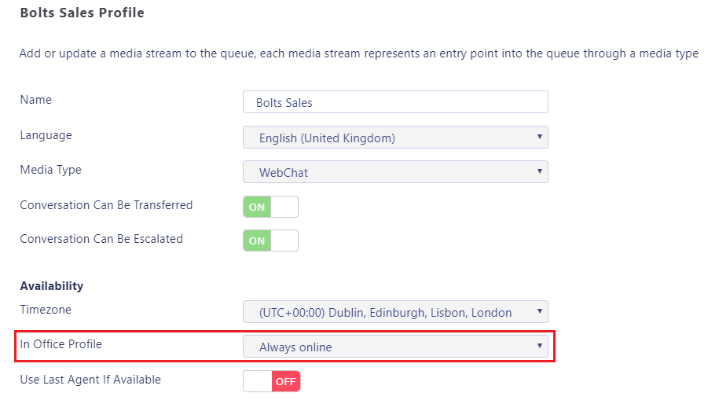
When the time zone is selected the portal will automatically confirm daylight savings parameters, if that location observes daylight savings.
Manage in-office profiles by clicking on the link from the main Contact Center menu.
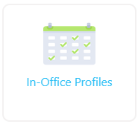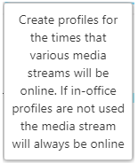

You can see which in-office profiles already exist and at which level they were created. These profiles can be assigned to all Queues and Media Streams below this level.
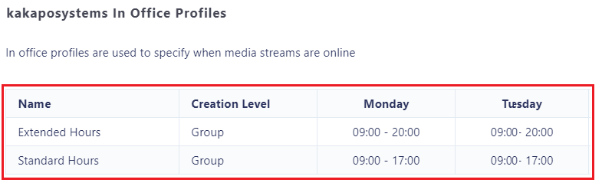

To add a new in-office profile click “Add Profile”, then enter a name for that profile and populate the relevant times using 24-hour time format, as shown below.
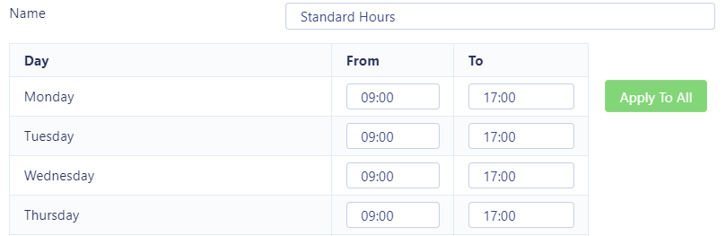

Click “Apply to All” for the times entered on Monday to apply all days. Leave blank the times for the days that the Media Stream is not available.

Please note: If an end time is set but a start time is not present then the Media Stream is not online for that day.

You can create multiple in-office profiles which can then be assigned to a Queue or Media Stream, but only one in-office profile can be assigned at a time. Any dates added in the Contact Center holiday section will override the in-office profiles.

Holidays

Create holidays to stipulate when the Contact Center is closed or reduced hours are used. They can be managed through the main Contact Center menu at all levels of the Unity hierarchy, including Service Provider, Reseller and Group. Any holidays created will automatically apply to all child levels, so a holiday created at the Service Provider level will apply to all Queues for all customers.
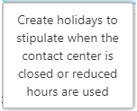

The list will display all holidays created at this level and above, all of which will be used by Queues at this level and below.
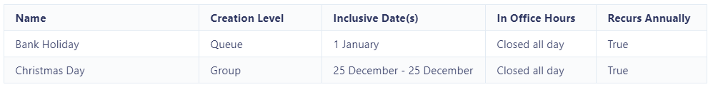

To add a new holiday, enter a name and a start date. Toggle the “Single Day” switch if the holiday is just for one day e.g. a public holiday. If the holiday is over multiple days then untoggle the switch and enter the end date for the holiday, as shown below.
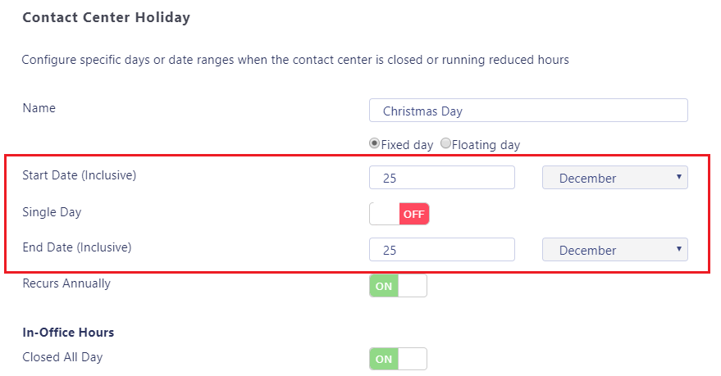
You can also set if the holiday occurs on the same date every year, and if the Contact Center will be closed for the entire day or if reduced hours will be used. Please note these hours are not related to an in-office profile, they will only be applied on the day(s) of the holiday period.

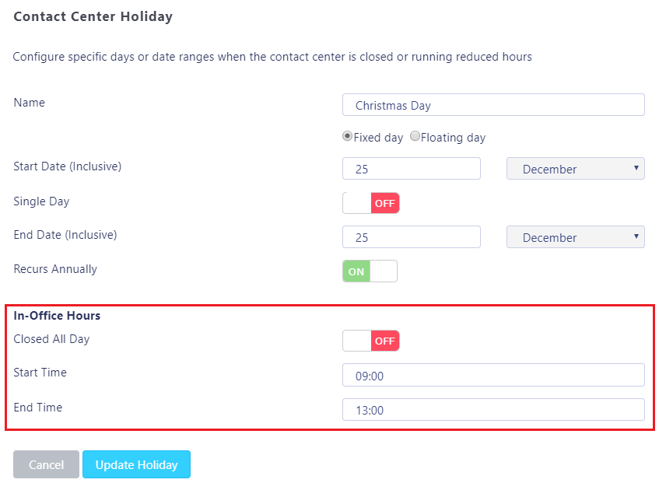

Please note: As mentioned, Holidays will apply to all levels below the level of creation. If you do not want certain holidays to apply to all Queues then you need to create the holiday at the Queue level rather than a higher level.

Availability & ACD State Management

Set default ACD states for different Agent actions within the Group, Queue or Media Stream and limit the number of conversations an Agent can process simultaneously. These can be configured at the Group, Queue and Media Stream level and will apply to all lower levels.

Agent Availability can be set at the Group, Queue and Media Stream levels through the main Contact Center menu, as shown below.

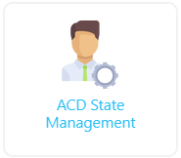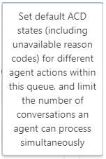

9.1 ACD State Change
Select the desired ACD state for an Agent when they are processing a Web Chat, Callback, Email, Twitter or Facebook conversation from the drop-down menu.

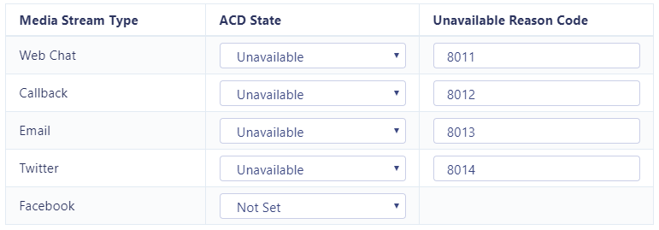

The “Unavailable Reason Code” needs to exactly match the unavailable reason code in BroadWorks, if the code doesn’t exist in BroadWorks then it will be ignored by the Unity client.

For example, if the user reserves a Web Chat conversation then Unity will change their ACD state to “Unavailable – Web Chat”, assuming the unavailable code “Web Chat” has been configured in BroadWorks.

This will prevent calls (and potentially conversations from other channels) from being received by the Agent while they are processing the conversation. Of course, these ACD states will also feed through to the Agent activity BroadWorks Call Center reports.

9.1.1 Post-Conversation ACD State
Unity can be configured with a post-conversation ACD state, which will be used when a Contact Center conversation is closed by the user. Options are available to only change the ACD state if there are no other reserved conversations for the user. This is set in Settings>Services>Call Center>ACD State.
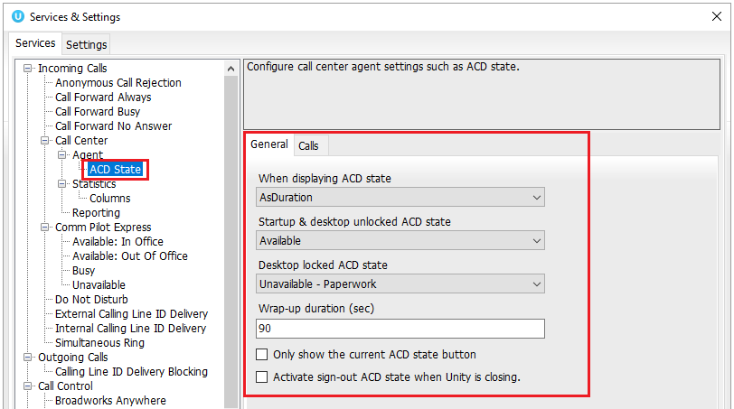

9.2 Simultaneous Conversations
Configure how many conversations a user can process concurrently. Enter the maximum number of conversations for each Media Stream type, as shown below.

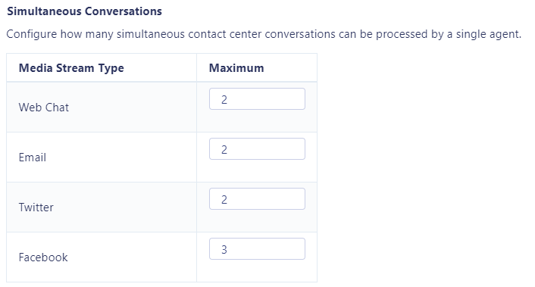

Please note that the Contact Center platform will only consider the maximum number of conversations for the same Media Stream type (Web Chat, Email etc) as the conversation for which the Agent is being alerted. Therefore, in the below screenshot the Agent can manage up to three Web Chats and one Email and three Twitter and two Facebook conversations. Maximum simultaneous conversations are not considered for call-backs, because the Agent is free to initiate the Callback in their own time.
Any setting from parent levels will cascade to lower levels, where they can be overridden. If a value is not set then the default value [from the higher level] will be applied.

9.3 Agent Availability Restrictions
Unity also allows you to configure when a new conversation can or must not be passed to an Agent. Restrictions can work with ACD state changes (as outlined in section 9.1) to build an Agent availability profile.

For example, when an Agent is replying to a Web Chat, Twitter or Facebook conversation then the Agent should not be available to take Call Center calls, but when they are replying to an Email conversation they are available to take Call Center Queues.

This type of routing profile can be configured by creating multiple unavailable reason codes in BroadWorks. Then configure Unity to automatically change the ACD state based on the type of Media Stream while adding restrictions to control if an Agent is available for subsequent conversations.

The list will show all restrictions for all parent levels as well as the current level, all of which will be considered when deciding if the Agent is available for new conversations. If there is a duplicate restriction at a higher level then the restriction at the lower level will take precedence.

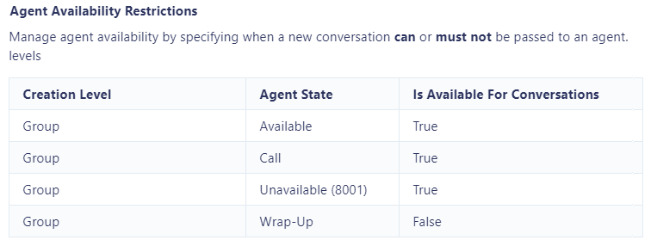

Restrictions will apply to all Media Streams if set at the Group or Queue level, so if each Media Stream will require different restrictions then they should be set at the Media Stream level.
Please note: All restrictions that allow the client to present the conversation alert to the user will be considered before those that block/bounce the conversation. This means that is there is a restriction for the Available ACD state set twice in the same level, then the one that presents the conversation will be applied. ACD state restrictions will still be processed from the Media Stream level up to the group or reseller level, so if an ACD state is set at the Media Stream level to not present a conversation, then the same ACD state is set at the group level to present it, then it won’t be presented because the Media Stream level restriction will be considered first.

Example 1: If a user is on a VoIP call then the user is not available for a new Contact Center conversation.
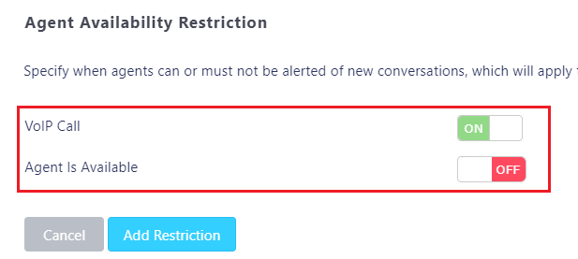

Example 2: If a user is in wrap-up then they are available for a new conversation. This will make the user available for a Web Chat, Email or other Media Stream but it will not make them available for VoIP calls.

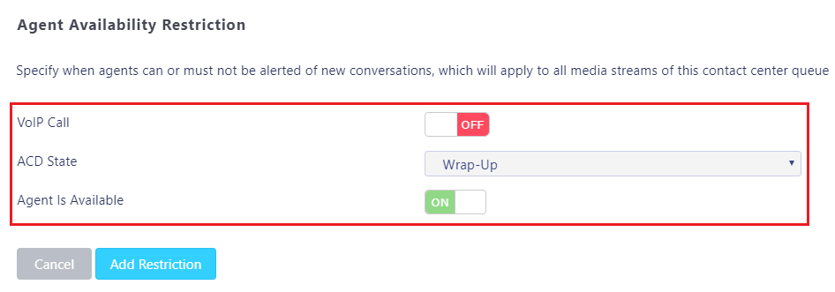

Example 3: If a user is available and not on a VoIP call then they are available for a new conversation or VoIP call.
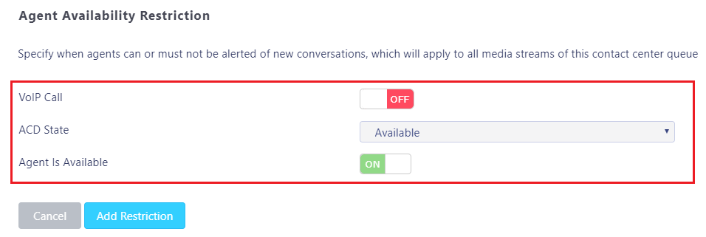

9.4 Unavailable Restrictions
If the ACD state is set to “Unavailable” in the Contact Center portal then it will not apply to all unavailable reason codes in the client – it will only apply if there is no unavailable reason code currently set in the client.

Wildcards: These can be used for unavailable reason codes, which is *. If this is set as the unavailable reason code in the Contact Center portal then it will apply to all unavailable reason codes in the client, as well as if there is no unavailable reason code. Wildcards are considered after restrictions that don’t include wildcards, so they can be used as “catch-all” baskets to either present or bounce the conversation alert in the client.

Queues

A Contact Center Queue can be thought of as similar to a VoIP Call Center, in that it allows an Agent to receive and reply to conversations through different channels. Unity will combine a BroadWorks Call Center with a Unity Contact Center Queue if the Call Center ID and the Contact Center identifier are identical. In this case the Agent will see a single entry in the personal wallboard that will contain omnichannel statistics from all Media Streams as well as from the Call Center, and Unity will simultaneously join or leave the Agent from both Queues. Therefore, for the Agent, this appears and behaves as a single omni-channel Queue.

10.1 Creating a new Queue
Click “Add Queue”. If you want the Contact Center Queue to match a BroadWorks Call Center Queue and be a combined queue in the Unity client, then toggle the “Is BroadWorks ACD Queue” switch and enter the BroadWorks ACD Queue identifier. The identifier cannot be modified so please make sure the correct identifier is used.
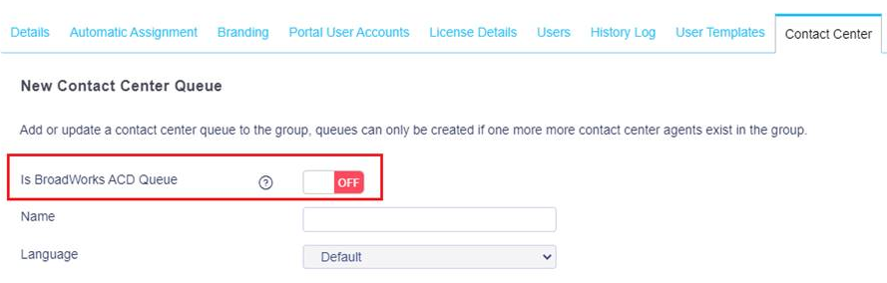

If you do not enter an identifier the Unity Portal will automatically generate a random one which will not match a BroadWorks Call Center Queue.

Please Note: Only a system admin will be able to see the identifier in the Queue profile page, but changes cannot be made once a queue has been created.

In the example below, “Kakapo Systems” Contact Center ID did not match to a BroadWorks Call Center ID therefore you can only see Web Chat and Email stats. “Bolt Sales” ID did match a BroadWorks Call Center ID, therefore you can see all Call Center and Web Chat/Email stats in a single row, as shown below. (To add and remove statistics from the Personal Wallboard please see section 13.2)
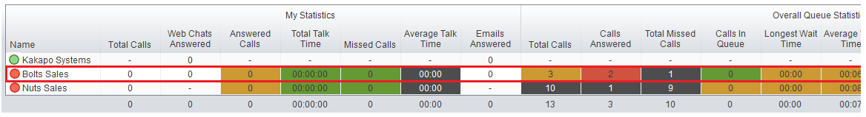

Select from the list of restrictions and set the time zone for that Queue. Select the in-office profile from the drop-down menu (please see the In-Office Profiles in section 7).
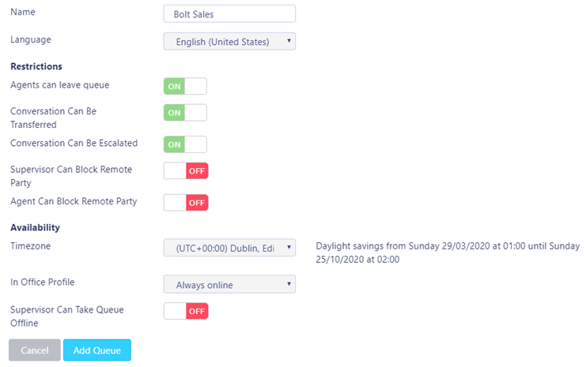

You can also allow the Supervisor to take the Queue offline by toggling the switch, e.g. If there is a fire alarm and the building has been evacuated.

Click “Add Queue”. To then make changes in that Queue select the Queue name in the list.
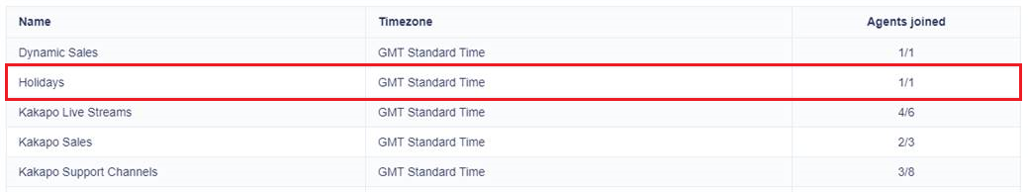

10.2 Profile
To configure the Contact Center Queue click profile.

10.3 Media Streams
Manage the Media Streams (Web Chats and Emails etc) associated with this Queue. (Pease see Media Streams in section 11).

10.4 Supervisors
Assign Supervisors for this Queue, which will also apply to all Media Streams within the Queue. Displayed are all the users in the Group that have a “Unity Contact Center Supervisor” license assigned to them including pre-configured staff Groups (please see section 4 for staff Groups).

To add users and staff Groups to the Supervisor list simply select them from the left box and click add. All users and Groups in the right box have already been added. Once you have modified the Supervisor list click “Save”.
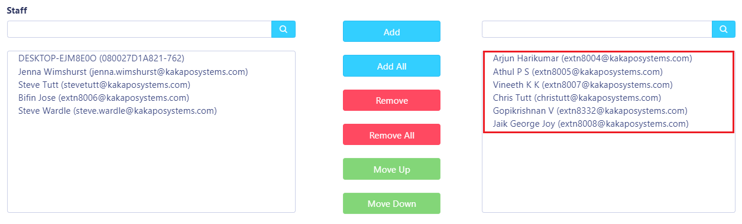

10.5 Availability & ACD State Management
Set default ACD states (including unavailable reason codes) for different Agent actions within this Queue, and limit the number of conversations an Agent can process simultaneously. Anything entered at this Queue level will override anything entered in the Group level. If nothing is set for the Queue level then Unity will take the configuration from the Group stage. (Pease see Availability and ACD State Management in section 9).

10.5 Reply Repository
Configure a repository of replies that will be available to users within all Media Streams within this Queue. All reply repositories cascade down from the Group so if you are viewing the repository at the Web Chat Media Stream level then you will see all replies created at the Queue and Group level that are available for Web Chats. (Please see Reply Repository in section 5).

10.6 Resource Repository
Configure a repository of documents and URLs that will be available to users within all Media Streams within this Queue. All resources cascade down from the Group so if you are viewing the resource repository at the Web Chat Media Stream level then you will see all resources created at the Queue and Group level that are available for Web Chats. (Please see section Resource Repository in section 6).

10.7 Holidays
Create holidays to stipulate when the Contact Center is closed or reduced hours are used. All holidays cascade down from the Group level but you can also create holidays for separate Queues at the Queue level. E.g. If some Call Centers are in different countries with different public holidays. (Please see Holidays in section 8).

10.8 History Log
View all activity performed in this Contact Center Queue.

Media Streams

A Media Stream is the channel to the public, similar to a phone number for a Call Center. In a Contact Center environment it represents a Web Chat or Callback client, an Email address, a Twitter handle or a Facebook login. Multiple Media Streams can belong to the same Queue, but each Media Stream follows a different routing profile.

All previously mentioned configuration settings [such as maximum concurrent conversations and restrictions etc] from a parent level will cascade down to all Media Streams by default, however this can be overridden at the Media Stream level.

11.1 Add Media Stream
Click the “View” button next to the Queue that you want to add the Media Stream to and then click Media Streams. You will then be presented with a list of all of the Media Streams in that Queue, as shown below.
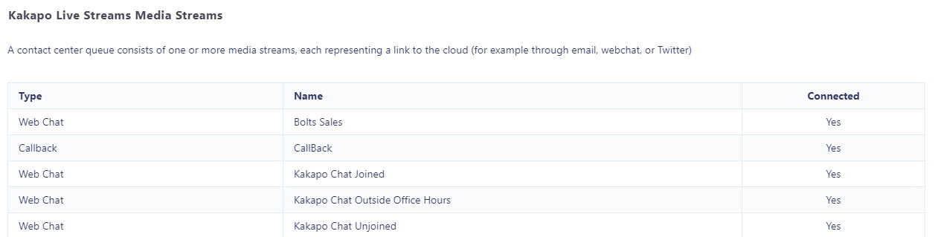

Click “Add Media Stream” and enter a name (this name will appear as the “to” field in the Activity Window when a Queued conversation is presented to a user) and then select the type of Media Stream from the drop-down menu.
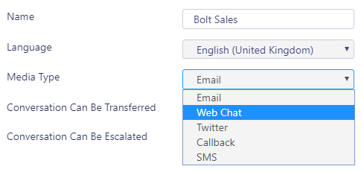
Set the time zone, it will default to what was set at the parent level but you can override this here. Select from the in-office profiles [if created], this will also default to what was set at the parent level but can be overridden.

If the “Use Last Agent If Available” setting is checked then the Contact Center platform will first alert the last Agent to reserve a conversation from the Email address or phone number of the remote party, for any channel type. This assumes that the user is still an Agent of the Media Stream and is joined. That last Agent will be alerted before the first routing phase is processed.

Please note: If an agent is joined to a Queue, then a new Media Stream is added under that Queue (and they are added to the routing phase) then they won’t receive conversations for that Media Stream until they leave the Queue, then join it again.

11.2 Web Chat
To set up a Web Chat enter the relevant Web Chat configuration and any automatic responses.
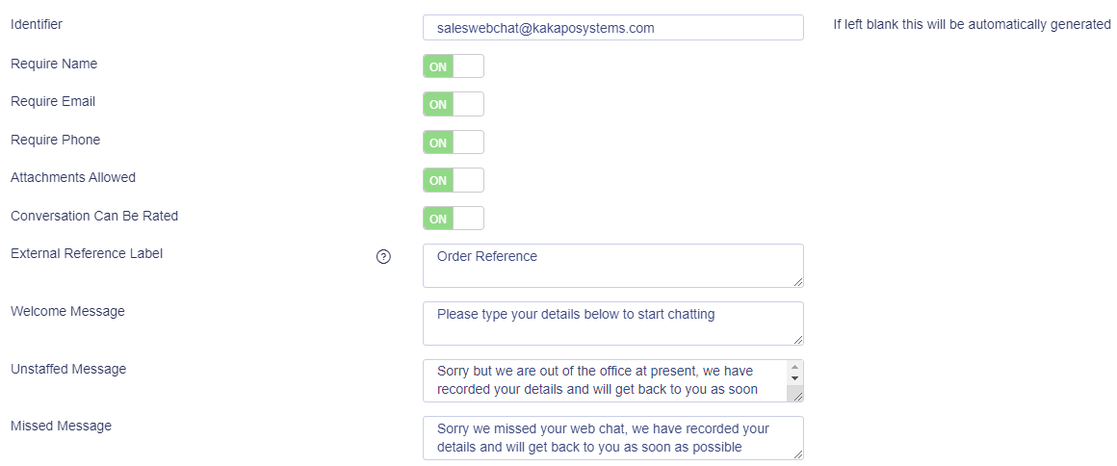

When the Web Chat client is loading it will look to see if the estimated wait time delimiters exist in the messages, and if so it will dynamically calculate the estimated wait time based on the last ten conversations that have been assigned to an Agent.
The possible descriptions are:
- in less than a minute
- in a few minutes
- within 10 minutes
- within 20 minutes
- within 30 minutes
- within an hour
- within a few hours
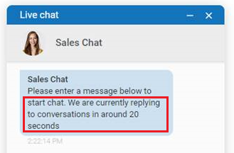

Identifier: This can follow whatever naming system you choose but it needs to be globally unique, so we recommend that a domain is included in the identifier to ensure uniqueness. If you do not enter an identifier, then it will be automated generated by the portal.

Please Note: Only a system admin will be able to see the identifier in the Media Stream profile page, but changes cannot be made once the Media Stream has been created.

Require: This forces the customer to enter their name, Email and/or phone number before they can use the Web Chat. The name and phone number are always mandatory for call-back Media Streams.

Attachments allowed: This allows the customer to send attachments through the Web Chat client.

Conversation can be rated: The customer will be asked to rate the conversation out of five stars once the conversation has ended, a comment can also be entered. Please note that the rating request will appear regardless of who ended the chat.

External reference label: Add a custom required field e.g. Ticket Number.
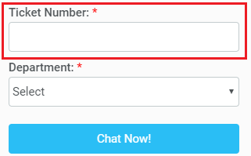

Welcome message: This is the message that is displayed after the customer has entered the required details but before they have started typing a message. It gives instructions on how to start the chat conversation.

Please note: we recommend having something similar to “please add a message below to start the chat” in the welcome message as Web Chats are only started once the visitor has sent at least one message.

Unstaffed message: This is the message that will display when the Contact Center is closed or when there are no Agents joined to the Queue. An unstaffed Email will be sent to the Email address entered with all the relevant information, as shown below.

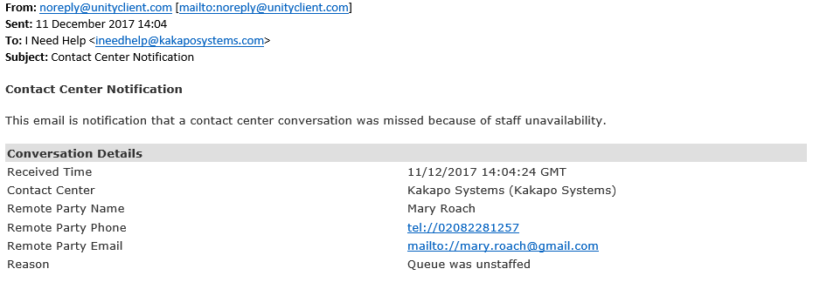

Missed message: This is the message that will display once all routing phases have completed and the conversation hasn’t been answered. A missed Email will be sent to the Email address entered with all the relevant information, similar to that shown above.

At the bottom of the Media Stream profile page you can brand the Web Chat using different colours, avatars, text and locations, as shown below. The sample client will change depending on the settings that you choose.
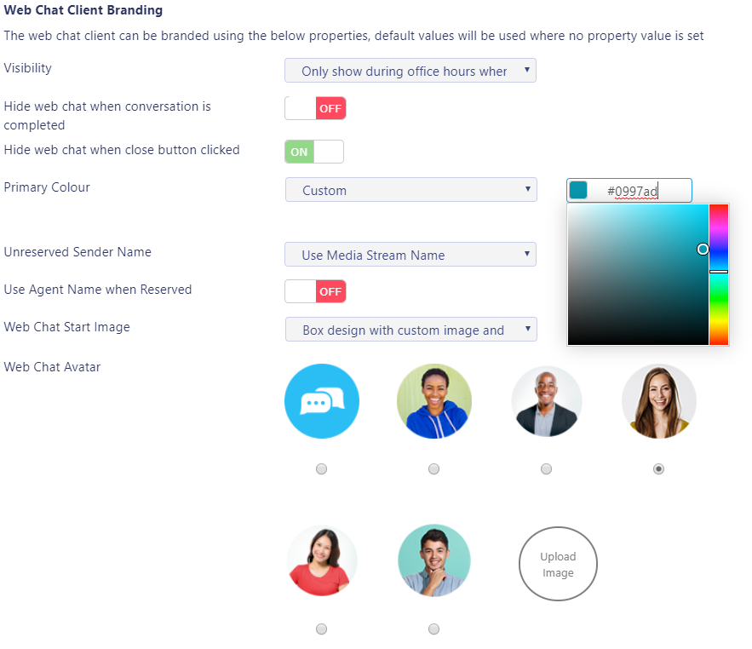

To add a custom colour, select “Custom” from the drop down menu and then use the colour picker or enter the hex colour code:
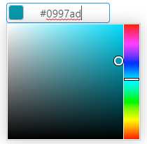

Use Agent Name and Avatar When Reserved: If the Agent that reserved the conversation has an avatar uploaded in the portal, then this will be shown in the Web Chat client along with the Agent’s name.

Hide Web Chat when conversation is completed: This will hide the Web Chat icon for the user for the rest of that session after the conversation has been completed.

Hide Web Chat when close button clicked: This will hide the Web Chat icon for the user for the rest of that session regardless of whether a Web Chat conversation was initiated.

Visibility: Change the visibility of the Media Stream by selecting the options from the dropdown menu:

Once the Media Stream has been added, you can test the Media Stream by viewing it from the Media Stream list, then clicking “Test Stream” in the Media Stream profile page, as shown below.
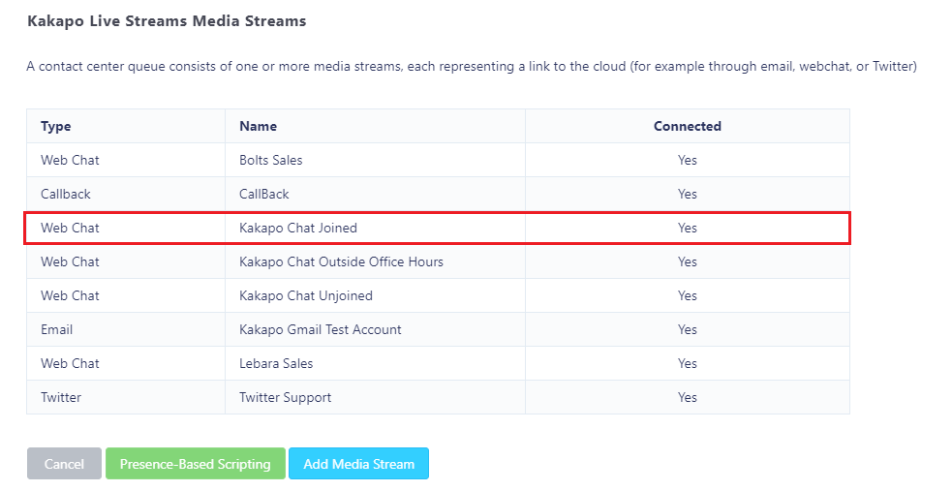
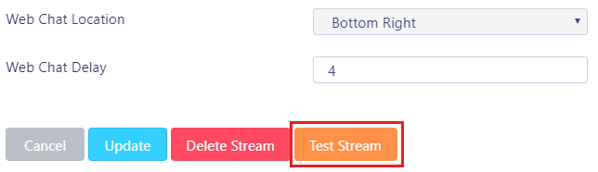

The portal will then show you how the icon will behave and provide you with the HTML code that you need to either download by clicking the “Create Test HTML File” or copying the code and then pasting it into any webpage where you want to provide the client.

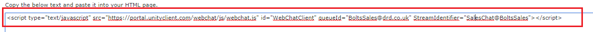
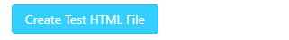

Please note that this HTML script block will not change if the Media Stream is updated, the new settings will be applied when the page is next loaded/refreshed. The HTML script block will be different for each Media Stream.
Please note: The Web Chat conversation will follow the visitor as they navigate to different webpages or open new tabs on the website.

11.3 Twitter
To log in to a Twitter Media Stream simply enter the Twitter handle and click “Add Media Stream”.
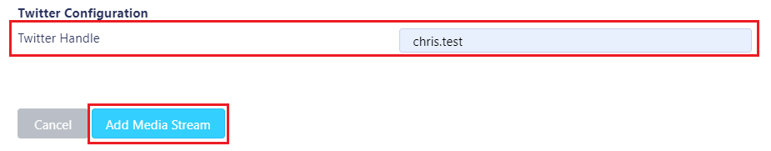

If one or more email addresses has been entered in the Administration section (See section 3.1)
then when creating a Twitter Media Stream, you only need to provide a name – you won’t need to the provide Twitter handle.

If you set the Twitter handle and then click “Add Media Stream” then you will get the option to complete the authorization yourself, or send the authorization email to the email addresses in the Administration section (see section 3.1).

If you do not set the Twitter handle, then an authorization email will be sent to the email addresses in the Administration section (see section 3.1) and prompt the addressee to complete the Twitter setup and authorization.

Users can also resend the authorization request if they need to. E.g. if the Twitter password has been changed.
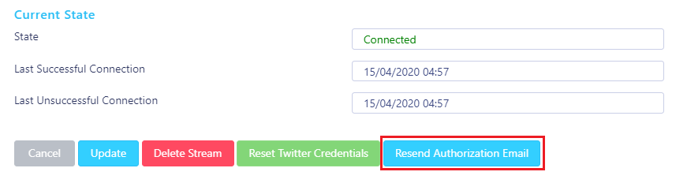

11.3.1 Authenticating Twitter
Click Add Media Stream or Complete Twitter Authorization, Twitter will then open in a new tab and ask you to authorise the app. Enter your twitter login details and click Authorise app.
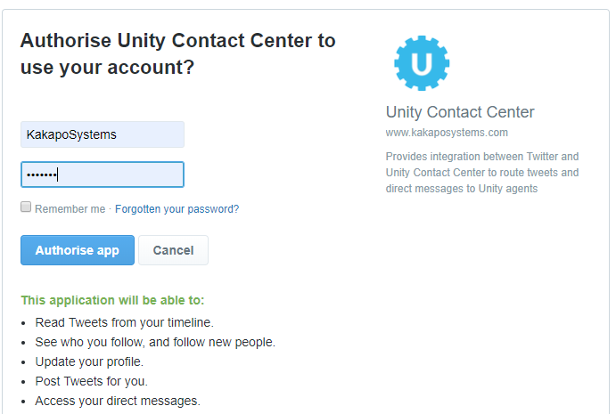

The portal will then show the below message if it has been successful:
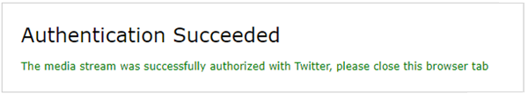

If the authentication is unsuccessful (if you are using a Twitter Handle that is already being used by another Twitter Media Stream) then the portal will show this message:
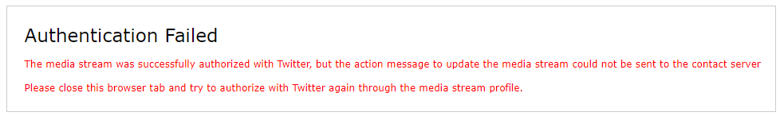
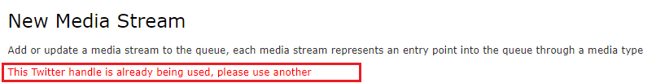

If you enter an incorrect Twitter handle, then the app will authenticate but will not be configured with the relevant details and will therefore not work.

11.3.2 Twitter Settings
Conversation Can Be Transferred
Conversations can be transferred to other Agents using the Unity interface

Conversation Can Be Escalated
Conversations can be escalated to a Supervisor using the Escalate button

Use Last Agent If Available
The tweet will be routed to the last Agent that customer spoke to, if the Agent is available and joined to the Contact Center.

Reopen Conversation On Reply
Reopen the same conversation thread if the tweet is sent from the customer within the specified amount of time. This will not be seen as a new tweet/conversation so the statistics will not increment.

Reopen Conversation If Reply Received Within: (This only applies if the “Reopen Conversation On Reply” switch is toggled.) Specify the duration of time that a conversation can be reopened Select how many minutes, hours or days.

11.4 Email
To add an Email Media Stream select Email Mailbox from the Media Type dropdown list, enter a name for the Media Stream and enter the configuration details by selecting the Email platform from the drop down list and filling in the relevant Email details.
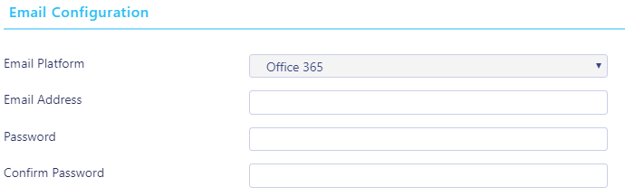

If one or more email addresses has been entered in the Administration section (See section 3.1)
then when creating an email Media Stream, you only need to provide a name – you won’t need to provide an email address or password.

You can set these of course, in which case they will be saved, but the portal will not stop you from creating the Media Stream if these details are missing, instead it will send an email to the email addresses in the Admin section alerting them that the Media Stream needs to be authorized.

Users can also resend the authorization request if they need to E.g. if the email password has been changed. Users can still send this even if the Media Stream is currently logged in, because the customer may want to change the password.
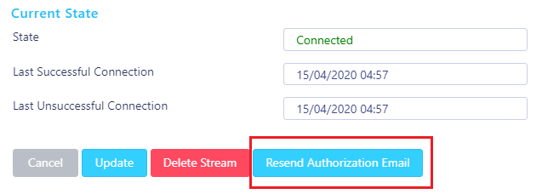

At the bottom of the page you can copy and paste your Email Signature and type an initial reply which will be sent to customers automatically either during business hours or out of business hours (depending on the In Office Profile that has been selected).
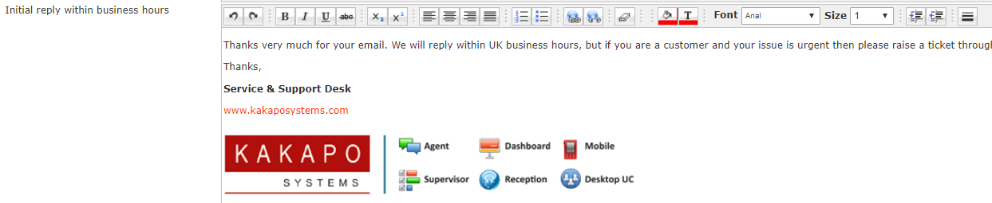

11.5 Callback
To add a Callback Media Stream enter the Callback configuration and select from the branding options, including colour, avatar, text and location. As mentioned, the name and number are mandatory, but you can also choose to require an Email address before the Callback is accepted.

A free text box allowing the customer to enter a reason for the Callback request is always present in the widget but is not a mandatory field.
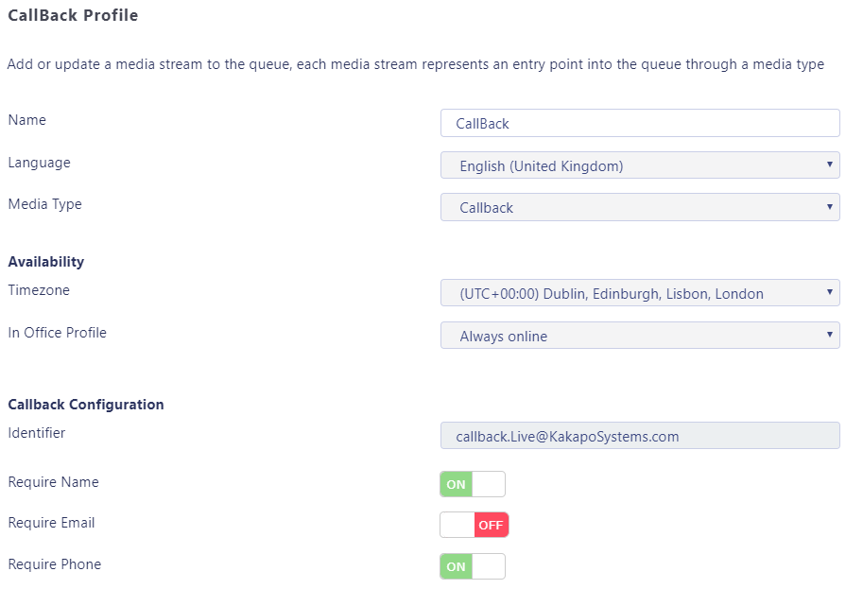

Identifier: This can follow whatever naming system you choose but it needs to be globally unique, so we recommend that a domain is included in the identifier to ensure uniqueness. If you do not enter an identifier then it will be automated generated by the portal.

Please Note: Only a system admin will be able to see the identifier in the Media Stream profile page, but changes cannot be made once the Media Stream has been created.

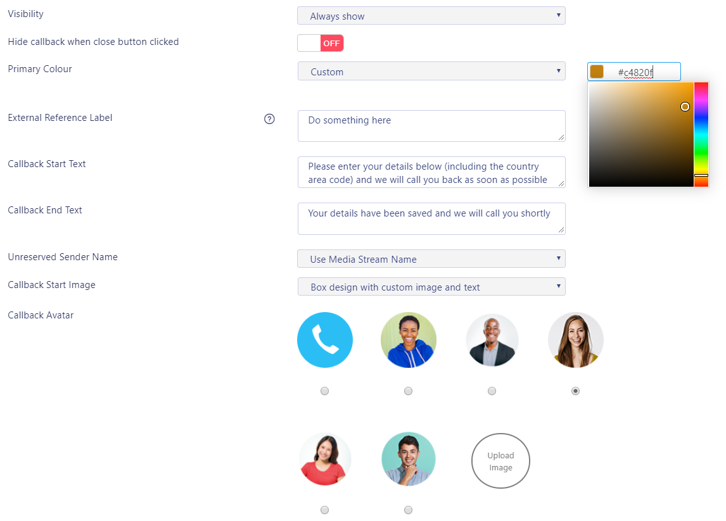

External reference label: Add a custom required field e.g. Ticket Number.

Hide Callback when close button clicked: This will hide the Callback icon for the user for the rest of that session one the close button has been clicked.

Callback Start Text: The beginning message presented to the customer once they have selected the Callback button.
Callback End Text: The message presented to the customer after they have submitted their details, as shown below.
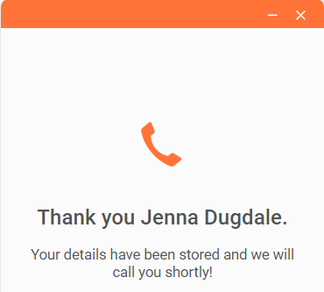

Start Text: The message that appears next to the avatar, as shown below. This setting will not always be available, for example the “circular fixed image without text” doesn’t accept start text.
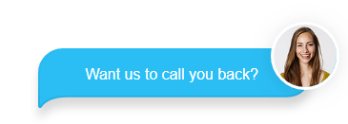

Delay: Delay the Callback icon appearing on the webpage. E.g. if you only want to offer a Callback service if the customer has been on the webpage for more than 10 seconds.

Please note: The call-back client will hide after 5 seconds once the visitor has requested the Callback.

11.6 SMS

To add an SMS Media Stream the Service Provider will have to have integrate with at least one CPaaS platform; Restcomm, Twilio or Nexmo.

To set up a SMS click Media Streams in the Queue section and then click Add Media Stream. Select SMS from the Media Type drop down, (this will only be an option if the Service Provider has integrated with at least one CPaaS platform).
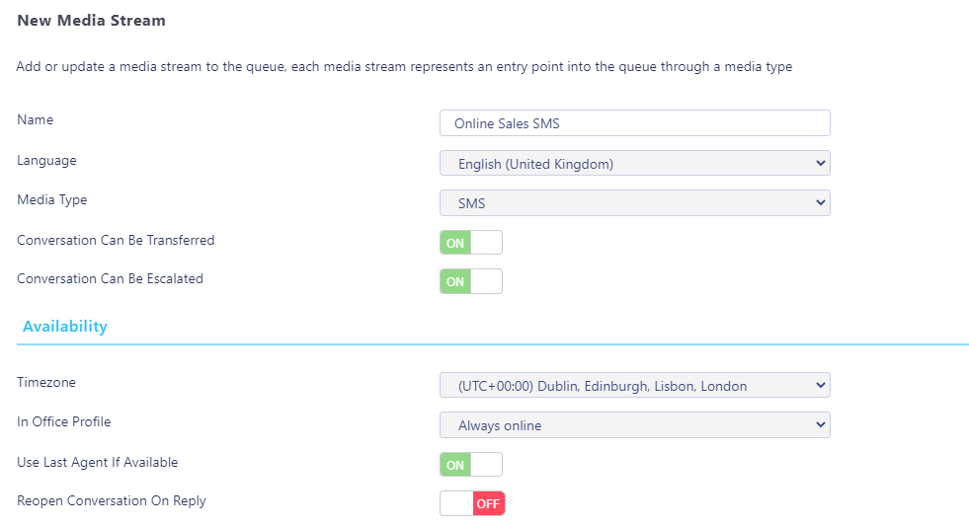

Select the Time zone, the In-Office Profile and the configuration for reopening SMS conversations on reply and then enter the SMS number and select the relevant platform.

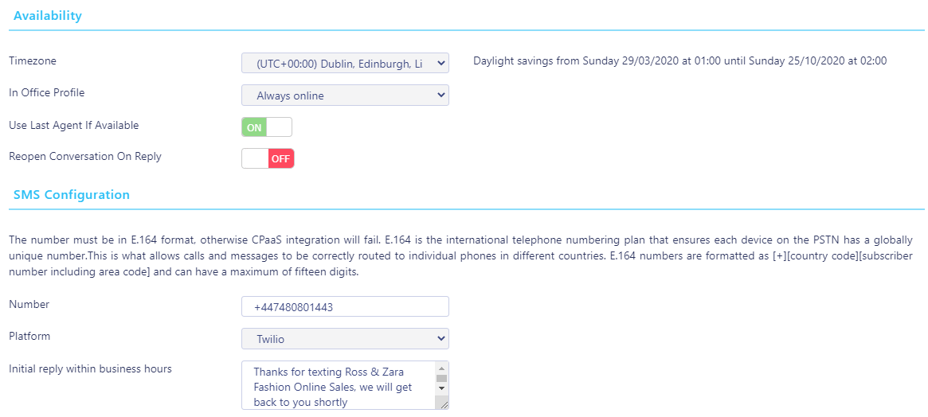

If the CPaaS platform integration is with Twilio or Nexmo then the number entered must be in E.164 format, otherwise the integration will fail.

If the CPaaS platform integration is Restcomm then the number does not need to be in E.164 format.

Only the SMS platforms that have been integrated with will be available in the drop-down option.
Enter an initial reply within business hours and click Add Media Stream.
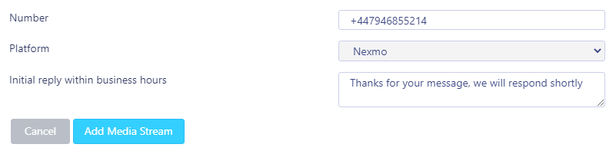

11.7 Profile
Configure the information for the Contact Center Media Stream and view the state of the Media Stream including when it last successfully connected to the 3rd party platform. This is only shown if you are a system login and if an identifier has been set (if not then we know the Media Stream hasn’t been connected).
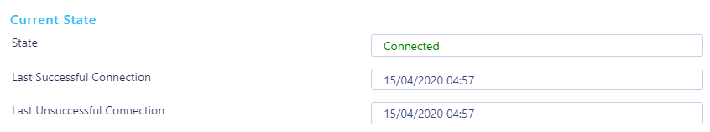

11.7.1 Deleting a Media Stream
To delete a Media Stream, scroll to the bottom of the Profile page and click “Delete Stream” remember to also delete the java script from all web pages that have the Media Stream java script on otherwise the widget will remain on the web page but will flag up an error.
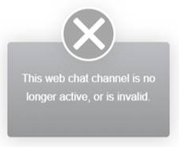

11.8 Routing Phases
A routing phase is a rule that instructs the Contact Center who to alert when a new conversation comes in through a Media Stream. Routing phases allow you to configure the type of routing to use (circular, simultaneous, longest idle etc) as well as the period of time a customer will wait before the conversation is classed as missed/abandoned.

As previously mentioned, rather than overflowing to other Queues [as with BroadWorks ACD], Unity allows multiple routing phases to be configured for a single Media Stream. When a new conversation is received, the Contact Center will process all routing phases in order before classing the conversation as abandoned, and acting accordingly.

Routing phases are managed through the Contact Center Media Stream menu, as shown below.

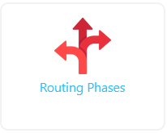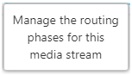

To add a new routing phase click “Add Phase”. If no phases currently exist for the Media Stream but do for other Media Streams within the Group or enterprise, then routing phases can be copied to this Media Stream rather than having to be manually recreated, as shown below. Routing phases can be copied to a Media Stream with phases already set, those phases just need to be deleted in order to see the copy option.

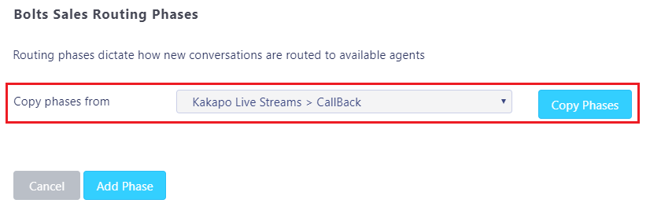

When creating a routing phase you must select the routing policy:

Circular: The conversation alert will move from one user to the next, in the order specified in the Agent list for the routing phase. You can move Agents up and down this list to change the order.

Longest Idle at Agent: Unity will send the conversation request to Agents in order of who has been idle for the longest, considering all Media Streams and Queues.

Longest Idle at Media Stream: Unity will send the conversation request to Agents in order of who has been idle for the longest time for that particular Media Stream.

Longest Idle at Queue: Unity will send the conversation request to Agents in order of who has been idle for the longest out of all the Agents in that Queue.

Simultaneous: Unity will send the conversation request to all joined Agents at the same time, the Unity client may then reject the conversation based on concurrent conversations and restrictions etc.

If the Media Stream selected is a Web Chat then an entrance message box will be presented to the customer while an Agent is found, as shown below. This is optional but can be used to provide feedback to the visitor.

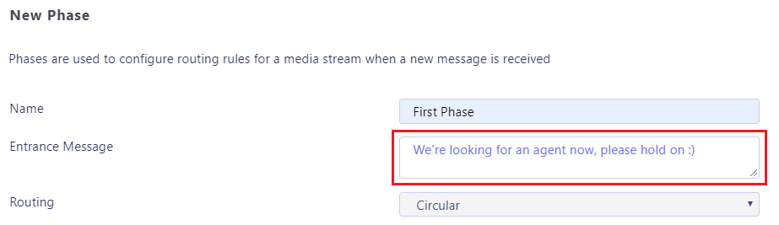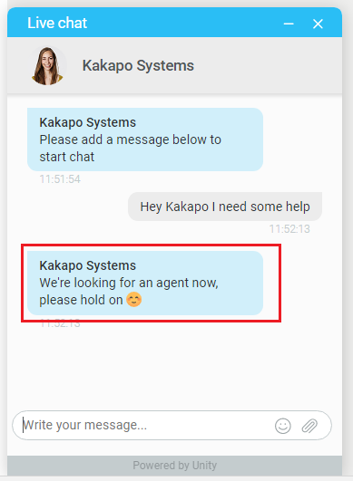
Loop Through Agents Until Duration Elapsed: Toggle this switch if you want the conversation request to loop back round to the first Agent after it has finished the list of Agents and is still unanswered. If you leave this switch untoggled, then once it has bounced from the last Agent in the list then it will go on to the next phase, or if this is the last phase then the conversation will be “missed”.
Please note: If an Agent is not online then the conversation request will skip over them and go to the next Agent.

Phase Duration: How long Unity will perform the configuration in this phase before moving on to the next phase.

Automatic Bounce Duration: How long the conversation request stays unanswered with one Agent before it bounces to another. This is not visible if the routing policy is simultaneous.
Add new Agents to this phase by selecting them in the left-hand box and clicking “Add”. All Agents in the right-hand box have been added to the phase.

Once you have configured your desired routing phases they will be listed with their name, routing type and bounce duration. Each phase will be given a number based on the order created, and phase 1 will always be the first phase to be processed. You can reorder the phases by using the “Move Up” and “Move Down” buttons in the list, as shown below.
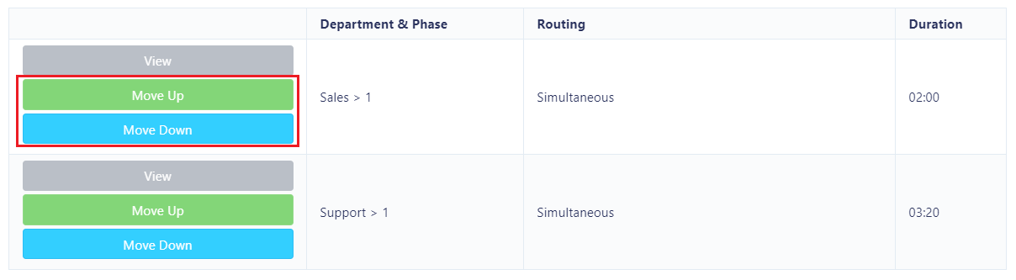

If a conversation still hasn’t been answered after all phases for this Media Stream have been completed then the customer will receive the default missed message entered in the “Missed Message” box which has been configured in the Media Stream profile section.

11.8.1 Routing by Department (Web Chat & Callback Only)
Give customers the option to choose which department they wish to speak to by toggling the “Use Departments to route conversations and Callbacks” switch in the Routing Phases section:
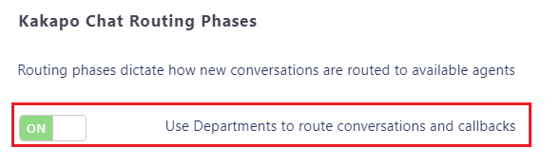

The “Name” field in the Routing Phase becomes the name of the department and is presented to the customers in the drop-down list.
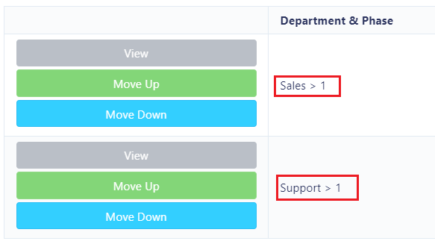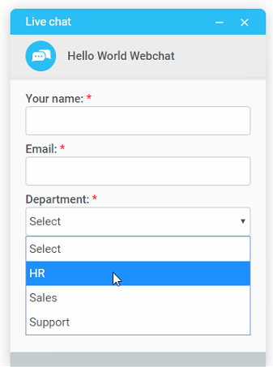
You can set multiple phases for departments and use the Move Up and Move Down buttons to change the order of those phases.

In the client the Agent will be presented with the Callback request/Web Chat along with the department name in the Activity Window, as shown below.
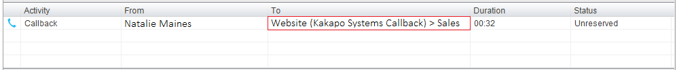

If you have configured departments in the Routing Phases but you no longer want to use Departments to route conversations, simply untoggle the “Use Departments to route conversations and Callbacks” switch.
You may get the below error message:
“There are routing phases that contain the same phase number, these must be deleted before the Media Stream can be configured not to use departments”

To correct this you will need to delete any duplicated phase number. E.g. You cannot have Sales>1 and HR>1 as these are both phase 1s.

11.9 Availability & ACD State Management
Set default ACD states (including unavailable reason codes) for different Agent actions within this Media Stream, and limit the number of conversations an Agent can process simultaneously. Anything entered at this Media Stream level will override anything entered in the parent level. If nothing is set for the Media Stream level then Unity will take the configuration from the parent level. (Please see section 9 for Availability & ACD State management).

11.10 Reply Repository
Configure a repository of replies that will be available to users within this Media Stream. All reply repositories cascade down from the parent level so if you are viewing the repository at the Web Chat Media Stream level then you will see all replies created at the Queue and Group level that are available for Web Chats. (Please see section 5 for Reply Repository).

11.11 Resource Repository
Configure a repository of documents and URLs that will be available to users within this Media Stream. All resources cascade down from the parent level so if you are viewing the resource repository at the Web Chat Media Stream level then you will see all resources created at the Queue and Group level that are available for Web Chats. (Please see section 6 for Resource Repository).

11.12 History Log
View all activity performed in this Media Stream.

Presence-Based Scripting

Presence-Based Scripting dynamically changes which Media Stream is shown at any one time, and allows you to add multiple Media Streams to one web page using just one script block.

Here is an example:
Show Web Chat A when Agent is joined. Show Web Chat B when Agent is not joined and show Callback outside of office hours.
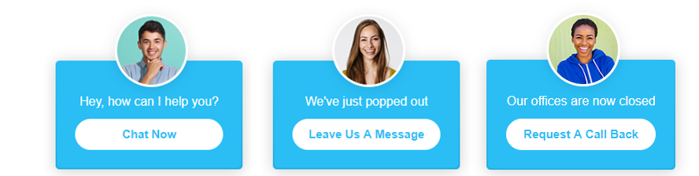

Unity Contact Center will display the Media Streams according to their in-office profile and visibility. Therefore, the visibility of all selected Media Streams must not clash.

E.g. If you select two Media Streams: Media Stream A is set to “show during office hours” and Media Stream B is set to “show during office hours when Agent is joined” then the portal will present you with an error, similar to the one below.

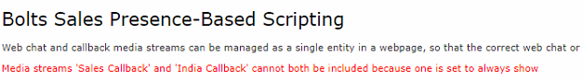

To configure Presence-Based Scripting go to the Queue and then to Media Streams and click Presence-Based Scripting:
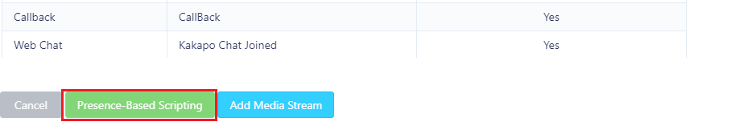

You will then be able to select the desired Media Streams that you want to add.

If you only have one Media Stream available, we recommend that you use Presence-Based Scripting anyway in order to make it easier to add additional streams in the future.

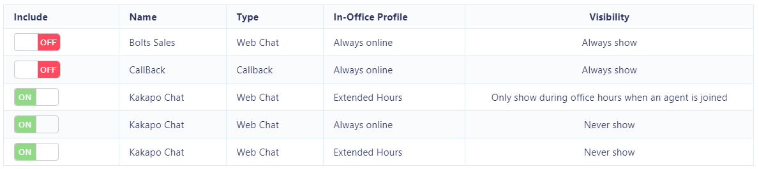

Once the Media Streams have been selected you can test them by clicking “Save Streams” and then “Test Streams”.

The portal will then show you how the icon will behave and provide you with the JavaScript that you need to copy and paste into the webpage where you want the client to be.
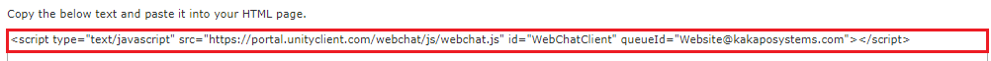

Please note that this script block will not change even if the Media Streams are changed and updated.

End User Experience

You have now completed configuring the Unity Contact Center platform, including Queues, Media Streams and Agents. This section describes how the Agent performs Contact Center actions within their Unity client.

13.1 New Conversation Alert
When a new conversation is received, Unity can be configured to show a toast notification and or play an audio alert, as shown below.
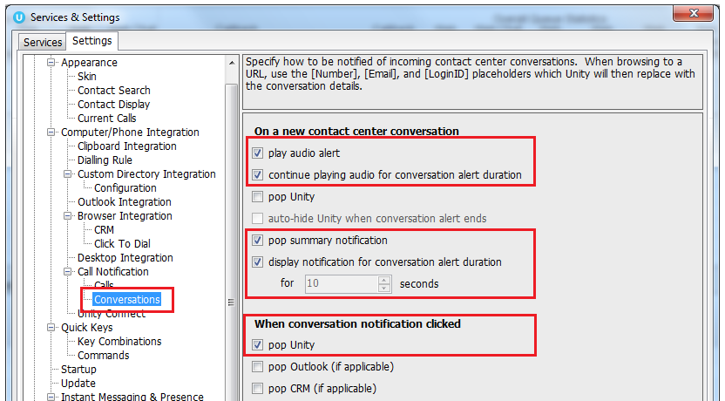

At present the alert is just the IM audio alert played in a loop if playing for the alert duration, the ability to change the audio file shortly.
If it’s not configured to continue playing then it will just be played once, the same as when you receive an IM.
The summary notification:
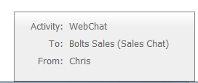

13.2 Conversation
When an Agent is joined to the Contact Center Queue and available [although we know that the Agent may be available when the ACD state is unavailable, for example unavailable (Web Chat) all conversation alerts will be presented in the Activity List, as shown below.

The Activity column in the Activity Window informs the user what type of conversation it is and the From column will populate with the customer’s name, Unity will integrate with a CRM platform to show the contact details based on the Email address or number if configured in Settings. The duration shows the time since the conversation alert was received, and the status will always be “Unreserved” at first.

Click the Duration heading in the Activity Window to sort the conversations by duration.

13.2.1 When Showing Unreserved Conversations
Users can show specific queued conversations according to preference. This is configured in Agent>services> Agent>Conversations, as shown below.

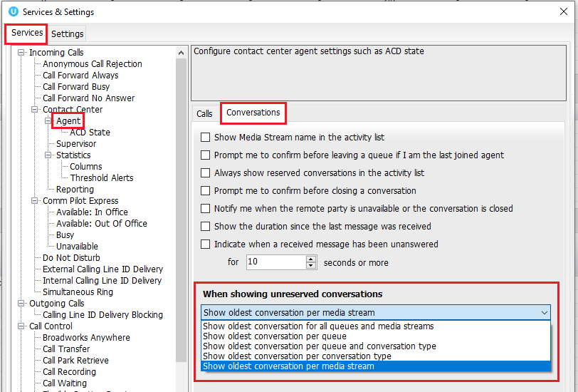

Show oldest conversation for all queues and media streams
This will show the oldest unreserved conversation within all Queues and regardless of the Media Stream type.
Show oldest conversation per queue
This will only show the oldest conversation for each Queue. E.g. If the Agent is a member of 3 Queues and there are 4 unreserved conversations in each Queue, the Agent will only see the oldest for each Queue so will have a total of 3 unreserved conversations in the Activity Window.

If there are multiple Media Streams under the same Queue and there are unreserved conversations for each Queue, then only the oldest conversation will be shown - even if one stream is an email stream and the other is a Web Chat stream

Show oldest conversation per queue and conversation type
This will show the oldest conversation for each Media Stream in each Queue. E.g. If the Agent is a member of 2 Queues which have multiple unreserved Emails, Web Chats and SMS conversations then the Agent will see 6 unreserved conversations in total, 3 for each Queue displaying the oldest Email, Web Chat and SMS conversation.

Show oldest conversation per conversation type
This will show the oldest unreserved conversation for each Media Stream type regardless of which Queue it came from.

Show oldest conversation per media stream (default)
This will show unreserved conversations by Media Stream E.g. If there are two Web Chats Streams in the same Queue, then both will be displayed.

13.2.2 Transferring & Closing Conversations
Agents can transfer all conversations (except Web Chats) to any other Agent regardless of their online status and the conversation will automatically be reserved by the new Agent.

Click the transfer icon within the conversion window to view the other Agent’s joined status, as shown below.
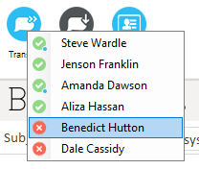

Please note: Agents can still transfer Web Chats to other Agents but they can only transfer to an online available Agent who will have to manually reserve the conversation before it is transferred.

When a conversation has been transferred the new recipient will receive a toast notification detailing the conversation type, who it was transferred from, which Queue it is from and the customer’s details:
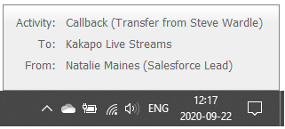

13.3 Managing Web Chat
When the Agent first sees the new Web Chat conversation in their Activity List they can either right click to reserve the chat or double click it and then click reserve, as shown below.
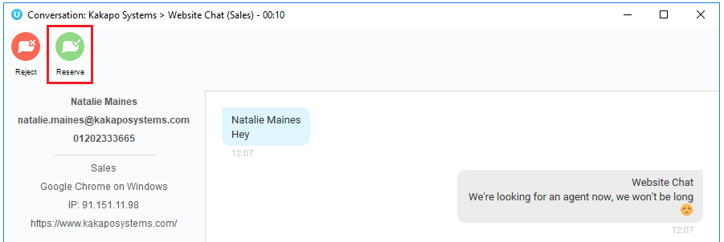

The difference is that by double-clicking the conversation first, the user can see any chat messages that have been entered by the visitor before reserving the conversation.
Reserve: To reserve a Web Chat conversation is to answer it. As soon as an Agent reserves the Web Chat then the routing phases will stop and the conversation will stay with that Agent. Any other Agents that have been alerted will be told that the conversation was reserved, so it will be removed from their Activity Window. The status of the conversation will change the “Reserved” and the duration will change to the time since the conversation was reserved. Unity will also change the ACD state of the Agent if set in the Agent Availability page in the portal.

Reject: Rejecting a conversation cancels the alert, so that the conversation will be removed from your Activity List. The Contact Center will act accordingly, by alerting another Agent if using circular of longest idle routing, or perhaps moving to the next phase. This will override the automatic bounce duration set in the routing phase, if the conversation is not reserved or rejected within the time stated in the “automatic bounce duration” for the routing phase, then the Unity client will automatically reject the conversation alert on behalf of the Agent.

If reserved, the Web Chat will stay in the Activity List for the duration of the conversation. The duration time in the brackets is the amount of time passed since the customer last sent a message which has not yet been replied to. This is configured in Settings>Agent>Conversations.

When a new message is received the “1 new message” alert will appear in the Status field, as shown below.

At any time the Unity user can double-click the conversation from the Activity List to see the Web Chat window.

On the left of the Web Chat box is the customer’s name, and telephone number [if entered], along with the department chosen by the customer, the internet browser, their IP address and the website address that the Web Chat was started on.
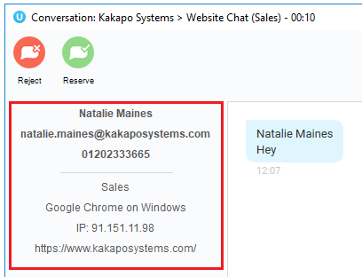

Simply click on the Email address to send an Email to the customer using the default Email program, or click on the number to immediately dial through Unity.

Conversation: This is where the user enters text to send to the customer. Simply type the message in the box and press enter to send.

Emojis can also be added to a message by left clicking the relevant image. Or right click on an emoji to send it immediately.
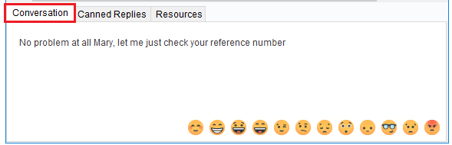

Canned Replies: This is where all canned replies entered at different levels in the portal are stored, the user simply double clicks on a reply to send it. The user can also use the search box to search for specific replies, based on the name or text entered in the portal.
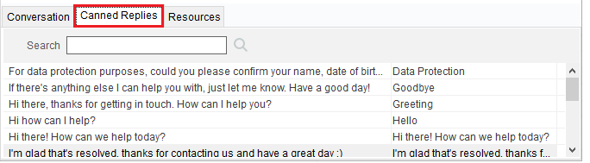
Add Reply to Cache
If a user is frequently typing the same message they can add it to their reply cache which is stored locally on their machine. Simply type the message, highlight it, right click and select “add reply to cache”.
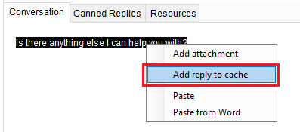

Resources: All URLs and uploaded resources created in the portal are available in this tab, the user simply double clicks on a resource to send it. The user can also use the search box to search for specific resources, based on the filename/URL or description.
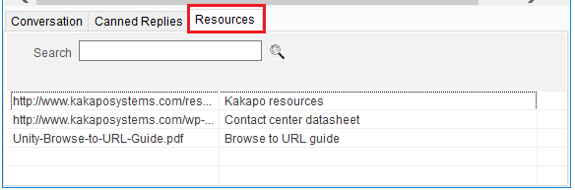

Attachments
Right click to access the recent attachments (the cache saves the file path, if the file has moved folders then the add recent attachment button will not work)
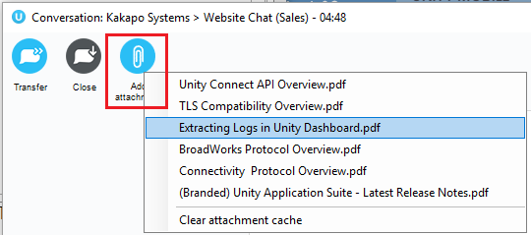

To end a Web Chat click the Close button on the top of the conversation box, as shown below.
Please note: Clicking the X will only close the Web Chat box, it will not end the Web Chat conversation.
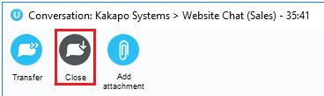

Unity will not allow an Agent to close Unity while there are one or more reserved and open Contact Center conversations in place, all conversations must be transferred or closed before closing Unity.
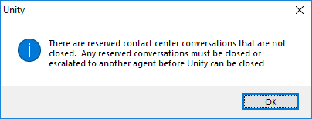

13.3.1 History
Users can view the last 10 conversations that has taken place with the customer, e.g. Web Chat, Twitter and Callback conversations.
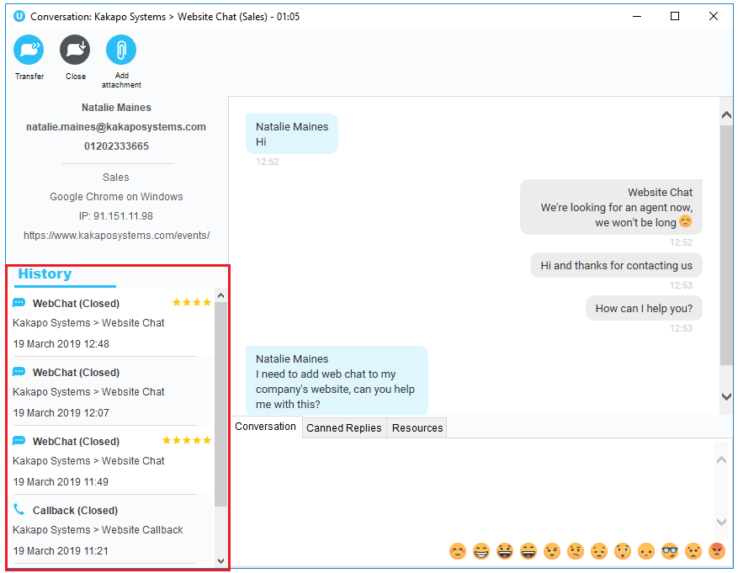

13.3.2 CRM Contacts & Leads
If the customer is in the integrated CRM platform then the Web Chat window will display two additional options at the top: “View contact in CRM” and “Add CRM call log entry”. Unity will automatically log a Web Chat entry against the contact or lead in the CRM platform. Click “Add CRM log entry” to manually add a custom entry.

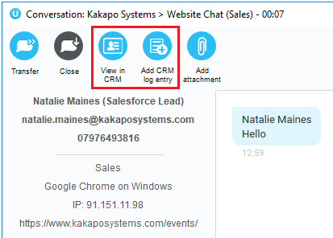

Users can also right click the conversation in the Activity List to access the same options.

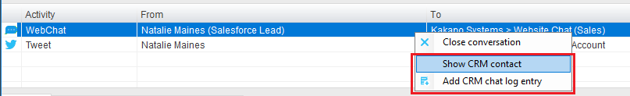

13.4 Managing Callbacks
Similar to a Web Chat conversation, when a new Callback request comes into the Queue it will appear in the Activity List.

The Callback request will stay in the Activity List of all users in the routing phase until the Callback has been reserved. If the Agent leaves the Queue then any unreserved Callbacks for Media Streams within that Queue will be removed, and will be refreshed/displayed when the Agent next joins the Queue.

Once an Agent has reserved the Callback it will disappear for all other Agents and will remain in the reserved Agent’s Activity list, even in between Unity sessions in case the remote party needs to be called multiple times.
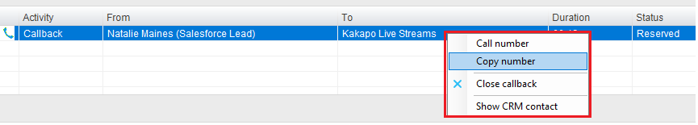

Please note the Callback will remain in the Activity List even if the Callback has been performed. The user needs to manually close the Callback for it to disappear. If the number provided is missing the area code, the Agent can select “copy number”, paste it into the dial pad and add the area code manually.

Unity will not allow a user to initiate a Callback when then are already on a call. If they try to initiate a Callback they will receive an error message.
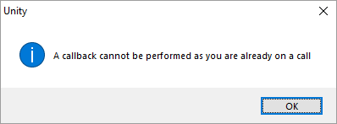

Agents can either right click and reserve it, or they can double click the request to open the callback window to view more information and reserve the callback using the icons at the top.

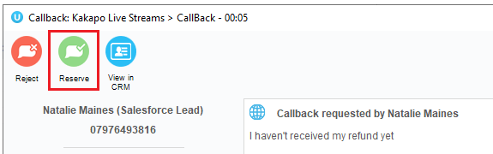

13.4.1 Reason for call back
Any information given by the customer in the “reason for request” box will appear at the top of the callback window, as shown below.

13.4.2 Agent Notes
Once reserved, the Agent can make additional notes to the callback request by typing in the text box and then clicking the plus icon to add it.
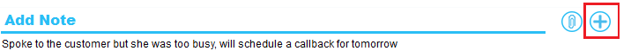

13.6.3 Schedule Callback
To schedule a callback click the clock icon and fill out the desired time.
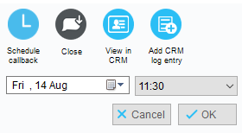

The callback request will then be shown with the scheduled time slot in the active call window and will notify the Agent by turning red when it’s time to perform the callback.

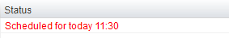

13.4.4 Close Callback
When the user has finished dealing with the Callback, simply right click it and select “Close Callback” and it will disappear from the Activity List.
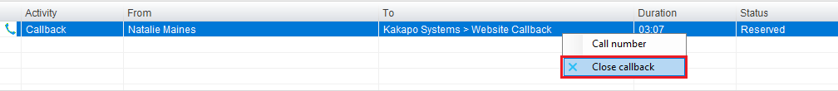

13.5 Managing Email
When an Email comes into the Queue it will appear in the Activity List.
Please note: Email address starting with
- noreply@
- no-reply@
- no_reply@
- donotreply@
- do-not-reply@
- do_not_reply@

Will be not be routed to Agents and are not stored in Database.

Agents can reserve the conversation, reject the conversation or show the CRM contact in the integrated CRM platform (if applicable).
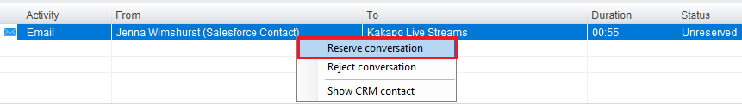

Once the Email conversation has been reserved the Agent opens the Email by double clicking it in the Activity List. The conversation window will then appear with the original Email from the customer at the bottom on the window, simply click at the top to start typing.

Any attachments sent from the customer will appear below the subject line. Please note that there is a blacklist for Email attachments, the list can be found here.
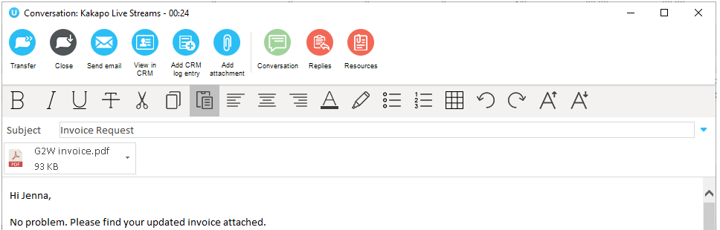
Using the icons at the top of the Email window, Agents can transfer conversations, add attachments, add CRM log entries and access the reply and resource repositories. Once the Agent has finished replying simply click the “Send Email” icon.

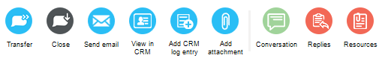

13.6 Managing Twitter
Twitter conversations are loaded within 3 minutes of the tweet being sent from the customer, so the longest duration a tweet can take to come into Unity is 3 minutes and the quickest is 1 second, depending on where the 3 minute cycle is when the tweet is sent.

Please note that tweets/replies sent from Unity are delivered immediately to the customer.
To reserve a Twitter conversation right click it and select Reserve.
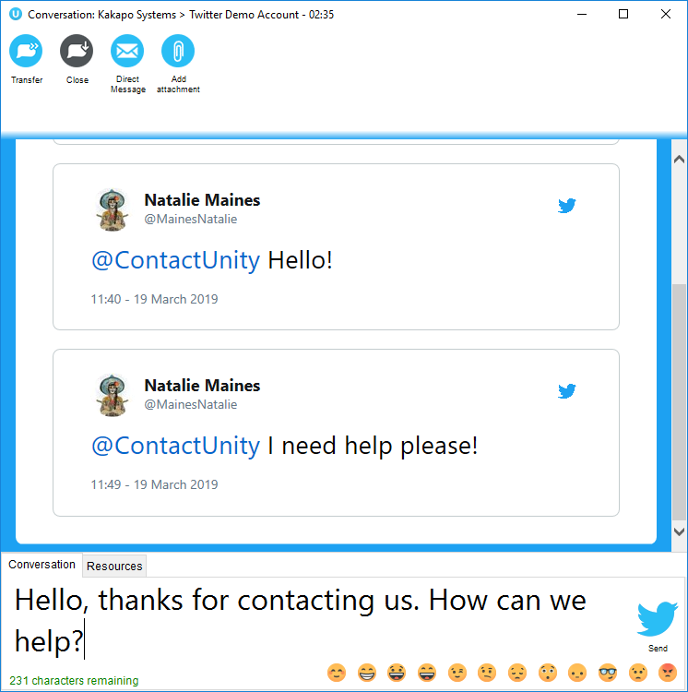
Transfer
Click to transfer to a colleague, only those who are joined to the same Media Stream will be shown. Only the Agents that are online and joined to the Queue will be available to transfer to.

This transferred conversation will also need to be manually reserved by the new recipient.
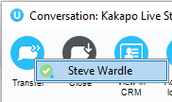

Attachments
Right click to access the recent attachments (the cache saves the file path, if the file has moved folders then the add recent attachment button will not work)
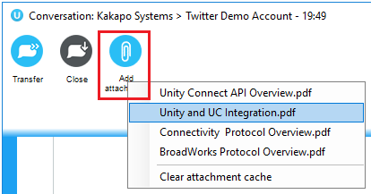

Unity will show 20 cached replies and attachments in Contact Center, plus more when Unity is running, but when it’s closing down only the latest 20 will be saved.

Direct Message Request
Click the Direct Message icon to send a direct message request to the customer. This will then send the customer a link, which when clicked, will open up a Direct Message conversation.

Please note that the Media Stream Twitter settings must be configured to allow anyone to send Direct Messages. This is done in Settings and Privacy>Privacy and Safety>Direct Messages.

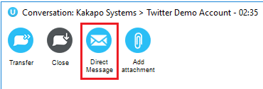
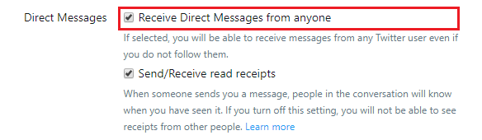
Once a Direct Message request has been sent to a customer the icon will disappear from the Twitter conversation window as the user cannot send the request twice.

The DM/Private Message invitation will be displayed to the customer, as shown below.
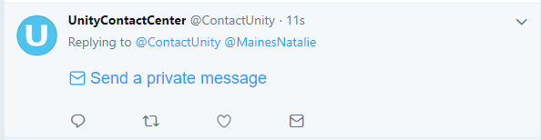

13.7 Managing SMS

SMS conversations are delivered to the Agent in the same way that Web Chats, Tweet, Emails and Callbacks are.
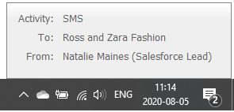
Simply right click to reserve the SMS conversation and then double click to open the conversation window.
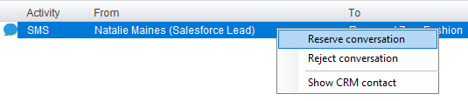
Reserve: To reserve an SMS conversation is to answer it. As soon as an Agent reserves the SMS conversation then the routing phases will stop and the conversation will stay with that Agent. Any other Agents that have been alerted will be told that the conversation was reserved, so it will be removed from their Activity Window. The status of the conversation will change the “Reserved” and the duration will change to the time since the conversation was reserved. Unity will also change the ACD state of the Agent if set in the Agent Availability page in the portal.

Reject: Rejecting a conversation cancels the alert, so that the conversation will be removed from your Activity List. The Contact Center will act accordingly, by alerting another Agent if using circular of longest idle routing, or perhaps moving to the next phase. This will override the automatic bounce duration set in the routing phase, if the conversation is not reserved or rejected within the time stated in the “automatic bounce duration” for the routing phase, then the Unity client will automatically reject the conversation alert on behalf of the Agent.

If reserved, the SMS conversation will stay in the Activity List for the duration of the conversation. The duration time in the brackets is the amount of time passed since the customer last sent a message which has not yet been replied to. This is configured in Settings>Agent>Conversations.

The conversation window will show the message sent from the customer and the automatic reply sent from the Contact Center which is set in the SMS Media Stream Profile page in the Kakapo portal:

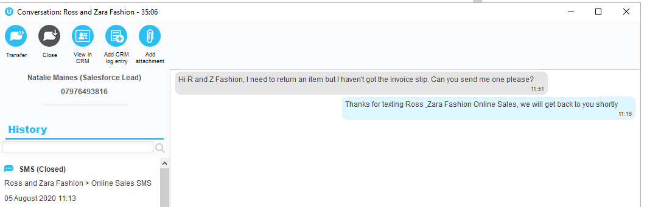

On the left-hand side of the conversation window Unity will load the history of all conversations (of all types) from that customer. Agents can read the full transcripts of previous conversations by double clicking the entries.

Unity will also perform a CRM lookup on the mobile/cell number allowing Agents to view the contact or lead in the CRM platform and add a CRM log entry.
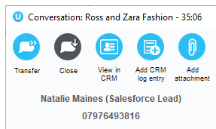

13.7.1 Delivered/Undelivered receipts
When the Kakapo cloud sends an outbound message, it provides a call-back URL to which all status updates (sent, delivered, failed etc) should be sent, these status updates are then delivered in real-time to Unity clients over the Kakapo IM&P backbone.

In this way Unity is able to display if an outbound SMS message was undelivered/failed, which would be shown as below. The user can click on the error image to attempt to resend the message.
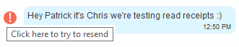

As soon as a message is successfully delivered to the remote party cell phone, Unity will be updated with the delivery receipt.
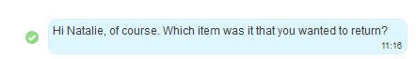

13.7.2 Sending attachments
Non-text media can be sent to customers as links, meaning that you can send images and PDFs within your text-only bundle.
To attach a document or image just click the attach icon  and double click on the file.

Right click the icon to access the recent attachments (the cache saves the file path, if the file has moved folders then the add recent attachment button will not work), as shown below.

13.7.3 Ending an SMS conversation
Unlike with a Web Chat, only Unity users can end an SMS conversation. However, the SMS profile settings can be configured so that if a reply is sent from the customer within a set period of time then the conversation is reopened.

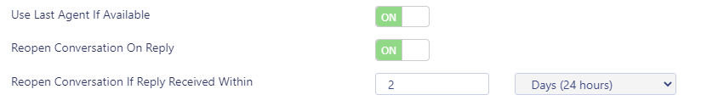

13.8 CRM automatic contact pop
Unity can now be configured to automatically pop a CRM contact (assuming a match was made on the CRM platform) when an Agent reserves a Contact Center conversation, as shown below.
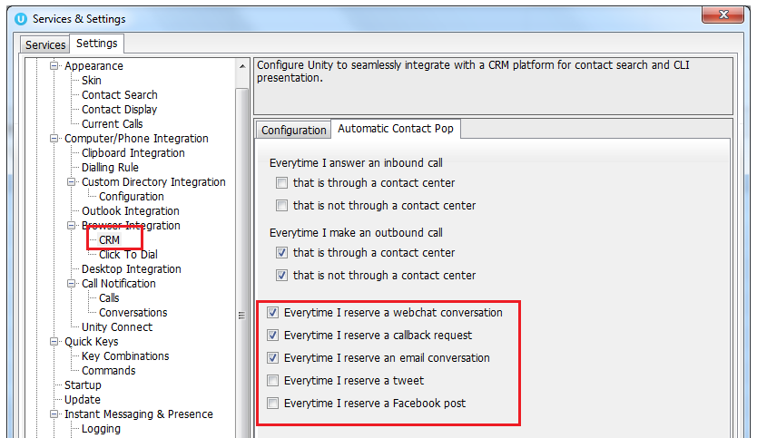
If Unity has performed a contact pop from a CRM platform then the notification will be displayed with the relevant information, as shown below.
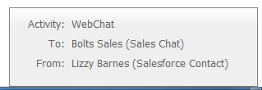

13.9 Viewing Historical Conversations
To drill-in to historical Web Chats, Twitter and Email conversations simply click on the Activity Log and then click Conversations.
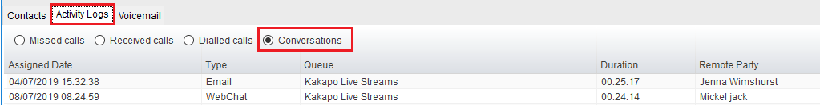
Double click the chosen conversation to show the entire conversation and any relevant rating, as shown below.
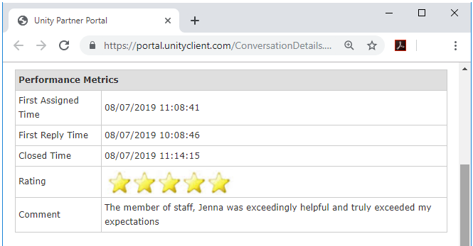

Desktop Functionality

As Unity Desktop does not feature the Personal Wallboard users cannot join and leave Contact Center Queues the same way that users do in Unity Agent and Supervisor.

14.1 Joining or Leaving Queues
Users join and leave Contact Center Queues by going to Tools > Queues and selecting or unselecting the relevant Queue.

A Queue with a tick next to it means that the User is joined to that Queue. A Queue without a tick next to it means that the User is not joined to that Queue.
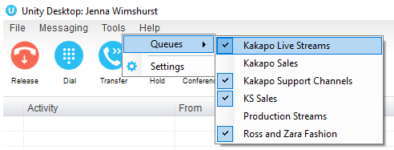

14.2 ACD State Information
As Unity Desktop does not feature the ACD functionality of Unity Agent and Supervisor any restrictions set in the ACD State management section of the portal will not be applied.

Therefore, a User only has to be joined to a Queue in order to receive incoming conversations.

Agent Functionality

15.1 Joining or Leaving Queues
Agents join and leave Contact Center Queues exactly the same way they would with a Call Center Queue. Simply right click on the Queue and select join or leave. If icon next to the Queue is green then they are joined to the Queue, if it is red then they are not joined to the Queue.
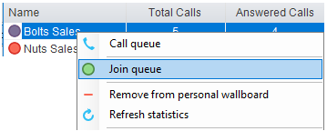
Unity can be configured to automatically join all Contact Center Queues on start-up, as shown below.
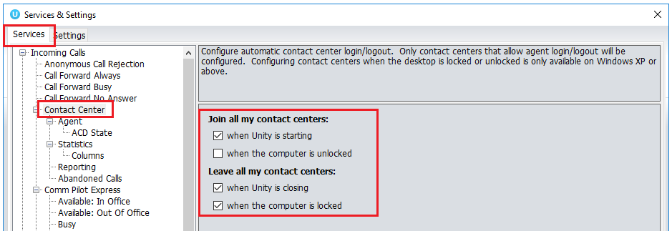

Unity can be configured to prompt the user that they are the last joined Agent when they attempt to leave a Queue, as shown below.

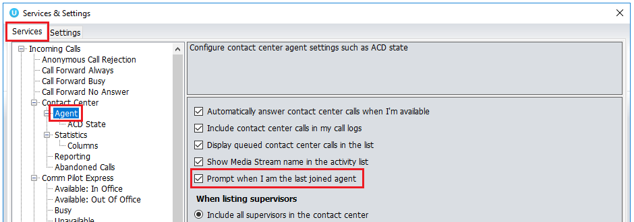

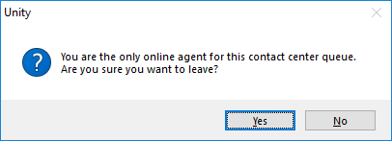

15.2 Adding/Removing Contact Center Statistics
To add Media Stream statistics to the Agent and Contact Center columns in the Personal Wallboard go to settings>services>columns and then add the available Contact Center stats using the green add icon at the bottom right.
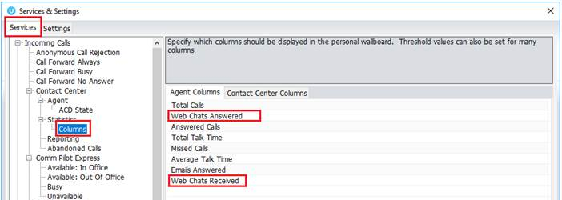

To remove Media Stream statistics simply click on the desired statistic and click the red minus icon at the bottom. You can reorder the statistics by selecting the statistic and using the arrows to move it up and down the column.

The Total Queued Conversations statistic available in the Contact Center Columns is a key statistic that shows all conversations queued for all Contact Center Queues.

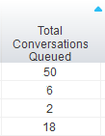

Supervisor Functionality

16.1 Licensing/Becoming A Supervisor for A Queue
When a user has a Supervisor Contact Center license, they can be both an Agent and a Supervisor of Queues in the Contact Center.

To add a user as a Supervisor to a Queue go to the Queue in the Kakapo portal and click Supervisors.
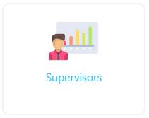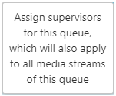

A list of all users with Supervisor Contact Center licenses will appear in the left column, simply move them to the right to add them as a Supervisor to that Queue and click save.

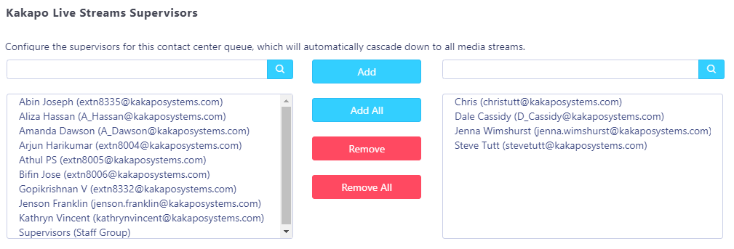

16.2 Show Queued and Reserved Conversations
Supervisors can view all queued and reserved conversations for all Queues by selecting the relevant boxes in Settings>Services>Supervisor>Conversations, as shown below.

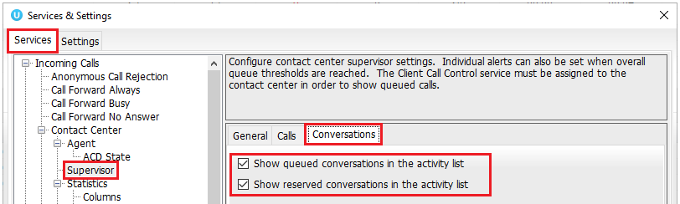

16.3 Transferring & Closing Conversations
Supervisors can transfer and close conversations by right clicking them and selecting the relevant option.
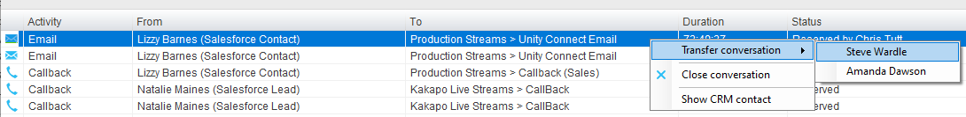

Web Chats cannot be transferred or closed by the Supervisor because it's a live “real time” conversation.

Agents and Supervisors can transfer all conversations (except Web Chats) to any other Agent regardless of their online status and the conversation will automatically be reserved by the new Agent.

Clicking the transfer icon within the conversion window to view the other Agent’s joined status, as shown below.
Please note: Agents can still transfer Web Chats to other Agents but they can only transfer to an online available Agent who will have to manually reserve the conversation before it is transferred.

When a conversation has been transferred the new recipient will receive a toast notification detailing the conversation type, who it was transferred from, which Queue it is from and the customer’s details:

16.4 Silent Monitoring Conversations
Supervisors can silent monitor all conversations by simply double clicking on the reserved conversation in the Activity Window.

The Supervisor will be able to view the entire conversation.
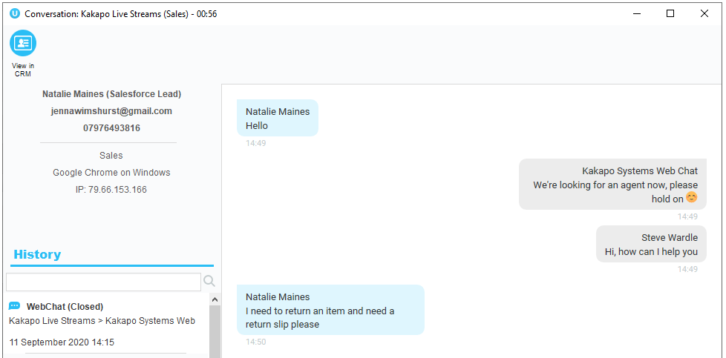

For Callback conversations Supervisors will be able to see the time that a Callback has been scheduled for and any notes added to the Callback.
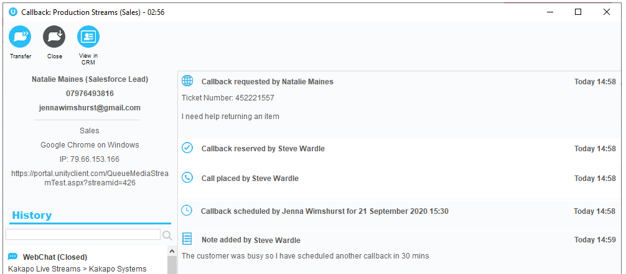

16.4 Agent Activity Tab
If a single Queue is both a Call and Contact Center Queue then you can click on the Queue in the Activity Tab and change both the Join and Leave state and the ACD Status of all Agents within that Queue.
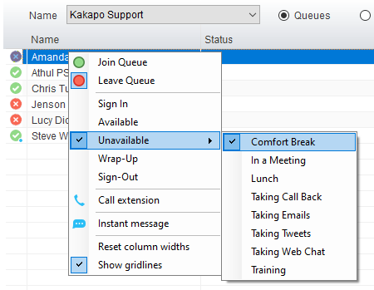

However, if the Queue is only a Contact Center Queue then the Supervisor will only be able to change the Agent’s Join and Leave State.
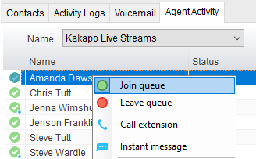

16.4.1 Agent Type
To add the Agent Type column to the Agent Activity Tab Go to Settings>Services>Columns>Agent Activity and select it using the green add icon.

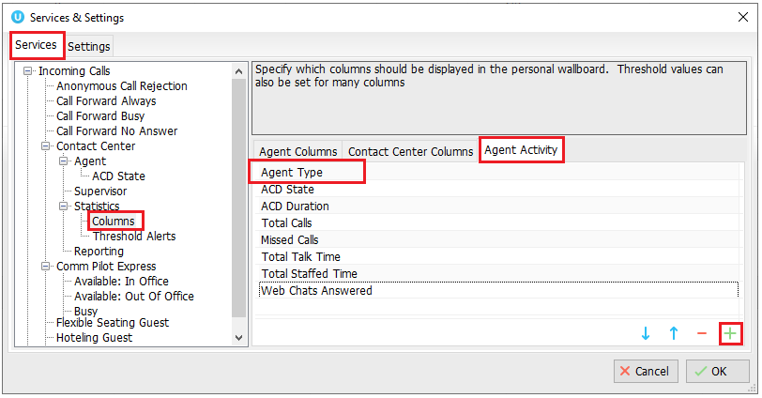

Agent type, this column shows the type of Agent the Agent is within the Queue. E.g. Omni means they are only an Agent for Contact Center conversations, Voice means they are only an Agent for VoIP calls and Both means the Agent can take all conversation types from the Queue.

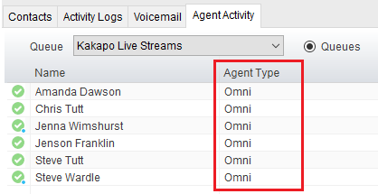

Troubleshooting

17.1 Web Chat Hyperlinks
If an Agent has sent a link of a PDF and the customer is unable to directly click the link from the chat window then the customer will need to install the Adobe extension and ensure they have turned off auto download in their Google Chrome:
https://chrome.google.com/webstore/detail/pdf-viewer/oemmndcbldboiebfnladdacbdfmadadm?hl=en

17.2 Can’t add Media Streams/Queues
If users are unable to create their own Media Stream or Queue and only manage them, this is because creating a Media Stream is a billing event and the portal user account doesn’t have the correct setting enabled.

Portal User Accounts must have the “Can Assign & Unassign Licenses” setting enabled as this allows users to add and remove licenses to users. It also allows the user to create Media Streams and assign CPaaS numbers to users. (If this permission is not set then the user won’t be able to create Media Streams and assign CPaaS numbers because these are billable actions).

If the permission is given
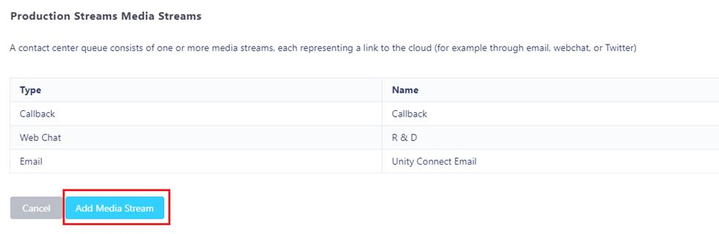

If the permission is not given
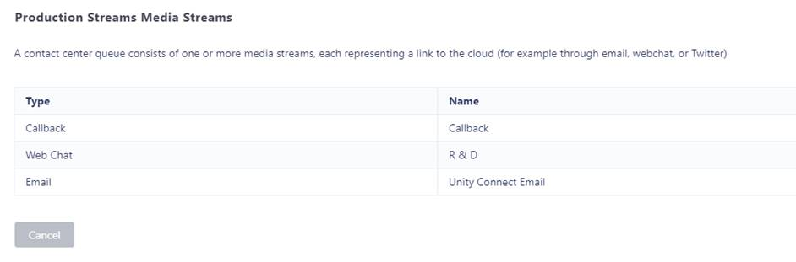

17.3 Channel Is No Longer Active Error
If the Web Chat or Callback widget on your website displays the below error, then either the Media Stream has been deleted in the Kakapo portal and the Java Script is still present in that webpage. Simply delete the Java Script from that web page.

Or, there is an error in the Java Script on that webpage. Simply copy and paste the Java Script from the Media Stream profile page again and update the webpage.

