

UNITY RECEPTION HELP GUIDE
Contents

1 About Unity Reception 7
1.1 Unity Reception Enterprise 8
1.1.1 Cached Licenses 8
1.2 System Requirements 9
1.2.1 Windows PC Requirements 9
1.2.2 Internet & Firewall 9
1.2.3 VoIP Platform Requirements 9
1.2.4 VoIP Platform Licence & Service Requirements 10
1.2.5 Remote Service Configuration Requirements 11
1.2.6 Call Centre Agent Requirements 11
1.3 Initial Setup 11
1.4 Manual and Auto Updates 12
1.5 Rollback available 13
2 Unity Reception Interface Overview 13
2.1 Resizing Unity Reception 14
2.2 Maximising and Minimising 14
2.3 Using Unity Reception from the System Tray 14
2.4 Call Notification Preferences 15
2.4.1 Show Remote Party Phone Number 16
2.4.2 Override Contact Name Using Number 16
2.5 Summary Toast Notification 16
2.6 Browser Screen-Pop 16
2.7 Appearance 17
2.8 Skins 17
3 Main Interface Elements 18
3.1 Call Control 18
3.2 Active Call Window 18
3.3 Contacts List [Busy Lamp Field] 18
3.4 Call Logs 19
3.5 Visual Voicemail 19
4 Call Control 20
4.1 Making a Call 20
4.1.1 Using the Dial Window 20
4.1.2 Using the Contacts Panel 21
4.1.3 Drag and Drop 21
4.1.4 Dial from the Clipboard 21
4.2 Answer a Call 21
4.3 End a Call 22
4.4 Redial 22
4.5 Send Call to Voicemail 22
4.5.1 Retrieving Voicemail Messages 22
4.6 Transferring a Call 22
4.6.1 Announced Transfer using Transfer Button 23
4.6.2 Announced Transfer using Drag & Drop 23
4.6.3 Announced Transfer using Warm Transfer Button 24
4.6.4 Blind Transfer using Drag & Drop 24
4.6.5 Blind Transfer using Transfer Button 25
4.6.6 Blind Transfer using Right Click 25
4.6.7 Transfer to Voicemail using Right Click 26
4.6.8 Transfer to Voicemail using Drag & Drop 26
4.6.9 Transfer to Mobile 26
4.7 Send Callback Request 26
4.8 Call Hold/Retrieve 27
4.8.1 Placing a Call on Hold 28
4.8.2 Retrieving a Held Call 28
4.9 Conference Calling 28
4.9.1 Starting a Conference Call 28
4.9.2 Adding Multiple Parties 29
4.9.3 Dropping a Participant 29
4.9.4 Ending a Conference 29
4.9.5 Conference Bridge Integration 30
4.10 Call Recording 30
4.10.1 Changing the Call Recording Option 30
4.10.2 Controlling Call Recording 31
4.11 Using Paging Groups 31
4.12 Retrieving a Parked Call 32
4.13 Quick Keys 32
4.13.1 Configuring Quick Keys 33
4.13.2 Contact Search 33
5 Active Call Window 34
5.1 Window Layout 34
5.1.1 From 34
5.1.2 To 34
5.1.3 Duration 34
5.1.4 Status 34
5.1.5 Notes 35
5.2 Resizing the Current Call List 35
5.3 Managing Multiple Calls 35
5.4 Configuring Which Calls are Displayed in Active Call Window 36
5.5 Transfer History 36
5.6 Configuration 36
5.6.1 Resize the Current Call List 37
5.6.2 Grouping Calls 37
5.6.3 Double Click to Retrieve 37
5.6.4 Display Parked & Camped Calls 37
5.6.5 Display Notes 37
5.6.6 When Linked User Becomes Available 37
5.6.7 Transfer History 37
6 Drag and Drop 38
6.1 Make a Call to a User or Number 38
6.2 Transferring a Call to a User 38
6.3 Make a Call to a Call Center 38
6.4 Transferring a Call to a Call Center 38
6.5 Send to Voicemail 38
6.6 Call Control 39
6.7 Manage Instant Messages 39
7 Contacts Panel [Busy Lamp Field] 40
7.1 Contact Panel Display Options 40
7.1.1 Details View 40
7.1.2 List View 41
7.1.3 Small Icon View 41
7.1.4 Tile View 41
7.2 User Icons 42
7.2.1 Displaying the Tool Tip 42
7.3 Selecting the Contacts Panel Default List 42
7.4 Contact Groups 43
7.4.1 Creating a Contact Group 44
7.4.2 Adding Users to an Existing Contact Group 44
7.4.3 Removing Users from Contact Groups 45
7.4.4 Deleting Contact Groups 45
7.4.5 Renaming Contact Groups 45
7.5 Performing Call Control Actions in the Contacts Panel 46
7.5.1 Call Extension 46
7.5.2 Answer This Call [Call Pick-Up] 46
7.5.3 Park Call on Extension 47
7.5.4 Camp Call on Extension 47
7.5.5 Hold Call and Link to User 47
7.5.6 Call Mobile 49
7.5.7 Transfer Call to Mobile 49
7.5.8 Transfer Call to VoiceMail 49
7.5.9 Barge into This Call 49
7.5.10 Call Extension When Available 50
7.5.11 View User Details 50
7.5.12 Add Note 51
7.5.13 Send Email 51
7.5.14 Show Calendar 52
7.5.15 Answer This Call [Call Pick-Up] 52
7.6 Configuration 52
7.6.1 Include External Contacts in all Searches 52
7.6.2 Show Monitored Users First When Searching 53
7.6.3 Always Sort New Search Results by Name 53
7.6.4 Include Department Name in Search 53
7.6.5 Clear the Search Box When Activated 53
7.6.6 Show Contact Groups 53
7.6.7 Including Contacts in Search Results 54
7.6.8 Show Call Duration 54
7.6.9 Menu Options on Drag & Drop 54
7.6.10 Contact Notes Folder 54
7.6.11 Show Most Searched Contacts 55
8 Instant Messaging 55
8.1 Online/Offline Indicator 55
8.2 Docking the IM Conversation 55
8.3 IM Conversation Overview 56
8.3.1 Docked IM Conversation 57
8.3.2 Undocked IM Conversation 58
8.4 Docking & Undocking IM Conversations 58
8.5 Starting an Instant Message Conversation 58
8.6 Adding Participants to an Existing Conversation 59
8.7 Sending Contact Directory Numbers 59
8.8 Notifications 60
8.9 XMPP Integration 60
8.9.1 XMPP Authentication 60
8.9.2 Managing XMPP Subscriptions 61
8.9.3 Instant Message Priority 63
8.10 Configuration 63
8.10.1 Send IMs to Offline Users 63
8.10.2 Show Instant Messages in Docked Panel 63
8.10.3 Always Show Docked Panel 63
8.10.4 Use Existing Conversation for Drag & Drop 64
8.10.5 When an Instant Message is Received 64
8.10.6 Play a Notification Sound 64
8.10.7 Show Popup Notification 64
8.10.8 Log Instant Message Conversations 65
8.10.9 Log Frequency & Type 65
8.10.10 Log Folder 65
9 Show Calendar 66
9.1 Outlook 67
9.2 Office 365 67
9.3 Exchange 69
9.4 Portal Calendar Integration 70
9.5 Configuration 71
9.6 Start and End hour 71
9.7 Show Calendar Events in Status Column 72
9.8 Monitored Users Calendar Display 72
10 Remote Service Configuration 73
11 Personal Directory 74
11.1 Add a Personal Directory Entry 74
11.2 Edit a Personal Directory Entry 75
11.3 Remove a Personal Directory Entry 75
11.4 Including External Contacts in the Default Contacts List 76
11.5 Import Personal Directory 76
11.6 Export Personal Directory 76
12 Directory Integration 76
12.1 Loading Directories 77
12.2 Configuring Outlook Contacts Preferences 78
12.3 Third Party Directories 79
12.4 Desktop Integration 79
13 My Status (Quick Access Service Configuration) 80
13.1 Configuring CommPilot Express States 81
13.1.1 Available: In Office 81
13.1.2 Available: Out Of Office 81
13.1.3 Busy 82
13.1.4 Unavailable 82
13.2 Do Not Disturb 82
13.3 Call Forward Always 83
13.4 Remote Office 83
13.5 Hot-Desk and Flexible seating 84
13.6 Personal Assistant Service 85
14 Reception Call Centre Agent 87
14.1 Joining & Leaving Queues 88
14.2 Changing ACD State 88
14.3 Personal Wallboard 88
14.3.1 Authentication & Configuration 89
14.3.1.1 Setting Default Password in the Portal 91
14.3.2 Overview 91
14.3.3 Columns 92
14.4 Receiving Call Center Calls 92
14.5 Assigning Disposition Codes 93
14.6 Supervisor Escalation 94
14.6.1 Standard Escalation 95
14.6.2 Emergency Escalation 95
14.7 Activating Outbound DNIS 95
16.8 Report Viewer 96
14.9 Call Center Agent Configuration 97
14.9.1 Call Center 97
14.9.2 Agent 97
14.9.3 ACD State 98
14.9.4 Statistics 100
14.9.5 Reporting 101

1 About Unity Reception

Unity Reception is a Microsoft® Windows® based application designed for busy, front desk call handling environments or for those users who need visibility of a large number of concurrent calls and extended presence information for colleagues.
Standard vs Enterprise Features
Unity is available in Standard and Enterprise variants. The features available are as follows:

Unity Reception Standard
Features provided;
- 50 user fixed busy lamp field (BLF)
- Drag and drop call control [to make a call, release, IM, transfer, park etc]
- BroadWorks call center agent functionality for join/leave queue and changing ACD state
- Hold & Link User - Custom tagging of held calls [ie holding for Andrew Smith]
- Microsoft Outlook integration to display the required users calendar events
- Visibility of the party the inbound caller was previously transferred to
- Ability to listen to, save and delete voicemails
- Add notes for inbound calls and all group or enterprise users
- XMPP support for IM&P with UC-One
1.1 Unity Reception Enterprise
All Unity Reception Standard features but also including;
- Office365 and Exchange Calendar integration to display the required users calendar events
- Unlimited dynamic busy lamp field [displays hook status of all matched users on contact search]
- Remote service configuration for all BroadWorks group and enterprise users
- Contact Groups
1.1.1 Cached Licenses
Unity saves an encrypted copy of the last successful license response from the Kakapo licensing
platform locally. If the licensing platform is offline when Unity is requesting a license, it will use the
locally cached license. This license can be used a maximum of eight times before it is considered invalid, which will cover 24 hours of continual use.

The current license & Unity version can be found by clicking Help > About from the main window.
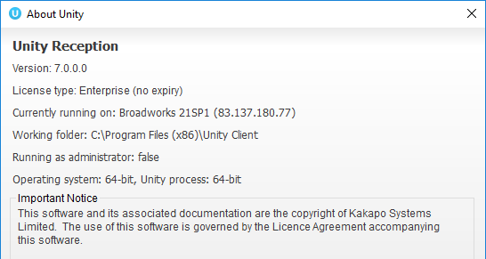
1.2 System Requirements
1.2.1 Windows PC Requirements
- Unity will require approx. 500MB of hard drive space on the local machine
- By default the install directory is C:\Program Files (x86)\Unity Client
- Minimum computer spec: CPU: dual core 3Ghz. Ram: 4GB. Video card: 256MB onboard RAM. As a general note, the requirements to run Unity Reception are considerably less than those required to run Windows
- Unity can be rolled out as an MSI file, which supports automated installations using Active Directory group profiles and other automation mechanisms.
- Unity is only supported on Windows 8.1, Windows 10 and Windows 11
- Both 32 and 64-bit versions of Windows are supported. There are no special permissions required to install Unity, other than those granted during installation.
1.2.2 Internet & Firewall
Unity requires high-speed internet connectivity and access to the below locations, which may require firewall rules to be added on the customer premises:
- TCP port 2208 to im.unityclient.com
- TCP port 2208 to the VoIP platform
- HTTP/HTTPS access to portal.unityclient.com
- TCP port 5222 to the XMPP server, if applicable
1.2.3 VoIP Platform Requirements
Unity Reception is supported on BroadWorks R17 sp4 and above.

1.2.4 VoIP Platform Licence & Service Requirements
Client Call Control: The Client Call Control service is mandatory as this is the service that allows Unity to integrate with the VoIP platform. If this service is not assigned the user will be alerted and Unity will not provide any functionality.

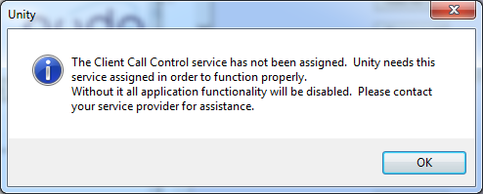

Internal/External Calling Line ID Delivery: The Internal Calling Line ID Delivery and External Calling Line Id Delivery services should both be assigned as these services allow Unity to identify calls to/from other users in the business. If not assigned Unity will function, but the user will be prompted that this functionality will not be available.

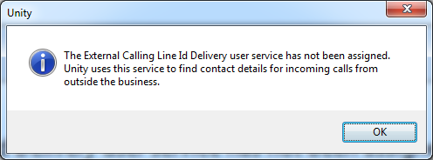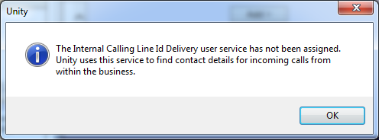

Call Transfer: The Call Transfer service is required in order to blind or announce transfer calls to internal and external numbers. Unity will alert the user if this service is not assigned.
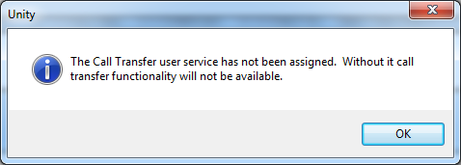

Three Way Call or N-Way Call: Either the Three-Way Calling or N-Way Calling service must be assigned in order to provide conferencing functionality, Unity will alert the user if neither service is assigned.

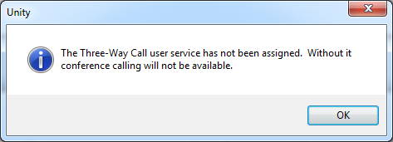

Basic Call Logs or Enhanced Call Logs: Either Basic Call Logs or Enhanced Call Logs must be assigned to the user in order to see dialled, received and missed calls. Unity will alert the user is neither service is assigned.

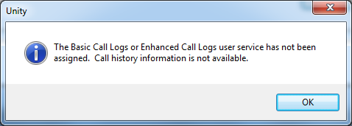
1.2.5 Remote Service Configuration Requirements
Unity Reception allows remote configuration of some services for other users within the group or enterprise. The services available to be remotely configured are activate/deactivate DND, configure Call Forward Always or change the CommPilot Express profile. To do this the user must have a group or enterprise administrator account entered in Settings > Authentication.
1.2.6 Call Centre Agent Requirements
Unity Reception features the full capability of Unity Agent for use within a call center environment. To use this functionality, the user must have the Call Center Agent Standard or Premium service assigned.

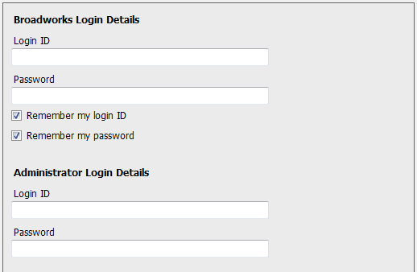

In addition, the Client Call Control service must be assigned to the call center the user is an agent of, if real-time call center statistics such as calls in queue are required. Call center authentication is outlined in section 14.1.
1.3 Initial Setup
The first time Unity is started you will be prompted to enter the connectivity and authentication details, as shown here. Unity can then retain these details for later use. The login ID and password will be assigned from your service provider. The administrator login is optional and only required for the remote service configuration feature, as outlined in section 10.

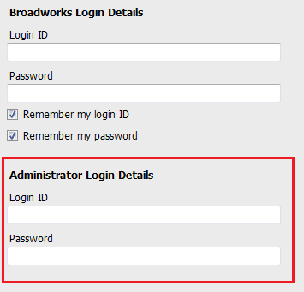
You may also be prompted for the server address of the VoIP platform, you can request this from your service provider if unknown. If this field is already populated do not change it. In most cases you can leave the server port as 2208. Please leave the Unity Server Connection Details as those prefilled.

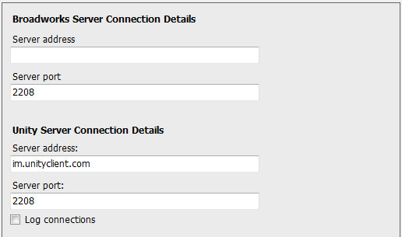

1.4 Manual and Auto Updates
Unity can be configured to automatically update when a new version is available. Simply tick the box in settings>update as shown below.
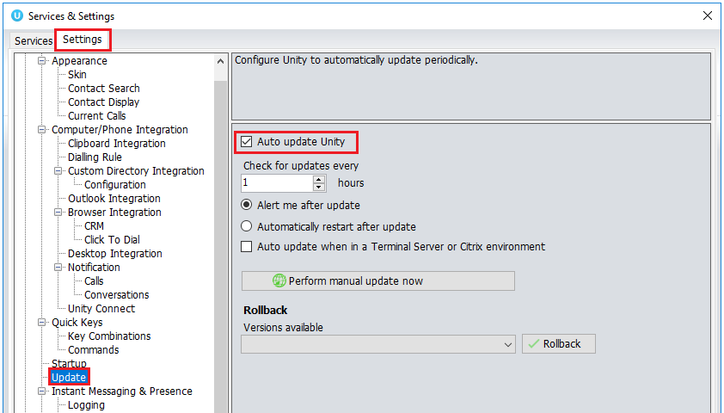

When a new version of Unity is available the user will be presented with a popup asking to restart Unity. Once Unity has restarted the latest version will be running. You can also configure how often Unity looks for updates under the auto update box.

To manually update Unity, click Perform manual update now and Unity will search for any new updates.
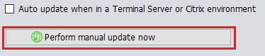
1.5 Rollback available
If rollback available is ticked in the Unity portal, then users can rollback to previous versions of Unity. Go to settings>update and the choose the desired version from the drop down menu.
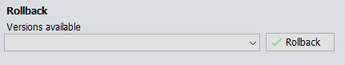

Once you’ve selected which version you want to rollback to click the green tick and the box below will appear.
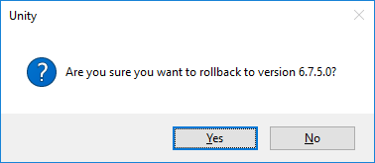

Click Yes and then click Ok.

2 Unity Reception Interface Overview

Unity is split into three functional areas; call control buttons, active call window and contacts [busy lamp field]. Contacts is a tab that can be toggled to display call logs and voicemail. Unity Reception can also act as an agent in a call centre environment. This is the case Unity will also display ACD state buttons and the Personal Wallboard, which shows current call center conditions. Call center agent functionality is covered in section 14.

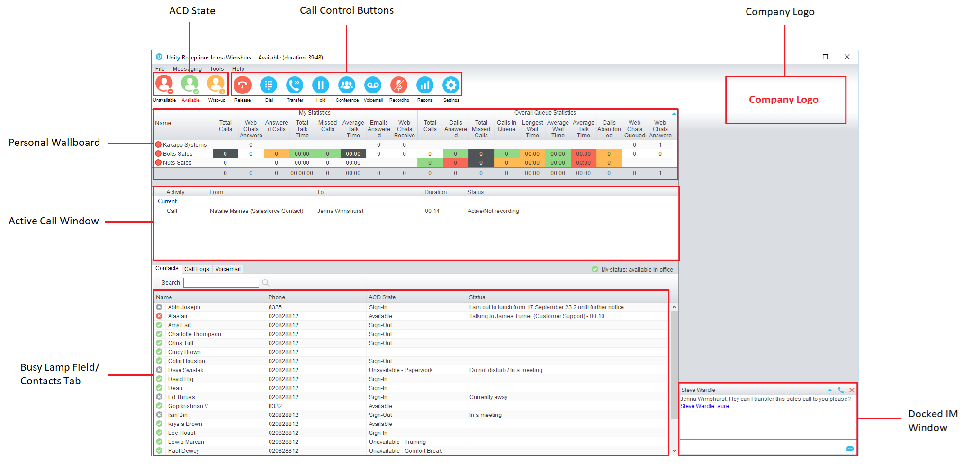
2.1 Resizing Unity Reception
Unity can be dragged from any corner to the required size. The Active Call Window resizes independently by dragging the border at the bottom of the list [where the lower red line is in the illustration above]. When Unity is closed, all current dimensions will be saved.

2.2 Maximising and Minimising
Unity can be maximised and minimised using the standard buttons in the top right hand corner of the application. When minimised, Unity can be configured to appear in the system tray in the bottom right hand corner of the desktop where the Unity icon  will be displayed. To re-open Unity simply double click this icon, or right click and select Restore from the menu, as shown here.
2.3 Using Unity Reception from the System Tray
In its minimised state, Unity Reception can be configured to sit in the system tray. This is configured in Settings as below. The default behaviour is to minimise Unity to the taskbar at the bottom of the desktop.
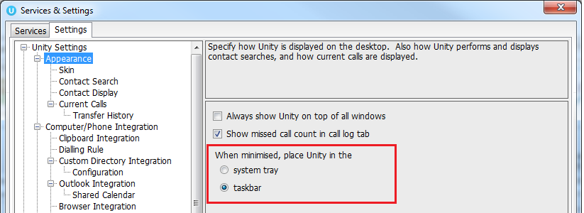

Right clicking the Unity icon in the system tray allows the user to dial or redial, configure settings such as CommPilot Express Profiles, DND, Call Forward Always or Remote Office. Note: Only those services that are assigned to the user will be displayed in the menu.

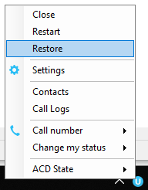

Selecting “Dial number” will provide a list of the last 10 dialled numbers as illustrated here. “New number” will pop a call box where the user enters the desired number using their keyboard.

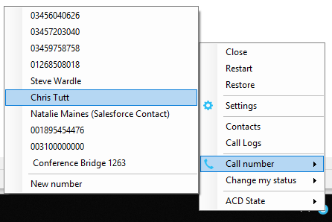

2.4 Call Notification Preferences
Unity Reception can be configured to automatically display, or “pop” when a call is presented, or pop a “toast” summary notification above the system tray when a call is presented. Optionally Unity can also perform auto-answer when using click-to-dial, in which case the primary device of the user will automatically go off-hook [if supported and a speaker is present]. If this is not selected, then all IP phones will ring and the user will have to lift the handset to initiate the outbound call.

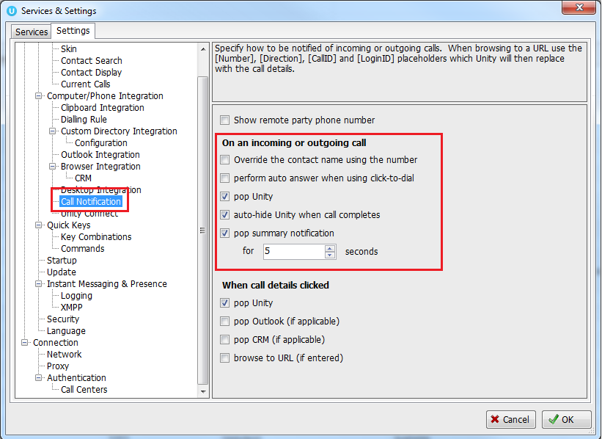
2.4.1 Show Remote Party Phone Number
This setting will configure to show the remote party number [if available], as shown below. This applies to both internal and external parties.
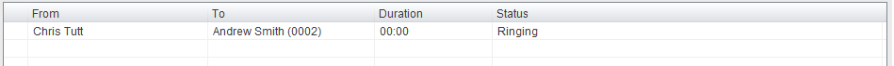
2.4.2 Override Contact Name Using Number
Unity can also perform a contact search based on the remote party number even if the name was provided by the Broadworks platform, this is especially useful when the name delivered through the PSTN is incorrect, for example in some cases this may always be “WIRELESS CALLER”.
2.5 Summary Toast Notification
The summary notification is presented for ACD and direct calls and can be used to route the call to voicemail or answer the call. Please note that if the notification is for an ACD call then the DNIS name may also be displayed if applicable.

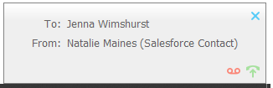
2.6 Browser Screen-Pop
The summary toast notification is also clickable and can be used to open the default browser to a preconfigured URL and append incoming call information, such as the remote party number. This feature can be used for screen popping CRM systems and other browser based applications. Further information on this feature is in a supplementary guide.
2.7 Appearance
In Settings [button] > Settings [tab] > Appearance, the user can change the behaviour of Unity.
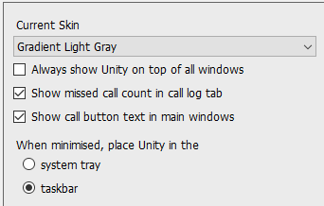

Always show on top of all windows – Unity will always be on top
Show missed call count in the call log tab – When enabled Unity will provide a count of the number of missed calls as below
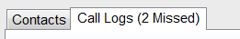
Show call button text in main windows – The button text will be displayed under the call control buttons
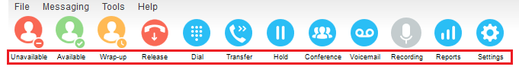
2.8 Skins
The user can change the colour scheme used in Unity with pre-set skins, as shown below. Please note that gradient skins may not appear as clearly as expected if the graphics card is not adequate, this can especially be the case in Citrix or Terminal Service environments.

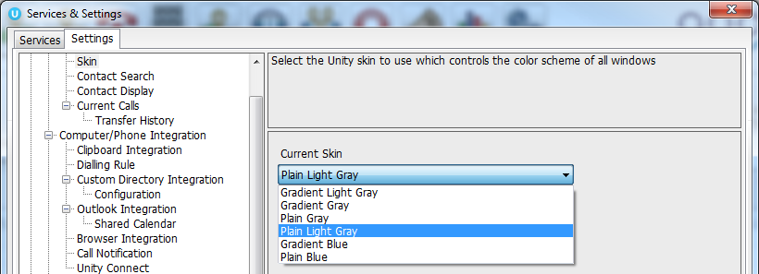

3 Main Interface Elements
3.1 Call Control
Call Control buttons provide quick access to common telephone handling commands. Only services that are assigned to the user are displayed. For example, if Call Recording and Voicemail are not assigned then these buttons will not be displayed.

3.2 Active Call Window
This provides a list of all current calls and their state. For example, ringing, active, held, parked etc. The duration of the call is also displayed, which is from the moment the call was first placed and does not reset when a call is held or retrieved. Unity will mirror any call handling made on the user’s IP phone. For example, if the call is placed on hold on the handset, the user will show as being on hold in the Active Call Window. If there are multiple calls in the Active Call List then the correct call must be selected before performing the call control action, similarly a call can be dragged over the Call Control button to perform the action on that call.

3.3 Contacts List [Busy Lamp Field]
This panel will display up to 50 monitored users, displaying their unavailable, available, Engaged or Ringing state as graphical icons, which are further outlined in section 8.1

The user can also perform a contact lookup which will search all directories available in Unity and return any internal or external contacts that meet the search criteria. External contacts or internal contacts that cannot be monitored through the BLF are easily identified.
Right-click the search box in the Contact list to view all directories available in Unity, then select the directory to load those contacts in the list, as below.

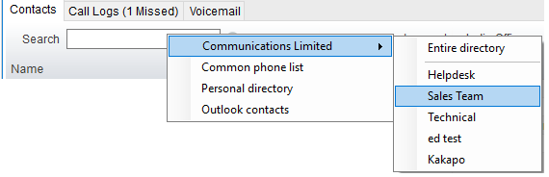

3.4 Call Logs
Toggling the bottom Contacts panel to Call Logs will display missed, received and dialled calls. Missed calls will include both direct inbound direct calls, as well as ACD and hunt group calls. 20 numbers can be stored unless the user has Enhanced Call Logs service assigned.

To call any entry in a call log, simply double-click, right-click and select “Call number” or drag the call log entry into the Active Call List.

Any recently missed calls are easily identified, as shown below. This will match the missed call count outlined in section 2.7.2.

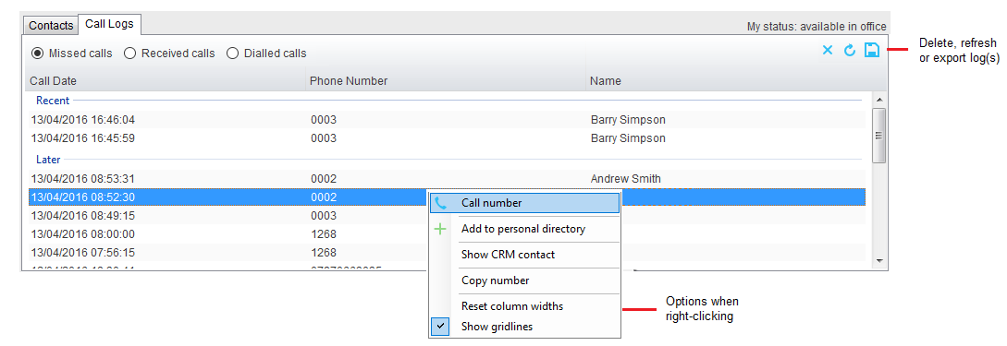
Call logs can also be deleted, refreshed or exported with the icons at top right of the panel.
3.5 Visual Voicemail
The Voicemail tab allows the user to interact with their voice mailbox to listen to, save and delete voicemails without using the phone.

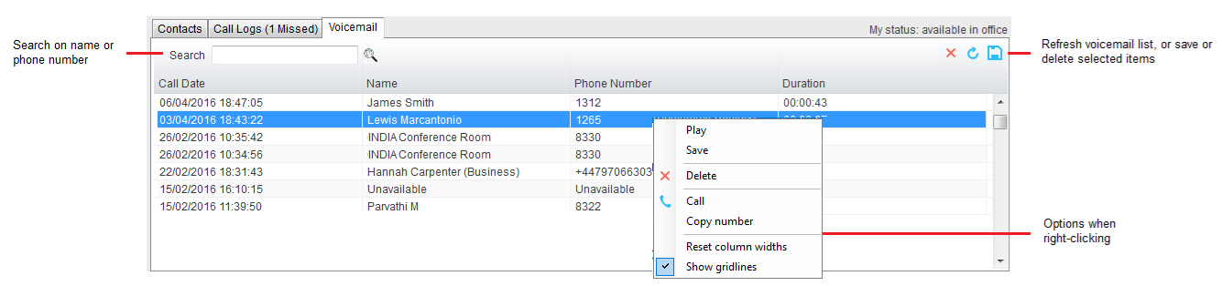

The Voicemail tab is only displayed if the Voice Messaging User service if active and configured to use unified messaging. The “Show visual voicemail tab” setting must also be enabled, as shown below.

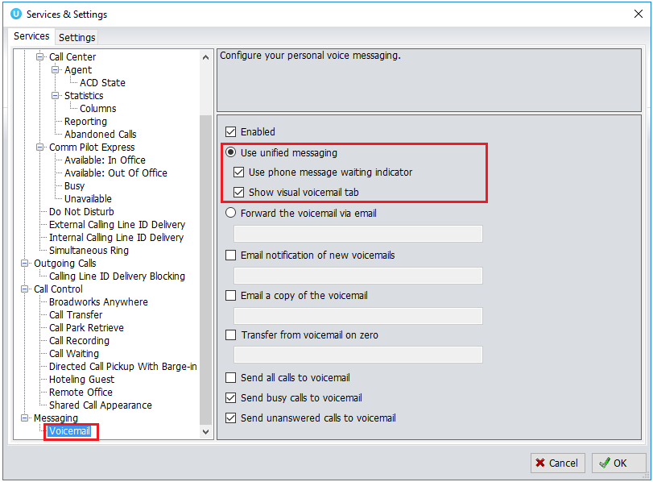

4 Call Control

All calls are managed through the call control buttons at the top of the main window. These buttons will change depending on the state of the selected call, or the only call if there is only one call in the Active Call Window. For example, the Answer/Release   and Hold/Retrieve  buttons toggle as only one of these options will be valid at any time. When an inbound call is ringing, Answer becomes the valid option. Once the call is active the icon will toggle to Release as hanging up is the only valid option.
4.1 Making a Call
4.1.1 Using the Dial Window
Click the Dial button  to bring up the Dial dialogue box, as shown here. Using the computer keypad enter the desired number and press Enter or click OK to make the call. The primary phone will default to using hands-free speakerphone, if configured as outlined in section 2. Otherwise you will need to lift the handset to establish the outbound call.

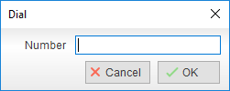
4.1.2 Using the Contacts Panel
Double click a user icon or right click and select “Call extension” or “Call number” if right-clicking on an external contact. It is also possible to call an internal user’s mobile number if entered in their profile.

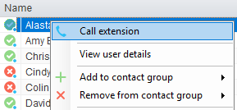
4.1.3 Drag and Drop
Left click a user in the Contacts panel and drag the icon up to the Active Call Window. This will open a call to that contact.
4.1.4 Dial from the Clipboard
Unity can be configured so that whenever a number is copied to the clipboard [from any application in Windows], Unity will prompt the user to dial that number.

This feature can be activated [the default] or deactivated through settings.

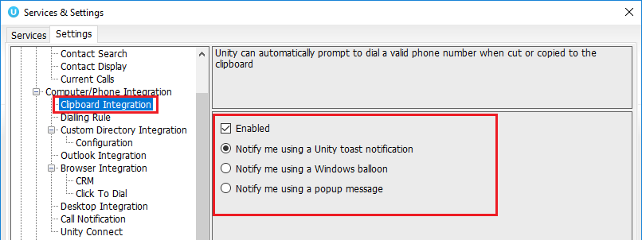
4.2 Answer a Call
When Unity displays an inbound call, click the Answer icon or double click the call in the Active Call Window to answer the call. Your primary phone will automatically answer the call using hands-free speakerphone, if it supports this feature with Unity. If there is an active call in progress, you will need to click the new inbound call in the Active Call List before clicking Answer, this will automatically place the first call on hold. Please note that answering a call by lifting the handset on the desk phone will have the same effect as clicking Answer in Unity.
4.3 End a Call
Click the Release button to end the currently selected call. If there are multiple calls in the current call list, make sure you select the right call before clicking Release.

Note: Replacing the telephone handset will also end the call, which will then be removed from the Active Call Window.
4.4 Redial
You can right-click the Dial button to see a list of the last 10 dialled numbers. Simply click on an entry to dial the party, as shown here.

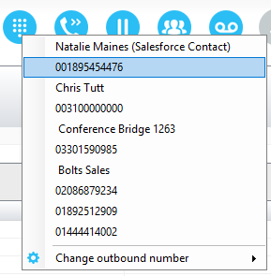
4.5 Send Call to Voicemail
To send an inbound caller directly to your voicemail click the Voicemail button. Please note this button will not be visible if the Voice Messaging User service is not assigned or is currently disabled.
4.5.1 Retrieving Voicemail Messages
When no calls are currently selected, clicking the Voicemail button will dial the user into their voicemail using the user’s primary device. This feature has been superseded by the Voicemail tab as outlined in section 3.5.
4.6 Transferring a Call
There are two ways to transfer a call; announced transfer, where you introduce the call to the receiving party before putting the call through, and blind transfer, where you transfer the caller directly to a recipient without introducing the call.
4.6.1 Announced Transfer using Transfer Button
With a call in progress, make a new call to the desired destination extension or number as described in section 4.1. This will automatically place the first call on hold and will add a new call in the Active Call Window. Once the called party answers, click Transfer  and select the context menu option to transfer both calling parties together. Both calls will now disappear from the Active Call Window.

Note: The user is not limited to transferring received calls. The user can make two outbound calls and then use announced transfer to join them together.

Example 1 – Transfer with two live calls

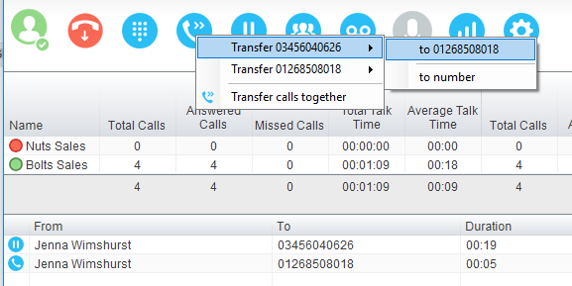

Example 2 – Transfer with four live calls

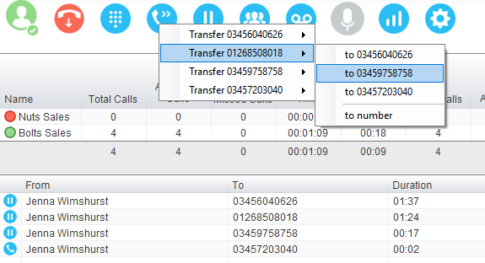

4.6.2 Announced Transfer using Drag & Drop
The easiest way to perform an announced transfer is simply to drag & drop one call on top of the other in the Active Call Window. This will join the calls together and remove them from the Active Call Window.

4.6.3 Announced Transfer using Warm Transfer Button
Unity offers a feature called Warm Transfer whereby the held call and the transferee are linked so that when either call is selected in the Active Call Window they can be joined by clicking the Warm Transfer button, as shown below.
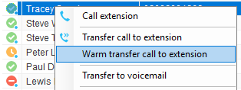

Please note that “Allow warm transfer through Unity” must be activated in order to see this option in the context menu. To do this go to Settings>Services>Call Control>Call Transfer, as shown below.
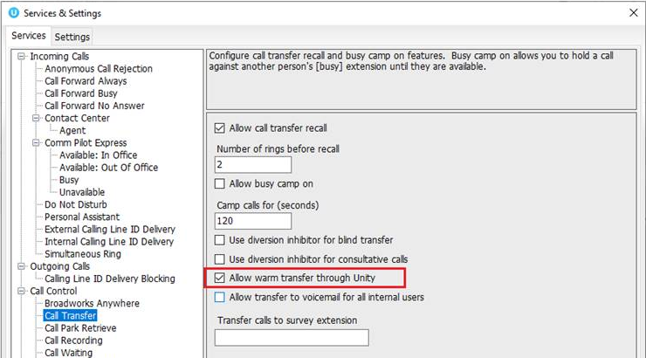

4.6.4 Blind Transfer using Drag & Drop
Unity Reception can be configured to automatically blind transfer a call by dragging the call from the Active Call Window and dropping it on a user icon or number icon in the Contacts panel, or dropping it onto a call center queue [if Reception is configured as an agent with call center queues, as outlined in section 14].

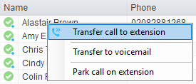
Note: Unity can be configured to display a menu when dropping a call onto a user icon. If only blind transfer is selected, then this will be performed automatically. If menu options are selected when dropping the call, click “Transfer call to extension” to perform blind transfer. For more information on drag & drop please refer to section 6.

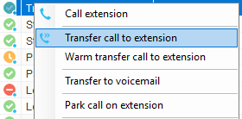
4.6.5 Blind Transfer using Transfer Button
Select a call in the Active Call Window [if there are multiple calls present] and click the Transfer button . In the Transfer window enter the destination and click OK.

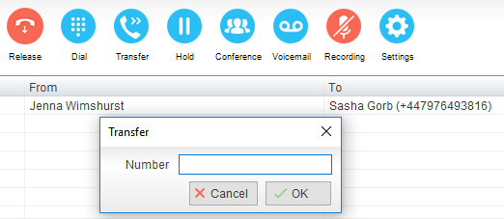
4.6.6 Blind Transfer using Right Click
Select a call in the Active Call Window [if there are multiple calls present] then right click the recipient icon or number in the Contacts list. Select “Transfer call to extension” to blind transfer the call to an internal user, or “Transfer call to number” to blind transfer to an external contact. It is also possible to transfer to the contact’s mobile phone if they are an internal user and the mobile number is entered in their profile.

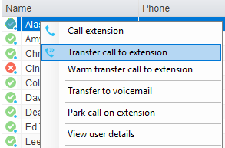
4.6.7 Transfer to Voicemail using Right Click
The option to Transfer to voicemail is valid only for internal contacts that have Voicemail assigned and activated. Select a call in the Active Call Window [if there are multiple calls present] then right click a user in the Contacts list and select “Transfer to voicemail”. This will send the selected call directly to the destination extension voicemail without introducing ringing.

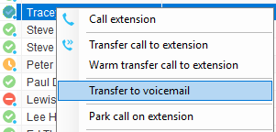
4.6.8 Transfer to Voicemail using Drag & Drop
If configured, Unity will display “Transfer to voicemail” as a context menu option when a call is dragged onto an internal contact in the Contacts panel. For more information on menu options when using drag & drop please refer to section 6.

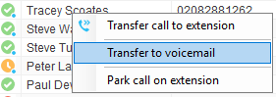
4.6.9 Transfer to Mobile
As mentioned, if the selected contact is an internal user and has a mobile number entered as part of their profile, you have the option to right click and select either “Call Mobile” [to perform an announced transfer] or “Transfer Call to Mobile” [to perform blind transfer]. This also applies when dragging a call, if configured in Settings as outlined in section 6.
4.7 Send Callback Request
Unity Reception (Enterprise license only) will allow the user to send a callback request email to a monitored user, provided their email address is specified in the BroadWorks user profile. The email is not sent through the local email client (for example Outlook) but through the Kakapo cloud. The “from” email address can be specified at all levels in the Kakapo portal under the Branding tab.

To send a callback request right click the desired user when the live call is up and select “Send Callback Request”. This will then open a window for the receptionist to enter a custom note to send with the call back request.

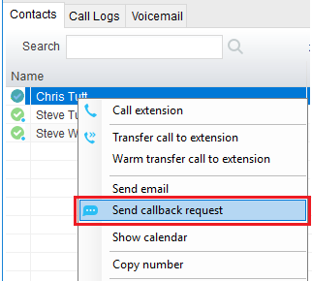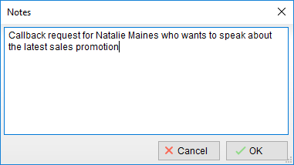
Please note: the “Send callback request” option will only appear if that user has an email address saved in their BroadWorks user profile.

The user will then receive the callback request as an email, as shown below.
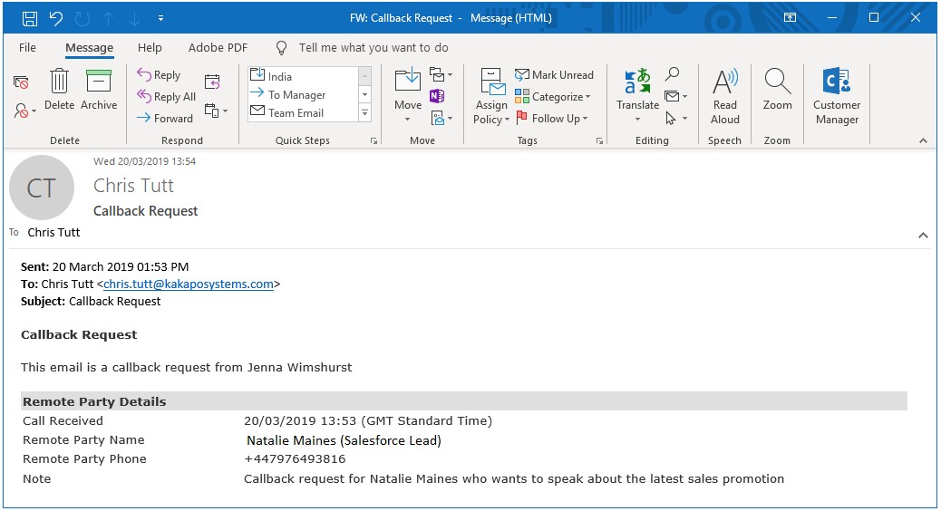
4.8 Call Hold/Retrieve
The Hold/Retrieve function toggles depending on the status of the currently selected call. Hold is only available for an active call while retrieve is only a valid option for a call currently on hold. When a call is on hold, the blue hold icon is shown in miniature to the left of the call in the Active Call Window and the status is On Hold, as shown below.

4.8.1 Placing a Call on Hold
To place a current active call on hold, select the call [if there are multiple calls in the list] and press the hold button. The call status will now show as on hold in the Current Call Window and an icon will appear alongside the call to illustrate that it is currently held.

4.8.2 Retrieving a Held Call
Select the call [if there are multiple calls in the list] and click the retrieve button , the “held” image alongside the call will disappear. You can also double click the call to retrieve it, if configured to do so in Settings. Please note that any other active calls will be placed on hold before the selected call is retrieved, meaning you can toggle between calls by double-clicking them in the Active Call Window.
4.9 Conference Calling
A conference call can be established with any combination of internal and external numbers. The total number of parties that can be supported is determined by service assignment. The Three-Way Calling user service supports conference calls with two other parties only while the N-Way Calling user service supports conference calls with more participants.

4.9.1 Starting a Conference Call
Once an active call is established [that you have either made or received] call a second person. You can do this by clicking the Dial button or double clicking a user in the Contacts panel or Search, or Call Log lists. Making this call will automatically place the first caller on hold. Once the second party has answered the call, click the Conference button  and a new conference will be created between you and the other two parties. This is represented in the Active Call Window as shown below. Please note that if there are more than two calls in the Active Call Window then the two calls to conference will need to be selected.

Selecting either call and clicking hold will place the conference call on hold, during which time the other callers can still talk to each other. The Active Call Window will be updated to illustrate that the conference is on hold, as shown below.

4.9.2 Adding Multiple Parties
Once a three-way conference is established you can add additional parties to create an n-way conference. Select the call to add and select Conference , you will be prompted to add the remote party to the existing conference, as shown below. You can see that the entire conference is held when processing other calls through the Active Call Window.

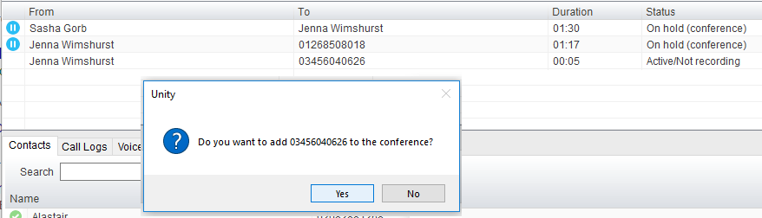

Please note that conference calls can be started with any two remote calls, regardless of the direction of either call or if the number is internal or external [for example between two mobile calls].

4.9.3 Dropping a Participant
To remove a caller from the conference call but continue speaking to the other caller[s], simply select the call to release in the Active Call Window and click the Release button  as you would normally. This will release the selected party and will show only the remaining party[s] in Active Call Window.

4.9.4 Ending a Conference
If the user wants to leave a three-way conference but allow the remote parties to continue talking, perform an announced transfer to join the calls together.

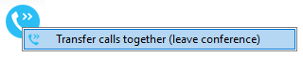
Otherwise to end the conference simply hang up the phone.
4.9.5 Conference Bridge Integration
Unity allows the user to right click the Conference button to view or copy details of their “reservation less” conference bridge(s), or to call a bridge as a moderator. If this has been configured in BroadWorks.
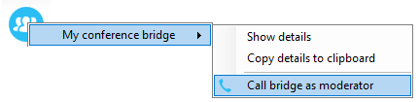

4.10 Call Recording
If the Call Recording User service is assigned then the user may be able to manage call recording, although this depends on the functionality offered by the VoIP platform and service configuration parameters. If the functionality isn’t available or is hidden then the Call Recording button is not displayed in the main window.
4.10.1 Changing the Call Recording Option
Right-click the Recording button to select the call recording option, as shown.
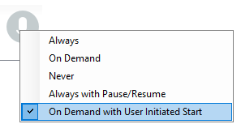

Please note that depending on permissions this may not be available, also not all the displayed options may be available. Call Recording options are:

Option | Description
Always | Calls are automatically recorded from the beginning of the call. There is no option to pause or stop recording.
On Demand | Calls are not automatically recorded from the start, but recording can be started at any time during the call in which case the entire call will be recorded.
Never | Calls are never recorded and recording cannot be started while a call is in progress.
Always with Pause/Resume | All calls are automatically recorded from the beginning of the call, but recording can be paused and resumed, which is especially important when taking credit card details over the phone [that need to be omitted]. This will still result in a single recording for the call, regardless of how many times it was paused and resumed.
On Demand with User Initiated Start | Calls are not automatically recorded from the start, but recording can be started at any time. However, any conversation before the recording was started will not be included in the recording. Recording can be paused and resumed, which will result in different recordings being created for a single call.

4.10.2 Controlling Call Recording
You can start, stop, pause and resume call recording depending on the Call Recording Option currently selected. Left-click the Recording button to manage recording for the selected call in the Active Call Window will toggle the option depending on the current recording state. The call recording button will change   to indicate this. When set as Always with Pause/Resume, the user can left click to Pause/Resume and the button will toggle as Resume [recording] or Pause .
When set as “On Demand With User initiated Start” left clicking the call recording button presents the following menu to allow the user to control the call recording behaviour.
Click the Recording button again to continue/restart recording the call.

The Active Call List will also indicate the recording state of all calls, as shown below.
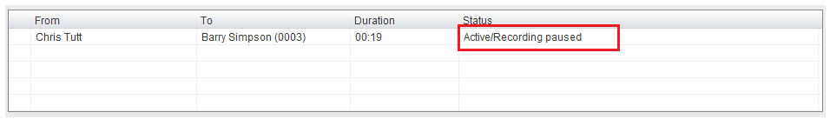
4.11 Using Paging Groups
Unity Reception allows the user to use paging groups to make instant calls to multiple users. When Unity dials a paging group [which are setup in the VoIP platform] all configured user’s phones will automatically go “hands-free” [meaning the speaker will be activated] so that whatever the receptionist says is broadcast to all phones and played through the speaker. Of course if a user is already on the phone they will not be included in the broadcast.

If a user is an originator for one of more paging groups, Unity will display the Announce button which will automatically dial the paging group if only one is configured, otherwise it will display a list of all paging groups that are available for the receptionist to use. Once the user selects the paging group Unity will dial that number and initiate the broadcast.
4.12 Retrieving a Parked Call
Unity offers a unique feature that allows the user to be notified when a call is parked on their extension, as shown below. Unity will automatically display a Pickup button and a “toast” notification popup, if the user clicks on either then the parked call will be retrieved to the user’s primary device.
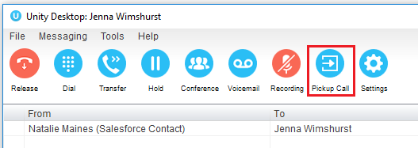
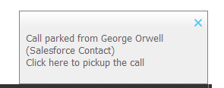

This can be configured through Settings, as shown below.
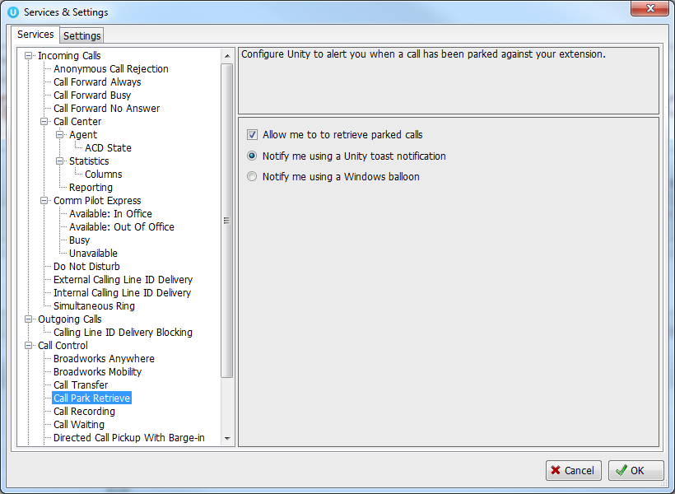
4.13 Quick Keys
The first time Unity is started it will load several default quick keys:
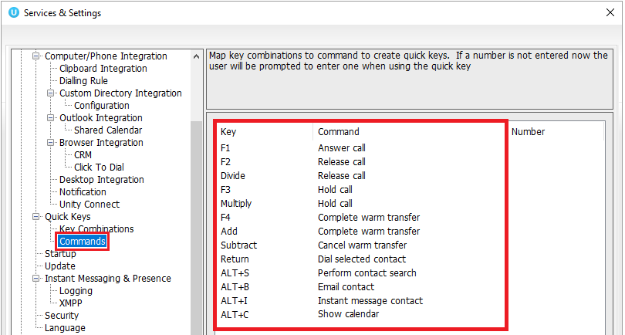
4.13.1 Configuring Quick Keys
All actions can be assigned user defined quick keys for a fast, mouse-free use. For example, ESC to Release and F1 or CTRL+T to Transfer.

To configure the quick keys, simply click on the green plus icon on the bottom right, select the desired key and command and then click OK.
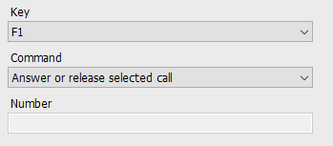
4.13.2 Contact Search
Unity can be configured to open the contact search as soon as a call has been answered, this is done in Settings, as shown below.
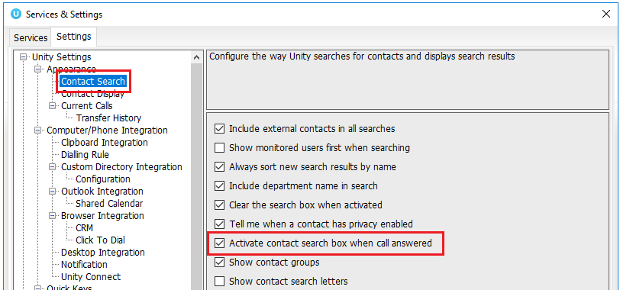

5 Active Call Window

The Active Call Window gives visual representation of the status of all calls the user receives or is currently managing.
5.1 Window Layout
The list is available in detail view only, columns widths can be changed which is stored between Unity sessions.

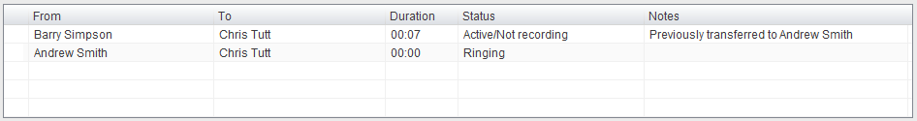
5.1.1 From
This column will display the name/number of the person who made the call. Therefore, it will be the remote calling party for an inbound call and the currently logged in user for an outbound call. If the name has not been delivered by the VoIP platform then Unity will use the remote party number to search the Group/Enterprise directory, the common and personal phone lists, Outlook, speed dials and any external directories that have been configured, as outlined below.
5.1.2 To
This column will display the name/number of the person called, if the call is through a call center it will display the name of the call center. If making about outbound call Unity will attempt to find the remote party name as outlined above.
5.1.3 Duration
This displays the total time elapsed since the call was first answered. The timer does not restart when the call is placed on hold.
5.1.4 Status
This will show the current state of the call, which can be “Ringing”, “Active”, “On Hold”, “Parked for… or “Camped for…” The current recording state will also be displayed if configured in Settings.
5.1.5 Notes
The Notes column will show the destination the call was previously transferred to for additional call handling information for repeat callers.

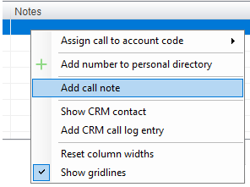

The user can also right click the call and select “Add call note” or double click in the Note field to add a note, if configured in Settings. This note is shared between Unity clients so that when the call is transferred the transferee will see the same note in their Unity client.

Receptionists can optionally see all calls in queue for the Call Centers they are joined to, as shown below. This is configured in Settings>Agent>Display queued call center calls in the list.

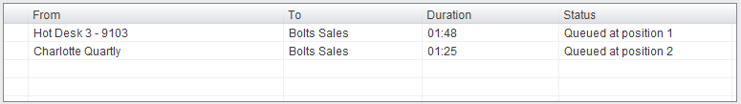

5.2 Resizing the Current Call List
The bottom border of the Active Call Window can be dragged down to display as many or as few calls as necessary. Unity will save these dimensions when closed. Unity can also be configured to automatically resize to include new calls, as outlined in section 5.6.1.

5.3 Managing Multiple Calls
To manage a particular call, first select it by clicking it in the Active Call Window. If there is only one call in the list it will be selected automatically. You can then use the call control buttons to perform different actions on the call. There is no limit to the number of calls that can be displayed in the Active Call Window, this is limited by the number of simultaneous calls allowed and if the Call Waiting user service is assigned and active.

You can also double-click an incoming [unanswered] call to answer it, or to retrieve it if currently on hold, if configured in Settings. Please note if this is not selected then double-clicking a call in the Active Call Window will allow a note to be entered, assuming the Notes column is being shown, as outlined in section 5.6.5.
5.4 Configuring Which Calls are Displayed in Active Call Window
The Active Call Window can be configured to retain visibility of processed calls, allowing the Reception user complete control of call management, as shown below.

Parked, camped and linked calls [explained in section 7.5] can all be displayed in the Active Call Window and retrieved at any time.
5.5 Transfer History
Unity can be configured to indicate who the remote party was last transferred to.
This is displayed in the Notes field, meaning it is only available if this column is being displayed.
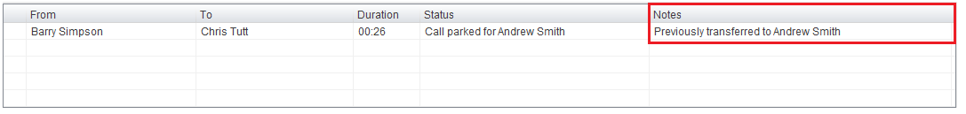
5.6 Configuration
The Active Call Window options can be configured in Settings as shown below.
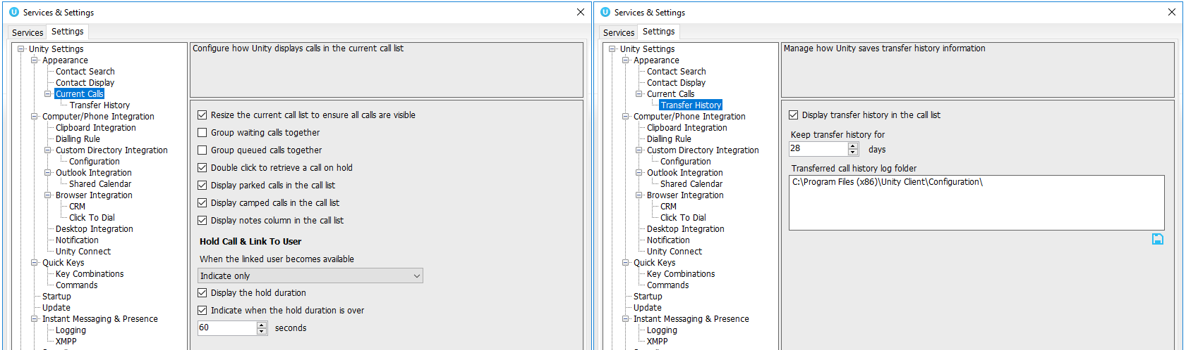
Options are immediately applied when the OK button is pressed.
5.6.1 Resize the Current Call List
If set then the Active Call Window will automatically resize to ensure all calls are visible, up until there are 10 calls in the list at which point scrollbars will be used.
5.6.2 Grouping Calls
Unity can group waiting [including held, parked, camped and linked] calls together, as shown below.
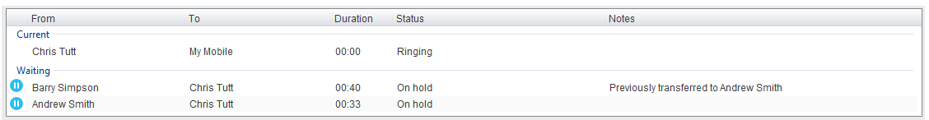
5.6.3 Double Click to Retrieve
When this setting is enabled, you can double-click on a held call in the Active Call Window to immediately place any active calls on hold and retrieve the selected one.
5.6.4 Display Parked & Camped Calls
When activated, Unity will retain all parked and camped calls in the Active Call Window, as described in section 7.5.
5.6.5 Display Notes
This setting allows notes to be displayed against calls in the Active Call Window, if this setting is disabled the Notes column will not be displayed.
5.6.6 When Linked User Becomes Available
When using the Hold & Link feature [as outlined in section 7.5.5] Unity can either alert the receptionist that the monitored user is now available, prompt to transfer or automatically transfer.
5.6.7 Transfer History
Transfer history is only available if the Notes field is being displayed. You can configure Unity to store transfer history information for a defined duration and can specify where the history should be stored if sharing information between Unity Reception clients.

6 Drag and Drop

Many common call handling actions can be performed with drag and drop, as well as right click and call control buttons.
6.1 Make a Call to a User or Number
Drag a user icon or a speed dial shortcut icon from the Contacts panel up into the Active Call Window to make a new call to the selected user or number. Call logs and voicemail items can also be dragged into the Active Call Window to call.
6.2 Transferring a Call to a User
Drag a live call onto a user to either perform blind transfer, or to populate a drop list with call handling options. Drag and drop configuration is configured through Settings.
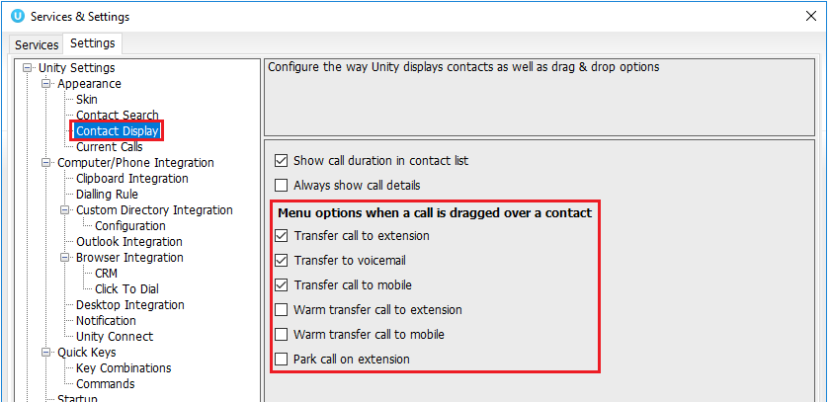
6.3 Make a Call to a Call Center
When Unity Reception is configured with call center agent functionality, drag a call center queue from the Personal Wallboard to the Active Call Window to make a call to that call center.
6.4 Transferring a Call to a Call Center
When Unity Reception is configured with call center agent functionality, you can drag a current call in the Active Call Window and drop it on a call center in the Personal Wallboard. This will blind transfer the call to that call center.

6.5 Send to Voicemail
Dragging an unanswered call from the Active Call Window onto the Voicemail button will blind transfer the incoming call to your voicemail.
6.6 Call Control
Dragging a call over the Hold/Retrieve, Answer/Release or Transfer buttons will perform that action on the selected call in the Active Call Window.
6.7 Manage Instant Messages
As illustrated in section 2, Unity offers a docked Instant Message (IM) panel, which fully supports drag & drop actions. The IM panel can always be displayed or only displayed when required, as configured through settings and outlined in section 8.10.

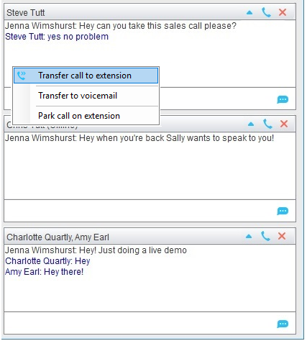

Drag an internal contact into the docked IM panel to send an instant message to that user. You can easily drag additional users into the same IM conversation to create group chat, and a call can be dragged from the Active Call Window into an IM conversation to quickly blind transfer to that user. This is particularly useful if you want to check the transferee’s availability before transferring a call.

If there are multiple users in the IM conversation, then a context menu will be displayed.

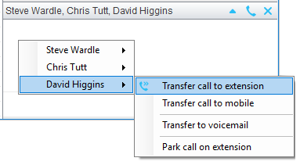

Please see section 8 for a full overview of Instant Messaging.

7 Contacts Panel [Busy Lamp Field]

The Contacts tab gives a visual indication of the status of users [within the group/enterprise] including current hook state and availability. Unity displays up to 50 internal users by default but will dynamically monitor any internal users returned through search results.
7.1 Contact Panel Display Options
There are four different views available, as outlined below. Right-click anywhere in the Contacts panel and select Appearance list to change the view.
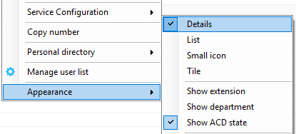
7.1.1 Details View
This view provides by far the greatest amount of detail, but requires more space [although the list can be shortened in which case scrollbars will automatically appear]. This is the default view when displaying search results.
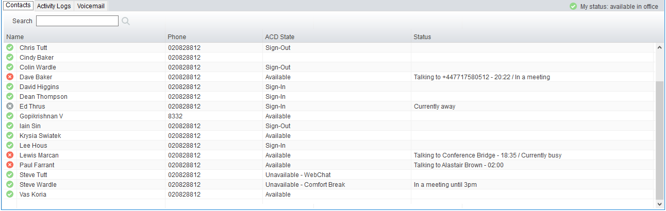

With this view the sort order and width for each column can be set, which is saved when Unity is closed. You can also configure Unity to display or hide the extension, department, ACD state and call duration columns.
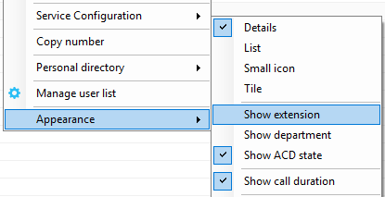
7.1.2 List View
This option will display all users in a list without detail, as shown below. It is only recommended when the default contact list contains many entries and space is limited.
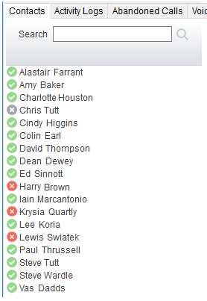
7.1.3 Small Icon View
This view combines a simplified look and space reduction.
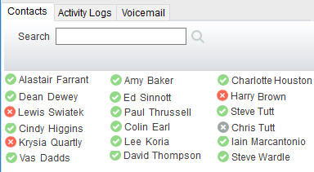
7.1.4 Tile View
This view is similar to Icon view but uses more white space to provide a cleaner look.
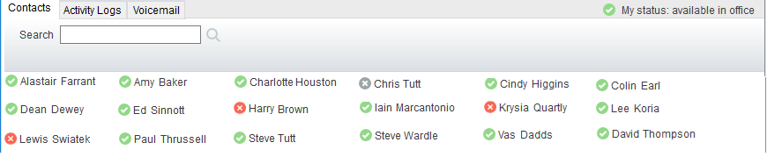

In both the List, Small Icon and Tile views, hovering the mouse over the image will provide more information about the monitored user, as outlined in section 7.2.1 below.
7.2 User Icons
There are four main user icons states shown for internal users in the Contacts panel, regardless of the view chosen. However, because the image will also illustrate if the monitored user is online (meaning they are currently logged into Unity) there are eight possible images, as outlined below.

 | Available | The monitored user extension is on hook
 | Ringing | The monitored user extension is ringing
 | Engaged | The user is on the phone
 | Do Not Disturb | The user has selected DND or Unavailable profile
7.2.1 Displaying the Tool Tip
Hovering the mouse over a red, yellow or grey icon will reveal more information about the user’s current state, if available. For engaged users this will include the name or number of the party they are engaged to and the duration off the current call as below [this feature can be disable for privacy reasons].
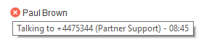

Please note that the tool tip is only available when displaying the contacts using the Small Icon or Tile view.
7.3 Selecting the Contacts Panel Default List
Unity Reception will display up to 50 internal users and an unlimited number of external users in a default list, which is always displayed when search criteria is not entered.

As outlined in section 7.6, Unity Reception can be configured to automatically select users to include in the default list, by periodically examining how often each user is searched on. This ensures the default list is always the most relevant thereby lessening the number of searches required. However, the default list can also be manually set in which case it will not be periodically updated based on search results. To manually set the default list right-click anywhere in the contacts list and select “Manage user list”.

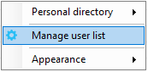

You will then be able to move users or departments between lists by checking the relevant box[es] then clicking the arrow button. All users in the right-side list will be monitored in the default contacts list. This list can be updated at any time and is saved between Unity sessions.

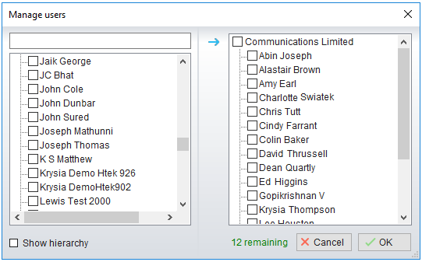

Tick the “Show hierarchy” box to include group and/or departments in the lists, when one of these entries is checked all child entries will also be checked. You can also easily search for available users using the search facility.

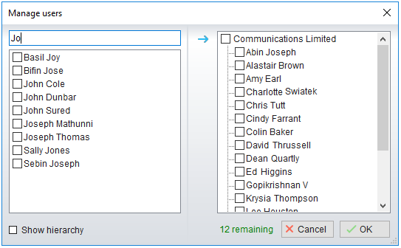
7.4 Contact Groups
Contact groups are pre-defined logical groups of internal and external contacts that allow the user to quickly load selected contacts, they are very similar to the default user list expect they are pinned to the Contacts tab, as shown below.
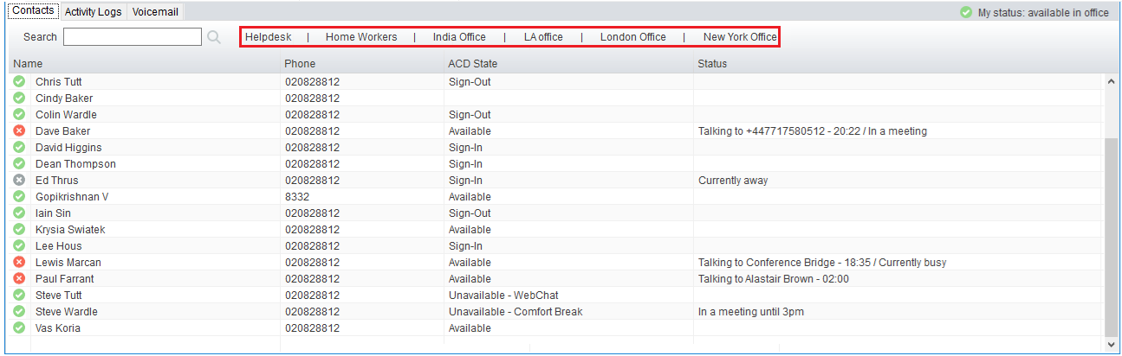

Contact groups provide multiple real-time BLF instances for efficient call handling. The contact groups can be named intuitively by the Reception user, for example, “Denver Office” or “Sales Team” as appropriate. Up to 12 contact groups can be added and each contact group allows up to 50 internal users and unlimited external contacts. Internal users can belong to multiple contact groups.

Section 7.6.6 outlines how to enable contact groups, which are displayed in the same place as the alphabet shortcut letters meaning if contact groups are enabled the shortcut letters will be hidden.
7.4.1 Creating a Contact Group
Assuming contact groups are enabled in Settings, drag over a group of monitored users in the Contacts panel, or CTRL + left click them in Contacts or Search and then right click the mouse and select “Add to contact group > New contact group”, as shown below.

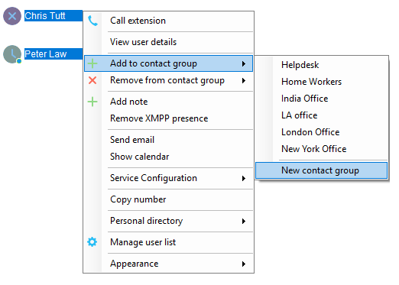

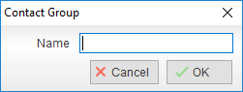

From the dialogue box name the group and click OK.
7.4.2 Adding Users to an Existing Contact Group
After selecting additional internal users or external contacts right-click to add them to an existing contact group, as shown below. If a user or contact already exists in the contact group, they will not be duplicated.

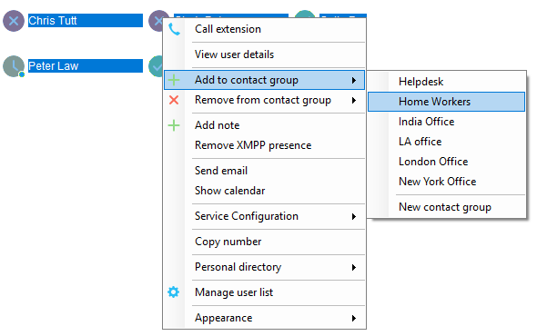
7.4.3 Removing Users from Contact Groups
Right click a user and select Remove from contact group.
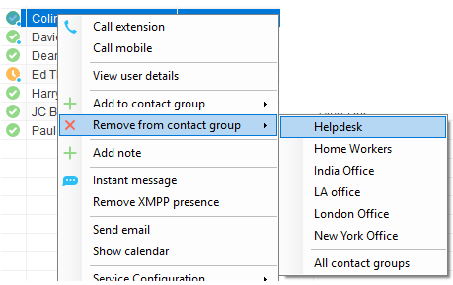
7.4.4 Deleting Contact Groups
Right click a Contact group name to delete it.
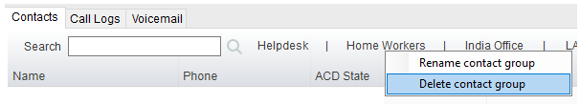

7.4.5 Renaming Contact Groups
Right click a contact group name and select “Rename contact group”, then enter the new name and click OK.
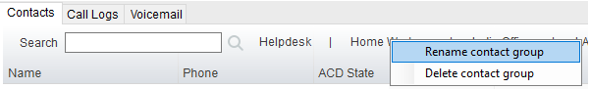

7.5 Performing Call Control Actions in the Contacts Panel
There are many call control functions that can be performed by right-clicking a monitored user or external contact in the main Contacts panel. The menu options displayed will dynamically change to only show those available depending on the state of the user/contact as well as the state of the selected call in the Active Call Window [if there is one]. For example, “Transfer to voicemail” will not be available if the user does not have the voicemail service assigned and “Camp call on extension” will not be available unless there is a call selected in the Active Call Window and the monitored user is currently on the phone.
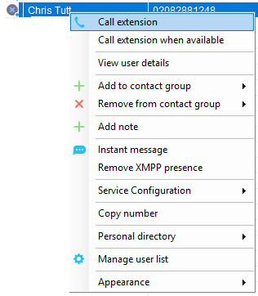

7.5.1 Call Extension
Selecting “Call extension” will initiate a new call to that user in the same way that double clicking the user icon would. Any current call will automatically be placed on hold. This can be used to make an announced transfer as opposed to a blind transfer using the “Transfer call” menu options.
7.5.2 Answer This Call [Call Pick-Up]
This feature is only available if either the Directed Call Pickup service is assigned to the receptionist, or the receptionist is in the same call pickup group as the monitored user. Please confirm with your service provider that these requirements are satisfied. When selected from the context menu, Unity will pull the ringing call to the receptionist. Only calls that are currently ringing can be answered by the receptionist.

7.5.3 Park Call on Extension
Unity will park the call selected in the Active Call Window onto the monitored user’s extension. The selected call cannot currently be parked or camped on another extension. If configured, the call will stay in the Active Call Window with a state of “Parked”, as shown below.

7.5.4 Camp Call on Extension
Unity will camp the call selected in the Active Call Window onto the engaged monitored user’s extension. When the user goes back on-hook the camped call will be delivered and their phone will start ringing. If the user does not go back on-hook before the camp timer expires the call will return to the receptionist. This call can also be kept in the Active Call Window [the same as parked calls, above] if configured in Settings.

Camping calls is a feature of the Call Transfer service so is only available if assigned and configured to allow calls to be camped.
7.5.5 Hold Call and Link to User
This is a unique feature to Unity that allows the receptionist to link a call in the Active Call Window with an internal contact in the Contacts list. This feature is designed to give the receptionist visibility of who the caller is holding for and also their current hook status without having to check manually, because the call remains in the Active Call Window. This is an essential feature for busy telephonist stations that manage a large number of calls and often have several callers on hold simultaneously. When the linked user goes back on hook, Unity can indicate availability, automatically transfer the call or prompt to transfer the call. This is configured in Settings, as outlined in section 5.6.6.

To hold and link a call to a monitored user, first ensure the call is selected in the Active Call Window [if multiple calls are present] and right click the monitored user in the Contacts list, as shown below. Please note that this feature is only available when the monitored user is currently on the phone.
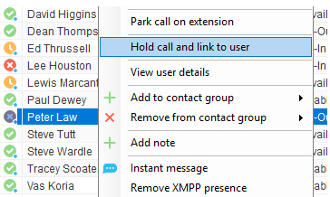

The call is now placed on hold and the receptionist user can continue taking other calls. The Notes field displays “Waiting for Andrew Smith” in red to indicate that he is still on the phone.

The Duration field will display the total time the call has been on hold for the user. This can be configured to have a threshold set against it, as shown below.

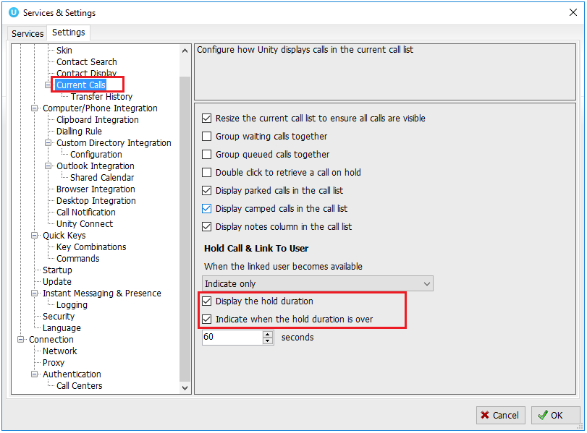

When Peter law becomes available the Notes field changes to green to alert the receptionist that the monitored user is available to take the call, as below.

The user can now transfer the call either by dragging it over the monitored user, or by right-clicking and selecting “Transfer call to extension”, as below. The call can also be un-linked from the monitored user by right-clicking and select “Remove link to user”.
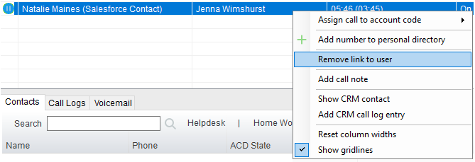

Unity can be configured to automatically blind transfer the call when the linked user becomes available, or to prompt the receptionist to blind transfer the call, as shown here.
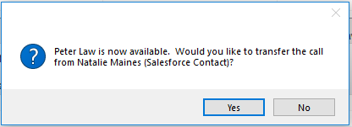

Once the call is transferred it will be removed from the Active Call Window. These options are set in Settings as outlined in section 5.6.6.
7.5.6 Call Mobile
When selected Unity will hold any active calls and dial the mobile number of the monitored user, which is added to the user profile in Broadworks.
7.5.7 Transfer Call to Mobile
When selected Unity will transfer the currently selected call in the Active Call Window [if multiple calls are present] to the mobile number of the selected monitored used. This menu option is only included when there is a call in the Active Call Window.
7.5.8 Transfer Call to VoiceMail
If the monitored user has the Voice Messaging User service assigned and activated, then the receptionist can blind transfer a call directly to that user’s voice mailbox. This menu option is only included when there is a call in the Active Call Window.
7.5.9 Barge into This Call
When selected Unity will make an immediate three-way conference call with the receptionist, the monitored user and the third party the monitored user is talking to. All parties will be able to talk and hear each other. When attempting to barge into a call, if the phone plays a “number doesn’t exist” tone then this means the monitored user cannot be barged into, normally because they have the Barge-In Exempt service assigned and activated. Only users without this service active can be barged into.

The Active Call Window will display like a normal conference call, as below, and the receptionist can hold/retrieve the same as for a conference call.

Please note that when leaving a call that has been barged into, you must transfer the call parties together in order to leave the conference without ending the original call. To do this press the Transfer button and select “Transfer these calls together”, as shown below.

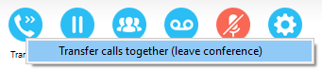

Please note this feature depends on the Directed Call Pickup with Barge-In user service being assigned to the receptionist.

7.5.10 Call Extension When Available
When selected Unity will place an alert on the engaged monitored user, so that when they become available a dialog box will prompt the receptionist to call.

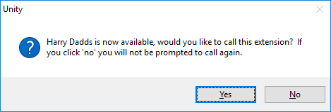
7.5.11 View User Details
View details as entered in the profile for this user in the VoIP platform. This includes their title, phone number, mobile and email address. Click on the email address to send an email using the default email program.
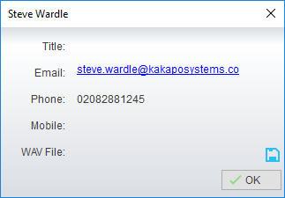

You can also configure Unity to play a WAV file whenever that user’s phone is ringing, which is useful in an assistant environment scenario where the receptionist is screening calls. Click the Save button to select the WAV file to play. When the audio alert plays that is the reminder for the receptionist to pick-up the call.

7.5.12 Add Note
The receptionist can add notes for an internal user which are shared between Unity Reception users. They provide more information about the monitored user over the hook status, service configuration and other presence settings. Notes are displayed in the detail list or as tooltips.

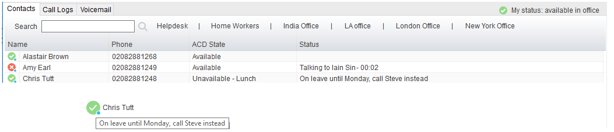
Right click the user again to edit or remove the note.
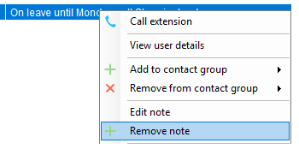
7.5.13 Send Email
If the email address has been entered in the profile for the user, Unity will use the default mail application to send an email.

7.5.14 Show Calendar
As discussed in detail in section 9, Unity will display any meetings for the monitored user that are available through the shared calendar in Outlook, Office365 and Exchange. This option will only be displayed if the email address for the monitored user is present in their VoIP profile.
7.5.15 Answer This Call [Call Pick-Up]
When a monitored user’s phone is ringing their icon in the Contacts list becomes orange . To perform pick-up and answer the call on behalf of the monitored user, right click the icon and select “Answer this call”. This option is only displayed when right clicking a ringing user, and if the receptionist and the monitored user belong to the same call pickup group, or the receptionist has the Directed Call Pickup with Barge-In service assigned.
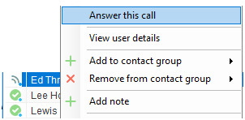
7.6 Configuration
The contacts panel is configured in Settings, as shown below. One panel manages how search results are displayed while the other manages the general behaviour of the Contact list.

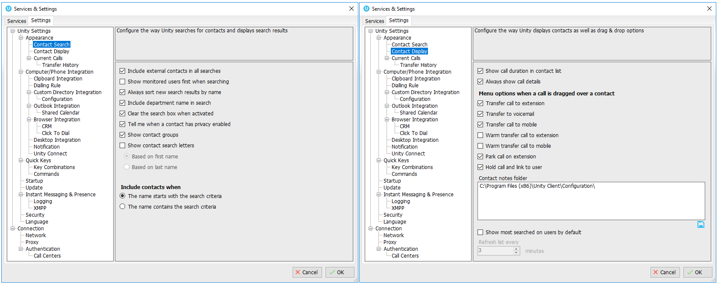
7.6.1 Include External Contacts in all Searches
When checked Unity will always search all directories every time a search is performed, which is one second after the last key was pressed. If the user is a slow typist this could result in many searches, so if there is a large external directory [for example an Outlook folder with several thousand records or a slow-performing SQL database] then Unity performance may be impacted. Turning this setting off means that by default only the group/enterprise directory is searched, other directories will only be searched if the user presses enter or clicks the search image.
7.6.2 Show Monitored Users First When Searching
When this setting is turned on Unity will always display monitored users first in alphabetical order, then external contact is monitored order. Otherwise internal and external contacts will be shown in alphabetical order, as below.

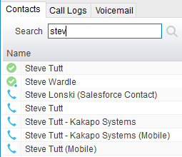
7.6.3 Always Sort New Search Results by Name
This setting can only be modified if the “Show Monitored Users First When Searching” setting is not active. If active then search results will always be displayed in alphabetical order based on the name of the contact, otherwise the same sorting used in the default list [which could be based on any column in the Contacts list] will be used when searching.
7.6.4 Include Department Name in Search
If activated then Unity will include any internal users where the department name matches the search criteria, for example the receptionist could type “sales” to quickly see a list of all sales people. In a nested department environment only the bottom-most department will be considered.
7.6.5 Clear the Search Box When Activated
If activated, then whenever the user clicks into the search box the current search criteria will be removed and the default list will be shown.
7.6.6 Show Contact Groups
Contact groups provide a fast way to access pre-configured groups of internal and external contacts.
7.6.7 Including Contacts in Search Results
When searching Unity can be configured to only include contacts in the search results if the name starts with the search criteria or contains the search criteria. When configured to search based on the contact name containing the search criteria, it will be possible to search on first or last name, but the search results will be less refined (there will often be more entries in the search results).
7.6.8 Show Call Duration
Unity can be configured to include the call duration when showing a monitored user on the phone. The default option is to show the call duration; this would likely only be deactivated for privacy reasons.
7.6.9 Menu Options on Drag & Drop
As outlined in section 7.6, when a call is dragged over an internal user in the Contact list [which may be displaying either the default contact list or search results] Unity can be configured to dynamically display available call actions, based on the state of the call and the status of the internal user that the call was dropped onto. For example, if the monitored user doesn’t have voicemail available then the option to transfer to voicemail would not be displayed, similarly if the monitored user isn’t on the phone then the Hold & Link option would not be available. At least one option must be selected from those available, if only one option is selected then that action will always be performed when a call is dragged over a monitored user, assuming the option is available at the time.

If a call is dropped over an external contact then the only options available are to blind transfer the call or perform a warm transfer [which will call the external contact that the call was dropped onto, as outlined in section 7.6].

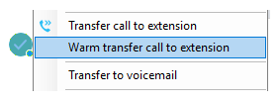
7.6.10 Contact Notes Folder
If multiple receptionists are working together then setting a common location for contact notes means that even if a receptionist is away from the office, when they next start Unity they will have the most recent notes about users in the Contact List.
7.6.11 Show Most Searched Contacts
Unity can be configured to dynamically load the default contact list based on the 50 most searched on users, this list is periodically refreshed to ensure it is always most relevant and is saved between Unity sessions.

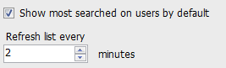

8 Instant Messaging

Instant messaging is available in all Unity clients and uses dynamic registration, meaning buddy lists are not required – users can instant message each other as soon as they start Unity. Instant messages can be sent both to online and offline users, offline meaning that user doesn’t currently have a Unity client open. If an instant message is sent to an offline user it will be delivered when that user next starts their Unity client.

The maximum character limit for each instant message is 700.
8.1 Online/Offline Indicator
An “online” user is one that is currently running an instance of Unity, and therefore available to send an online message to. These users are indicated with a small envelope on their user icon. This applies to the user regardless of the current state, as illustrated below.

State | Online [Unity Open] | Offline [Unity Closed]
Available
Ringing
Engaged
DND/unavailable profile

8.2 Docking the IM Conversation
Instant messages can be displayed in the docked IM panel or as separate windows for each individual IM conversation. If the docked window is used new conversations can be initiated via drag and drop and new IM windows will not pop over other applications.

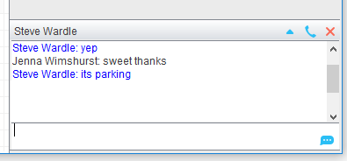

Configuration options for instant messaging - including the docked IM panel, are outlined in section 8.10.
8.3 IM Conversation Overview
In both docked and undocked IM conversation panels the upper part of the IM message log will automatically scroll to display the most recent message. Outgoing messages are in black while incoming messages [from other users] are in blue. Whenever a new conversation is started Unity will automatically load any messages from previous conversations with the participant, these messages are not stored between Unity sessions however messages are logged locally, as outlined in section 8.9.10. Type your message in the bottom window and press enter or click the envelope image to send the message.

If a user was online when the conversation started by then closes Unity, the IM conversation window will automatically add an entry to notify the user, as shown here.
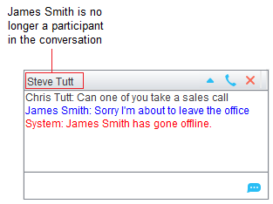

If there is only a single participant in the conversation then if Unity is configured to send instant messages to offline users [as outlined in section 8.10.1] then the participant will be shown as offline in the conversation, but messages can still be sent which will be received when the user next opens Unity. If Unity is not allowed to send messages to offline users then the participants list will be cleared and Unity will not allow new messages to be added to the conversation. Please note this logic applies to both docked and undocked IM conversations.

8.3.1 Docked IM Conversation
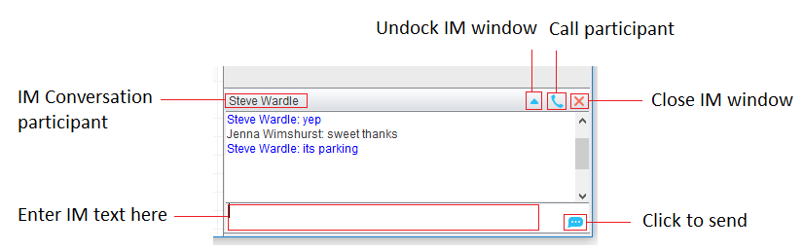

You can see all participants in the conversation in the title bar, and can hover the mouse over to see a complete list which includes if the user is using Unity IM or XMPP, as outlined in section 8.9. Group chat is discussed in section 8.5.

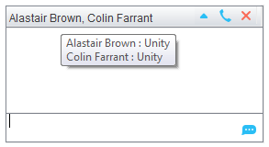

When there are multiple participants in the conversation you must select which user to call from the drop-down menu. Instant conference with all parties is not available.
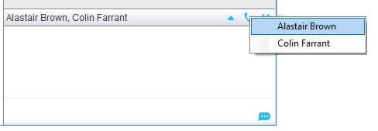
8.3.2 Undocked IM Conversation
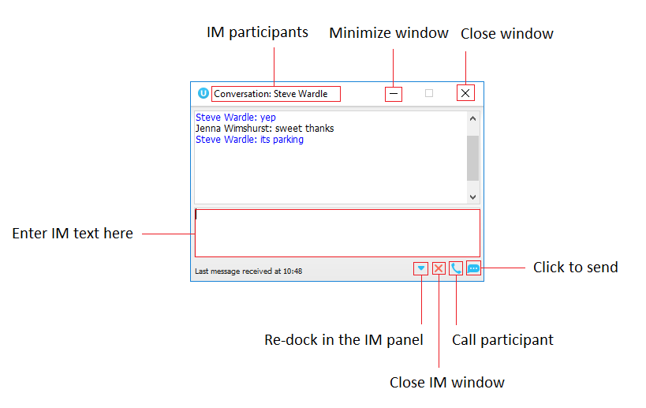

Because this is a separate window it can be minimized, maximized or closed independently to Unity. If a docked IM conversation is closed then when a message is received for the same conversation, the previous message log will be reloaded in the new undocked conversation.
8.4 Docking & Undocking IM Conversations
Depending on how Unity is configured, all new IM conversations will begin docked or undocked. You can undock a conversation by clicking the button. The conversation will be moved to a standalone window. Dock a conversation by clicking the button, the window will automatically be closed and the conversation added to the docked IM panel.
8.5 Starting an Instant Message Conversation
New IM conversations to a single user are easily created by right-clicking the user in the Contacts list and selecting “Instant message” from the menu. If the docked IM panel is displayed then you can also drag the user over the panel to start a new conversation.

To start a new IM conversation with one or more participants, click Message > Start conversation from the main Unity window, as shown below.

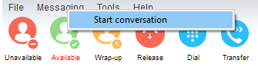

Unity will show a list of all users that are currently online, select which users to include in the conversation by moving them into the list on the right-hand side, similar to when selecting monitored users as described in section 7.3.

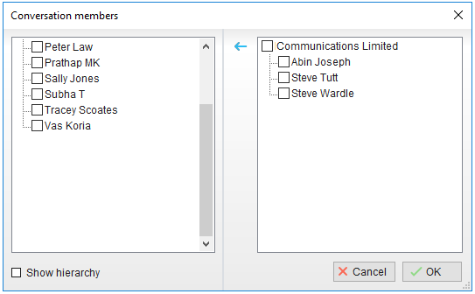

Click OK to setup the new conversation with all participants included in the list, there is no limit to the number of users that can be added to a conversation. When any participant sends a message all other participants will receive it as a broadcast. Conversations with multiple participants are often referred to as “group chat”, please note that all users must be online in order to participate in a group chat. When a participant becomes offline Unity will update the conversation by alerting the user and removing that participant from the list.
8.6 Adding Participants to an Existing Conversation
To add an online participant to an existing conversation simply drag the user over the conversation and select “Add to the conversation” from the context menu that appears.

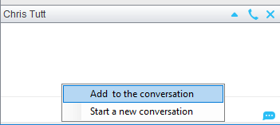

When the IM conversation is undocked you click the button to add and remove participants, which uses the same window as adding users to a new conversation, as described in section 8.5.
8.7 Sending Contact Directory Numbers
Personal directory entries (as outlined in section 11) can easily be shared with all participants in a conversation by right-clicking the box where messages are sent, and selecting the directory entry from the context menu.

8.8 Notifications
Unity can be configured to show a “toast” notification when a new instant message is received, as shown here. Clicking on the text will pop Unity and ensure that conversation is visible in the docked conversation panel.

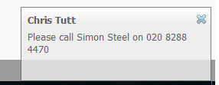
8.9 XMPP Integration
Unity provides seamless integration with XMPP in order for Unity users to share instant messaging and presence (IM&P) functionality with UC-One clients. All instant messages are displayed and managed to the user as a docked or undocked IM conversation, regardless of the IM&P platform being used. Only online users in Unity can participate in group chats, group chat is not currently supported with XMPP.

8.9.1 XMPP Authentication
Unity is unable to extract the XMPP password from the VoIP platform, meaning it must be reset from within Unity. This functionality relies on the Integrated IM&P service being assigned to the Receptionist, although no other UC-One related service need be assigned.

In order to set the XMPP password go into Settings and click on the “XMPP > Change Password” item as shown below. You can see the current XMPP status is offline.

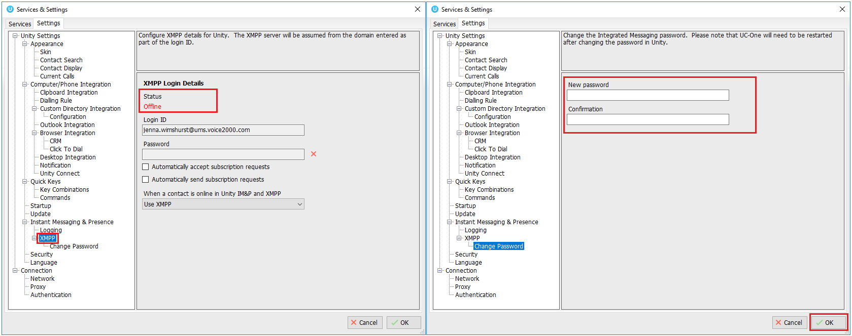

Once the password has been entered you must click the OK button to save the password, before moving to any other panels in settings. Please note that the XMPP password should not be the same as the password used to first log into Unity. You will be notified once the password has been changed and the XMPP status changed to online, as shown below.

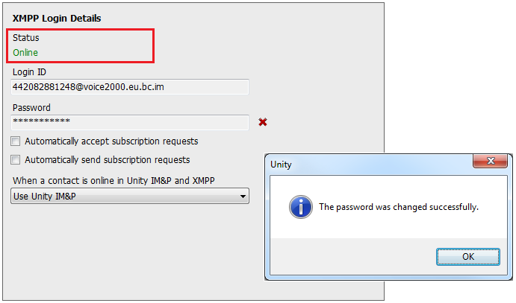

Unity can be configured to automatically generate an XMPP password the first time it is loaded, this is a branding property that is set in the Unity Client branding portal. In this case Unity will save the randomly generated password in Broadworks and also in the registry, from where it will be used whenever Unity is next started. When the password is reset in Broadworks it will automatically be updated in the device configuration file for UC-One, if in use. Furthermore, if UC-One is currently in use this will not impact the existing XMPP registration, therefore there is no impact on UC-One.
8.9.2 Managing XMPP Subscriptions
To subscribe to XMPP presence for a monitored user (meaning the receptionist will receive real-time updates as the monitored user changes their presence in UC-One) simply right-click the user and select “Add XMPP presence”, as shown here. If already subscribed, then right-click the user to remove XMPP presence.

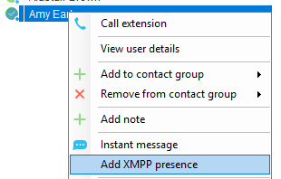

Unity will show the unavailable, busy etc status of the user, as well as any status message manually entered in UC-One, as illustrated below.

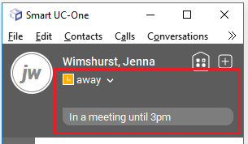

Please note that at present XMPP is only used by Unity to communicate with UC-One clients.

Unity can be configured to automatically subscribe to all monitored user’s XMPP presence, as shown here. However, this may result in the buddy/contact list in UC-One becoming very large so should only be activated if the Receptionist doesn’t often refer to the buddy list.

Unity can also be configured to automatically accept subscription requests from other users, if this setting is not activated then whenever a user subscribes to the Receptionist’s XMPP presence a prompt will be displayed, as below.

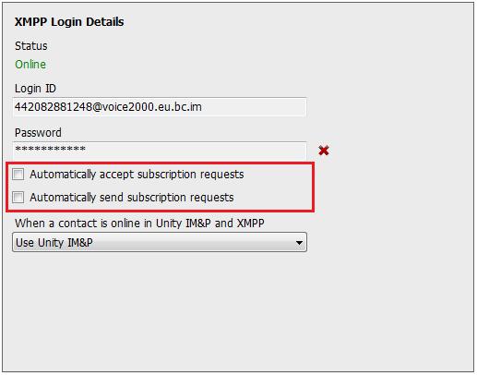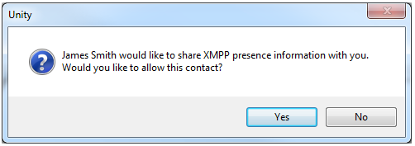

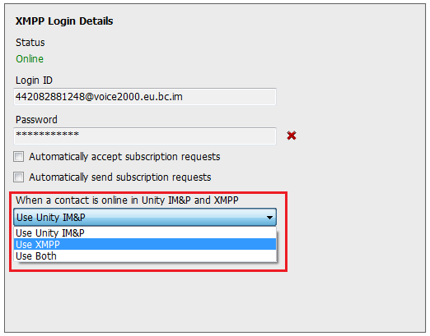
8.9.3 Instant Message Priority
Because a monitored user could be running Unity and UC-One, that user could be available to receive instant messages using either client, or both. In these situations, Unity can be configured to prioritise one IM platform over the other, as shown below.

Options are to only send the instant message using only Unity IM&P meaning the instant message will not be received by UC-One, to only send using XMPP meaning the monitored user’s Unity client will not receive the message, or to send through both messaging protocols meaning both clients will receive any instant messages sent from Unity. The last option is the default and is recommended in most scenarios.
8.10 Configuration
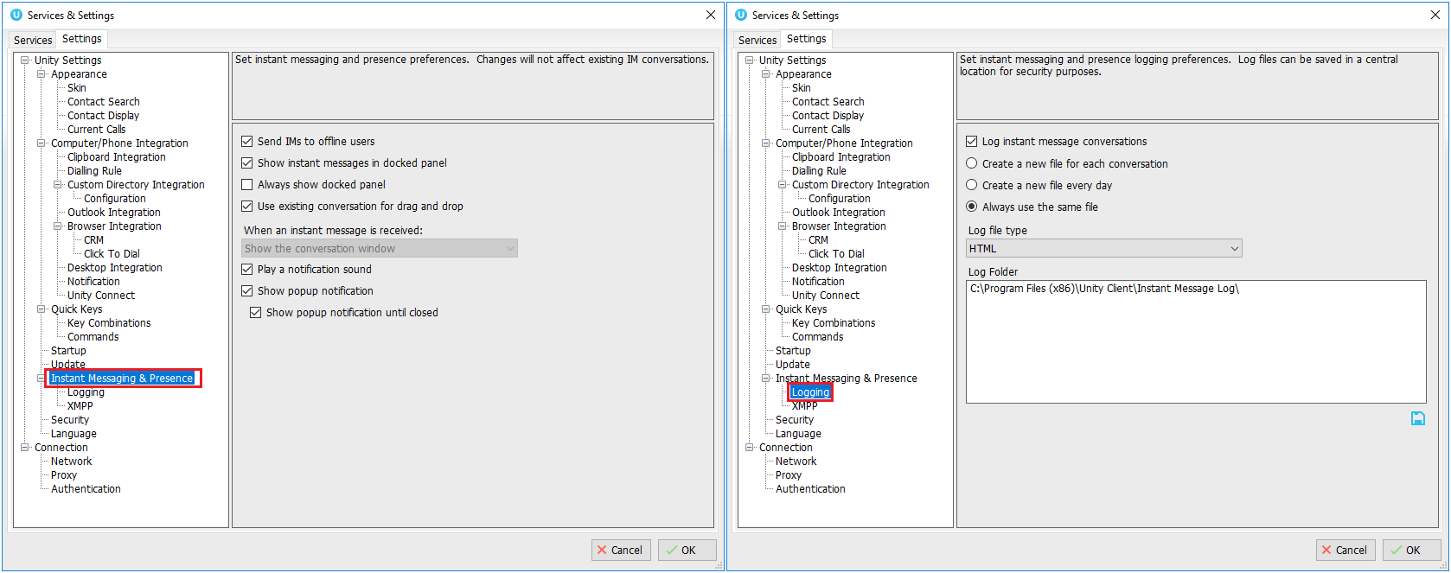
8.10.1 Send IMs to Offline Users
As discussed in section 8.3, Unity can be configured to send IMs to offline users which are then delivered when the recipient’s Unity is next started. This is the default behaviour but can be turned off depending on company policy.
8.10.2 Show Instant Messages in Docked Panel
This setting instructs Unity whether IM conversations should be docked or undocked by default, as discussed in section 8.3.1 & 8.3.2.
8.10.3 Always Show Docked Panel
This setting can only be changed if IM conversations are docked by default. The docked IM panel can be configured to only appear when there is an instant message conversation, or to always be displayed. The advantage of the latter is that drag & drop will always be available to quickly start a new IM conversation, which may be preferred in a receptionist environment.
8.10.4 Use Existing Conversation for Drag & Drop
This setting can only be changed if IM conversations are docked by default. When a monitored user is dragged into the docked IM panel, if there is an existing conversation for that user in the panel then Unity will ensure it is visible and prompt the user to continue the existing conversation, rather than starting a new one.
8.10.5 When an Instant Message is Received
This setting can only be changed if IM conversations are undocked by default. When a new instant message is received Unity can be configured to show the IM conversation window on top of all windows [and keep it on top], to pop over the top of windows but allow other windows to be placed over it, or to show the conversation window minimized.
8.10.6 Play a Notification Sound
Unity can be configured to play an audio announcement when an instant message is received and Unity is not the active application on the desktop.
8.10.7 Show Popup Notification
As outlined in section 8.8, Unity can be configured to display a “toast” notification to appear when an instant message is received and Unity is not the active application on the desktop.
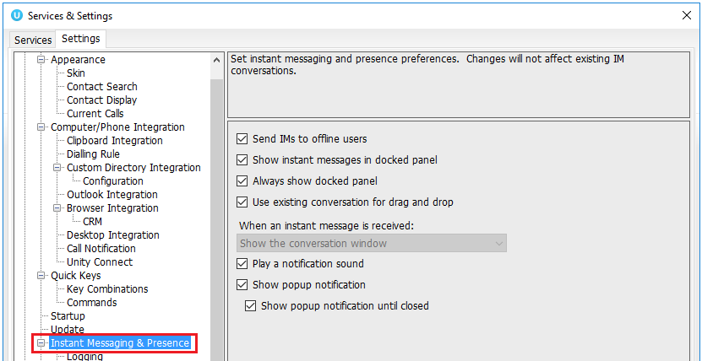

Under Instant Messaging & Presence – select the ‘Show popup notification until closed’ to keep the IM popup on the screen until it has been closed or clicked.
8.10.8 Log Instant Message Conversations
By default Unity logs all instant message conversations locally, although this may need to be disabled for privacy reasons.

8.10.9 Log Frequency & Type
By default a single file is used to record all messages for all conversations, but this can be changed to create a new log file per day or even per conversation. Messages can be stored as an HTML document as shown below, or a CSV file.

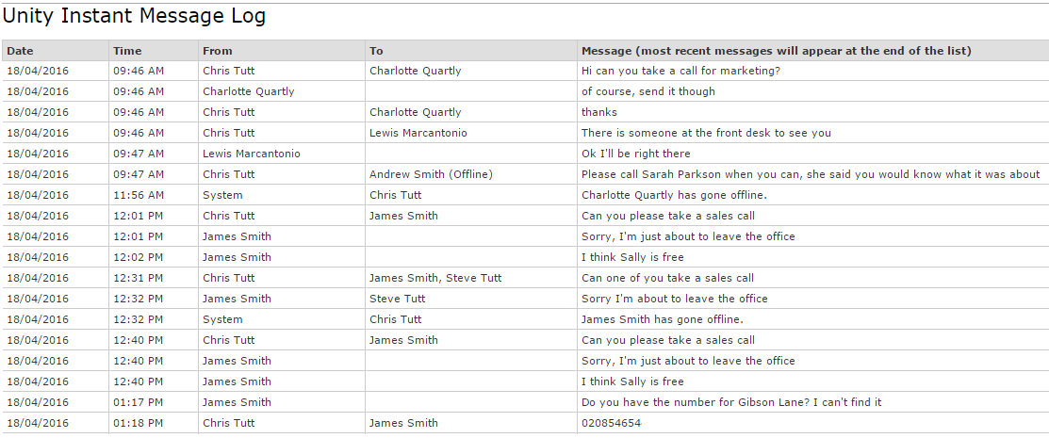

8.10.10 Log Folder
This specifies the directory that instant message logs are stored in, this would often be set to a central repository (for example a network share on a server) for centralized control and access.

9 Show Calendar

Unity Reception integrates with the shared calendar in Microsoft Outlook, Exchange and Office365 to display appointments for the selected monitored user. Unity will use colour to show the availability state for each calendar event, as shown below.

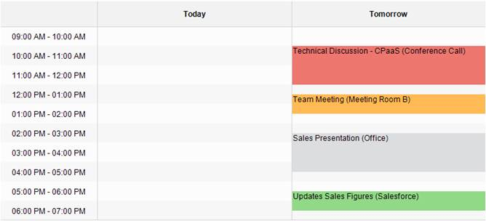

Free: Green
Tentative: Orange
Busy: Red
Away: Grey
Working Elsewhere: Grey
Anything else (including error): Blue

The default is set to show colours, but this can be changed in settings, as shown below.
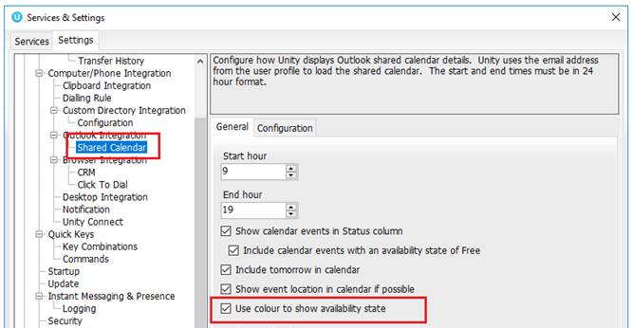

To setup the shared calendar go to Settings>Settings>Shared Calendar, as shown below.
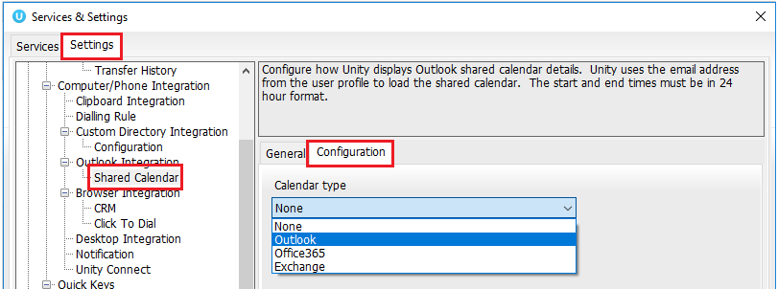
9.1 Outlook
To integrate an Outlook calendar, select Outlook from the drop-down menu and then press Ok. Unity will connect to the Outlook client that is running on the local machine.
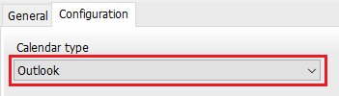

In order to display the calendar, Unity requires “full details” access to read the calendar, it is recommended that the Reviewer permission level be set for the receptionist to all calendars that Unity needs to display – This could be everyone in the organisation.
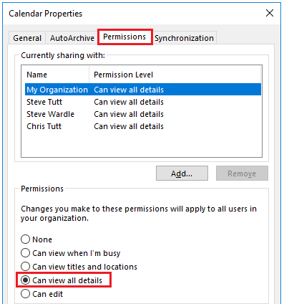

Once the calendar request has been sent, the colleague will need to pop open up the email invitation and click Accept.
9.2 Office 365
To integrate an Office365 calendar, select Office365 from the drop-down menu and then click authorise.
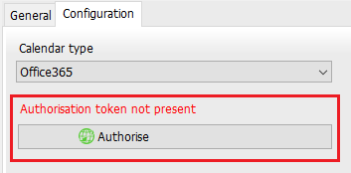

The default internet browser will then ask you to login to your Office365 account to authorise the token. Login and then click Accept to accept the requested permissions.
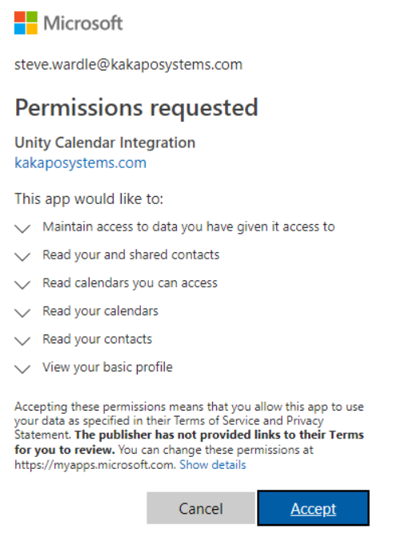
A notification will then appear alerting the user that the authorisation has been successful, as shown below.
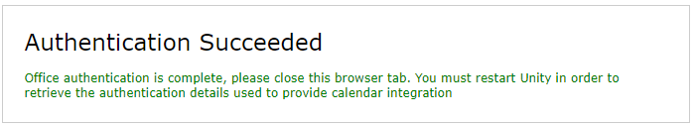

Go back to Unity Reception and select Complete authorisation, then click OK.
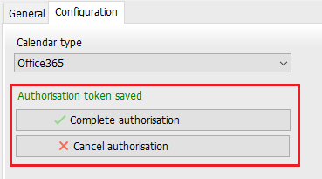

The shared permissions will need to be set at either View All Details, Can edit or Delegate. Unity will not show the calendar events for a user that only has view titles and location or I’m busy selected.
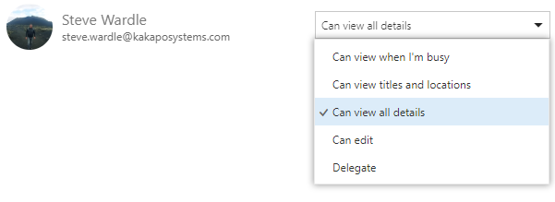

Once the calendar request has been sent, the colleague will need to pop open up the email invitation and click Accept.
9.3 Exchange
To setup an Exchange calendar, select Exchange from the drop-down menu, enter your server web service URL and login details, and then click Test.
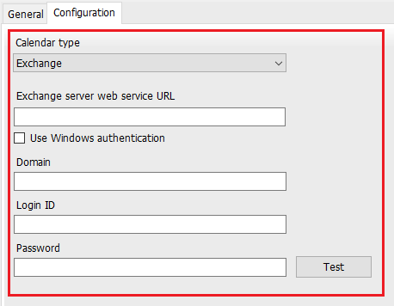
If the test is unsuccessful, you will receive the below alert.
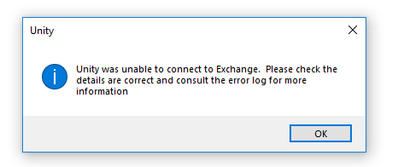

If the test is successful then Unity will alert you that it has successfully connected to Exchange, click OK and then OK again.
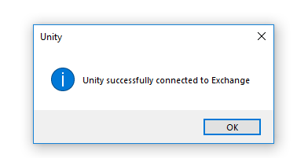
9.4 Shared Calendar in Exchange
The shared permissions will need to be set at either Full Details, Editor or Delegate. Unity will not show the calendar events for a user that only has Limited Details or Availability only.
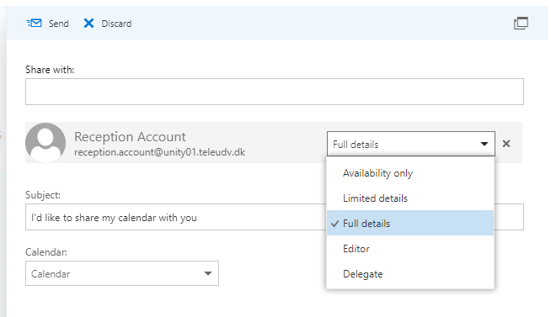

Once the calendar request has been sent, the colleague will need to pop open up the email invitation and click Accept.
9.4 Portal Calendar Integration
If all receptionists under the Reseller or Group level share the same account for Exchange or Office365 then the calendar integration can be set in the Kakapo portal under the Branding tab.

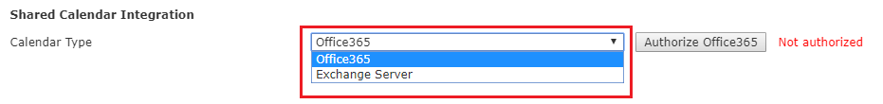

Select either Exchange Server or Office365 from the drop-down menu. For Exchange, enter the relevant details and then click update at the bottom of the page:

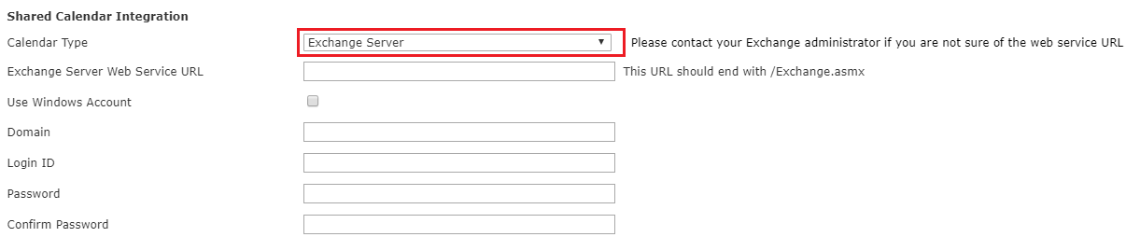

For Office365, click Authorize Office365 and follow the steps to authorize the token. Once the authorisation has been successful, click update at the bottom of the Branding page.

This will mean that all Reception users under the Group or Reseller level (depending which level you have configured the calendar integration at) will be integrated with that shared calendar.
Therefore, the Reception users will no longer be able to set the calendar integration in their own Unity settings as it will be greyed out, as shown below.
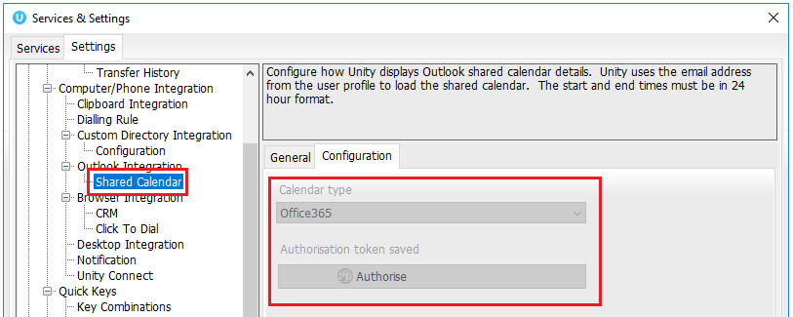

To delete the authorisation in the portal, simply click Clear and then OK at the top.

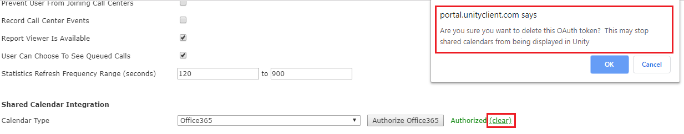
9.5 Configuration
9.6 Start and End hour
Unity can be set to only show calendar events between certain times, in the example below only meetings between 9am and 7pm will be shown.

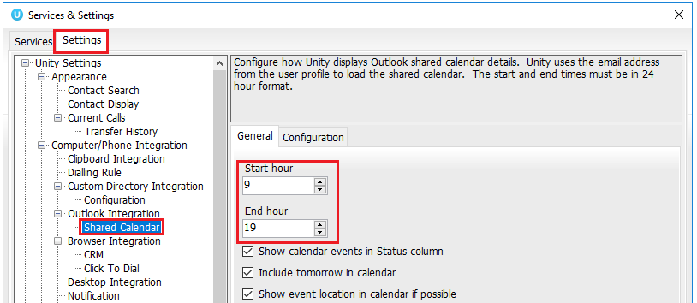
9.7 Show Calendar Events in Status Column
Show calendar events in the status column (with the availability state to free) will be selected by default and only displays whether or not the user is in a meeting and until what time, as shown below.
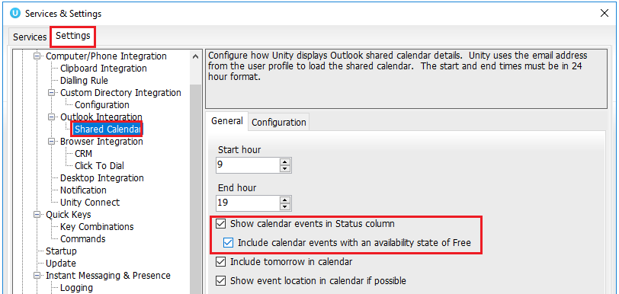

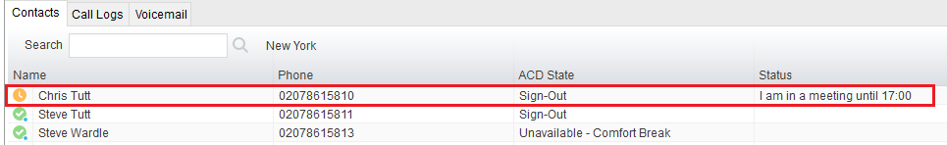
Please note: If you are using Outlook to share calendar events then the option to show calendar events in the status column is not available.
9.8 Monitored Users Calendar Display
If the monitored user has a full day event, then Unity will display that they are in a meeting all day.

Monitored User icons will change depending on the status that have been selected for that particular meeting.

Free =
Working Elsewhere =
Tentative =
Busy =
Out of office/Away =

To find out more information, the Reception user will need to right click the user and select Show Calendar. If the “Show event location in calendar if possible” box is ticked in settings then Unity will show the location of the events, if one has been specified.

10 Remote Service Configuration

Unity Reception allows the user to change the service configuration for monitored users, for example to activate Do Not Disturb or to forward all calls to a specified number. The services that can be configured are:
Service | Configuration Option
Do Not Disturb (DND) | Activation and deactivation only
Call Forward Always (CFA) | Activate to forward all calls to the monitored user’s mobile phone (if present in the user profile), the receptionist’s phone or a specified number. The service can also be deactivated.
CommPilot Express (CPE) | Activate the “Available: In Office”, “Available: Out of Office”, “Busy”, “Unavailable” profile for call routing and presence, or set to “None” to deactivate.

When right-clicking the monitored user, Unity will display the current activated state for each service, if assigned to the monitored user. In the below example we configure call forward always to a specified number.
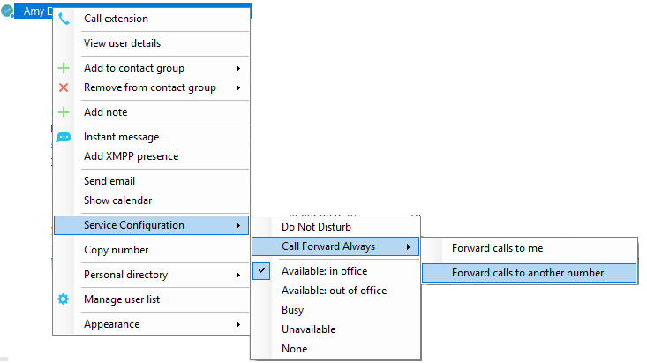

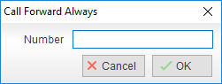

This feature requires that either a group or enterprise level administrator account be entered into Unity, as shown below. Please restart Unity after entering the authentication details. If successfully logged in, Unity will indicate the level at which the administrator account resides. If the admin account resides at the group level but the receptionist is part of an enterprise, then remote service configuration will only be available for users in the same groups.

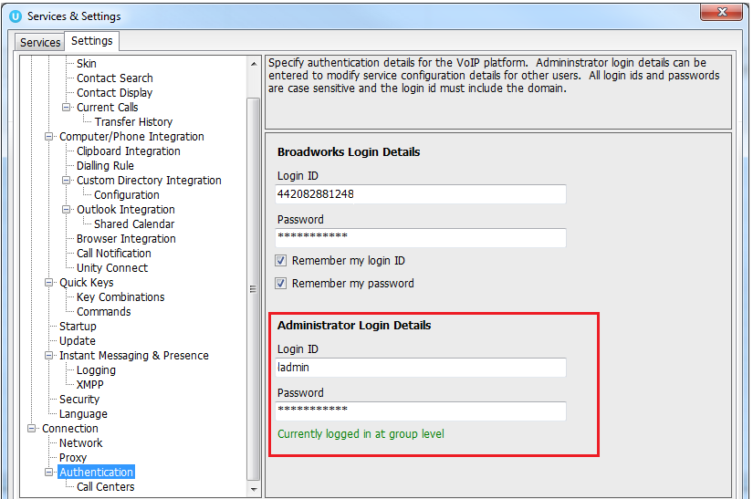

11 Personal Directory

The Personal Directory is a repository on the VoIP platform for each individual user to store personal contacts, which are available to be added to the default contact list and are included when searching in the Contacts list. Personal directory entries are classed as external contacts, so are shown with a image. Double clicking the item in the Contacts list will make a call to the associated number.
11.1 Add a Personal Directory Entry
To add an entry, right-click anywhere in the Contacts list and select “Add new entry”.
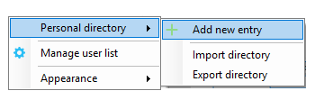
Then enter the name and number and click OK. If the number specified is already in the Directory the user will be alerted.
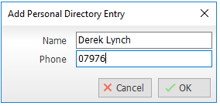
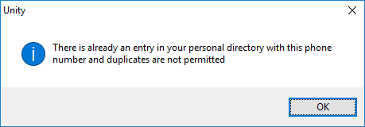
11.2 Edit a Personal Directory Entry
Search for the contact using either the name or number, then right-click and select the menu option to edit to contact, as shown below.
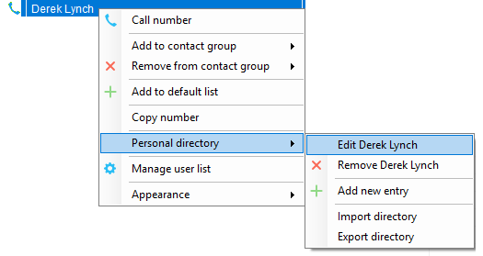
11.3 Remove a Personal Directory Entry
Search for the contact using either the name or number, then right-click and select the menu option to edit to contact, as shown below.
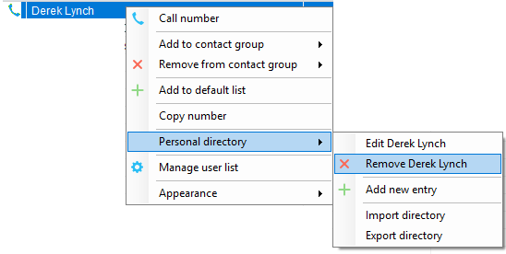

You will be prompted to confirm the action as below. Please note that once the contact has been removed it cannot be undone.
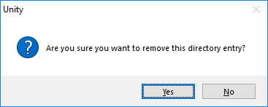
11.4 Including External Contacts in the Default Contacts List
To “pin” a personal directory entry [or any other external contact] to the default Contacts list, right click and select “Add to default list”, as shown here.
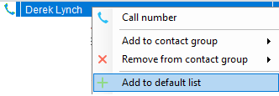

Please note that external contacts that are pinned to the default Contacts list do not contribute to the limit of 50 monitored users.
11.5 Import Personal Directory
Unity allows multiple contacts to be imported into the personal directory through a .csv file, provided the file is in “name, number” format. Right click anywhere in the Contacts list and select the import menu option as shown below, then select the location of the file to import. Depending on the number of contacts this may take several minutes.

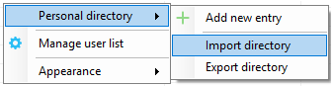
11.6 Export Personal Directory
You can export the personal directory in case it needs to be imported for another user. To do this right click anywhere in the Contacts list and select the export menu option, as shown below. You will be prompted to specify the file location, the format is csv and the default file name is PersonalDirectory.csv

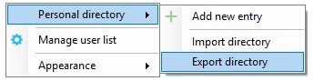

12 Directory Integration

Unity combines list of contacts from multiple locations to create a central search repository. This includes public and private directories from the VoIP platform, Outlook contacts from Outlook [if applicable] and any third-party data stores.
Please see your Administrator for a separate guide on using CRM integration.

Directory Owner | Directory Type | Entry Type
BroadSoft | Group Directory | All other users for BLF presence as well as hunt groups and auto attendants
BroadSoft | Common Phone List | Speed dials entries at the Group level
BroadSoft | Personal Directory | The user’s own personal speed dial entries
Outlook | Personal Contacts [private folder] | The user’s own Outlook Contacts
Outlook | Group Contacts [public folder] | The shared Outlook Contacts at the Outlook group level
Third Party | SQL | External SQL Directory
Third Party | LDAP | External LDAP Directory

12.1 Loading Directories
Unity will load all directory entries from the different locations on start up, and will not reload directories during the same Unity session. This means if contacts are added to the VoIP platform or Outlook contacts list while Unity is running they will not be visible until Unity has restarted.

Please note: It is possible not to include the Common Phone List from the Group or Enterprise level when loading Unity, this is configured at the System Provider level of the Kakapo Partner Portal and will impact all users.

Right-click the search box in the Contact list to view all directories available in Unity, then select the directory to load those contacts in the list, as below.

If you see the Business ID rather than the Business Name this is because the enterprise and group names are the IDs in BroadWorks by default and the “Use Business Name In Client Directory” box isn’t ticked in the Kakapo portal.

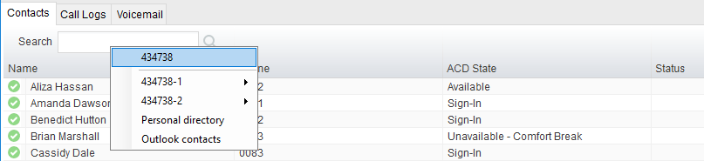

Tick the box in the portal and then restart Unity. You might need to do this at the group level as well.
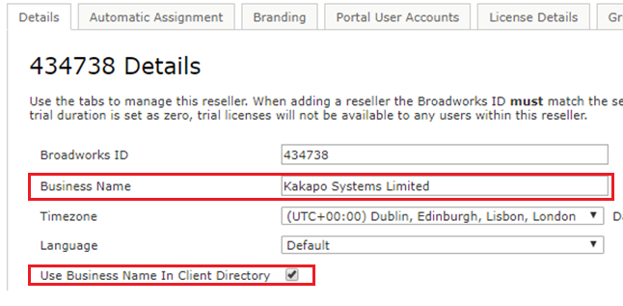
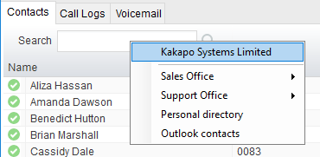
12.2 Configuring Outlook Contacts Preferences
Outlook folders can be included or excluded through Settings, as shown below. Please note only Outlook folders where the default object is “Outlook Contact” will be available.

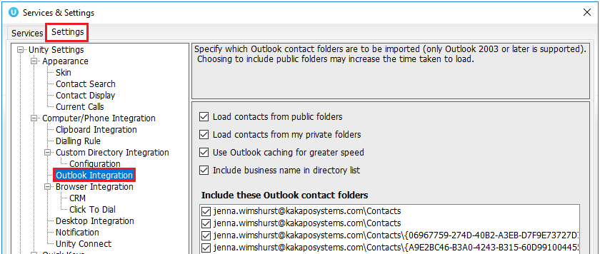

12.3 Third Party Directories
If configured, Unity will search any LDAP-compliant or SQL data stores using dynamic SQL statements or LDAP filters, rather than loading these directories on startup. This means that as contacts are added, modified deleted while Unity is running, the most recent information will always be displayed. In order to reduce the footprint on the data server and Unity, third party data sources are not included in searches unless the user presses the enter key or clicks the search button.

Unity includes a wizard to connect to third party SQL and LDAP-compliant directories, as shown below.

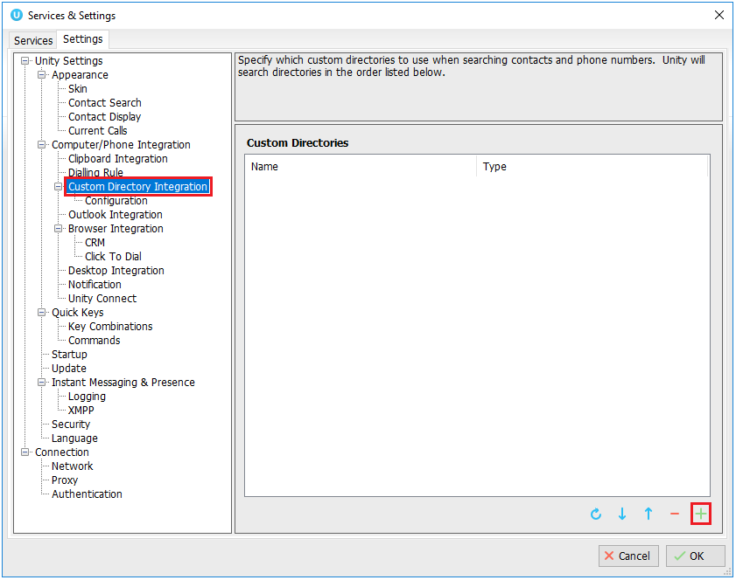
12.4 Desktop Integration
Go into Settings > Settings tab > Desktop Integration, as below.
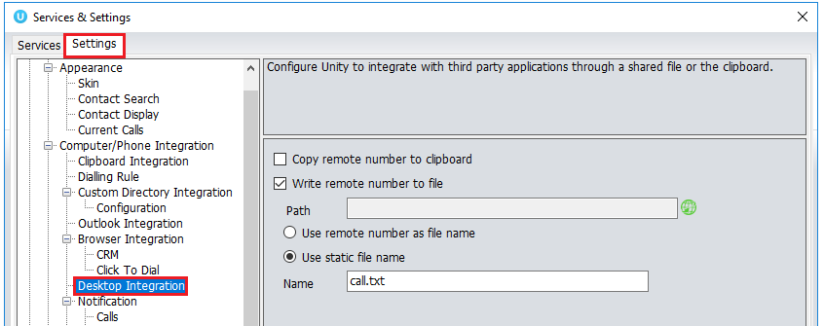

Unity must be configured with the folder location where the file is to be written, you can also specify whether to use the remote number as the filename (for example 02082881248.txt) or to include the remote number in a text file with whatever naming convention you require. Lastly you should instruct Unity when to create the file, for example only when receiving [call center] calls. Please note that Unity will only create the file for an inbound call when the user has answered it.

When you click OK to save, Unity will attempt to create a file called test.txt in the specified folder, then to delete it, which is to test that appropriate folder permissions have been applied. If this fails, Unity will alert the user and the settings will not be saved.

13 My Status (Quick Access Service Configuration)

The “My Status” link provides an indication of the current status of the user as well as quick access to key services that are regularly modified. Unity will only display the options for the services that have been assigned to the user, available services are CommPilot Express (CPE), Do Not Disturb (DND), Call Forward Always (CFA), Remote Office and Hoteling Guest (for hot-desk environments).

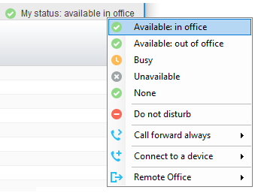

CommPilot profiles are also used to convey presence information to other users within the group or enterprise. As users change their CommPilot Express state, any Unity client that is monitoring that user [through the User Status list] will see their image change, as outlined below.

User State | Description | User Status Image
Available: In Office | I am in the office and available to receive calls. | 
Available: Out Of Office | I am not in the office but am available to take calls
Busy | I am currently busy (short term) | 
Unavailable | I am currently unavailable (longer term)
None | No call routing plan is in use
13.1 Configuring CommPilot Express States
CommPilot Express allows the user to specify how inbound calls are to be handled. Once the four different profiles (above) have been configured in Settings, the profile in use can quickly be changed through the My Status link. Unity can also be configured to automatically apply a CommPilot Express profile when starting or closing, as below.

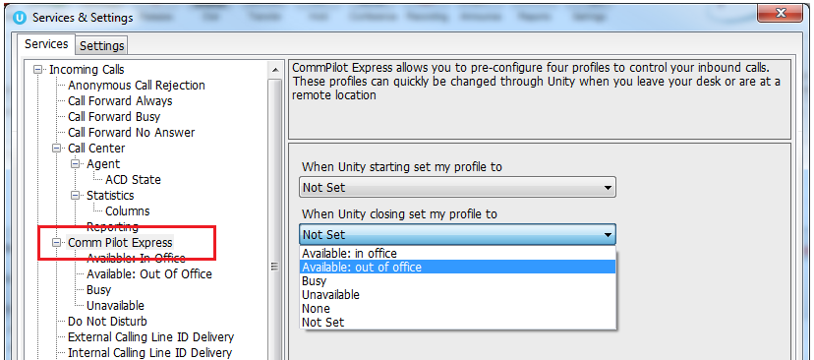
13.1.1 Available: In Office
This is the profile to use when you are working from the desk where you phone is location, it should represent “normal” routing rules.

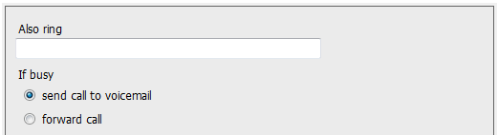
13.1.2 Available: Out Of Office
This is the profile to use when you are away from your desk for an extended period, but still available for receive calls. Examples are when in a meeting or when travelling.
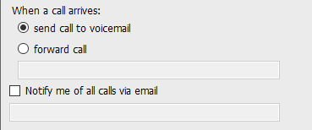
13.1.3 Busy
This is the profile to use when you are temporarily unavailable to take calls, for example when in a meeting where you don’t want to be disturbed.
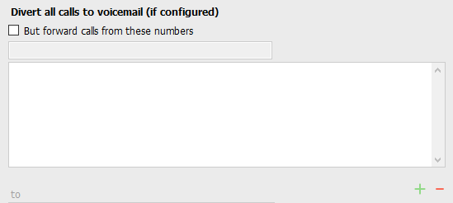
13.1.4 Unavailable
Use this profile when you are away for an extended period of time and not available to take calls, for example when on vacation.
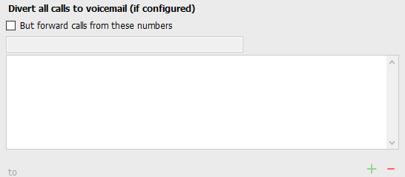
13.2 Do Not Disturb
To activate Do Not Disturb, click on the My Status link and click the menu option. The My Status link will change to indicate the service activation, as will the Unity title bar.
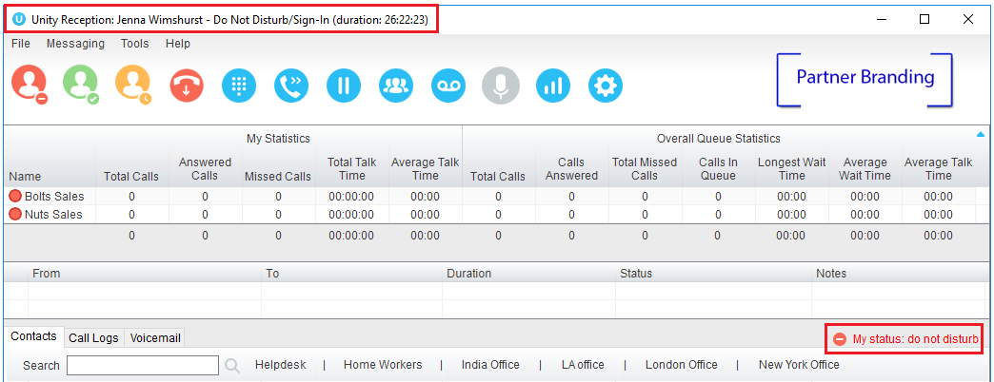

Anyone monitoring the user [in the Contacts list] will also see that they currently have Do Not Disturb activated.
13.3 Call Forward Always
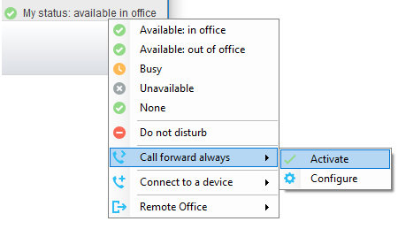
Use the My Status link to quickly activate/deactivate the service, or click configure to go directly to that service in Settings.

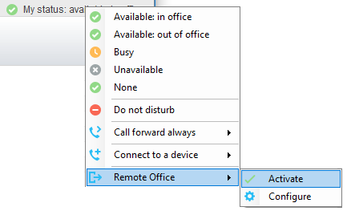
13.4 Remote Office
Use the My Status link to quickly activate/deactivate the service, or click configure to go directly to that service in Settings.

Unity can also be configured to automatically activate and deactivate Remote Office on startup and shutdown. If Unity is not configured to automatically deactivate when closing a prompt will be presented to the user, as shown below.
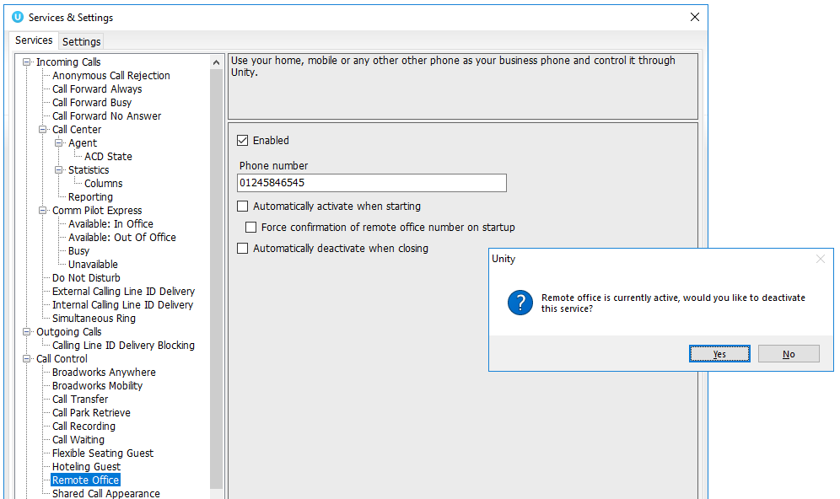
13.5 Hot-Desk and Flexible seating
Hoteling Guest allows the user to connect to a device, typically in a hot-desk and flexible seating environment. To attach the user account to a device, select the device from the menu option below. Please note that only available devices [that aren’t already in use] will be displayed.
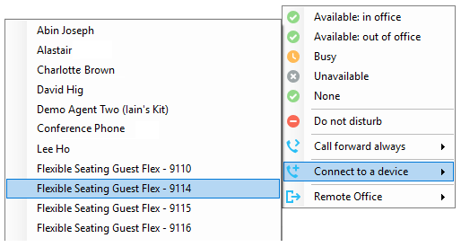

There is no visual notification that the user account is attached to a device, other than if the user clicks in the My Status link, in which case they will see the device is ticked.

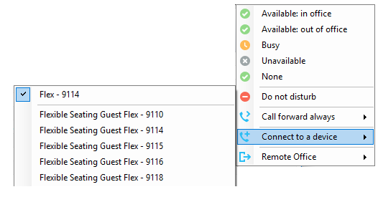

When Unity is closing, it will prompt the user to remove the device attachment.

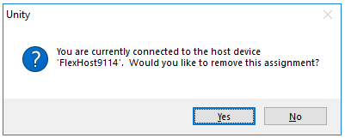

If the user clicks no they will continue to be attached to the device until the association is automatically ceased by the Broadsoft.

13.6 Personal Assistant Service
All Unity clients provide the ability to set the current status for the Personal Assistant service through the “My Status” quick access link, as shown below. This menu option is only shown if the service is assigned to the user in BroadWorks.
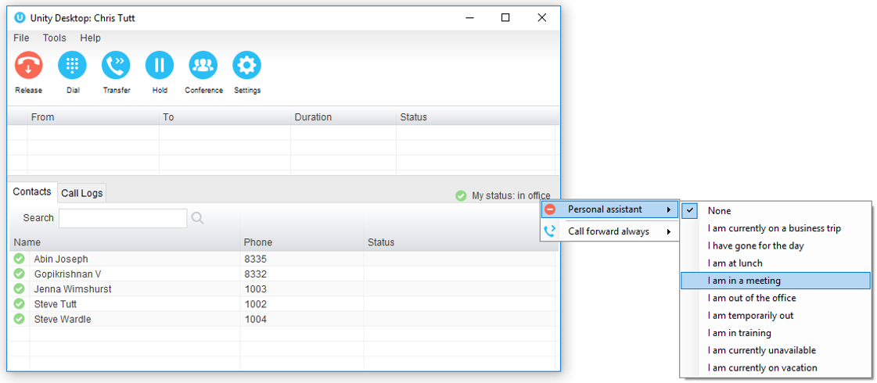

If the user selects a status from the My Status quick link then an expiry date/time will not be configured. If there is a status currently assigned with an expiry date/time then this will be removed. This is for users to quickly set a status “until further notice”.

If a user wants to set an expiry date/time for the status then this can be done through Unity Settings, as shown below. The user can configure all aspects of the service here, including setting the assigned numbers that the status will apply to, and any exclusion numbers that will bypass this service (meaning if there is a status set but a call is received from an exclusion number, then it will be routed to the user rather than caught and processed by the service.)
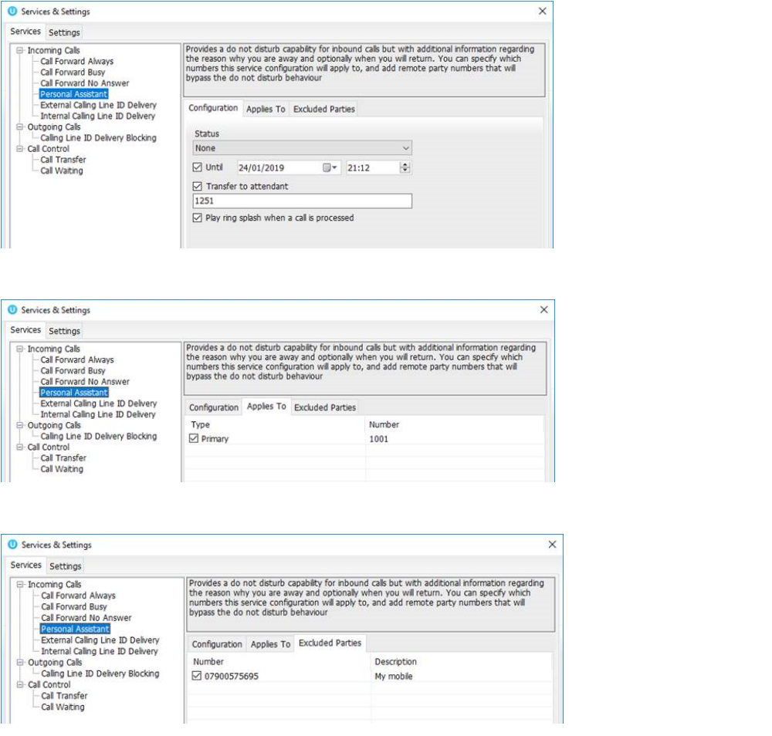

These settings map directly to the service configuration pages in the BroadWorks portal.
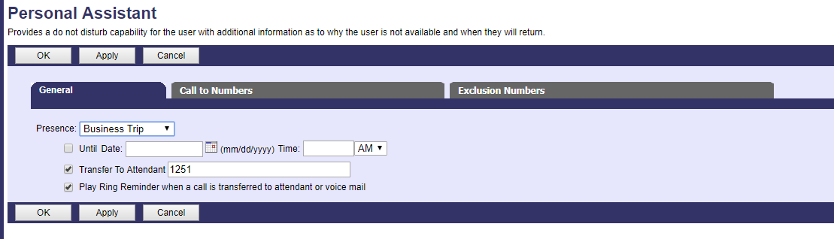

Only Unity Reception clients will show the Personal Assistant status of other users in the group or enterprise, as shown below.
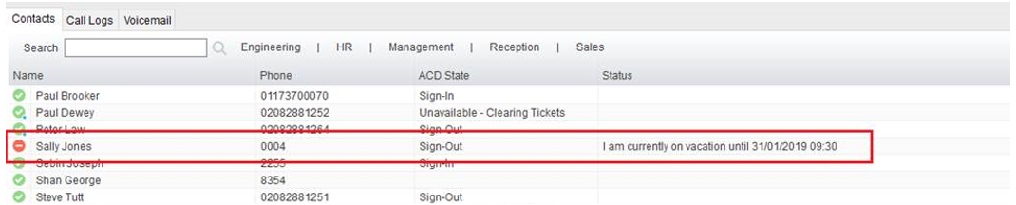
Unity will show the state and the expiry date/time if one was set, the available status messages are:
- I am currently on a business trip
- I have gone for the day
- I am at lunch
- I am in a meeting
- I am out of the office
- I am temporarily out
- I am in training
- I am currently unavailable
- I am currently on vacation

The Do Not Disturb image will always be shown for that user when a Personal Assistant status is set, because this service is an extension of DND.

The Personal Assistant status can only be displayed if the BroadWorks CTI protocol is being used.

14 Reception Call Centre Agent

Unity Reception includes all the call center features of Unity Agent, because a receptionist may be part of a call center in a busy front desk environment. If a call center agent service assigned to the receptionist, then Unity will automatically display ACD state buttons and allow the user to join or leave specific call centers [if permitted in the VoIP platform].

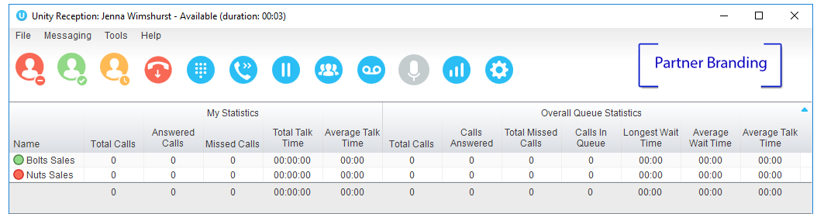
14.1 Joining & Leaving Queues
To join or leave a call center queue, the user can right-click on that queue in the Personal Wallboard [if displayed] or use the Tools menu, as shown below.

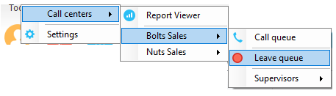
The Tools menu will display all call centers that the user belongs to, even if not displayed in the Personal Wallboard.
14.2 Changing ACD State
The ACD State buttons allow the user to change their current ACD state, including setting the unavailable reason code, as shown here. The title bar will show the current ACD state.

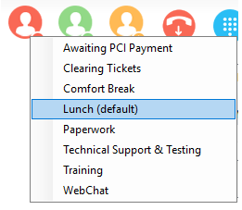
14.3 Personal Wallboard
The Personal Wallboard gives the call center agent a view of personal and overall queue performance by displaying key metrics. Statistics are broken down by “My Statistics” which shows the agent’s individual performance and “Overall Queue Statistics” which will show the current conditions across the entire call centre[s]. Some statistics are real-time while others are periodically polled from the VoIP platform. The Personal Wallboard can show a detailed view [one row per call center] or a summary view only, this is toggled using the button in the upper right corner.
14.3.1 Authentication & Configuration
In order to display the Personal Wallboard Unity must log into the VoIP platform as each call center, as well as the agent. In order to display real-time statistics the call center must have the Client Call Control service assigned in the VoIP platform, if this is not the case the call center will still be displayed in the Personal Wallboard but all statistics will be periodically polled. Section 14.3.3 confirms which statistics are available in real-time.

Call center authentication is performed through Settings, as shown below.
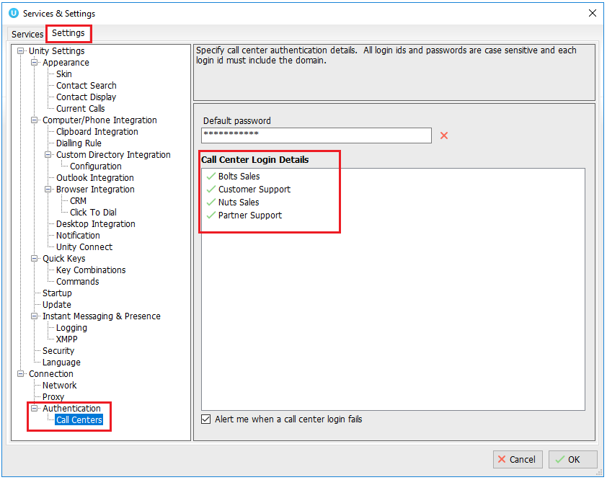

If all call centers share the same password then it should be entered as the default password in Unity, which will then use it when logging into the VoIP platform as each call center that the agent is a member of. Otherwise double-click on each call center in the list to enter the password, the call center ID will not be editable. If a default password has been entered, then this cannot be overridden for a call center.

When setting the password for a specific queue, the same password can be used when logging into any other queues that don’t currently have a password set, as shown here. The difference between this setting and the default password is that this setting only applies at the call center level, meaning any new call centers that the agent becomes a member of will not take this password by default, whereas they will take the default password. Also, if some call centers have a different password then they can set first, then this used to apply the same password to any other queues.

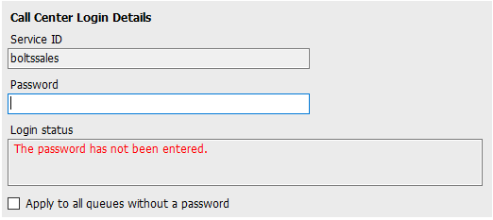
The login status field will always show the current authentication state for that call center, options are:

The call center logged in successfully:
Unity has successfully logged in as the call center and the Client Call Control Service is assigned, meaning real-time statistics are available.

The Client Call Control service is not assigned to this queue meaning the 'calls in queue' statistic is not available in real-time:
Unity was able to log into the VoIP platform as the call center so statistics will be displayed in the Personal Wallboard. However, because the Client Call Control service hasn’t been assigned to the call center, all statistics will be polled.

The password has not been entered:
A default password has not been specified and there is no password entered for this specific call center.

The call center login attempt failed. Please check the authentication details are correct and ensure the account is not disabled:
Unity was not able to login as the call center, most likely because the password is incorrect or the account has been disabled through too many failed login attempts. Unity may also display a message to the user when the login fails, as below. This depends on the “Alert me when a call center login fails” setting being active.

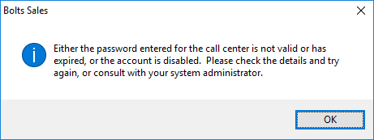
14.3.1.1 Setting Default Password in the Portal
The default Call Center password can be set in the Kakapo portal at the Service Provider, Reseller, Business and Group level. This will set the default password for all users under that level. To set the password go to Branding>Call Center, as shown below.

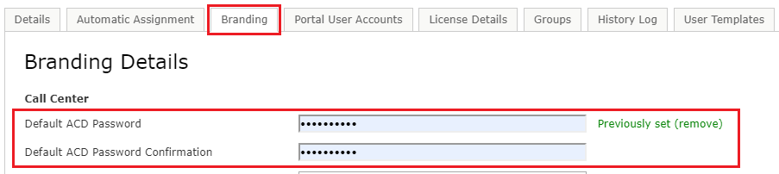

Please note: If the default password has been set in the portal then it cannot be overridden in the Unity settings.
14.3.2 Overview
The Personal Wallboard is used not only to show agent and queue statistics for call centers, but also to quickly perform other actions on behalf of the agent.
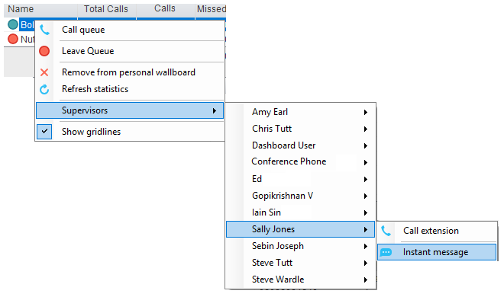
By right-clicking the call center, the agent can join or leave the call center [this toggles depending on whether the agent is currently joined or not], can call the queue [or transfer if there is a call in progress], or instant message or call a supervisor of the call center, as shown above.

14.3.3 Columns
There are 6 agent level and 22 call center level statistics available to be displayed in the Personal Wallboard, which will automatically resize to include all columns in the window width available. Columns can be added removed and reordered through Settings, as shown below.

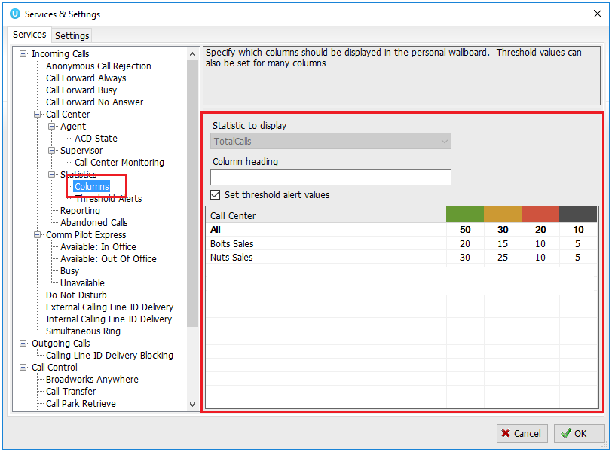

The left panel shows the columns that are currently displayed both for the agent and call center and the order. Use the arrow buttons to reorder columns in the personal wallboard, the plus and minus buttons to add or remove columns, or simply double-click a column to view its configuration.

Many columns support thresholds which employ a “traffic light” scheme to quickly indicate important call center metrics, such as the number of missed calls or the longest wait time for queued calls.

Please note that all statistics shown in Personal Wallboard reset every 24 hours at midnight.
14.4 Receiving Call Center Calls
Agents will only receive calls routed through the call center if they are currently joined to that call center and the ACD state is set to Available. When receiving a call center call, Unity will display the “To” field as the name of the queue rather than the name of the agent, to indicate that this is a call center call. If a DNIS name is present this will also be shown [in brackets].

Call center calls are managed in exactly the same way as non-call center calls, as outlined in section 5.
14.5 Assigning Disposition Codes
Although unlikely in a reception environment, a call center call can be flagged with one or more disposition codes, which is recorded by the VoIP platform to give more information about this call, for example was it the result of a marketing compaign, is it a complaint etc.

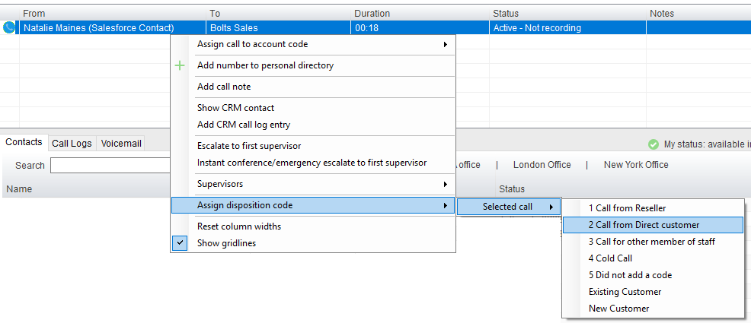

Assign a disposition code to a call by right-clicking and selecting the menu option above, a single disposition code can only be assigned once to a call, but multiple codes can be assigned to the same call.

A disposition code can also be assigned to the last received call center call, as shown below. Right-click in the Active Call Window to assign the disposition code, please note that Unity indicates that “Sales Call” has already been assigned to this call.

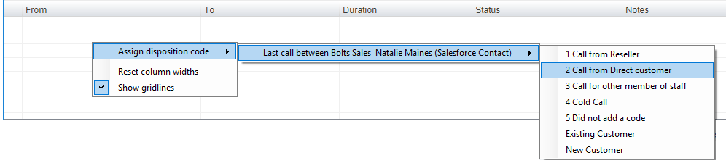

The agent must be in Wrap-Up ACD state in order to assign a disposition code to the previous call center call. If this isn’t the case Unity will prompt the user to change the ACD state the Wrap-Up, assign the disposition code, then change the ACD back to the current state.

When Unity is configured to force the agent to assign a disposition code through a popup window which is automatically displayed to the user when the call is released.
The Unity UI will be disabled and the popup window will appear over all applications on the user’s desktop. A timer can be specified which will display a count-down to the user, and will automatically close once the timer duration has elapsed. When they click Available they get a drop list of Disposition Codes.

Unity can also be configured to also change the ACD state to Available or not. The default behaviour is to change the ACD state back to Available either when the disposition code has been assigned, or when the disposition code timer expires without a code being entered.

This feature is activated in Settings>Services>ACD State as below.
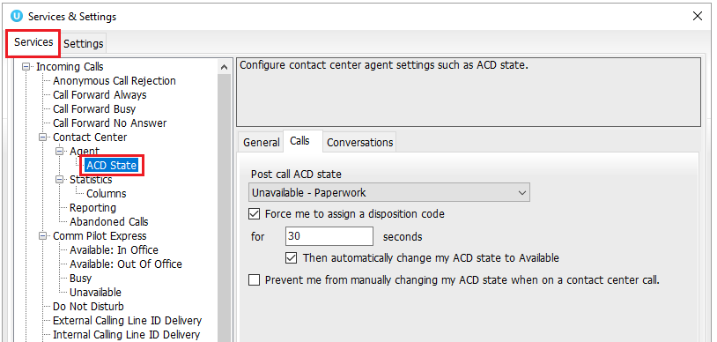
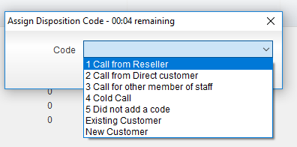

14.6 Supervisor Escalation
Part of the call center agent functionality included in Unity Reception is the ability to escalate a call center call to a specific supervisor, or to the first supervisor available.

There are two kinds of escalation available, both of which are recorded as an escalation in the VoIP platform.
14.6.1 Standard Escalation
This will put the call on hold and dial the supervisor. Once the supervisor answers the agent can perform an announced transfer, a three-way conference or simply toggle between calls.
14.6.2 Emergency Escalation
Unity will dial the supervisor and when then call is answered, will start an instant conference with that supervisor and the remote caller.
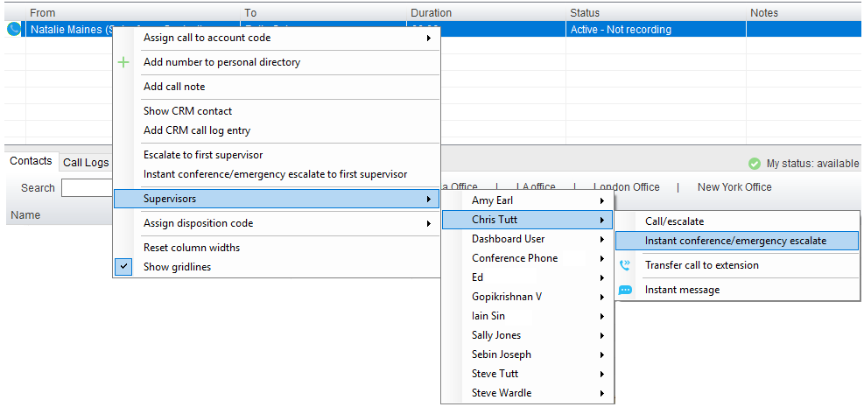

Escalate a call by right-clicking in the Active Call Window and selecting the escalation option as shown above. When performing a call escalation, the agent can select a specific supervisor to escalate to, or the first available supervisor which is decided by the VoIP platform. The agent can also blind transfer the call to the supervisor without performing an escalation or send an instant message if the supervisor.

14.7 Activating Outbound DNIS
If the receptionist is an agent of one or more call centers that support outbound DNIS, then the user can select an outbound DNIS which will determine which outbound caller ID/name is presented to the remote party when the user makes external outbound calls. To change the outbound DNIS right click the Dial button and select the menu option to change the outbound number, as below. All numbers configured as outbound DNIS will be presented, and the currently select number will be ticked. Please note that if an outbound number is selected here, it will be used when making all calls until Unity is closed or the “None” menu option is selected.
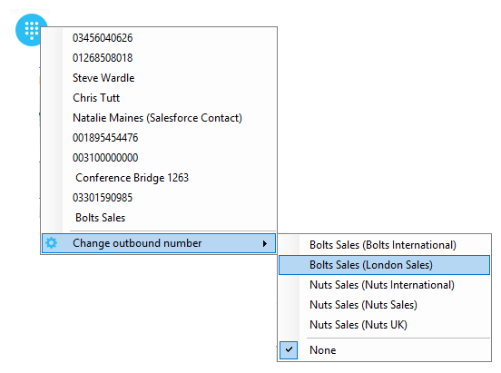
16.8 Report Viewer
Unity offers standard call center agent reporting to the receptionist, which is accessed through the Report Viewer  button or by clicking Tools > Call Centers > Report Viewer.
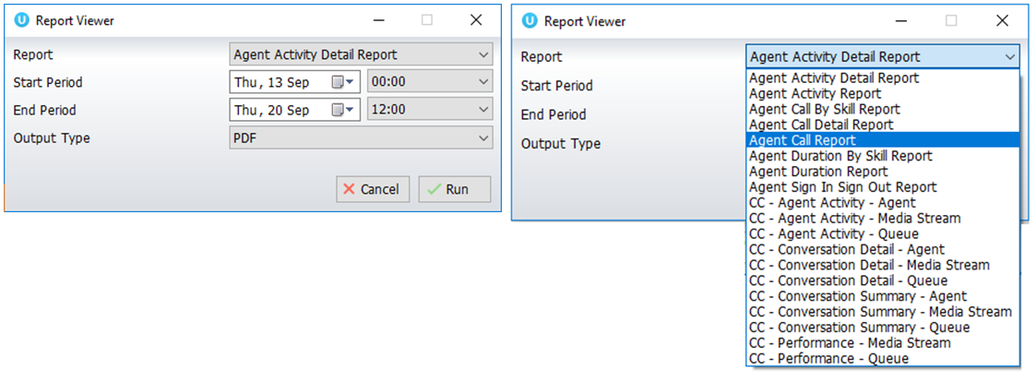

The below reports are available to be generated by the agent:
- Agent Activity Detail Report
- Agent Activity Report
- Agent Call by Skill report
- Agent Call Detail Report
- Agent Call Report
- Agent Duration by Skill Report
- Agent Duration Report
- Agent Sign-In/Sign-Out Report
As additional reports are made available in the VoIP platform they will be displayed in the report viewer. Please consult your telephony service provider for an overview of the call center reports, including input parameters.
14.9 Call Center Agent Configuration
Outside of call center authentication, there are many settings available within Unity to automate actions or configure the call center agent environment.
14.9.1 Call Center
Unity can be configured to automatically join the agent to all call centers that they are a member of [regardless of whether that call center is displaying in the Personal Wallboard] when Unity is starting up or is unlocked. The agent can also be set to leave all call centers when closing Unity or locking the desktop.
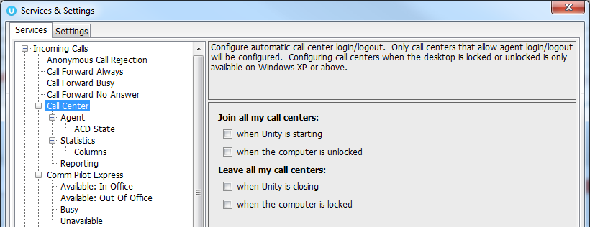
14.9.2 Agent
Unity may be required to automatically answer inbound call center calls if the agent is available and not currently on a call, which removes the ability for them to reject/bounce the call.

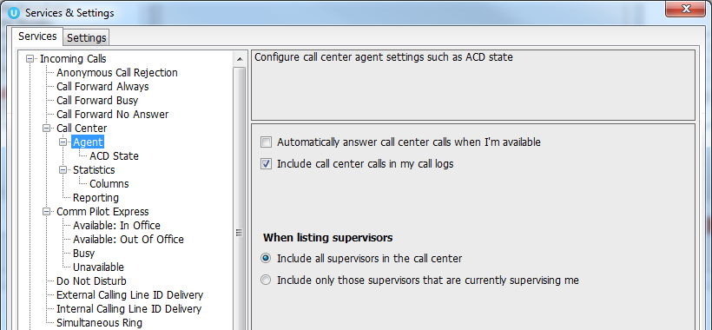

Call center calls may need to be included in the Call Logs list, as shown below. If the call log entry is for a call center then the queue name will be shown in the Name field, however this is not stored in the VoIP platform so if the logs are refreshed or Unity is restarted this information will be lost.
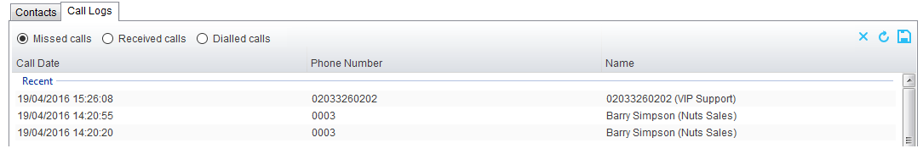

When listing supervisors in the menus, Unity can show all supervisors in the call center or only those that are currently monitoring the agent.
14.9.3 ACD State
Unity can be configured to automatically change the ACD state of the agent based on specific events ocurring, such as the desktop being locked or unlocked or a call center call ending.

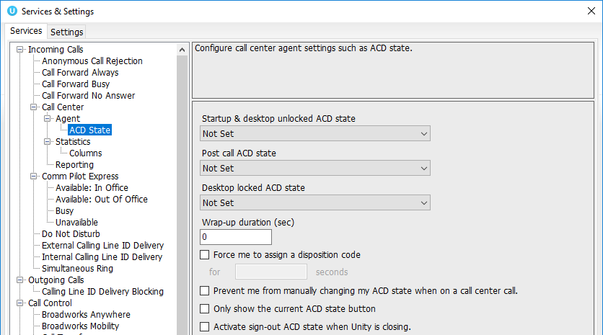

Wrap Up Duration: This will automatically change the ACD state to Available after the specified duration [in seconds] has passed. Please note this does not work with the same setting in the VoIP platform, so should only be set here if not set there.

Froce me to assign a disposition code: If this setting is active then when a call ends for a call center that offers disposition codes, the ACD state will be automatically changed to Wrap-Up and the agent won’t be able to change it back to Available without assigning a disposition code to the last call, as shown below.

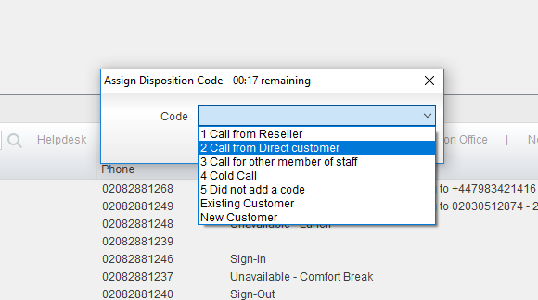

When the agent selects a disposition code it will be recorded on the VoIP platform and Unity will change the ACD state to Available.

Prevent me from manually changing my ACD state when on a call center call: When activated, Unity will show the below message if the user attempts to change the ACD state when on a call center call, because this may impact agent performance statistics.

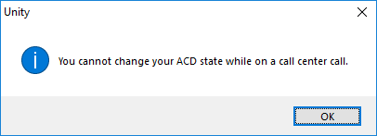

Only show the current ACD state button: Unity can show the three main ACD state buttons which is the default option, or only the current ACD state, in which case the agent changes the state using the context menu, as shown below.

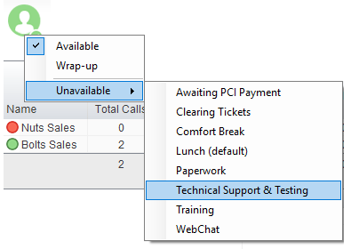

Activate sign-out ACD state when Unity is closing: If this setting is not active then Unity will not change the ACD state when closing, which may impact agent performance statistics.

Displaying ACD state: When showing the ACD state in the title bar, Unity can show the start time or the duration, as shown below.
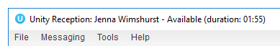
14.9.4 Statistics
Those call center statistics that aren’t displayed in real-time are periodically polled from the VoIP platform, the polling frequency can be set in Settings but must adhere to minimum values set by the telephony service provider. The minimum and maximum values in a range must be entered, from which Unity will randomly generate a number to use as the polling interval, this will be different per call center to reduce any potential resource usage spikes when gathering statistics.

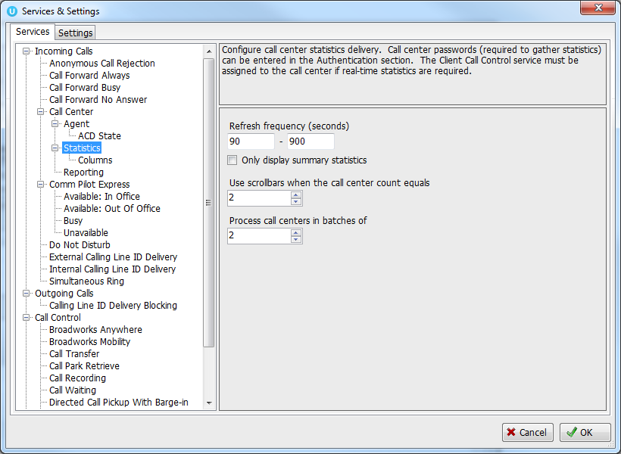

Only display summary statistics: If active the Personal Wallboard will only be shown in summary view, the agent will not be able to expand the list to include the call center detail.

Use scrollbars: When displaying a large number of call centers in the Personal Wallboard, scrollbars must be used to ensure the Personal Wallboard doesn’t take all the space in the screen. This will ensure scrollbars are employed, the maximum value is 20.

Process call centers: This setting is used to batch call centers together when loading information during startup. It should not be changed unless there is a delay when loading the Personal Wallboard during startup, and only by those that understand the implications of changing this value.
14.9.5 Reporting
Unity can be configured to generate reports with specific date/time formats, as illustrated below. These settings are used when the Report Viewer is generating call center reports.



