

GETTING STARTED WITH UNITY SUPERVISOR

Contents

1 Initial Setup 1
2 The Interface 2
3 Call Control 3
Transferring a Call 3
Starting a Conference Call 3
Ending a Conference Call 4
Managing Multiple Calls 4
Call Recording 4
4 Busy Lamp Field 5
User Status Views 5
Monitored User States 5
Drag And Drop Calling And IM 5
Call Pickup 5
5 Instant Messaging 6
6 My Status 7
7 Supervisor Functionality 7
Assigning Abandoned CallerIDs to Agents 7
Remotely Changing Agent State 8
Configuring Thresholds 8
Silent Monitoring 8
Configuring Statistics Columns in Personal Wallboard 9
Adding Agents to Monitored Agents List 9

1 Initial Setup

- The first time Unity is started you will be prompted to enter the configuration details, as shown below.
- Enter your Login ID and password as provided by your Service Provider and click OK.

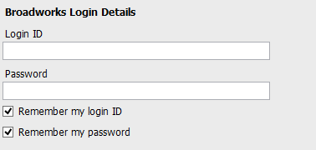
- Now enter the server address when prompted. If this is prepopulated, please do not change.
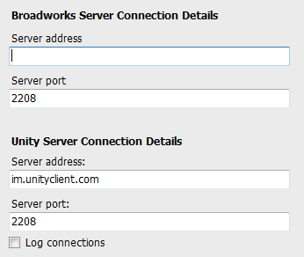
- To complete and save your settings click OK at bottom right. The application will now open.

2 The Interface

- Unity is split into three functional areas; Call Control, Current Call List and Productivity Tabs. The Productivity tabs are further split into Call Logs, Abandoned Calls, Voicemail and Agent Activity tab.
- The Current Call List will display the status of all current calls for the logged in user, which are controlled using the Call Control buttons.
- These call control buttons will change based on the status of the call.
- When Unity first starts it will automatically populate the Busy Lamp Field with 30 random users in your group or enterprise.
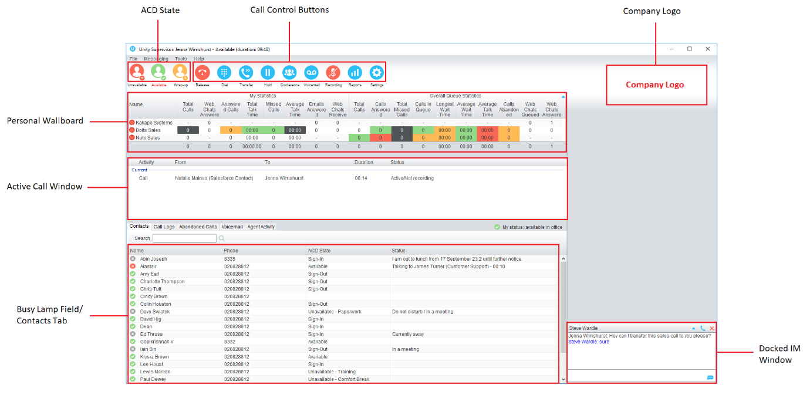

3 Call Control

ICON | FUNCTION | DESCRIPTION
 | Dial | Click this to dial a number and make a call. Right click it to redial from the last 10 numbers called.
 | Answer | This button will appear when a call is ringing.
 | Release/End call | This button will appear once you have a call active. Click to end the call. If you have multiple calls, click the call you want to end first.
 | Hold | This button will appear during a call. Click to hold the call. If you have multiple calls, click the call you want to put on hold first.
 | Retrieve | This button will appear if you have a caller on hold. Click the button to take the caller off hold.
 | Voicemail | Click the voicemail button to send an incoming call to voicemail. Click the button when you don’t have a call and it will call your voicemail box.
 | Transfer | Click this button to transfer a current call to a certain number. Drag and drop the call over a contact to transfer them without entering their number.
 | Conference | Select two or more calls then click the conference button to start a conference with those callers.
 | Recording | Click to start, pause or resume recording.

Transferring a Call
- Announced Transfer: Answer an inbound call then make a new call to the desired number, this will place the first caller on hold and initiate a new call. Once the new party answers, click transfer and transfer the two calls together.
- Blind Transfer: While on an active call, dial a number or drag to/right click the recipient then select transfer, this will send the caller directly to the destination number and disappear from your call list.
- Warm Transfer: Right click the user you want to transfer the call to and select “warm transfer”. This will then put the original caller on hold while you talk to the other user, when ready, click the transfer button.

(You can also transfer a call to someone’s voicemail or mobile by right clicking their icon and selecting the option.)

Starting a Conference Call
- Establish the first call.
- Call a second person.
- Click the conference button to create a new conference for all three of you.
- To add more people to the conference simply dial or start another call then click the conference button.

Ending a Conference Call
- To end the conference call but continue speaking to one of the callers, simply select the person/ call you want to end and click the Release button.
- To end the conference call and disconnect both parties, simply hang up the phone or select both calls and select Release.
- To leave the conference but allow the other callers to continue speaking to each other, perform an announced transfer between the two calls.

Managing Multiple Calls
- To manage a particular call, first select it by clicking it in the Active Call Window. If there is only one call in the list it will be selected automatically. You can then use the call control buttons to perform different actions on the call.

Call Recording
Call Recording options are:

4 Busy Lamp Field

User Status Views
- Right-click anywhere in the list to change the view of the users, e.g. list, icons etc.
- To modify the list of users currently being monitored, right-click and select Manage user list. Select the users you want to add or remove by using the arrows. Your monitored users are on the right.
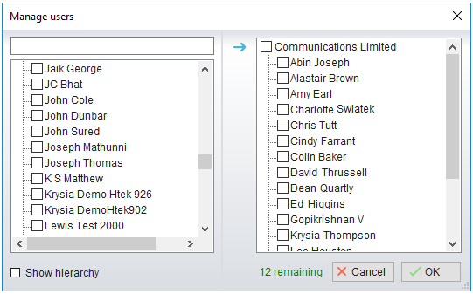

Monitored User States
A monitored user will always be displayed in one of four states:
User State | Description | User Status Image
Available: In Office | I am in the office and available to receive calls. | 
Available: Out Of Office | I am not in the office but am available to take calls
Busy | I am currently busy (short term) | 
Unavailable | I am currently unavailable (longer term)
None | No call routing plan is in use

Drag And Drop Calling And IM
- Hold down and drag a user’s icon to the docked IM panel to start instant messaging
- Drag a user to the Active Call Window to call them
- Drag an active call to another user to transfer/show available transfer options

Call Pickup
This feature allows the logged in user to answer an incoming call on behalf of a monitored user. Simply right click a ringing user and pick up the call.
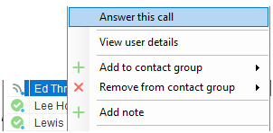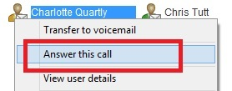
Options For A Busy User
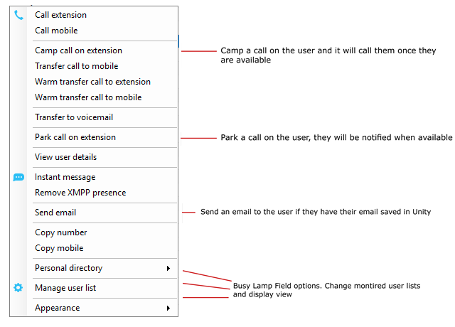
Options For An Available User
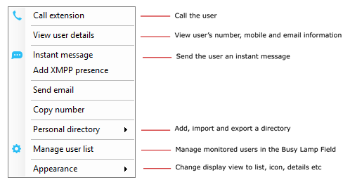

5 Instant Messaging

If a user has a small blue dot then they are available for instant messaging. Send an instant message by:
- Right clicking their user icon and selecting instant message
- Drag and drop the user to the docked panel on the right (this can be set up in the settings tab)
- Click messaging at the top of Unity and select start conversation. Then add the people you want to instant message
- Multiple users can be selected to start an IM conversation [by holding down the CTRL key while selecting users], but they must all be online.
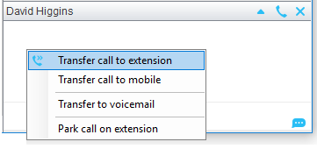

6 My Status

- To activate your status, Available, Busy, Do Not Disturb etc, click on the My Status link and click the menu option.
- To activate call forwarding, select the option “Call forward always”, then configure the number. All incoming calls to the
pre-defined phone number, meaning the user’s phone will not ring.
- To active and deactivate call forwarding, simply hover over “Call forward always” and select the option.
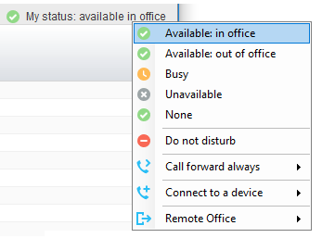

7 Supervisor Functionality

Assigning Abandoned CallerIDs to Agents
Right click [or Shift right click for multiple] abandoned calls and right click to assign to agents.

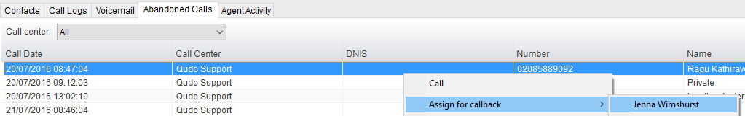

Remotely Changing Agent State
- Change the Agent’s availability to the call center and change their ACD state by right clicking the user’s icon in the Agent Activity tab.

Configuring Thresholds
- Click Settings [button] > Services [tab] > Statistics> Columns > Call Center Columns – double click the statics (e.g. total calls) to set thresholds.
- Different thresholds can be set for all queue parameters for different call centers, or all call centers can have the same threshold.

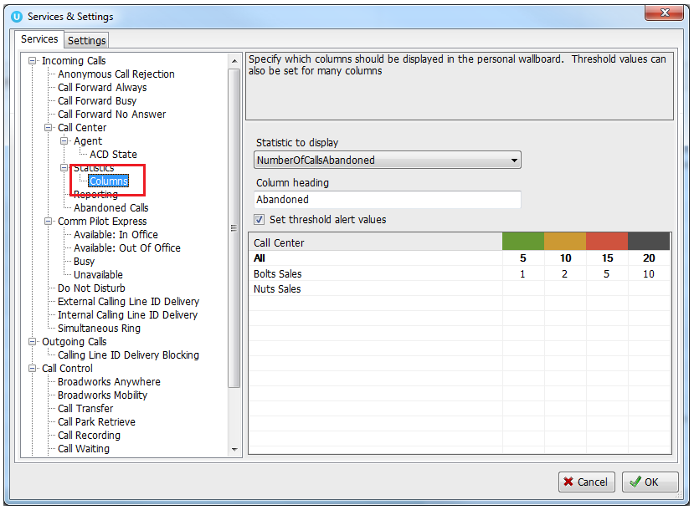
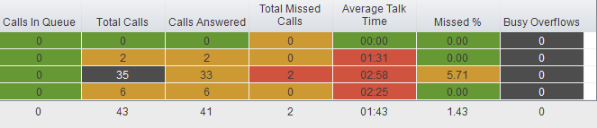

Silent Monitoring
- Right click the call center queue in Personal Wallboard > select the agent > select Next Call Only or All Calls.
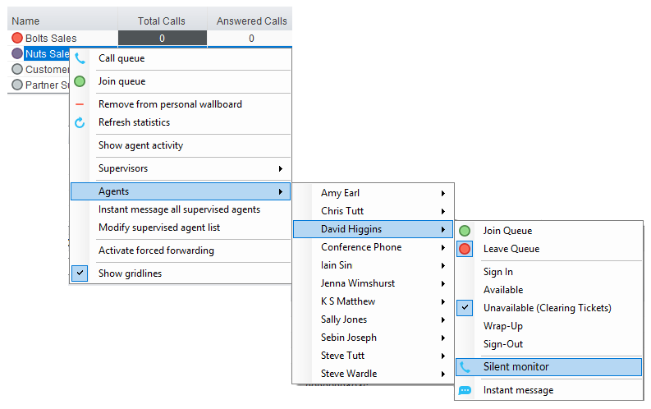

Configuring Statistics Columns in Personal Wallboard
- Configure the statistics shown in the Personal Wallboard by going to Settings > Services > Call Center > Statistics > Columnns.
- Statistics can be added or removed with the buttons and the order they are displayed.
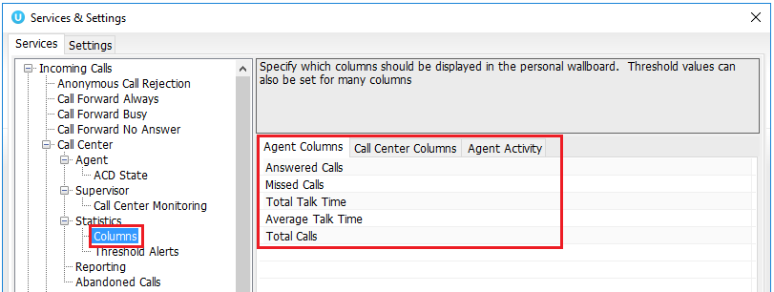

Adding Agents to Monitored Agents List
- To monitor a specific subset of the total agents, go to Settings [button] > Settings [tab] > Supervisor and uncheck “Automatically add all agents to my supervised agent list” and restart Unity.

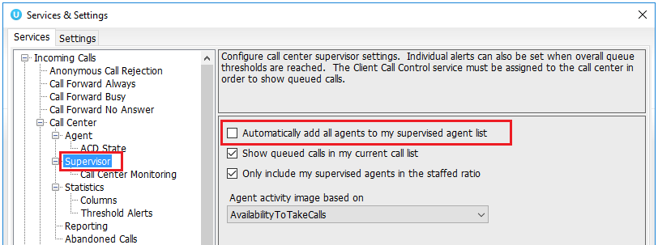

- Then right click the call center queue in Personal Wallboard, select “Modify supervised agent list” and add the agents you want to supervise.

