

UNITY SUPERVISOR HELP GUIDE
CONTENTS

1 About Unity Supervisor 7
1.1 Features 7
1.2 Naming Conventions for this Help 8
1.3 System Requirements 8
1.3.1 Windows PC Requirements 8
1.3.2 Internet & Firewall 8
1.3.3 BroadWorks Platform Requirements 9
1.3.4 BroadWorks License and Service Requirements 9
2 Initial Setup 10
2.1 Call Center Login Details 10
2.2 Call Center Login Default Password 12
2.3 Selecting a Pre-Configured Template 12
2.4 Manual and Auto Updates 13
2.5 Rollback available 14
3 Unity Supervisor Interface Overview 14
3.1 Resizing Unity Supervisor 15
3.2 Maximising and Minimising 15
3.3 Using Unity Supervisor from the System Tray 15
3.4 Call Notification Preferences 16
3.4.1 Show Remote Party Phone Number 16
3.4.2 Override Contact Name Using Number 17
3.5 Summary Toast Notification 17
3.6 Browser Screen-Pop 17
3.7 Appearance 17
3.8 Skins 18
4 Main Interface Elements 18
4.1 ACD State Buttons 18
4.2 Call Control 18
4.3 Active Call Window 18
4.4 Contacts [Busy Lamp Field] 18
4.5 Call Logs 19
4.6 Abandoned Calls 19
4.6.1 Previously Abandoned Calls 19
4.7 Voicemail 19
4.8 Personal Wallboard 20
4.9 Using Personal Wallboard 21
4.10 Locking in Minimized State 21
4.11 Staffed Ratio 21
4.13 Statistics Refresh Timer 22
5 Call Center Agent Functionality 22
5.1 Changing ACD State 22
5.1.1 Only Show One ACD Button 23
5.1.2 Assigning Unavailable Codes 23
5.1.3 Force Disposition Code 24
5.1.4 Displaying ACD State Duration 24
5.2 Using Personal Wallboard 25
5.2.1 Locking in Minimized State 26
5.2.2 Configuring Statistics Columns in Personal Wallboard 26
5.2.3 Customizing Statistics Label 27
5.2.4 Configuring Alert Thresholds in Personal Wallboard 27
5.3 Joining & Leaving Queues 28
5.4 Receiving ACD Calls 28
5.5 Using Disposition Codes 29
5.6 Auto Answer 30
5.7 Supervisor Escalation 30
5.7.1 Standard Escalation 31
5.7.2 Emergency Escalation 31
5.7.3 Escalation via Active Call Window 31
5.7.4 Escalation via Personal Wallboard 32
5.8 Activating Outbound DNIS 32
5.9 Personal Statistical Reports 33
5.10 Pre-configuration of ACD State 33
6 Supervisor Functionality 34
6.1 Remotely Changing Agent State 34
6.2 Remotely Changing Agent State from Personal Wallboard 35
6.3 Remotely Changing Agent State from Agent Activity Tab 35
6.3.1 View Satistics and Set Thresholds Against Agents 36
6.3.2 Changing The Agent’s Icon In The Agent Activity Tab 36
6.4 Remotely Changing Agent State from Tools Menu 37
6.5 Threshold Alerts 38
6.5.1 Configuring Thresholds 38
6.5.2 Alerting Options – Dialogue Box and Email 38
6.6 Silent Monitoring 40
6.7 Configuring Statistics Columns in Personal Wallboard 41
6.8 Running Reports 42
6.9 Adding Agents to Monitored Agents List 43
6.10 Supervised Agents in Staffed Ratio Statistic 43
7 Call Control 44
7.1 Making a Call 44
7.1.1 Using the Dial Window 44
7.1.2 Using the Contacts Panel 44
7.1.3 Drag and Drop 45
7.1.4 Using Directory Search 45
7.1.4 Dialling from the clipboard 45
7.2 Answer a Call 45
7.3 End a Call 45
7.3 Redial 46
7.4 Send Call to Voicemail 46
7.4.1 Retrieving Voicemail Messages via VoiceMail Button 46
7.4.2 Retrieving Voicemail Messages via Voicemail tab 46
7.5 Transferring a Call 47
7.5.1 Announced Transfer 47
7.5.1.1 Warm Transfer 48
7.5.2 Blind Transfer 49
7.5.2.1 Using Contacts Panel Drag and Drop 49
7.5.2.2 Using Transfer Button 49
7.5.2.3 Using Right Click 50
7.5.3 Transfer to Voicemail 50
7.5.3.1 Using Contacts Panel Right Click - Voicemail 50
7.5.3.2 Using Drag and Drop 50
7.5.4 Transfer to Mobile 50
7.5.4.1 Using Contacts Panel Right Click - Mobile 51
7.5.4.2 Using Drag and Drop 51
7.7 Call Hold/Retrieve 51
7.7.1 Placing a Call on Hold 51
7.7.2 Retrieving a Held Call 51
7.7 Conference Calling 51
7.7.1 Starting a Conference Call 52
7.7.1.1 Adding Multiple Parties 52
7.7.2 Ending a Conference Call 52
7.7.3 Conference Bridge Integration 53
7.8 Call Recording 53
7.8.1 Changing the Call Recording Option 53
7.8.2 Controlling Call Recording 54
8 Active Call Window 54
8.1 Window Layout 55
8.1.1 Queued Calls/Calls in Queue 55
8.2 Managing Multiple Calls 56
8.3 Resizing the Current Call List 56
8.4 Assigning an Account Code 57
9 Drag and Drop 57
9.1 Make a Call to a User or Number 58
9.2 Transferring a Call to a User 58
9.3 Make a Call to a Call Center Queue 58
9.4 Transferring a Call to a Call Center Queue 58
9.5 Send to Voicemail 58
9.6 Call Control 58
9.7 Send New Instant Message 59
9.7.1 Add Participant to Existing IM Session 59
9.7.2 Transfer Call to IM Participant 60
10 Contacts Panel [Busy Lamp Field] 60
10.1 Contact Panel Display Options 60
10.1.1 Details View 61
10.1.2 List View 61
10.1.3 Small Icon View 62
10.1.4 Tile View 62
10.2 User Icons 63
10.2.1 User Icon Engaged Tool Tip 63
10.2.2 Instant Messaging Availability 63
10.3 Managing Monitored Users in the Contacts Panel 63
10.5 Performing Call Control Actions in the Contacts Panel 64
10.5.1 Call Extension 64
10.5.2 Answer This Call [Call Pick-Up] 65
10.5.3 Park Call on Extension 65
10.5.3.1 Retrieving Parked Calls 65
10.5.4 Camp Call on Extension 65
10.5.6 Call Mobile 66
10.5.7 Transfer Call to Mobile 66
10.5.8 Transfer Call to VoiceMail 66
10.5.10 Barge into This Call 67
10.5.10 Call Extension When Available 67
10.5.11 View User Details 68
10.5.11.1 Adding Audio Alerts to Monitored Users 68
10.5.12 Send Email 68
10.5.13 Answer This Call [Call Pick-Up] 68
11 Instant Messaging 69
11.1 Online/Offline Indicator 69
11.2 Docking the IM Window 69
11.3 Undocking and Redocking IM sessions 70
11.4 Sending an Instant Message 71
11.5 Overview of IM Window 71
11.6 Adding Participants to an Existing IM Session 72
11.7 Sending Contact Directory Numbers 73
11.8 IM Notification Settings 73
11.9 Send IMs to Offline Users 73
11.9.1 Logging IM Sessions 73
11.11 XMPP Integration 74
11.11.1 XMPP Authentication 74
11.11.2 Managing XMPP Subscriptions 75
11.11.3 Instant Message Priority 77
11.11.4 Configuration 77
12 Personal Directory 77
12.1 Add New Entry 78
12.2 Edit Entry 79
12.3 Remove Entry 79
12.4 Dialling Directory Entry 80
12.5 Import Personal Directory 80
12.6 Export Personal Directory 80
13 Contact Search Directories 81
13.1 Loading Directories 82
13.2 Contact Search Results Layout 82
13.3 Contact Search Settings 82
13.3.1 Listing Directories 83
13.4 Configuring Outlook Contacts Preferences 83
13.5 Third Party Directories 83
13.6 Desktop Integration 84
14 Call Logs 85
15 My Status 85
15.1 Configuring CommPilot Express States 86
15.1.1 Available: In Office 87
15.1.2 Available: Out Of Office 87
15.1.3 Busy 87
15.1.4 Unavailable 88
15.2 Do Not Disturb 88
15.3 Call Forward Always 89
15.4 Remote Office 89
15.5 Hot-Desk and Flexible seating 90
15.6 Personal Assistant Service 91
1 About Unity Supervisor

Unity Supervisor is a Microsoft® Windows® based application designed for use with the BroadSoft Call Center Supervisor Standard or Premium service. Unity Supervisor provides a fully integrated hosted telephony environment, including allowing the user to join/leave call center queues to which they are assigned, change their ACD state and view personal and overall call center statistics and queue conditions.
1.1 Features
The features available are as follows:
Full call control, directory integration and service configuration [as outlined in the Unity Desktop user guide], plus:
- Remotely change Supervisors ACD state [available, unavailable, wrap-up]
- Allows the Supervisor to set threshold alerts against real time statistics for call centers
- Callback CallerID capture of abandoned calls. Call center abandoned calls can be assigned to Agents for call back and reporting.
- Unity Connect API – integration with third party database applications.
The current version can be found in Help > About Unity
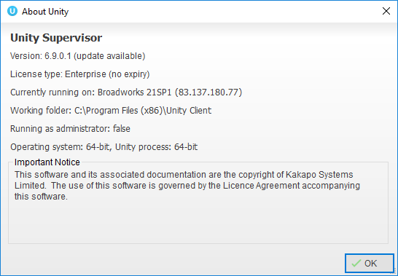
1.2 Naming Conventions for this Help

  - Call Center instances are also referred to as Queues in this guide
  - ACD calls mean incoming calls into the call center/queue
  - BWKS means the BroadSoft BroadWorks platform
1.3 System Requirements
1.3.1 Windows PC Requirements
- Unity will require approx 500MB of hard drive space on the local machine
- By default the install directory is C:\Program Files (x86)\Unity Client
- Minimum computer spec: CPU: dual core 3Ghz. Ram: 4GB. Video Card: 256MB onboard RAM. As a general note, the requirements to run Unity Supervisor are considerably less than those required to run Windows
- Unity can be rolled out as an MSI file, which supports Active Directory group profiles
- Unity is only supported on Windows 8.1, Windows 10 and Windows 11
- Both 32 and 64-bit versions of Windows are supported. There are no special permissions required to install Unity
1.3.2 Internet & Firewall
Unity requires high-speed internet connectivity and access to the below locations, which may require firewall rules to be added on the customer premises:
- TCP port 2208 to im.unityclient.com
- TCP port 2208 to the VoIP platform OCI server
- HTTP/HTTPS access to portal.unityclient.com
- HTTP/HTTPS access to the VoIP platform XSI server [if call recording, visual voicemail or enhanced call center reports are used]
1.3.3 BroadWorks Platform Requirements
- Unity Supervisor is supported on BWKS R17 SP4 and above
1.3.4 BroadWorks License and Service Requirements

Client Call Control
The Client Call Control service, assigned to the user, is mandatory as this is the service that allows Unity to integrate with the VoIP platform. If this service is not assigned, then the user will be alerted and Unity will not provide any functionality.
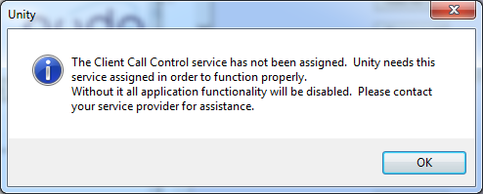
Internal calling line ID delivery & external calling line ID delivery
The Internal Calling Line ID Delivery and External Calling Line Id Delivery services should both be assigned as these services allow Unity to identify calls to/from other users in the business. If not assigned Unity will function, but the user will be prompted that this functionality will not be available.
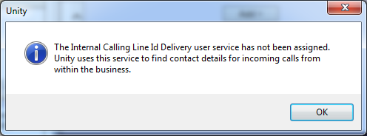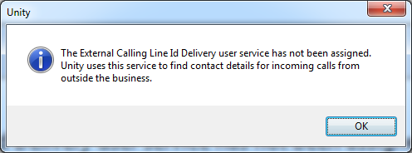

Call transfer
The Call Transfer service is required in order to blind or announce transfer calls to internal and external numbers. Unity will alert the user if this service is not assigned.
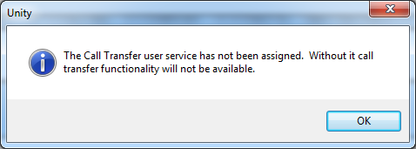

Three-Way Call or N-Way Call
Either the Three-Way Calling or N-Way Calling service must be assigned to provide conferencing functionality, Unity will alert the user if neither service is assigned.
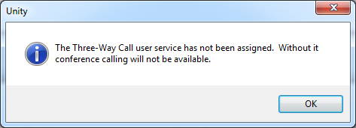

Basic Call Logs or Enhanced Call Logs
Either Basic Call Logs or Enhanced Call Logs must be assigned to the user in order to see dialled, received and missed calls. Unity will alert the user if neither service is assigned.
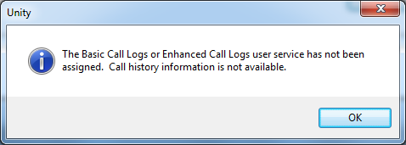
2 Initial Setup

The first time Unity is started you will be prompted to enter the configuration details, as shown below. Unity can then retain the connection and authentication details for later use. The Login ID and Password will be assigned from your Service Provider.
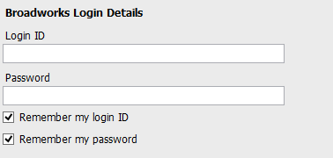

Next you will be prompted for the server address for your Service Provider. If this field is already populated do not change it. In most cases you can leave the Server Port as 2208. Leave the Unity Server Connection Details as those prefilled.
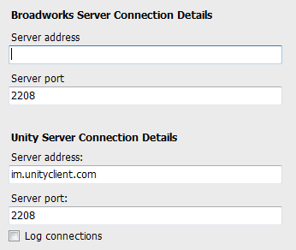

Restart Unity Supervisor to begin.
2.1 Call Center Login Details
Once Unity has been restarted it will connect to the host BroadWorks system and populate all the Call Center Instance IDs for the call centers that the supervisor is a member of as shown below.

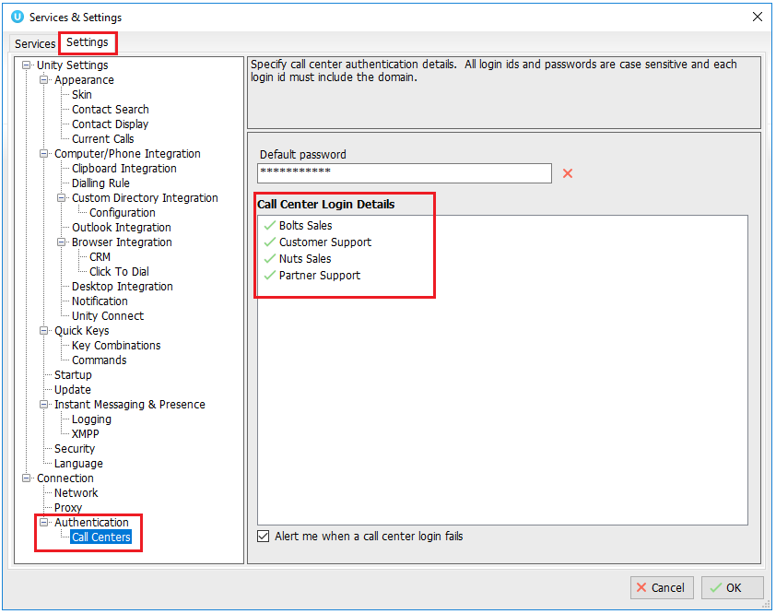

The password for each call center must be added in order to populate the call centers in the Personal Wallboard. Double click a call center to add the password. Where the password is the same for each call center click the “Apply to all queues without a password” box and restart. Unity will now login as the call center queues and you will see these begin to populate the Personal Wallboard.

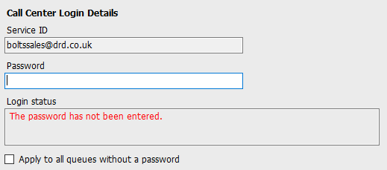

Ticking “Alert me when a call center login fails” will pop this dialogue box when Supervisor starts and cannot login successfully to a call center.

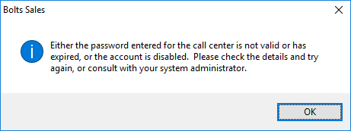
2.2 Call Center Login Default Password
If all call center passwords are the same, use the default password option. Enter the password for the call centers so that when a new call center is added in the future the supervisor doesn’t have to enter the call center password as Unity will do this automatically. Please note that all call center passwords have to be the same for this option to work.

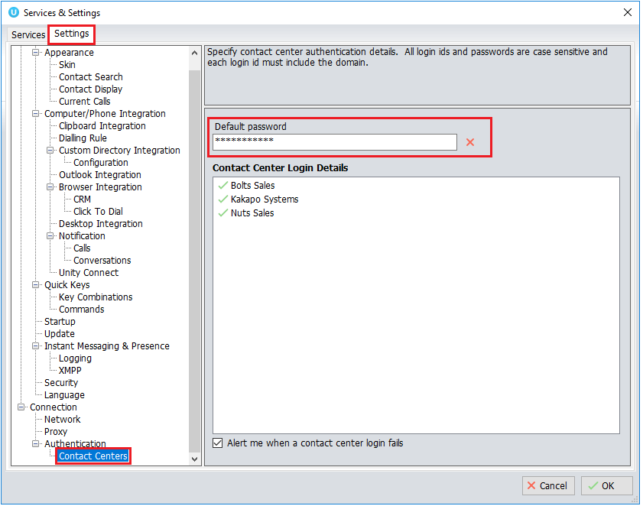
2.3 Selecting a Pre-Configured Template
User templates can only be created by an administrator to configure default settings for supervisors. ACD buttons, call center control, recording options and all other settings can be configured and saved as a template that can be easily assigned to all users.
Please see your Administrator for a separate guide on using Unity Templates.

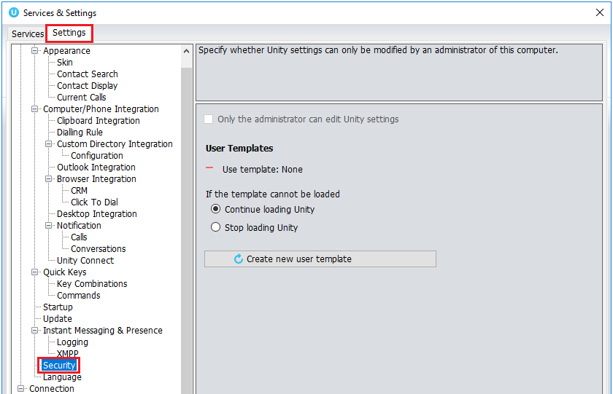

2.4 Manual and Auto Updates
Unity can be configured to automatically update when a new version is available. Simply tick the box in settings>update as shown below.
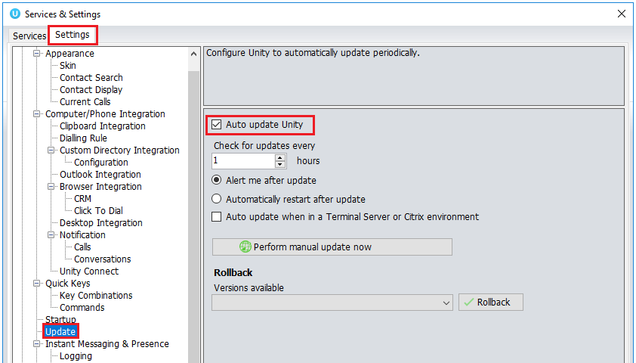

When a new version of Unity is available the user will be presented with a popup asking to restart Unity. Once Unity has restarted the latest version will be running. You can also configure how often Unity looks for updates under the auto update box.

To manually update Unity, click Perform manual update now and Unity will search for any new updates.
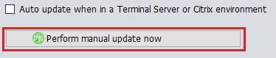
2.5 Rollback available
If rollback available is ticked in the Unity portal, then users can rollback to previous versions of Unity. Go to settings>update and the choose the desired version from the drop down menu.
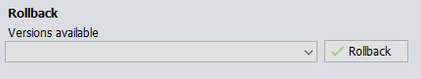

Once you’ve selected which version you want to rollback to click the green tick and the box below will appear.
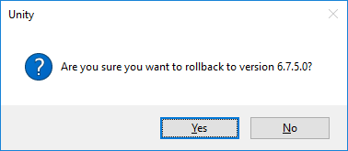

Click Yes and then click Ok.
3 Unity Supervisor Interface Overview

Unity is split into six functional areas; ACD Buttons, Call Control buttons, Personal Wallboard, Active Call Window, Contacts [Busy Lamp Field and Instant Messages]. Contacts is a tab that can be toggled to display Call Logs, Abandoned Calls and the Voicemail tab.

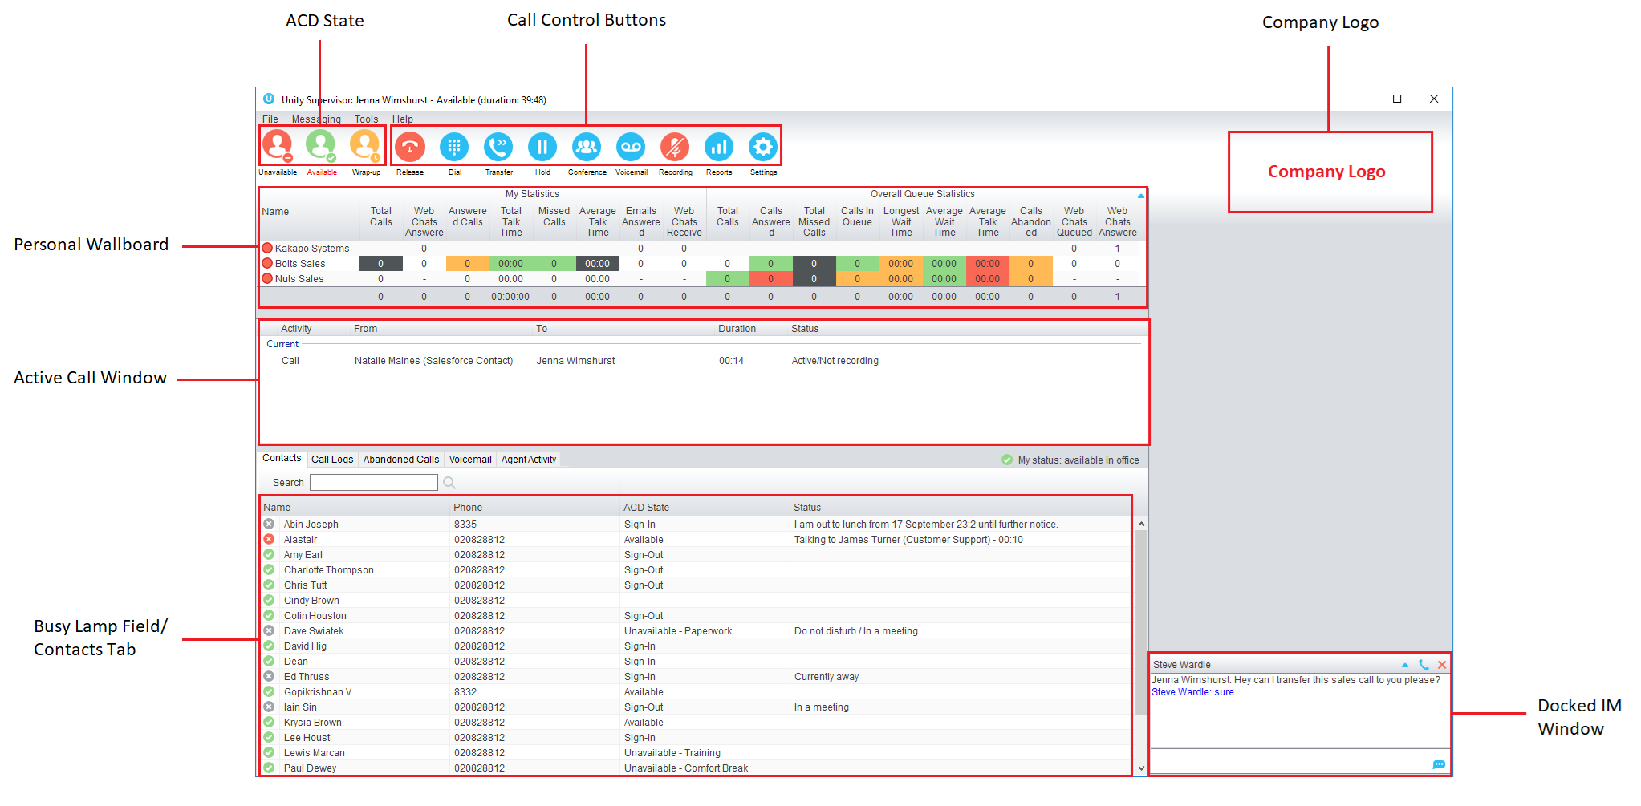
3.1 Resizing Unity Supervisor
Unity can be dragged from any corner to the required size. The Active Call Window resizes independently by dragging the border at the bottom of the list [where the lower red line is in the illustration above]. When Unity is closed, all current dimensions will be saved.
3.2 Maximising and Minimising
Unity can be maximised and minimised using the standard buttons in the top right hand corner of the application. When minimised, Unity appears in the system tray in the bottom right hand corner of the desktop where the Unity icon will be displayed. To re-open Unity simply double click this icon, or right click and select Restore from the menu, as shown below.
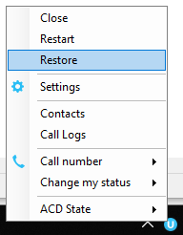
3.3 Using Unity Supervisor from the System Tray
In its minimised state, Unity Supervisor can be configured to sit in the System Tray. This is in Settings [button] > Settings [tab] Appearance.

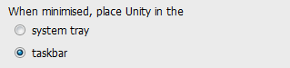

Right clicking the Unity icon in the system tray allows the user to dial or redial, configure settings such as CommPilot Express Profiles, DND, Call Forward Always or Remote Office, or change their ACD state. Note: Only those services that are assigned to the user in BroadWorks will be displayed.
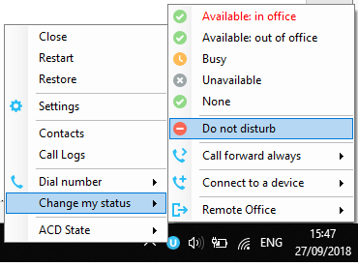
Selecting “Call number” will provide a list of the last 10 dialled numbers as illustrated below. “New number” will pop a call box where the user enters the desired number using their computer keyboard.
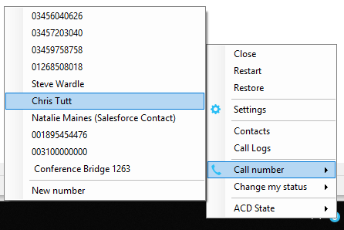
3.4 Call Notification Preferences
Unity Supervisor can be configured to pop when a call is presented, or pop a “toast” summary notification above the system tray when a call is presented. Optionally, Supervisor can also perform auto-answer when using click-to-dial. If this is not selected then the IP phone will ring and the user will have to lift the handset to initiate the outbound call.

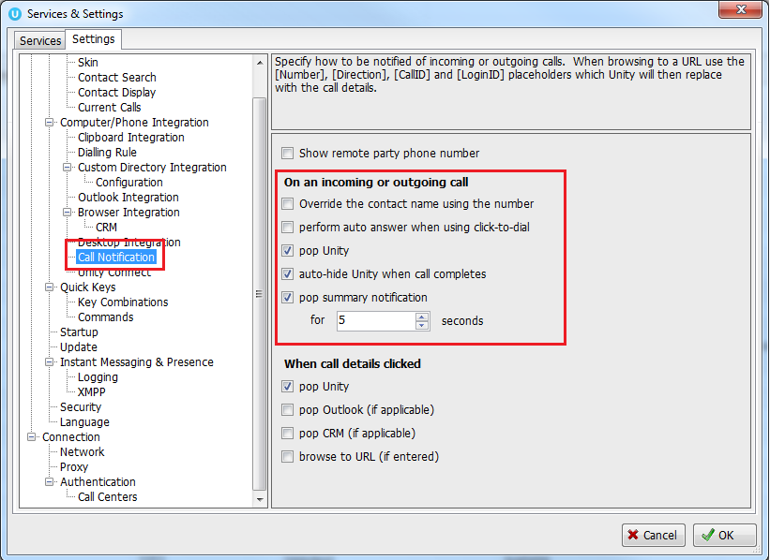
3.4.1 Show Remote Party Phone Number
This setting will configure to show the remote party number [if available], as shown below. This applies to both internal and external parties.

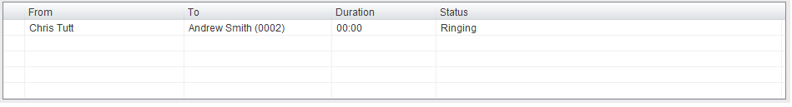
3.4.2 Override Contact Name Using Number
Unity can also perform a contact search based on the remote party number even if the name was provided by the Broadworks platform, this is especially useful when the name delivered through the PSTN is incorrect, for example in some cases this may always be “WIRELESS CALLER”.
3.5 Summary Toast Notification
The summary notification is presented for hunt group, ACD and DID calls and can be used to route the call to voicemail or answer the call.

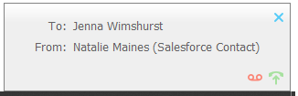
3.6 Browser Screen-Pop
The summary notification is also clickable and can be used to open the PC default browser to a preconfigured URL and append incoming call information, such as the phone number of the remote party. This feature can be used for screen popping CRM systems and other browser based applications. Further information on this feature is in a supplementary guide.
3.7 Appearance
In Settings [button] > Settings [tab] > Appearance, the user can change the behaviour of Unity.

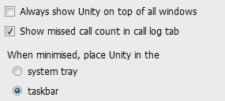

Always show on top of all windows – Unity will always be on top
Show missed call count in the call log tab – When enabled Unity will provide a count of the number of missed calls as below

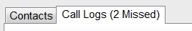

Show remote party phone number – This will show the phone number and the name [if matched] in the “From” field
3.8 Skins
In Settings [button] > Settings [tab] > Appearance > Skin, the user can change the look of Unity with preset Skins.

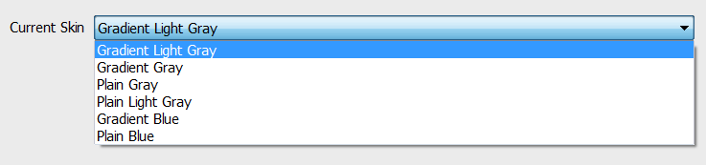

4 Main Interface Elements
4.1 ACD State Buttons
ACD State buttons for setting the supervisor’s availability to the call center. When clicking “Unavailable” the user will be presented a list of unavailable codes as configured in BroadWorks.
Please note this is only available if either Call Center Agent Standard or Premium service is assigned to the user.

4.2 Call Control
Call Control buttons provide quick access to common telephone handling commands. Only services that are assigned to the user are displayed. For example, if Call Recording and Voicemail are not assigned then the buttons will not be displayed.

4.3 Active Call Window
This provides a list of all current calls and their state. For example, Ringing, Active or On Hold. The duration of the call is also displayed. This is from the moment the call was first placed and does not reset when a call is Held or Retrieved. Unity will mirror any call handling made on the user’s IP phone. For example, if the call is placed on Hold on the handset, the user will show as being on Hold in the Active Call Window.
4.4 Contacts [Busy Lamp Field]
This panel will display up to 30 monitored users, displaying their Do Not Disturb [grey], Available [green], Engaged [red] or Ringing [orange] state as icons.
4.5 Call Logs
Toggling the bottom Contacts panel to Call Logs will display Missed Calls, Received Calls and Dialled Calls. Missed Calls will include both direct inward DID calls, ACD and Hunt Group calls. 20 numbers can be stored unless the user has Enhanced Call Logs service assigned.
Call Logs can also be cleared, reloaded or exported with the icons at top right of the panel.
4.6 Abandoned Calls
A Supervisor can assign abandoned calls to an Agent for a call back. These will be listed in the “Abandoned Calls” tab. Right click these calls to assign them to an Agent or double click to make the outbound call. If the Supervisor is a member of BroadSoft premium call center using DNIS, then Unity will automatically change the outbound CLI to be that of the DNIS queue. Right click the call to mark as processed and remove from the abandoned call list.
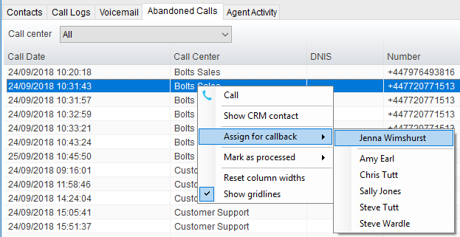

4.6.1 Previously Abandoned Calls
Unity will show if the current queued calls were previously abandoned, as shown below.
4.7 Voicemail
Clicking into the Voicemail tab will display a list of voice messages with the most recent at the top. Double click an entry to play through the PC’s default media player. Right click to save locally or delete.
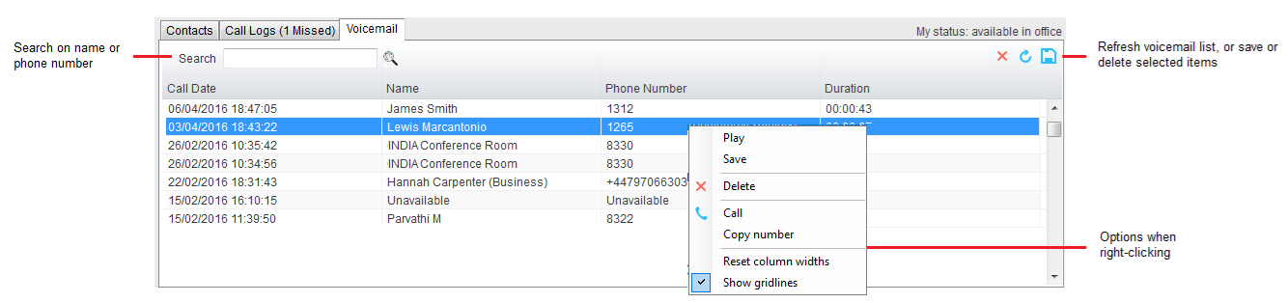
In order for the Voicemail tab to appear, Supervisor must be configured for “Use unified messaging” and “Show visual voicemail tab” in Voicemail settings as below.

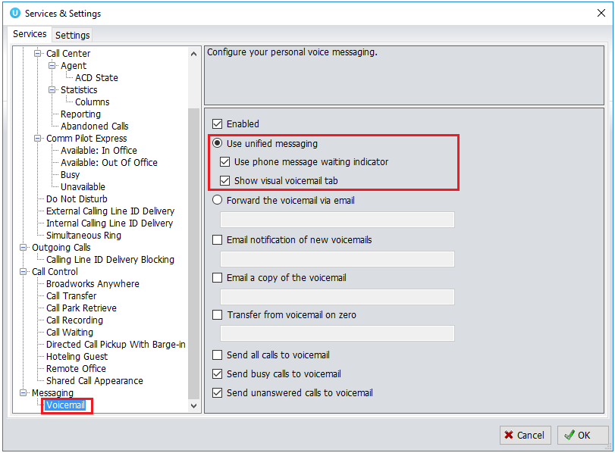

4.8 Personal Wallboard
If the Supervisor is not also an agent for the queue in BWKS, then they will not be able to Join/Leave or take calls for those queues. The Join/Leave status icon will show as grey and there will be no statistics in the “My Statistics” window as below.

When the user is also an agent
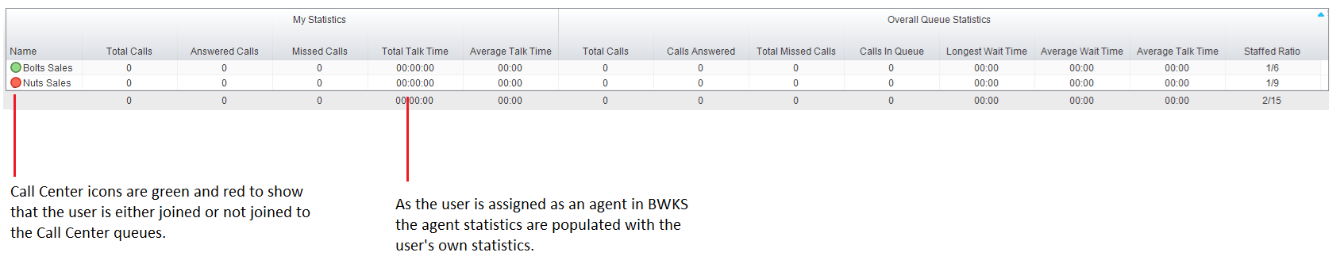

When the user is not an agent
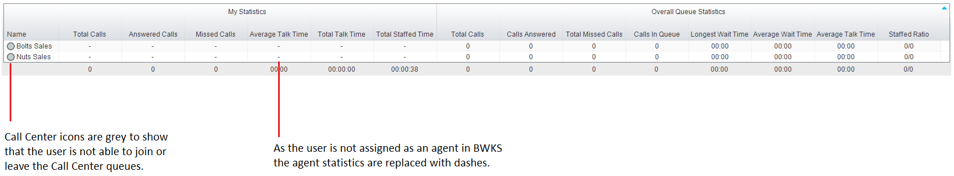

4.9 Using Personal Wallboard
The Personal Wallboard will show current performance metrics for the call centers the Supervisor is assigned to. The statistics are broken down by “My Statistics” which shows the Supervisor’s individual performance [assuming the supervisor is also an agent of the call center, as described above] and “Overall Queue Statistics” which will show the current conditions across the entire call center[s]. The icon at the upper right hand corner of Personal Wallboard toggles between showing all call centers individually [Maximized View] or a summary of all call centers combined [Minimized View].
Maximized View
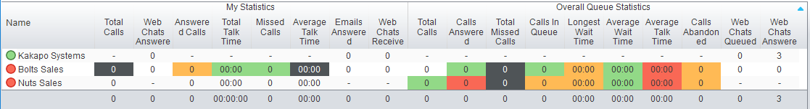
Minimized View
Note: Statistics shown in Personal Wallboard reset every 24 hours at midnight.

4.10 Locking in Minimized State
To disable the ability to maximise and minismise the Personal Wallboard, activate “Only display summary statistics” in Settings > Call Center > Statistics as below.

4.11 Staffed Ratio
Personal Wallboard in Unity Supervisor includes “Staffed Ratio”, an additional stat that is not available in Unity Agent. For each queue, Staffed Ratio shows the total number of Agents that are available to take calls [i.e. that are Joined to the queue and have ACD state set to Available], out of the total number of Agents assigned to the queue in BWKS.
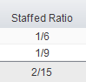

4.12 Longest Wait Statistic
By default, Unity Supervisor displays the “Longest Wait Time” stat. This shows the wait time of the longest waiting call in the queue. If there are no calls in the queue this will be zero. This stat can optionally be removed in Settings > Services > Columns > Call Center Columns. Click the statistics you want to remove then click the minus sign to remove it.

4.13 Statistics Refresh Timer
If the Client Call Control service is assigned to the queue in BWKS then the “Calls in Queue” stat [as shown in Personal Wallboard in Agent and Supervisor and Wallboard] will be a real-time stat. The “Longest Wait” stat is also real-time, in that it will start showing the wait duration in seconds for the longest waiting call in queue from the point it was displayed, so if there are no calls currently in queue then this statistic will be zero. All other statistics are polled from BWKS on a default 900 second timer. The timer can optionally be configured to a minimum level specified by the Service Provider with the minimum permissible duration being 60 seconds.

5 Call Center Agent Functionality

Unity Supervisor also allows the user to perform call center agent functionality such as changing ACD state, joining and leaving a queue and taking calls for that queue. This functionality is dependent on either the Call Center Agent Standard or Call Center Agent Premium service being assigned to the user, in which case the below functionality will automatically become available.
5.1 Changing ACD State
Clicking Unavailable, Available or Wrap-Up will change your availability for all queues you are a member of. This will not impact receiving inbound direct calls. The currently selected state will have the ACD state name in red text, as Available is in the below example.


5.1.1 Only Show One ACD Button
Unity Supervisor can optionally be configured in Settings > Incoming Calls > Call Center > Agent > ACD State to only display one ACD button, which will be the currently selected state. Left clicking will provide the other ACD options.

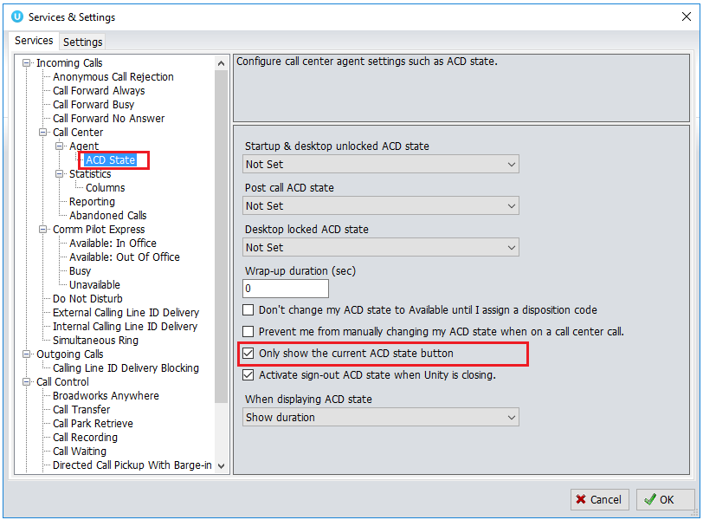
5.1.2 Assigning Unavailable Codes
When the supervisor selects unavailable, any unavailable codes that have been configured in BroadWorks will appear.

Unavailable Code assignment with one ACD button:
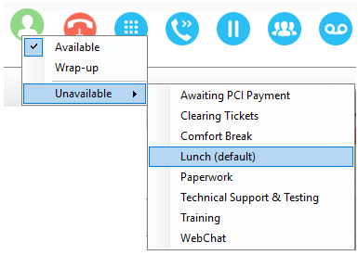

Unavailable Code assignment with three ACD buttons:
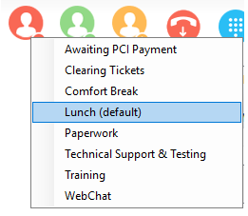
5.1.3 Force Disposition Code
To assign a Disposition Code the supervisor right clicks in the Active Call Window. Unity can force the supervisor to enter a disposition code by setting their ACD state post-call to Wrap-Up ACD state. When they click Available they get a drop list of Disposition Codes. They must choose one for the previous call before they can become Available. This feature is activated in Settings as below.

When Unity is configured to force the agent to assign a disposition code through a popup window which is automatically displayed to the user when the call is released.
The Unity UI will be disabled and the popup window will appear over all applications on the user’s desktop. A timer can be specified which will display a count-down to the user, and will automatically close once the timer duration has elapsed. When they click Available they get a drop list of Disposition Codes. They must choose one for the previous call before they can become Available. This feature is activated in Settings as below.

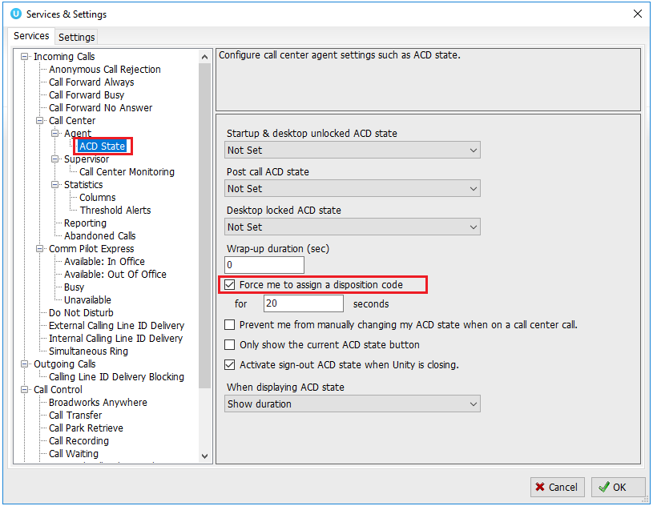

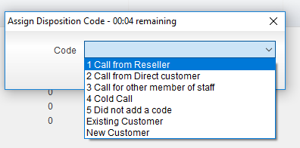
5.1.4 Displaying ACD State Duration
The top bar in Unity Supervisor will show the current ACD state as below.

This can optionally be configured to also display the ACD duration or the time that the ACD state was changed. This is configured in Settings > Agent > ACD State as below.
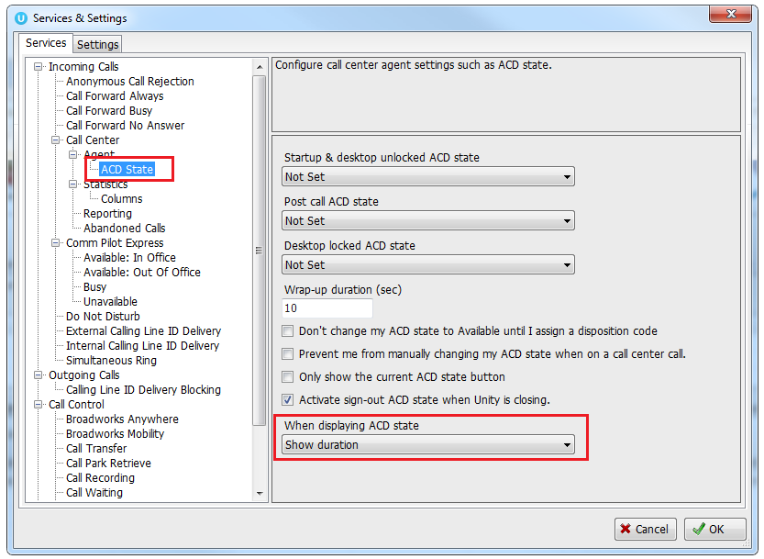
5.2 Using Personal Wallboard
The Personal Wallboard will show current performance metrics for the call centers the supervisor is assigned to. The statistics are broken down by “My Statistics” which shows the supervisor’s individual performance and “Overall Queue Statistics” which will show the current conditions across the entire call center[s]. The icon at the upper right hand corner of Personal Wallboard toggles between showing all call centers individually [maximized view] or a summary of all call centers combined [minimized view].

Maximized View
Minimized View

Note: Statistics shown in Personal Wallboard reset every 24 hours at midnight.
5.2.1 Locking in Minimized State
To disable the ability to maximise and minismise the Personal Wallboard, activate “Only display summary statistics” in Settings > Call Center > Statistics as below.

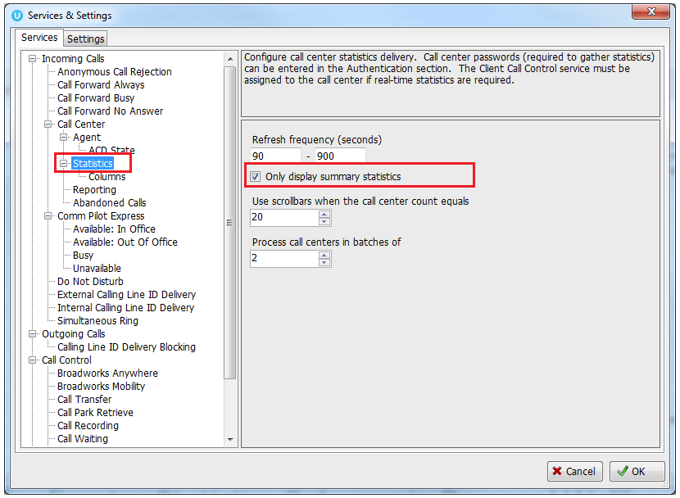
5.2.2 Configuring Statistics Columns in Personal Wallboard
The statistics shown in “My Statistics” and “Overall Queue Statistics” panels of the Personal Wallboard are configurable in Settings > Services > Call Center > Statistics > Columnns.
Statistics can be added or removed with the buttons and the order they are displayed, from left to right in the Personal Wallboard can be changed with the arrows. Topmost is to the left.

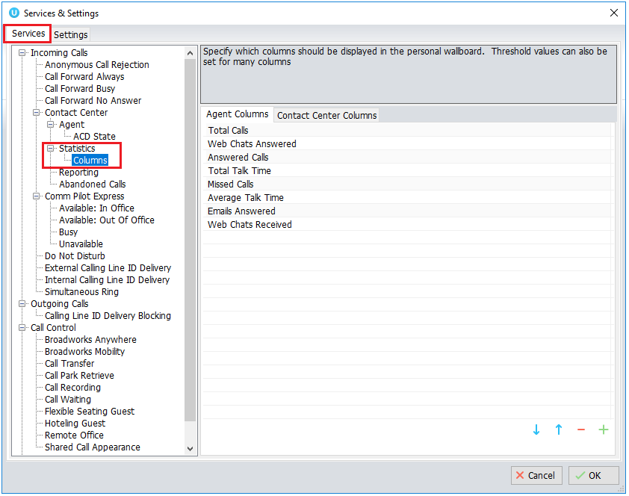
5.2.3 Customizing Statistics Label
Double click any statistic as displayed in the list above. From the below field you are able to customize the statistic label as required.

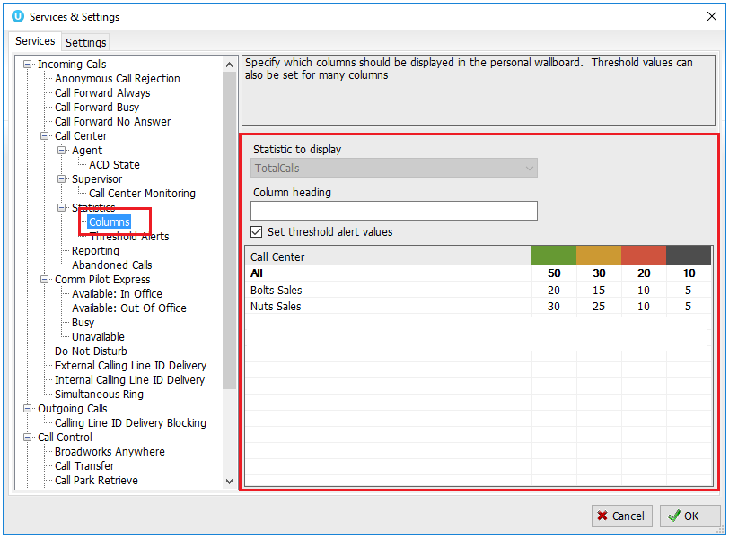

Selecting “Highlight non-zero values” will cause any value over 0 to be displayed in red. This has been activated for the “Total Calls” statistic below.

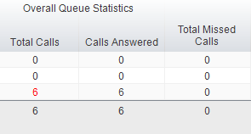
5.2.4 Configuring Alert Thresholds in Personal Wallboard
Double click any Statistic in Settings > Services > Call center > Statistics > Columns and tick “Set threshold alert values”. This will display a table where corresponding values can be configured that will progressively change the statistic background colour green, yellow, red and black.

Some statistics allow a different threshold to be set per call center, for example important queues can have lower thresholds.
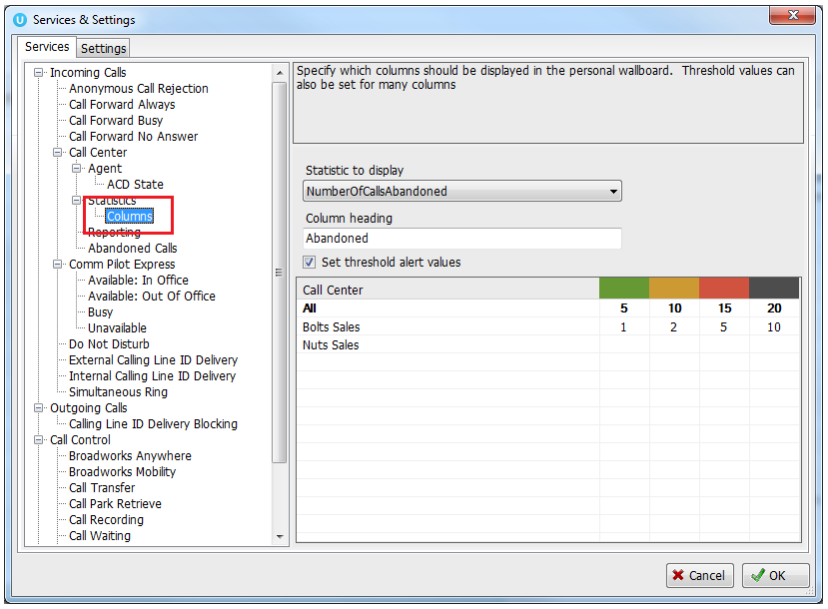

Double click an entry in the list to set overall threshold values or those for a specific call center.
In the example below statistics columns have been added, some have been renamed from the default and threshold alerts have been configured.

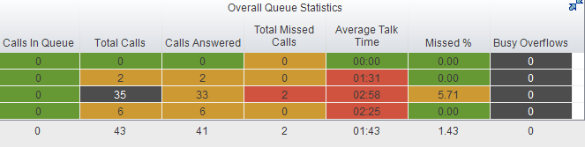
5.3 Joining & Leaving Queues
Right click any queue in the Personal Wallboard to toggle between Join and Leave queue. Queues that you are joined to have a green icon next to them. A red icon indicates that you are not joined to that queue.

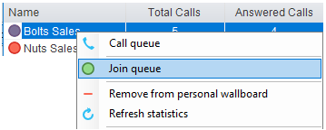
5.4 Receiving ACD Calls
Inbound ACD calls will display the call center name, as configured in BroadWorks, in the “To” field. The “From” field will display the incoming CallerID [if not withheld] or the name of the caller if that can be matched from the Directory. Answer the call by lifting the IP phone handset, clicking Answer/Release call control button or double clicking the call in the Active Call Window.

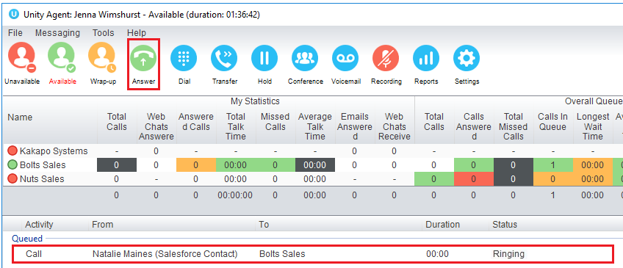
Hang up the IP phone handset or click Release  to end the call.
5.5 Using Disposition Codes
Unity will expose ACD Disposition Codes as configured in BroadWorks, to supervisors within the Active Call Window. The user can enter one or more Disposition Codes by right clicking the active call and selecting from the context menu. Disposition Codes can be entered while the call is active, or immediately after, when the call has ended and before another call is answered. Only Disposition Codes configured for the queue that the supervisor has answered are displayed.

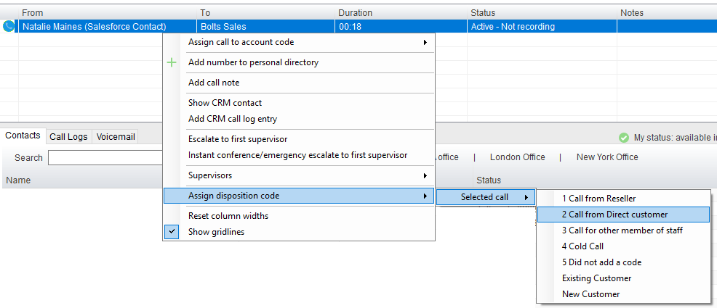

Disposition Codes can be assigned to the previous call either by selecting Assign disposition code > Last call as above, or by right clicking in the Active Call Window post ACD call as below.

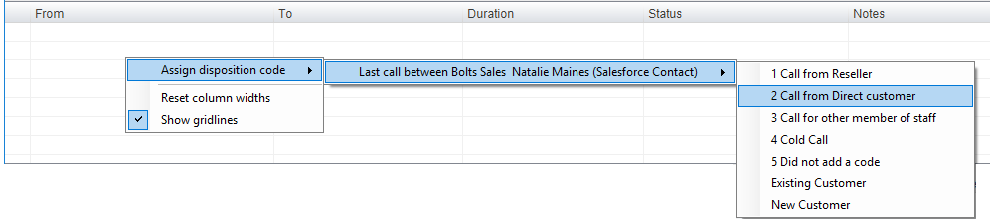
5.6 Auto Answer
Unity Supervisor optionally allows ACD calls to auto-answer when the supervisor is in the “Available” state. This is toggled on/off in Settings > Incoming Calls > Agent.
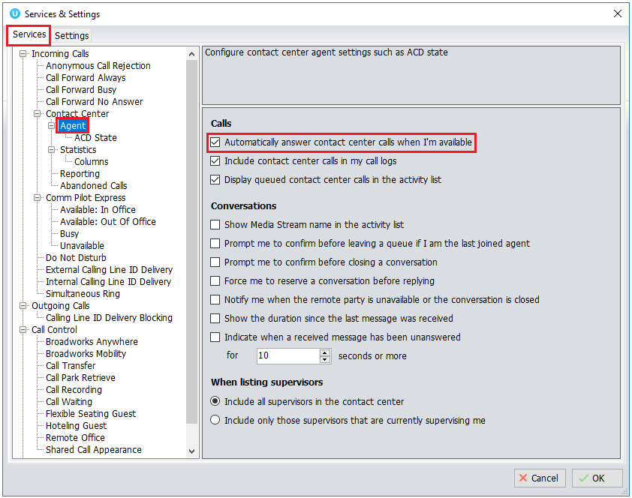
5.7 Supervisor Escalation
Unity Call Center Supervisor facilitates the BroadWorks call center escalation feature by allowing both standard and emergency call escalation. Both types of escalation can only be performed on call center calls and both inbound and outbound [DNIS] calls are supported. In either case, a user can only escalate a call to a supervisor if they are currently supervising them in BroadWorks. If this is not the case the user will be told [through the phone] that the supervisor is not a valid supervisor.
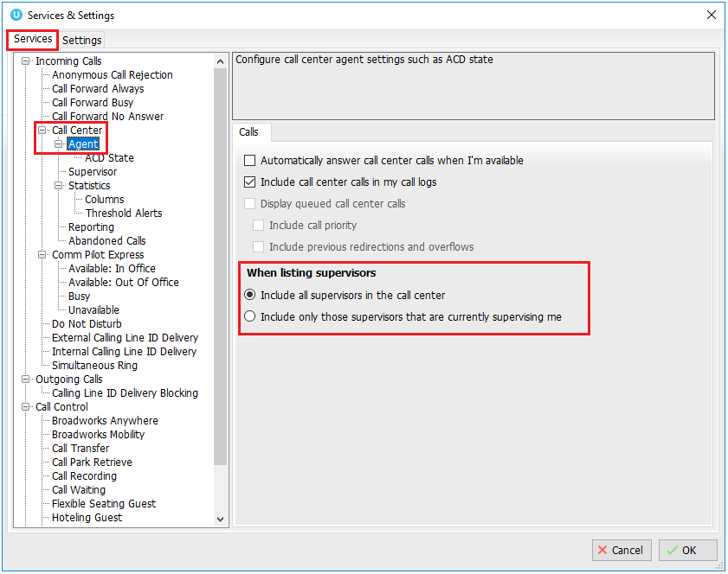
5.7.1 Standard Escalation
Standard escalation is used when an agent needs to be given information or instruction from the supervisor without conferencing in the remote party. Typically, the agent will release the call to the supervisor and replay the information to the remote party. Unity allows the call to be escalated to a specific supervisor or to the first supervisor that is available. The Agent’s Unity client will automatically place the ACD call on hold, then dial the extension of the supervisor as an escalated call. This call will then appear as an escalated call in all center reports. Standard call policy/routing rules will be used when calling the supervisor, such as DND, call forwarding and hoteling guest etc. At any time, the agent can release the escalated call, or can transfer or conference both calls together if required.
5.7.2 Emergency Escalation
Emergency escalation is used to immediately conference a supervisor into the call with the remote party, therefore it relies on either the 3-Way or N-Way Calling user service being assigned. When performing an emergency escalation, Unity will place any active calls on hold then dial the selected supervisor, or the first supervisor that is available.
5.7.3 Escalation via Active Call Window
To perform escalation, the agent right-clicks the call in the active call window, then either chooses the supervisor to escalate the call to:
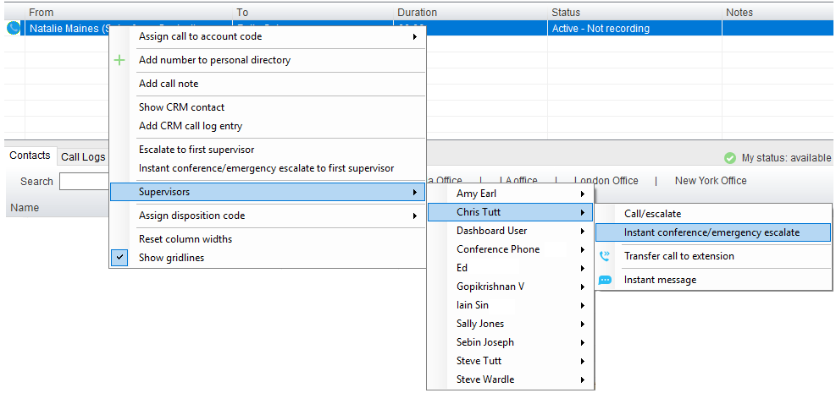

Or escalates the call to the first available supervisor.
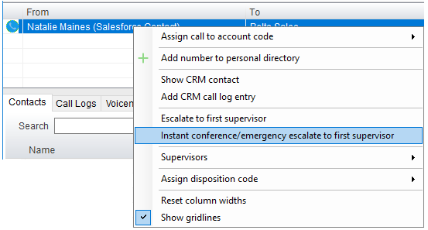
5.7.4 Escalation via Personal Wallboard
The supervisor can escalate a call center call by using the context menu displayed when right-clicking on the call center in the personal wallboard, as shown below. This assumes that Unity has logged in as the call center and is displaying statistics in the personal wallboard.

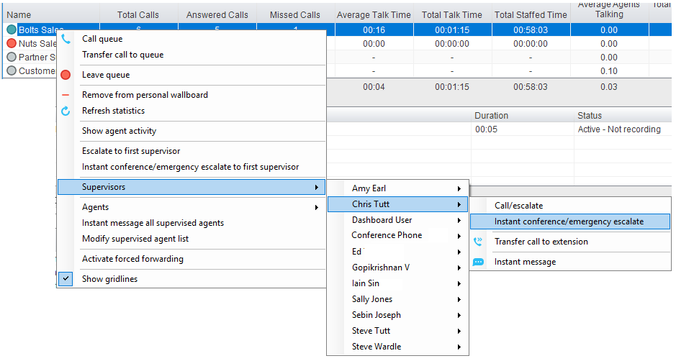

Please note that if the supervisor right-clicks on a different call center in the personal wallboard [to the one that the call was routed through] then the call escalation options will not be displayed.
5.8 Activating Outbound DNIS
If the supervisor is a member of BroadWorks call center premium queues, and the DNIS capability has been configured, then the user can select an outbound DNIS which will determine which outbound CallerID is presented when the supervisor makes external outbound calls.
Right click the Dial icon and mouse over “Change Outbound Number” at the bottom [the numbers above are a clickable list of last 10 numbers for redial]. The outbound DNIS that are available are presented. The currently selected outbound DNIS is ticked. This will affect all outbound calls until the outbound DNIS setting is changed, or set to none.

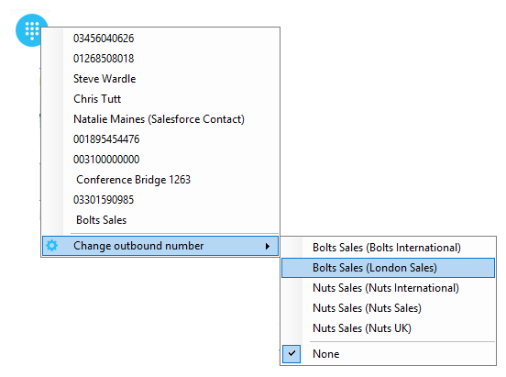
5.9 Personal Statistical Reports
Unity Supervisor provides access to the following agent reports (refer to section 6.8 for Supervisor reports):

Agent Activity Detail Report
Agent Activity Report
Agent Call By Skill Report
Agent Call Detail Report
Agent Call Report
Agent Duration By Skill Report
Agent Duration Report
Agent Sign In Sign Out Report

To access these reports, click the Reports button  or select Tools > Call Centers > Report Viewer from the menu. Specify the reporting period, click Tools > Call Centre > Report Viewer. From the Report Viewer interface [shown below] select the desired report and reporting period.

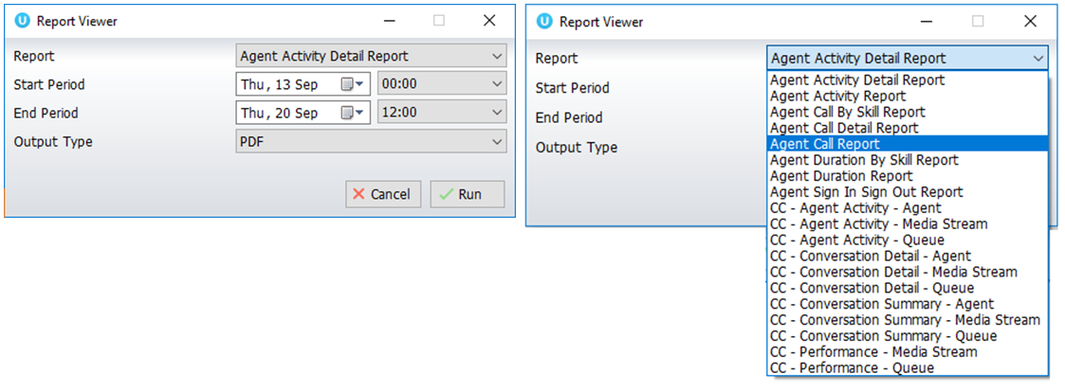
5.10 Pre-configuration of ACD State
Unity Supervisor offers a cascading hierarchy of supervisor availability settings that control the supervisor’s join and ACD status depending on the status of the host computer. This is in Settings > Services > Incoming Calls > Agent.
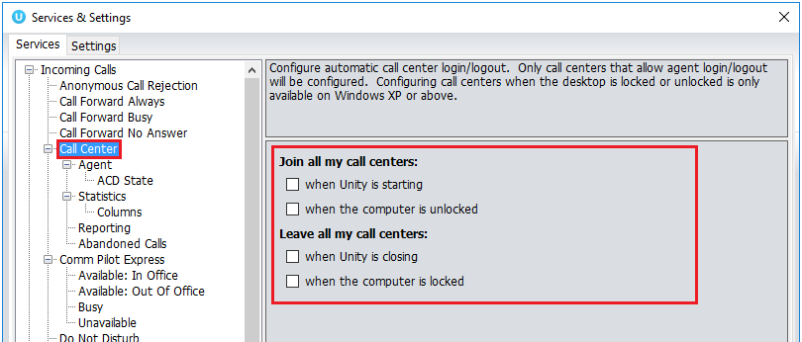

In additon, the ACD state can be configured for computer startup and unlock state, postcall state and desktop locked state.

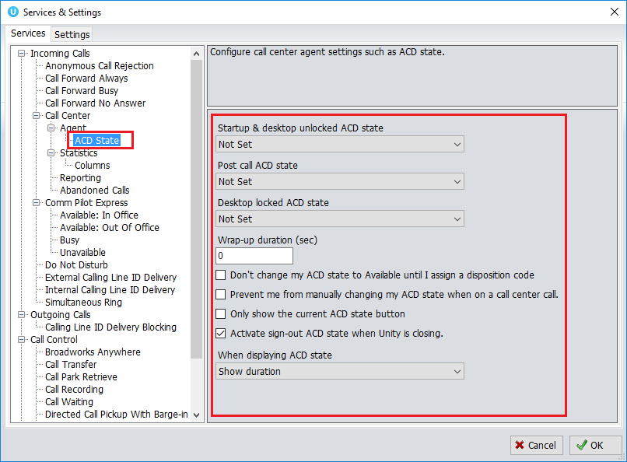

6 Supervisor Functionality

6.1 Remotely Changing Agent State
The supervisor can change the agent’s availability to the call center either from the Personal Wallboard, Tools menu or Agent Activity tab. The actions that are available are forcing the agent to Join or Leave specific queues and changing their ACD state, including the unavailable reason code if applicable. The supervisor can also specify an Unavailable code when selecting this state and Call or Instant Message the Agent from the drop list.

When providing the option to change a monitored agent’s ACD state or joined status, Unity will show if the agent is currently joined to the queue and what the current ACD state is, as shown below.

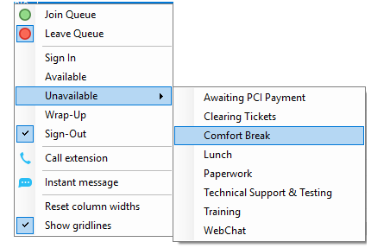

6.2 Remotely Changing Agent State from Personal Wallboard
Right clicking any queue in the Personal Wallboard will present a drop list of options. Hover over “Agents” to see a list of all agents assigned to the selected queue. Hovering over the agent in turn will present the supervisor options to Join/Leave the agent from the queue and change their ACD State.
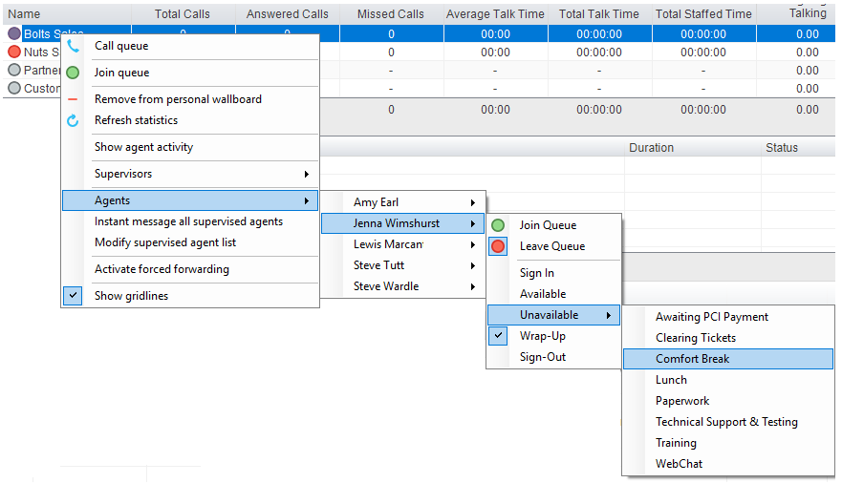

6.3 Remotely Changing Agent State from Agent Activity Tab
To display an agent’s queue membership and their current status, click the “Agents” radio button in the Agent Activity tab and select from the drop list. Right clicking an individual queue allows the supervisor to Join/Leave the agent to/from each queue or to change their ACD state for all queues that the agent is a member of.

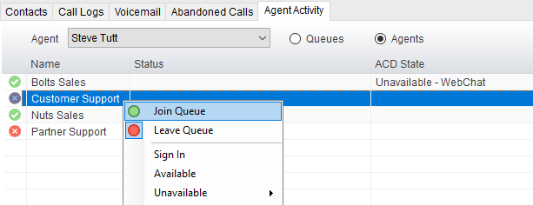

6.3.1 View Satistics and Set Thresholds Against Agents
All statistics in the Agent Activity tab are configurable and allow thresholds to be set against them. To add and remove statistics in the Agent Activity tab go to Settings>Statistics>Columns>Agent Activity. To set thresholds against a statistic, double click it and set the values.

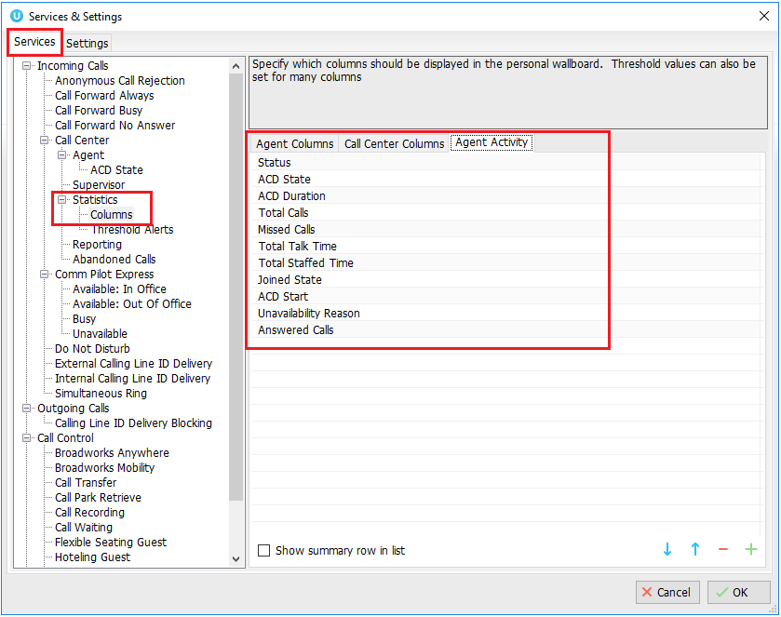

6.3.2 Changing The Agent’s Icon In The Agent Activity Tab
The Agent’s icon in the Agent Activity tab can be based on a range of states, for example, JoinedState which displays either red or green to represent whether the Agent is joined to the Call Center or not.

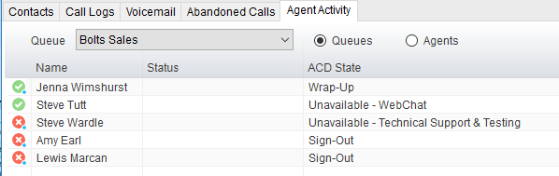

This is configured in Settings>Supervisor>Agent activity image based on, as shown below.
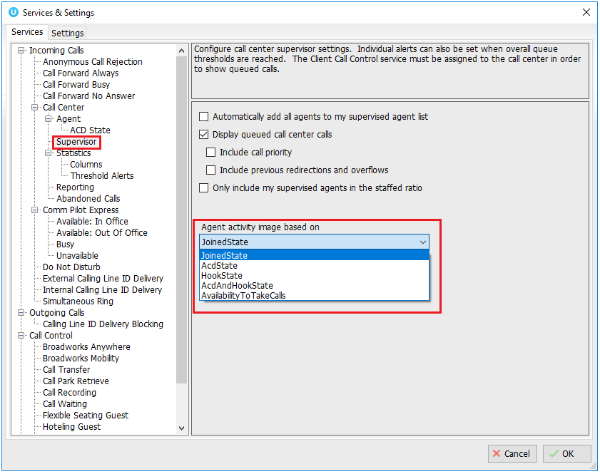

6.4 Remotely Changing Agent State from Tools Menu
Clicking Tools > Call Centers will list the call centers currently being supervised. Mouse over a call center > Agents to change the agent’s ACD state.
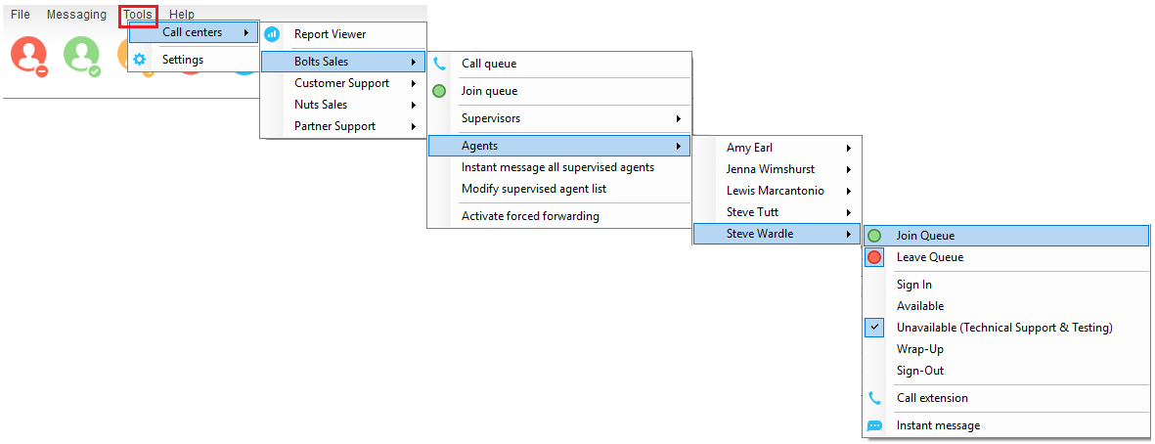

6.5 Threshold Alerts
Thresholds allow the supervisor to configure performance triggers against various parameters for all the queues they are supervising. These will not affect the call handling and construction of the queue, but are designed as a warning that the call center is experiencing abnormal behaviour and allowing the supervisor to take remedial action.

6.5.1 Configuring Thresholds
Click Settings [button] > Services [tab] > Statistics> Columns > Call Center Columns – double click the statics (e.g. total calls) to set thresholds. Different thresholds can be set for all queue parameters for different call centers, or all call centers can have the same threshold. Double click the boxes to populate the threshold value. Tick ok to confirm.
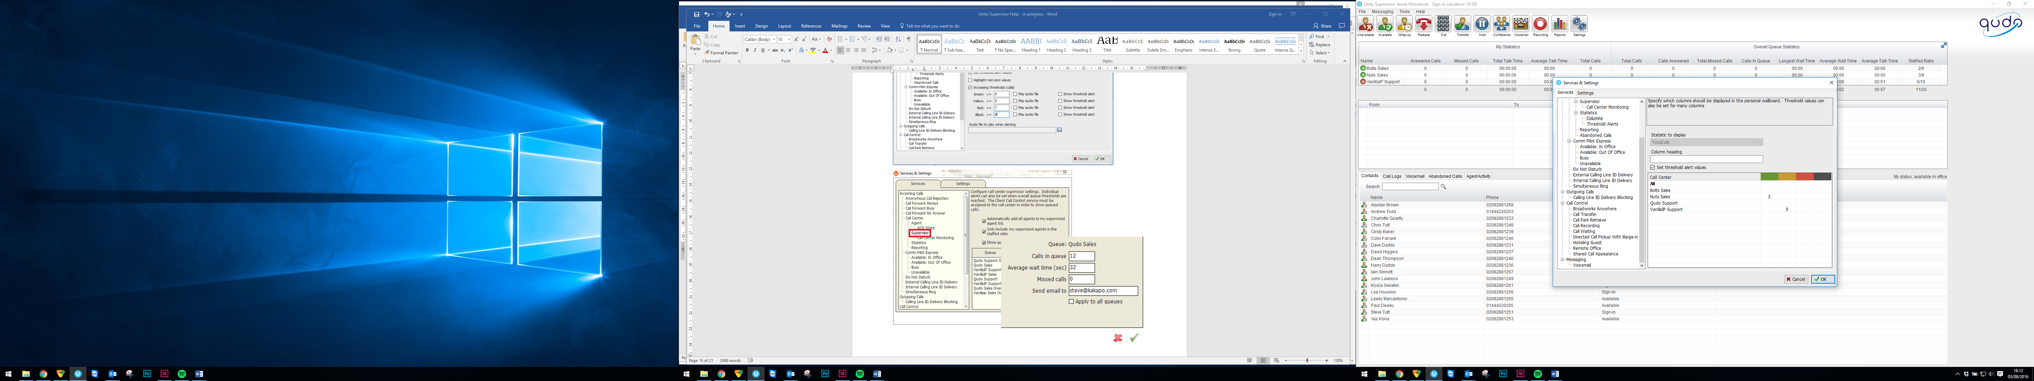

6.5.2 Alerting Options – Dialogue Box and Email
Unity Supervisor will pop-up a dialogue box indicating the threshold that has been breached.
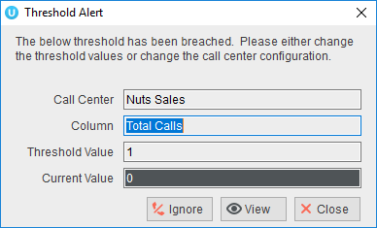

Supervisor can also be configured to show the alert in a toast notification.

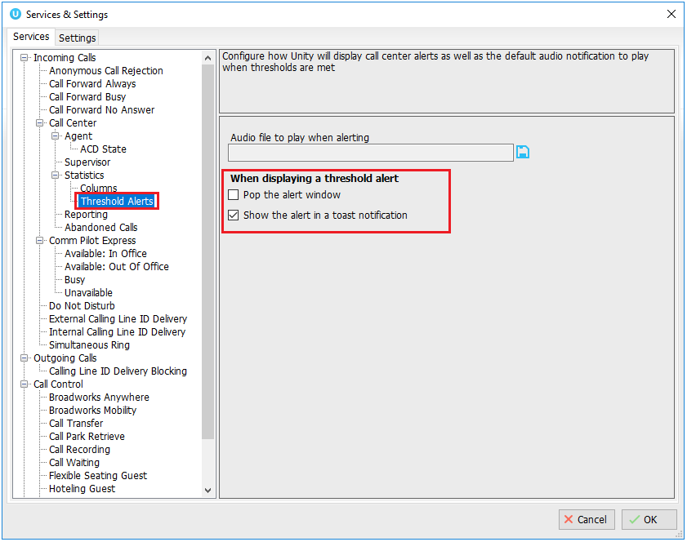

An audio alert can be set and used as a default, however this can be overridden for specific threshold values, as shown below.

Please note: An audio alert can only be set if a visible alert has been set.

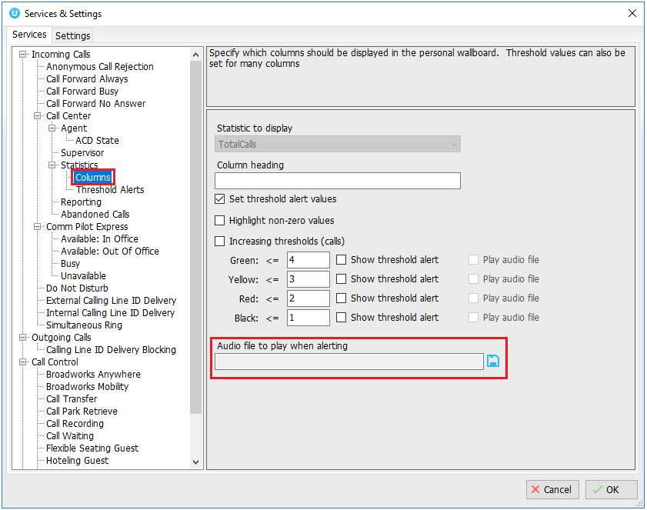
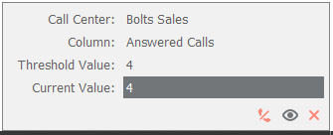

Audio and visual threshold alerts will only be activated if the applicable checkbox is checked in the threshold, so for example you can configure Unity to only play an alert if the red threshold value is reached.

Where the “Send email to” field has been populated, Supervisor will send an alert by email as below.

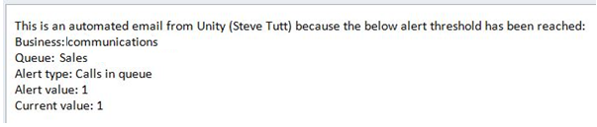

6.6 Silent Monitoring
Allows the supervisor to silently monitor the next call or calls taken by a specified agent. Requires the Call Center Monitoring service assigned to the Supervisor in BWKS. Requires Call Center Agent Premium call center.

To activate Silent Monitoring, right click the call center queue in Personal Wallboard > select the agent > select Next Call Only or All Calls.
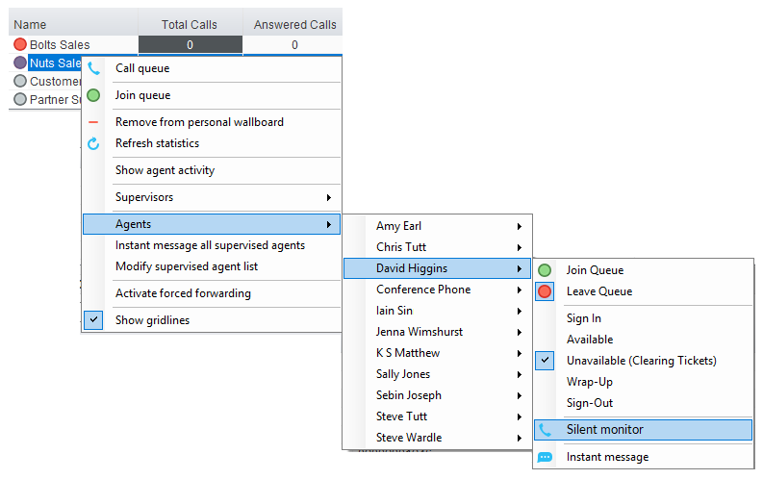
Silent Monitoring Warning Tone
The supervisor can optionally play the agent a tone to alert them that they are being monitored. This can be toggled on/off in Settings [button] > Services [tab] > Supervisor.

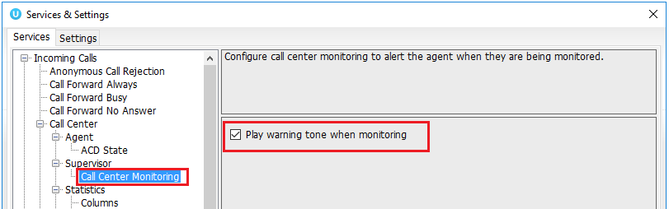

6.7 Configuring Statistics Columns in Personal Wallboard
The statistics shown in “My Statistics” and “Overall Queue Statistics” panels of the Personal Wallboard are configurable in Settings > Services > Call Center > Statistics > Columnns.
Statistics can be added or removed with the buttons and the order they are displayed, from left to right in the Personal Wallboard can be changed with the arrows. Top most is to the left.
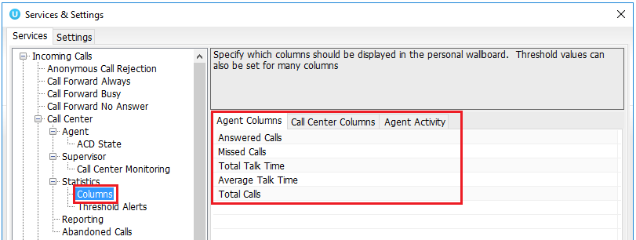

6.8 Running Reports
Unity Supervisor provides access to the real-time and historical reports provided by the BWKS DBS reporting server. The information in these reports is entirely produced by BWKS. To access reports click Tools > Call Centre > Report Viewer.

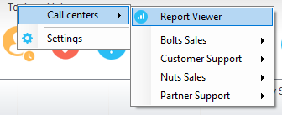

From the Report Viewer interface, select the desired report in the “Template” drop list.
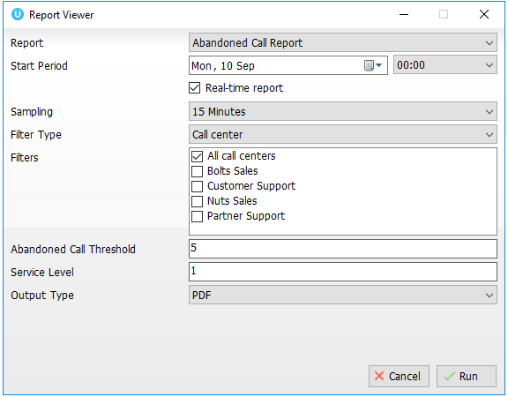

Supervisor reports include:

Abandoned Call Report
Agent Disposition Code Report
Agent Summary Report
Agent Unavailability Report
Call Center Call Detail Report
Call Center Disposition Code Report
Call Center Incoming Calls Report
Call Center Overflow Matrix Report
Call Center Presented Calls Report
Call Center Report
Call Center Summary Report
Service Level Report

6.9 Adding Agents to Monitored Agents List
By default, Unity Supervisor will take use of the list of supervised agents from BWKS. To monitor a specific subset of the total agents, go to Settings [button] > Settings [tab] > Supervisor and uncheck “Automatically add all agents to my supervised agent list” and restart Unity.

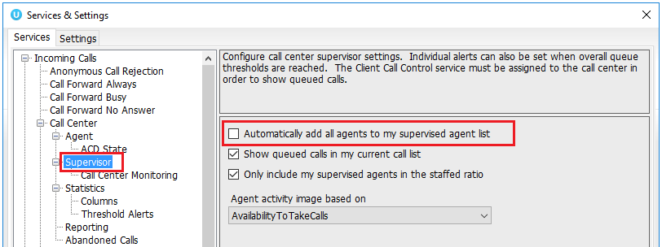

Right click the call center queue in Personal Wallboard, select “Modify supervised agent list” and add the agents you want to supervise.

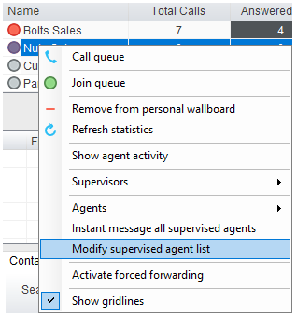

6.10 Supervised Agents in Staffed Ratio Statistic
The supervisor can optionally configure the “Staffed Ratio” statistic so that it only shows agents that are being supervised. In Settings [button] > Settings [tab] > Supervisor – check “Only included my supervised agents in the staffed ratio”. This means that even if there are hundreds of other agents available in the queue, the supervisor will only see how many of the agents they supervise are available in each queue through the staffed ratio statistic.

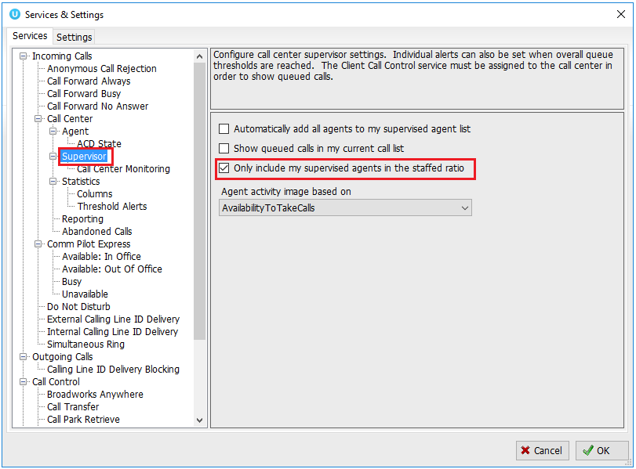
7 Call Control

All calls are managed through the call control buttons at the top of the application. These buttons will change depending on the state of the selected call, or the only call if there is only one call in the Active Call Window. For example, the Answer/Release   and Hold/Retrieve  buttons toggle as only one of these options will be valid at any time. When an inbound call is ringing Answer becomes the valid option. Once the call is active the icon will toggle to Release as hanging up is the only valid option.
7.1 Making a Call
7.1.1 Using the Dial Window
Click the Dial button  to bring up the Dial dialogue box, as shown below. Using the computer keypad enter the desired number and press Enter or click OK to make the call. The desk telephone will default to using hands-free speakerphone. If the telephone does not support speakerphone, you will need to lift the handset when the call is answered.
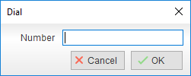
7.1.2 Using the Contacts Panel
Double click a user icon or right click and select “Call extension”
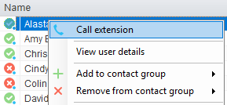
7.1.3 Drag and Drop
Right click a user icon on the Contacts panel and drag the icon up to the Active Call Window. This will open a call to that user. Calls can also be dragged from the Active Call Window onto a call center to perform a blind transfer. Calls dragged onto a monitored user will either be blind transferred or present options depending on the user preferences in Settings and whether the monitored user is engaged or not. For engaged contacts, park, camp-on and transfer to voicemail are available. For available contacts transfer to extension, transfer to mobile, transfer to voicemail or present call hold, camp on and transfer are available.
7.1.4 Using Directory Search
Enter the search field in the Contacts panel to dynamically search all internal users and speed dials. Either right click and select “Call extension” or right-click and drag the icon into the Active Call Window to make the call.
7.1.4 Dialling from the clipboard
Any number that is copied to the Windows clipboard, (highlight the telephone number, right click, then clicking copy) this will cause a popup toast above the system tray with the option to call the number. Click the toast notification to make the call. This feature can be enabled/disabled in Settings. When a number is copied to the clipboard, Unity can show a prompt to the user which appears over all applications, rather than show a toast notification. This can be configured through Settings>Settings tab>Clipboard Integration.
7.2 Answer a Call
When Unity displays an inbound call, click the Answer icon or double click the call in the Active Call Window to answer the call. Your desk telephone will now be on hands-free speakerphone, if it supports this feature with Unity. If there is an active call in progress, you will need to click the new inbound call in the Current Call List before clicking Answer, this will automatically place the first call on Hold. Please note that answering a call by lifting the handset on the desk phone will have the same effect as clicking Answer in Unity.
7.3 End a Call
Click the Release button to end the currently selected call. If there are multiple calls in the current call list, make sure you select the right call before clicking Release.

Note: Replacing the telephone handset will also end the call, which will then be removed from the Active Call Window.
7.3 Redial
You can also right-click the Dial button to see a list of the last 10 dialled numbers. Simply click on an entry to dial the party, as shown below.
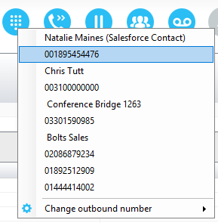
7.4 Send Call to Voicemail
To send an inbound caller directly to your voicemail click the Voicemail button.
Please note that if voicemail is not assigned or is disabled, the button will still be visible
but inactive.
7.4.1 Retrieving Voicemail Messages via VoiceMail Button
When no calls are currently selected, clicking the Voicemail button will dial the user into their voicemail. The phone will default to hands-free speaker phone if it has this capability.
7.4.2 Retrieving Voicemail Messages via Voicemail tab
Clicking into the Voicemail tab will display a list of voice messages with the most recent at the top. Double click an entry to play through the PC’s default media player. Right click to save locally or delete. In order for the Voicemail tab to appear, Supervisor must be configured for “Use unified messaging” and “Show visual voicemail tab” in Voicemail settings as below.

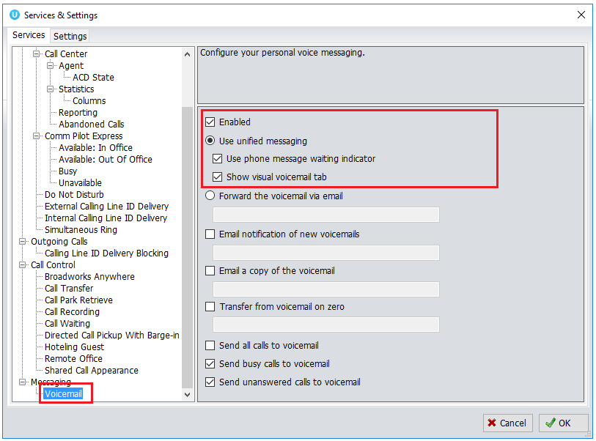
7.5 Transferring a Call
There are two ways to transfer a call; Announced Transfer, where you introduce the call to the receiving party before putting the call through, and Blind Transfer, where you transfer the caller directly to a recipient without introducing the call. Please note that calls can be transferred both to internal users and external contacts.
7.5.1 Announced Transfer
Receive and answer an inbound call. Make a new call to the desired destination extension or number as described Make a Call above. This will automatically place the first caller on Hold and will open a new call in the Active Call Window. Once the called party answers, click Transfer  and select the context menu option to transfer both calling parties together. Both calls will now disappear from the Active Call Window.
Note: The user is not limiting to transferring received calls. They can make two outbound calls and then use transfer to “bridge” them together.
Calls can also be transferred together by dragging one call on top of another within the Active Call List.

Example 1 – Transfer with two live calls
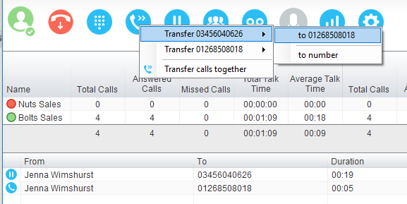

Example 2 – Transfer with four live calls
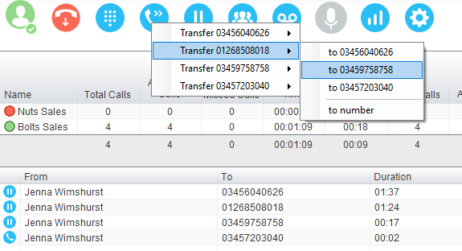
7.5.1.1 Warm Transfer
Unity Supervisor allows you to warm transfer a call by right clicking the user you want to transfer the call to and selecting “warm transfer” from the context menu. This will then put the original caller on hold and dial the selected number. When ready, click the transfer button in the call center control options panel and the two calls will be transferred, automatically disappearing from your active call window.

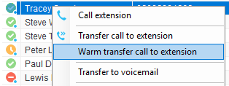

Please note that “Allow warm transfer through Unity” must be activated in order to see this option in the context menu. To do this go to Settings>Services>Call Control>Call Transfer, as shown below.
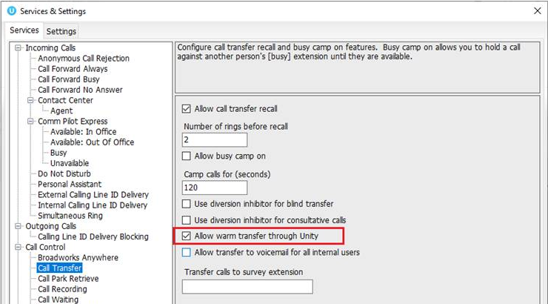

7.5.2 Blind Transfer
7.5.2.1 Using Contacts Panel Drag and Drop
Unity Supervisor can be configured to automatically blind transfer a call by dragging the call from the Active Call Window and dropping it on a user icon or number icon in the Contacts panel, or dropping it onto a call center queue [if supervisor is configured as an supervisor with call center queues].
Note: Unity can be configured to display a menu when dropping a call onto a user icon. If no menu options are selected the blind transfer is performed. If menu options are selected, click “Transfer call to extension” to also perform blind transfer. For more information on Drag & drop refer to section 9.
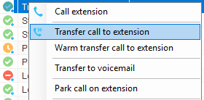
7.5.2.2 Using Transfer Button
Once on a call click the Transfer call control button. In the Transfer window enter the destination and click OK.
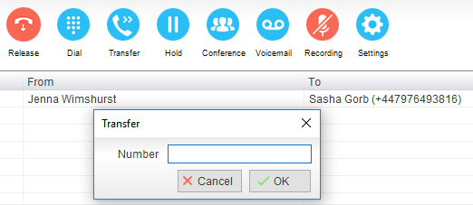
7.5.2.3 Using Right Click
While on an active call right click the recipient icon or number in the Contacts panel or Search. Select “Transfer call to extension” to blind transfer the call.
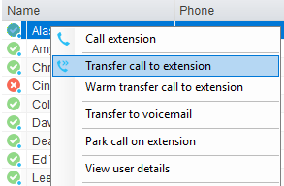
7.5.3 Transfer to Voicemail
The option to Transfer to voicemail is valid only for internal company users that have Voicemail assigned and activated.
7.5.3.1 Using Contacts Panel Right Click - Voicemail
While on an active call, right click a user in the User Status list and select “Transfer to voicemail”. This will send the selected call directly to the destination extension voicemail without introducing ringing.
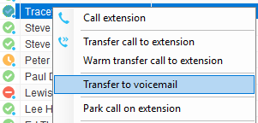
7.5.3.2 Using Drag and Drop
If configured, Unity will display “Transfer to voicemail” in the list when an active call is dragged onto the destination user icon in the Contacts panel. For more information, refer to section 9.
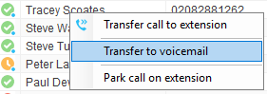
7.5.4 Transfer to Mobile
If the destination user has a mobile number entered as part of their profile in BroadWorks, you have the option to right click and select either Dial Mobile [to perform an announced transfer] or Transfer Call to Mobile [to perform blind transfer].
7.5.4.1 Using Contacts Panel Right Click - Mobile
Right click the desired user in the Contacts panel. To announce the call, click Dial Mobile. Once the recipient answers, click Transfer and select the context menu option to transfer the calls together. To blind transfer the call without introduction click Transfer call to mobile.

7.5.4.2 Using Drag and Drop
If configured, Unity will display “Transfer to mobile” in the list when an active call is dragged onto the destination user icon in the Contacts panel. For more information, refer to section 9.

7.7 Call Hold/Retrieve
The Hold/Retrieve function toggles depending on the status of the currently selected call. Hold is only available for an active call while Retrieve is only a valid option for a call currently on Hold. When a call is on Hold, the blue Hold icon is shown in miniature to the left of the call in the Active Call Window and the status is On Hold, as shown below.
7.7.1 Placing a Call on Hold
To place a current active call on Hold, press the red Hold button. The call status will now show as on hold in the Current Call List and there will be an On Hold icon alongside the call.

7.7.2 Retrieving a Held Call
Click the held call in the Current Call List to select it. Click the Retrieve button to take the call off hold, you can also double click the call to retrieve it. Please note that any other active calls will be placed on hold before the selected call is retrieved, meaning you can toggle between call by double-clicking them in the Active Call Window.
7.7 Conference Calling
A conference call can be established with any combination of internal and external numbers. The total number of parties that can be supported is determined by service assignment. The Three-Way Calling user service supports conference calls with two other parties only while the N-Way Calling user service supports conference calls with more participants.

7.7.1 Starting a Conference Call
Once an active call is established [that you have either made or received] call a second person. You can do this by clicking the Dial button or double clicking a user in the Contacts panel or Search, or Call Log lists. Making this call will automatically place the first caller on Hold.
Once the second party has answered the call, click the Conference button  and a new conference will be created between you and the other two parties. This is represented in the Active Call Window as shown below:

Selecting either call and clicking Hold will place the conference call on hold, during which time the other callers can still talk to each other.
7.7.1.1 Adding Multiple Parties
Once you have a conference established you can add additional parties by calling them. This will place the existing conference on hold. Now click the Conference button . You will be prompted to add the new party to the existing conference as below.

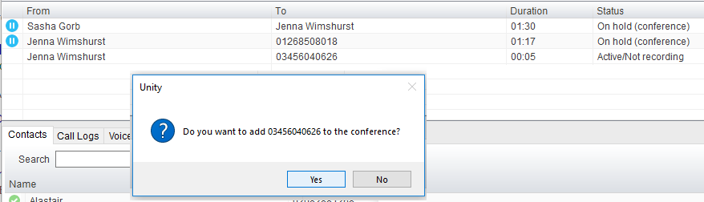

Please note that conference calls can be started with any two remote calls, regardless of the direction of either call or if the number is internal or external [for example between two mobile calls].
7.7.2 Ending a Conference Call
To remove a caller from the conference call but continue speaking to the other caller[s], simply select the call to release in the Active Call Window and click the Release button  as you would normally. This will release the selected party and will show only the remaining party[s] in the Active Call Window.
To end a conference call but leave the two remote parties in conversation with each other, click the Transfer button and select the “leave conference” menu option, as shown below.

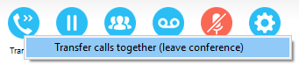
7.7.3 Conference Bridge Integration
Unity allows the user to right click the Conference button to view or copy details of their “reservation less” conference bridge(s), or to call a bridge as a moderator. If this has been configured in BroadWorks.
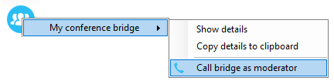
7.8 Call Recording
If the Call Recording User service is assigned then the user may be able to manage call recording, although this depends on the functionality offered by the VoIP platform and service configuration parameters. If this service isn’t assigned, then the Call Recording button is not displayed in the main window.
7.8.1 Changing the Call Recording Option
Right-click the Recording button to select the call recording option, as below. Please note that depending on permissions this may not be available.
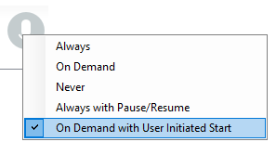

Call Recording options are:
Option | Description
Always | Calls are automatically recorded from the beginning of the call. There is no option to pause or stop recording.
On Demand | Calls are not automatically recorded from the start, but recording can be started at any time during the call in which case the entire call will be recorded.
Never | Calls are never recorded and recording cannot be started while a call is in progress.
Always with Pause/Resume | All calls are automatically recorded from the beginning of the call, but recording can be paused and resumed, which is especially important when taking credit card details over the phone [that need to be omitted]. This will still result in a single recording for the call, regardless of how many times it was paused and resumed.
On Demand with User Initiated Start | Calls are not automatically recorded from the start, but recording can be started at any time. However, any conversation before the recording was started will not be included in the recording. Recording can be paused and resumed, which will result in different recordings being created for a single call.

7.8.2 Controlling Call Recording
You can start, stop, pause and resume call recording depending on the Call Recording Option currently selected. Left-click the Recording button to manage recording for the selected call in the Active Call Window will toggle the option depending on the current recording state. The call recording button will change   to indicate this. When set as Always with Pause/Resume, the user can left click to Pause/Resume and the button will toggle as Resume [recording] or Pause .
When set as “On Demand With User initiated Start” left clicking the call recording button presents the following menu to allow the user to control the call recording behaviour.
Click the Recording button again to continue/restart recording the call.

The Active Call List will also indicate the recording state of all calls, as shown below.
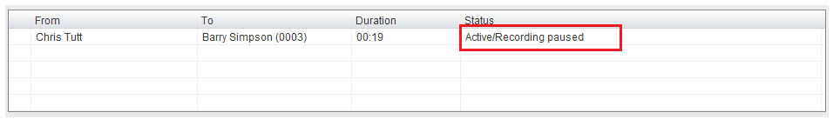

8 Active Call Window

The Active Call Window gives visual representation of the status of all calls the user receives or is currently managing.
8.1 Window Layout
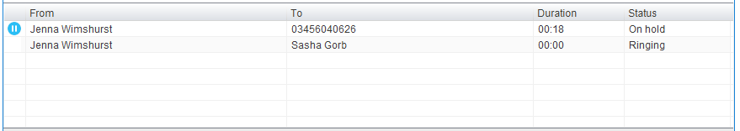

From – This field will display the incoming CallerID or the name if it is matched in the Group/Enterprise directory, Personal Contacts or Outlook Contacts.
To – This field displays the name of the user, hunt group or call center that has been called ensuring the call can be answered appropriately.
Duration – This displays the total time elapsed since the call was first answered. The timer does not restart when the call is placed on hold.
Status – This shows the Ringing/Active on On Hold status of each call.

8.1.1 Queued Calls/Calls in Queue
Users can optionally see all calls in queue for the Call Centers they are joined to, as shown below.
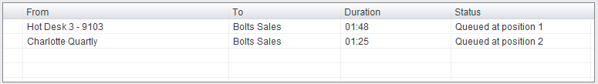

To set this go to Settings>Services>Supervisor and tick the relevant box. If the box is greyed out, then the setting “User can choose to see queued calls” needs to be enabled in the Kakapo Portal underneath the Branding section.
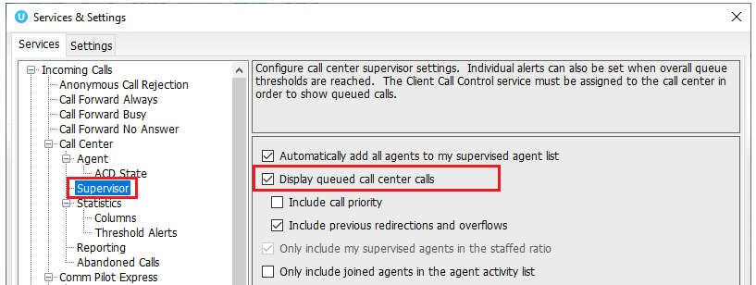

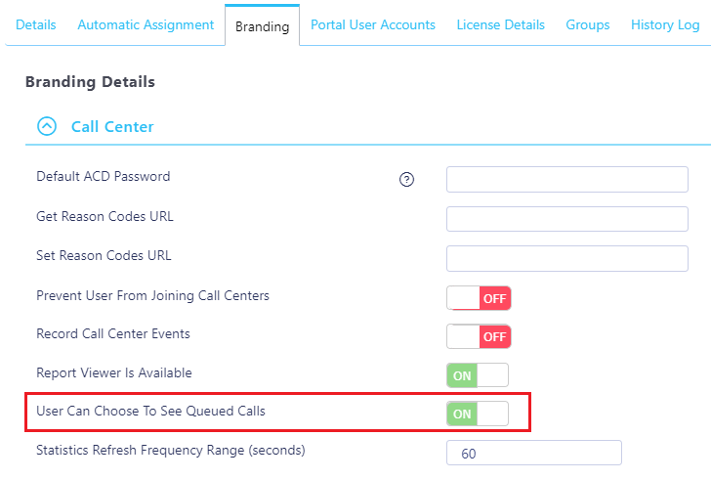
8.2 Managing Multiple Calls
To manage a particular call, first select it by clicking it in the Current Call List. If there is only one call in the list it will be selected automatically. You can then use the call control buttons to perform different actions on the call. There is no limit to the number of calls that can be displayed in the Current Call List, this is limited by the number of simultaneous calls allowed and if the Call Waiting user service is assigned and active.

You can also double-click an incoming [unanswered] call to answer it, or to retrieve it if currently on hold.
8.3 Resizing the Current Call List
The bottom border of the Current Call List can be dragged down to display as many or as few calls as necessary. Unity will save these dimensions when closed. Unity can automatically resize itself to include all calls, as well as group waiting and queued [if applicable] calls together, as shown below.
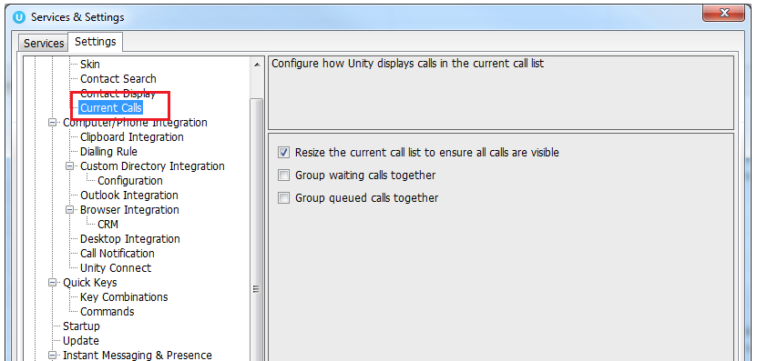
8.4 Assigning an Account Code
Account codes can be assigned to a call through the Active Call Window as shown below, please note that Unity must place the call on hold in order to assign the account code, then will attempt to retrieve the call although this isn’t always possible in which case the user must retrieve the call using the phone.

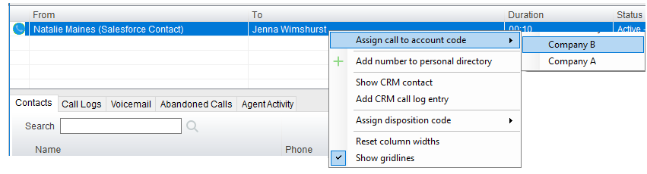
Unity will display a notification to indicate that the call was successfully assigned to the account code.

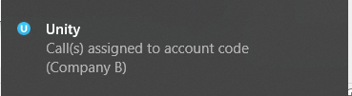

9 Drag and Drop

Many common call handling actions can be performed with drag and drop, as well as right click and call control buttons.
9.1 Make a Call to a User or Number
Drag a user icon or a speed dial shortcut icon from the Contacts panel up into the Active Call Window to make a new call to the selected user or number.
9.2 Transferring a Call to a User
Drag a live call onto a user to either perform blind transfer, or to populate a drop list with call handling options. The drag and drop behaviour for this action is configured in Settings as shown below.

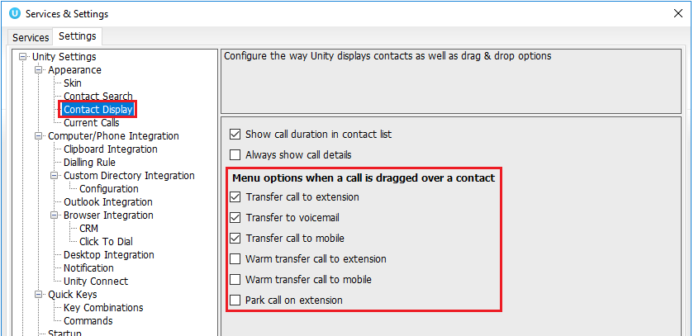
9.3 Make a Call to a Call Center Queue
When the supervisor is configured as an agent, drag a call center queue from the Personal Wallboard to the Active Call Window to make a call to that call center.
9.4 Transferring a Call to a Call Center Queue
If supervisor is configured as an agent, you can drag a current call in the Active Call Window up and drop it on a Call Center in the Personal Wallboard. This will blind transfer the call to the call center.
9.5 Send to Voicemail
Dragging an unanswered call from the Active Call Window onto the Voicemail button will blind transfer the incoming call to your voicemail.
9.6 Call Control
Dragging a call over the Hold/Retrieve, Answer/Release, Transfer or park buttons will perform that action on the selected call.
9.7 Send New Instant Message
Drag a user to the docked IM window to the right of the Contacts panel to send an IM to that user. This requires that the “Always show docked panel” field is ticked in Settings > Instant Messaging and Presence.

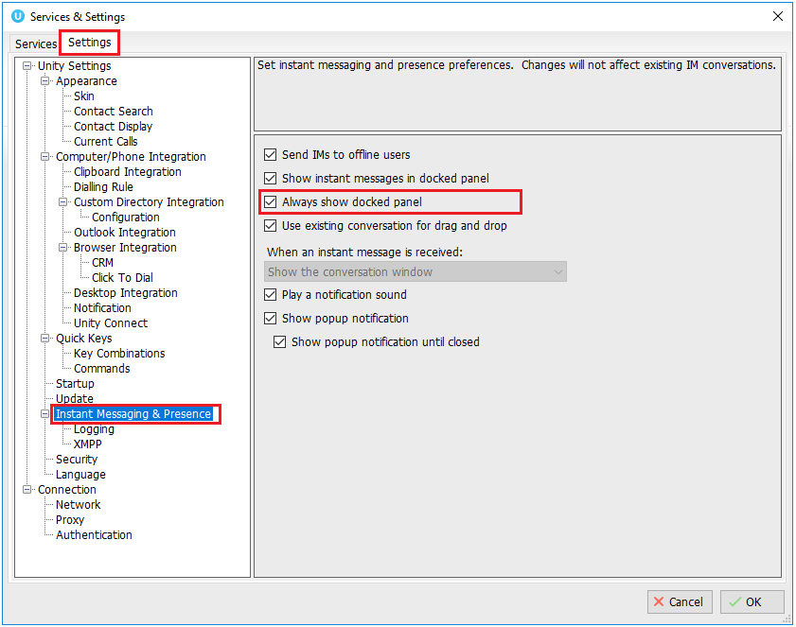

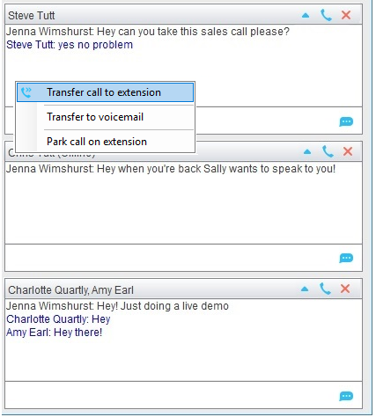

See also section 11 on Instant Messaging.
9.7.1 Add Participant to Existing IM Session
Drag a user icon onto an existing IM and choose “Add to the conversation”

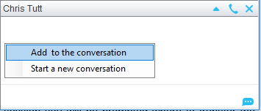
9.7.2 Transfer Call to IM Participant
Drag a call from the Active Call Window onto an IM session in the Docked IM Window and you will see a prompt to transfer the call. This is particularly useful if you want to check the recipient’s availability before you transfer.
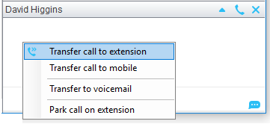

When dropping a call onto a multi-party IM session you will be prompted where to transfer the call.
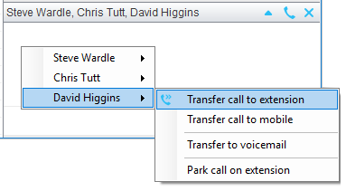
10 Contacts Panel [Busy Lamp Field]

The Contacts tab gives a visual indication of the status of users [within the group/enterprise] that are currently being monitoring. A maximum of 30 users can be displayed. Double clicking a monitored user will call them and right clicking will bring up a dynamic options menu.

10.1 Contact Panel Display Options
There are four different views available, as outlined below. Right-click anywhere in the Contacts panel and select Appearance list to change the view.
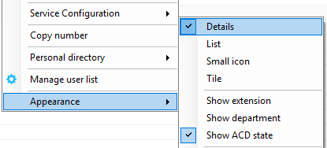

10.1.1 Details View
This view provides by far the greatest amount of detail, but requires more space [although the list can be shortened in which case scrollbars will automatically appear].
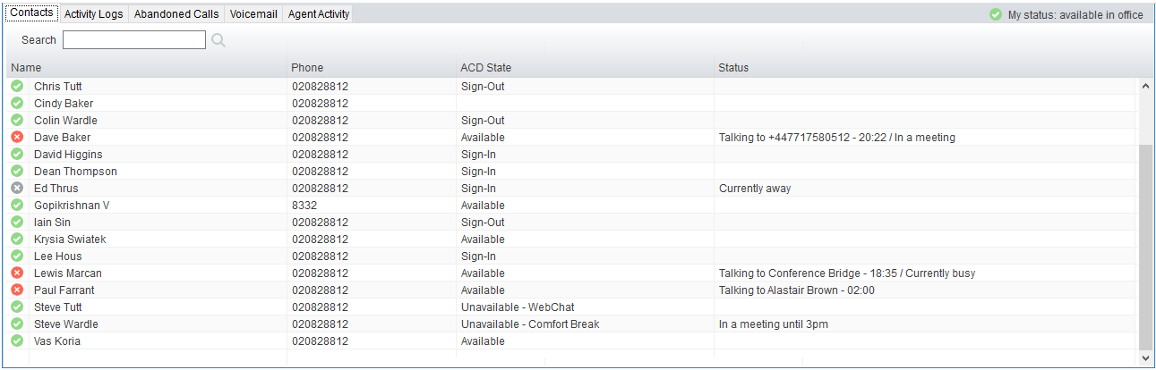

With this view the sort order for each column can be set, which is saved when Unity is closed. You can also configure Unity to display or hide the extension, department, ACD state and call duration columns.
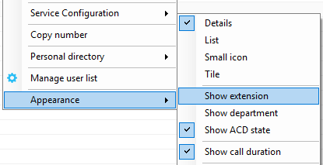
10.1.2 List View
This option will display all users in a list.
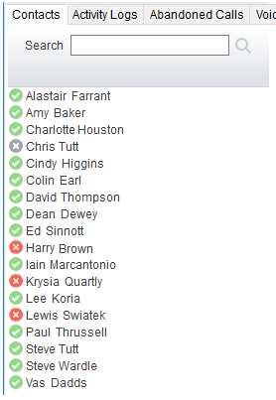
10.1.3 Small Icon View
This view combines a simplified look and space reduction.
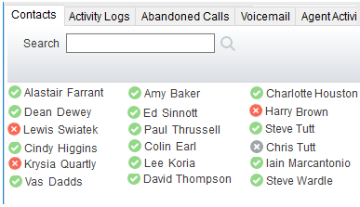

10.1.4 Tile View
This view is similar to Icon view but uses more white space to provide a cleaner look.
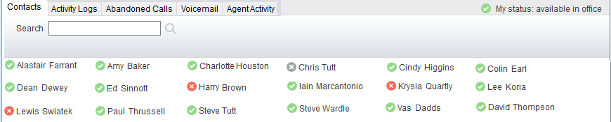

In both the Icon and Tile views, hovering the mouse over the image will provide more information about the monitored user, for example their service configuration:

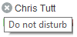
10.2 User Icons
There are four main user icons states shown in the Contacts panel, regardless of the view chosen.
 | Available | The monitored user extension is on hook
 | Ringing | The monitored user extension is ringing
 | Engaged | The user is on the phone
 | Do Not Disturb | The user has selected DND or Unavailable profile

10.2.1 User Icon Engaged Tool Tip
Hovering your mouse over an engaged or DND icon will reveal more information about their current state, if available. For engaged users this will include the name or number of the party they are engaged to and the duration off the current call as below [this feature can be disable for privacy reasons].
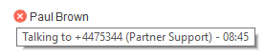
Please note that the tool tip is only available when displaying the contacts using the Small Icon or Tile view.
10.2.2 Instant Messaging Availability
Regardless of a user’s Available/Ringing/Engaged/DND state, if they currently have any version of Unity open they will be available for instant messaging. This is shown by the envelope at bottom right of the user icon, as per the following examples.

Ringing. Unity open and available for IM
DND/Unavailable profile. Unity open and available for IM
Engaged. Unity open and available for IM
Available/on-hook. Unity open and available for IM

10.3 Managing Monitored Users in the Contacts Panel
The Contacts panel will display 30 users. In the Contacts panel right click anywhere and click “Manage user list”. This will allow you to choose which users to display.

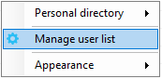

You will then be able to move users or departments between the lists either by double-clicking them or using the arrow button. All users in the right-side list will be monitored in the Contacts panel. This list is saved when Unity is closed.
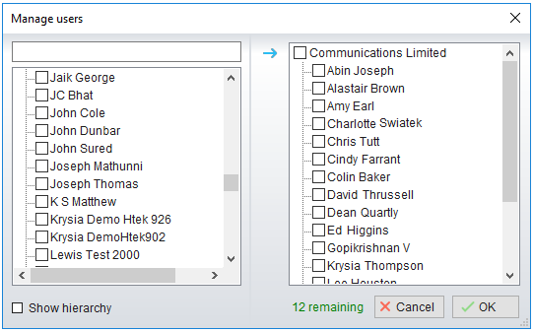

The box at top left will dynamically search the group directory.
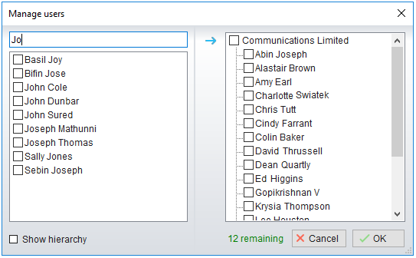
10.5 Performing Call Control Actions in the Contacts Panel
There are many call control functions that can be performed by right-clicking a monitored user in the main Contacts panel or Search. The menu options displayed will dynamically change to only show those available depending on the state of the monitored user and/or the state of the selected call in the Active Call Window [if there is one]. For example, “Transfer to voicemail” will not be available if the user does not have the voicemail service assigned and “Camp call on extension” will not be available unless there is a live call selected in the Active Call Window.

10.5.1 Call Extension
Selecting “Call extension” will open a new call to that user in the same way that double clicking the user icon would. Any current call will automatically be placed on hold. This can be used to make an announced transfer as opposed to a blind transfer using the “Transfer call” commands further down the menu.
10.5.2 Answer This Call [Call Pick-Up]
This will perform call pick-up and will pull the call to the ringing Supervisor user.

Feature Dependency:
- Monitored user must be ringing [orange icon]
- Supervisor and monitored users must be in the same pick-up group
10.5.3 Park Call on Extension
Will park the call on the monitored user’s extension park slot.
Feature Dependency
- Must have a live call
10.5.3.1 Retrieving Parked Calls
Once a call has been parked onto a user’s extension, their Unity will display a Pickup Call Icon and a toast pop up window will appear. In order for the user to retrieve the parked call they simply need to click either the Pickup button or the toast pop up. If the call is not retrieved it will be redirected back to the original user who parked the call.
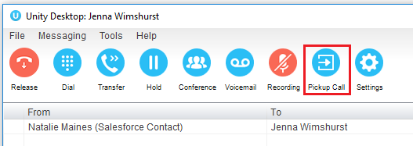
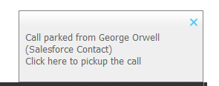
10.5.4 Camp Call on Extension
Will camp the call onto the engaged monitored user. When the user goes back on-hook the camped call will be delivered and their phone will start ringing. If the user does not go back on-hook before the camp timer expires the call will return to the Supervisor user.

Feature Dependency
- Must have a live call in the Active Call Window
- Must be enabled in Settings > Call Transfer as below
The Camp Call option will only be available if activated in Settings > Call Control > Call Transfer as below.

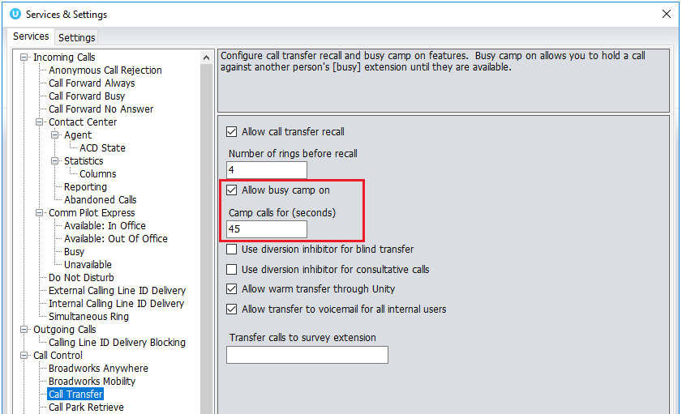
10.5.6 Call Mobile
Places call to mobile. Any live call placed on hold.

Feature Dependency:
The monitored user must have their mobile number entered in BWKS

10.5.7 Transfer Call to Mobile
Performs blind transfer call to monitored users mobile.

Feature Dependency:
- The destination user must have their mobile number entered in BWKS
- Must have a live call
10.5.8 Transfer Call to VoiceMail
Performs blind transfer to the destination user’s voicemail.

Feature Dependency:
- The destination user must have voicemail service assigned
- Must have a live call
10.5.10 Barge into This Call
Makes an immediate three-way conference call with the Supervisor user, the monitored user and the third party the monitored user is talking to. All parties will be able to talk and hear each other. When attempting to barge into a call, if the phone plays a “number doesn’t exist” tone then this means the monitored user cannot be barged into, because they have the Barge-In Exempt service assigned and activated. Only users without this service active can be barged into.

The Active Call Window will display like a normal conference call, as below, and the Supervisor user can Hold/Retrieve the same as for a conference call.

Please note that when leaving a call that you barged into, you must transfer the call parties together in order to leave the conference without ending the original call. To do this either drag one call on top of the other in the Active Call List, or press Transfer then select the option to leave the conference, as shown below.

Feature Dependency:
- The Supervisor user must have directed call pick-up with barge-in service assigned
- Monitored user must be engaged on a call
- The monitored user must not have the barge in Exempt service active
10.5.10 Call Extension When Available
Places an alert on the engaged monitored user. When they become free a dialogue box prompts the Supervisor user and allows them to open the call back.

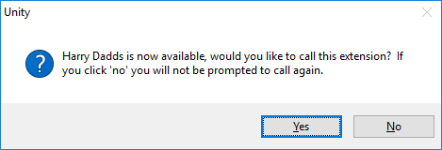

Feature Dependency:
- Monitored user must be engaged on a call
10.5.11 View User Details
Performs a lookup on the user’s details as entered in BWKS. This includes their phone number, mobile and email address.

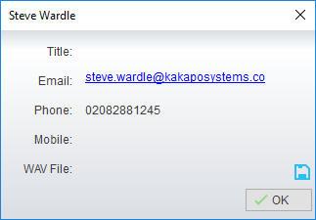
10.5.11.1 Adding Audio Alerts to Monitored Users
The “View user details” box also allows a wav file to be specified that will be played when the monitored user receives a call. Click the icon to select the wav file then click OK. This feature is useful in Manager/Secretary scenarios where the Supervisor user is screening calls. When the audio alert plays that is the reminder for the user to perform call pick-up.
10.5.12 Send Email
This will open a new email window in the default Email application. The user must have the email filed populated against their name in BWKS.

Feature Dependency:
- The recipient user must have their email address entered in the system
10.5.13 Answer This Call [Call Pick-Up]
When monitored users are ringing their icon in Contacts becomes orange. To perform pick-up and answer the call right click the icon and select “Answer this call”. This option is only displayed when right clicking a ringing user.
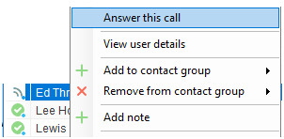

Feature Dependency:
- The Supervisor user and the monitored user must be the same pickup group or the Supervisor user must have the “Directed Call Pick-Up” service assigned.

11 Instant Messaging

Instant messages can be sent and received between any Unity app [Reception, Desktop, Agent, or Supervisor]. Messages sent to offline user [those that do not have an instance of Unity open] can be stored and delivered when the recipient next opens Unity.

The maximum character limit for each instant message is 700.
11.1 Online/Offline Indicator
A person that is running an instance of Unity, and therefore available to send an online IM to is indicated with a small envelope on their user icon. This applies across all the available, engaged, ringing and DND states as shown below.

State | Online [Unity Open] | Offline [Unity Closed]
Available
Ringing
Engaged
DND/unavailable profile
11.2 Docking the IM Window
Instant Messages can be displayed in the Docked IM Window or as separate dialogue boxes for each individual IM thread. If the docked window is used IMs can be initiated via drag and drop and new IM windows will not pop over other applications.

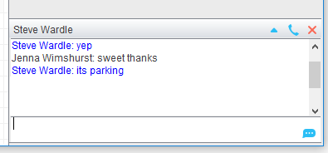

Docking the IM window is specified in Settings > Settings > Instant Messaging and Presence > “Show instant messages in docked panel”. Individual IM messages can still be undocked and redocked as required.

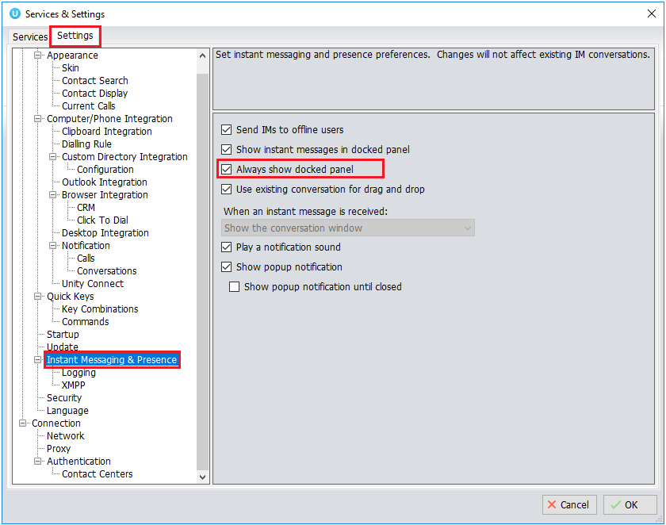

11.3 Undocking and Redocking IM sessions
You can undock an IM message by clicking the “Expand conversation to separate window” button. The IM session will now be a standalone window.

Docked IM
Click the “Dock conversation in main window” button to pull the IM session back into the docked panel in the main Supervisor interface.

Undocked IM
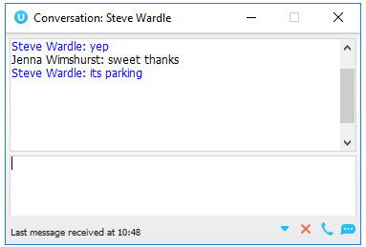
11.4 Sending an Instant Message
Send an instant message either by right clicking a user icon in Contacts panel or Search and selecting “Instant Message” from the drop list, or by dragging a user icon into the docked IM panel. Alternatively, you can select Messaging > Start Conversation from the top menu bar.

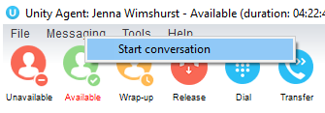

You can then select the users to include in the IM conversation. Please note that only online users will be displayed in the lists. The left list contains all online users, to include them in the IM conversation move them into the right list either by double-clicking the entry or using the arrow button.
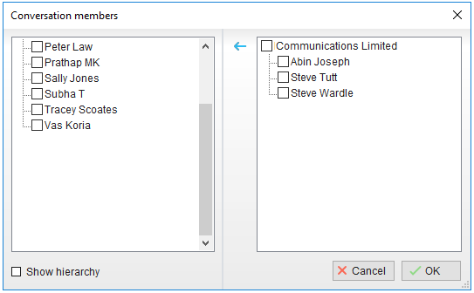
11.5 Overview of IM Window
The upper part of the IM window will scroll to display the most recent comment. Type your comment in the bottom window and press Enter or click the envelope at bottom right.

IM Window - Docked
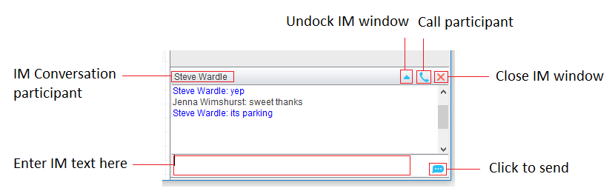

IM Window – Undocked
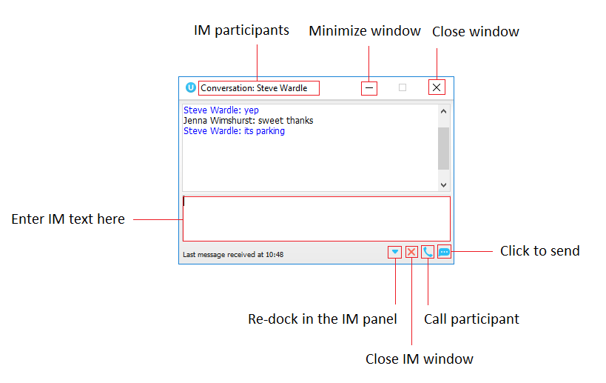
11.6 Adding Participants to an Existing IM Session
When an IM conversation is in the Docked IM panel you can drag a user icon from the Contacts Panel or Search and drop them on the IM window to add them to the conversation. When the IM Window is undocked you click the Search icon and select participants to add to the conversation, as below.
11.7 Sending Contact Directory Numbers
To send another user a number from your Directory right click in the bottom panel where you enter text. Mouse over to see your Directory entries and select the appropriate number.

Feature Dependency:
- The recipient user must have their email address entered in the system
- The Supervisor user must have their outlook client open and they must have full sharing
Permissions to see the monitored user’s Calendar in Outlook
11.8 IM Notification Settings
All notification options for IMs, including sound and popup notifications can be found in the
settings under Instant messaging & Presence.
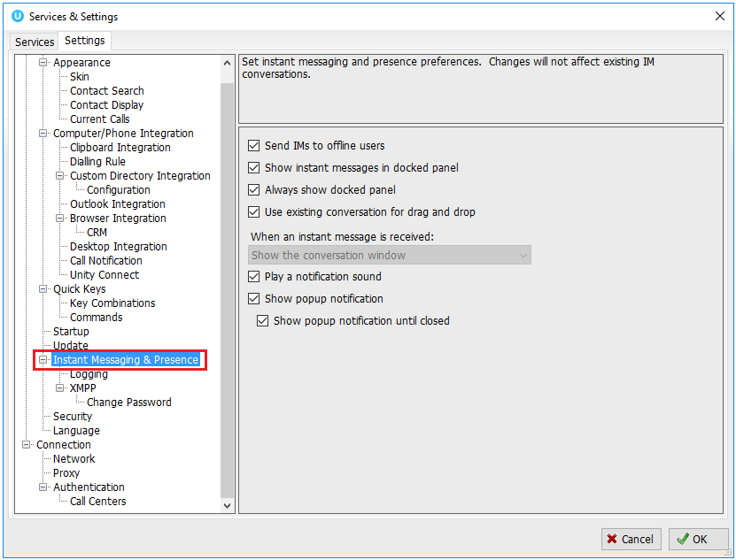
Selecting the ‘Show popup notification until closed’ will keep the IM popup on the screen until it has been closed or clicked.

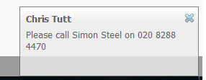
11.9 Send IMs to Offline Users
Even when a user is offline, Unity will allow you to send them an instant message which will then
be queued and will appear the next time the user is online.
11.9.1 Logging IM Sessions
You will find the Instant Messaging and presence logging options in the Settings tab. Here you
will be able to configure how IMs are saved, what file type they are (CSV or HTML) and where
they are saved, for example, you may want to save IM conversations on your server rather than
on the supervisor’s local computer.

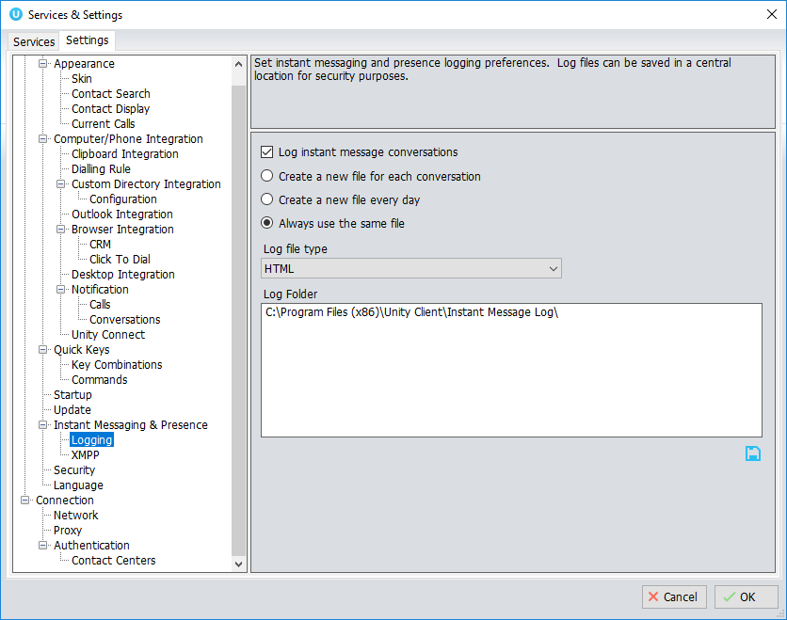

11.11 XMPP Integration
Unity provides seamless integration with XMPP in order for Unity users to share instant messaging and presence (IM&P) functionality with UC-One clients. All instant messages are displayed and managed to the user as a docked or undocked IM conversation, regardless of the IM&P platform being used. Only online users in Unity can participate in group chats, group chat is not currently supported with XMPP.

11.11.1 XMPP Authentication
Unity is unable to extract the XMPP password from the VoIP platform, meaning it must be reset from within Unity. This functionality relies on the Integrated IM&P service being assigned to the receptionist, although no other UC-One related service need be assigned.
In order to set the XMPP password go into Settings and click on the “XMPP > Change Password” item as shown below. You can see the current XMPP status is offline.

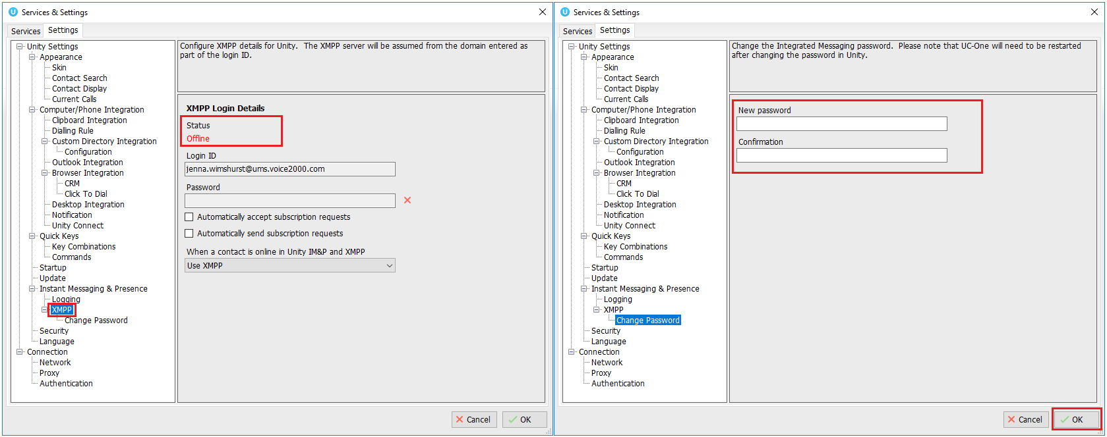

Once the password has been entered you must click the OK button to save the password, before moving to any other panels in settings. Please note that the XMPP password should not be the same as the password used to first log into Unity. You will be notified once the password has been changed and the XMPP status changed to online, as shown below.

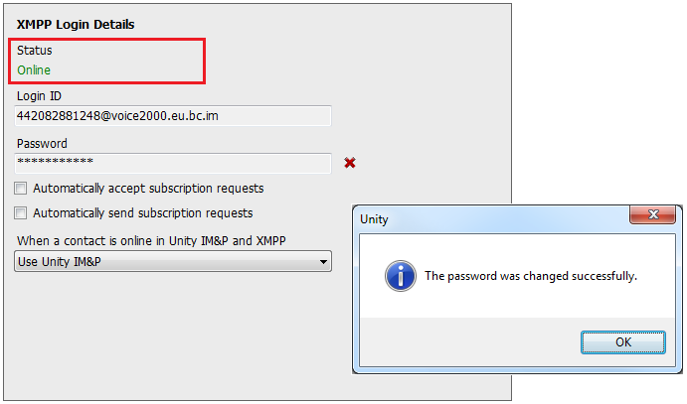

11.11.2 Managing XMPP Subscriptions
To subscribe to XMPP presence for a monitored user (meaning the receptionist will receive real-time updates as the monitored user changes their presence in UC-One) simply right-click the user and select “Add XMPP presence”, as shown here. If already subscribed, then right-click the user to remove XMPP presence.
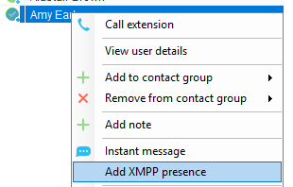

Unity will show the unavailable, busy etc status of the user, as well as any status message manually entered in UC-One, as illustrated below.

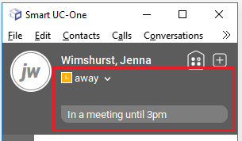

Please note that at present XMPP is only used by Unity to communicate with UC-One clients.

Unity can be configured to automatically subscribe to all monitored user’s XMPP presence, as shown here. However, this may result in the buddy/contact list in UC-One becoming very large so should only be activated if the receptionist doesn’t often refer to the buddy list.

Unity can also be configured to automatically accept subscription requests from other users, if this setting is not activated then whenever a user subscribes to the receptionists XMPP presence a prompt will be displayed, as below.
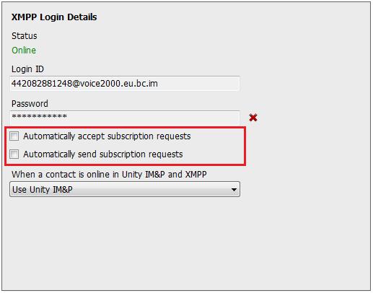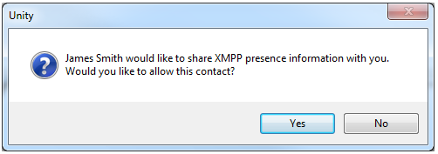
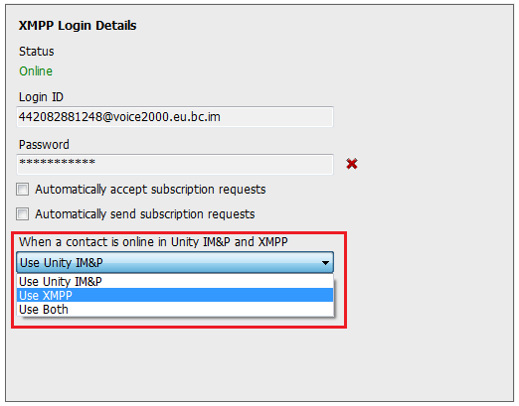

Unity can be configured to automatically generate an XMPP password the first time it is loaded, this is a branding property that is set in the Unity Client branding portal. In this case Unity will save the randomly generated password in Broadworks and also in the registry, from where it will be used whenever Unity is next started. When the password is reset in Broadworks it will automatically be updated in the device configuration file for UC-One, if in use. Furthermore, if UC-One is currently in use this will not impact the existing XMPP registration, therefore there is no impact on UC-One.

11.11.3 Instant Message Priority
Because a monitored user could be running Unity and UC-One, that user could be available to receive instant messages using either client, or both. In these situations, Unity can be configured to prioritise one IM platform over the other, as shown below.

Options are to only send the instant message using only Unity IM&P meaning the instant message will not be received by UC-One, to only send using XMPP meaning the monitored user’s Unity client will not receive the message, or to send through both messaging protocols meaning both clients will receive any instant messages sent from Unity. The last option is the default and is recommended in most scenarios.

11.11.4 Configuration
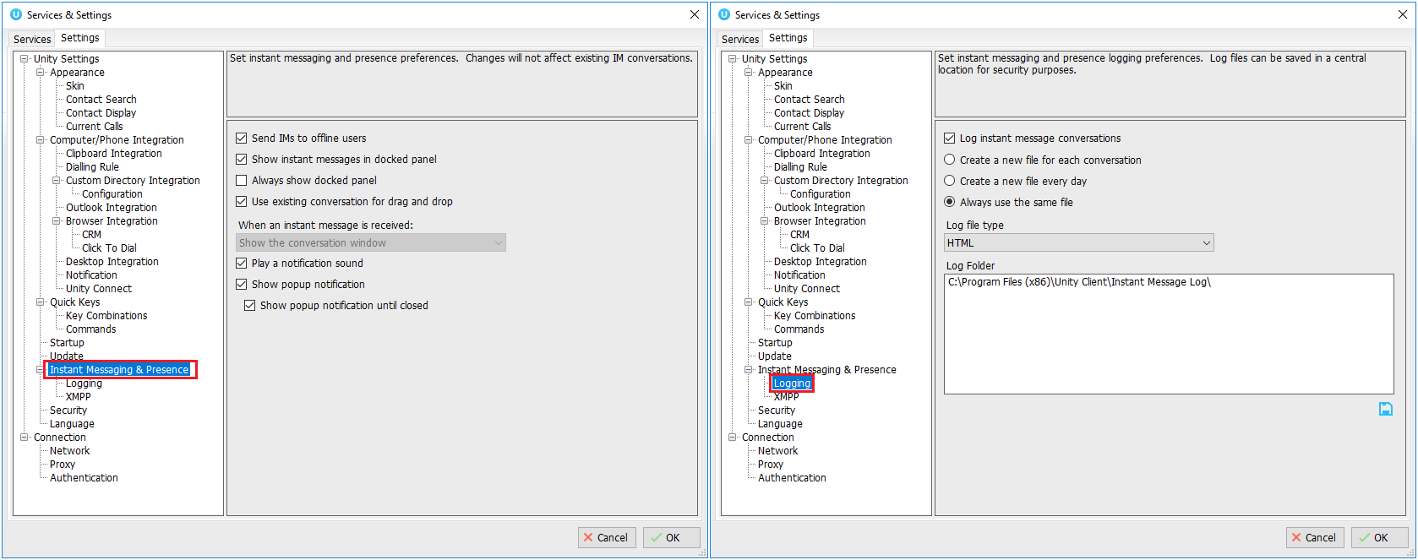

12 Personal Directory

The Personal Directory is a repository on BroadWorks for each user to store personal speed dials. Using this feature in Unity will populate the directory on the host BroadWorks platform. Once numbers have been entered they are available in the Search panel or can be pinned to the main Contacts Panel. A Personal Directory entry is shown by a icon. Double clicking the icon will make a call to the Directory number. The Personal Directory menu is available when right clicking a monitored user or in the Contacts panel.

Personal Directory – Right click in Contacts
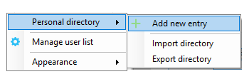

Personal Directory – Right click on monitored user
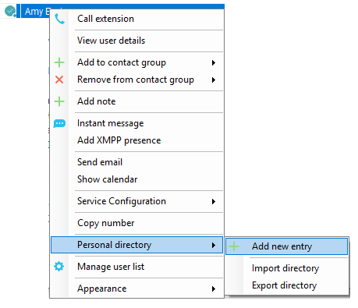
12.1 Add New Entry
Enter the Name and Number and click Ok

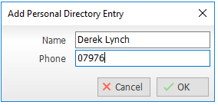

If the number specified is already in the Directory the user will be alerted as below.

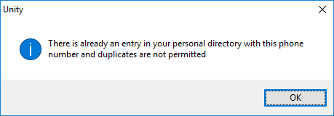
12.2 Edit Entry
Use the Search field in Contacts to locate the entry. You can search by either Name or Number. Right click the Entry and select “Edit”.

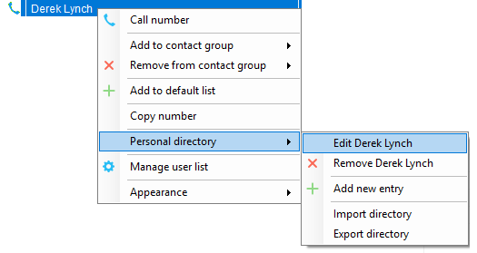
12.3 Remove Entry
Use the Search field in Contacts to locate the entry. You can search by either Name or Number. Right click the Entry and select “Remove”.

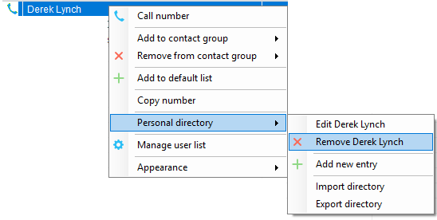
12.4 Dialling Directory Entry
Locate the entry either on the Contacts panel or Search. Drag the entry into the Active Call Window or double click to make a call, or right click the entry and click “Call number”.

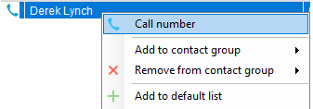

12.5 Import Personal Directory
Supervisor will allow the user to import a .csv file of directory entries, provided they are in “name, number” format. Right click in the Contacts panel, select “Personal directory > “Import” and then browse to the location of the csv.
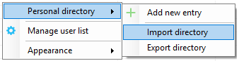
12.6 Export Personal Directory
To export Personal Directory entries right click in Contacts and select Personal directory > “export”. You will be prompted to save the file locally. The format is csv and the default file name is PersonalDirectory.csv

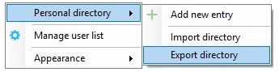

Choose save location on local PC. The format of the csv is Name and then Number. Note the example below is edited for privacy.

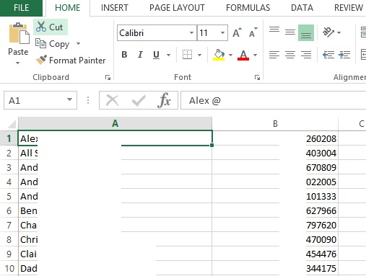

13 Contact Search Directories

The Contact Search field combines all BroadWorks and Outlook Contacts directories to create a central search repository. The BroadWorks directories include the Common Phone List [system speed dials], the receptions user’s own Personal Directory entries, and the Group Directory which includes all the other users in the group as well as hunt groups, auto attendants and call centers. Unity can also integrate with third party LDAP [including Microsoft Active Directory] and SQL directories as well as integrating with CRM systems.

Please see your Administrator for a separate guide on using CRM integration.

Directory Owner | Directory Type | Entry Type
BroadSoft | Group Directory | All other users for BLF presence as well as hunt groups and auto attendants
BroadSoft | Common Phone List | Speed dials entries at the Group level
BroadSoft | Personal Directory | The user’s own personal speed dial entries
Outlook | Personal Contacts [private folder] | The user’s own Outlook Contacts
Outlook | Group Contacts [public folder] | The shared Outlook Contacts at the Outlook group level
Third Party | SQL | External SQL Directory
Third Party | LDAP | External LDAP Directory

13.1 Loading Directories
Unity will load all directory entries into Contact Search on start. If users are added to the BroadWorks Group Directory while Unity is running, they will not be visible until Unity has restarted. Personal directory entries the user adds will be available to use immediately without restarting.

Please note: It is possible not to include the Common Phone List from the Group or Enterprise level when loading Unity, this is configured at the System Provider level of the Kakapo Partner Portal and will impact all users.
13.2 Contact Search Results Layout
To perform a search type characters or numbers in the Search field and Supervisor will start dynamically populating a list of matching entries across all directories. The list will narrow as more characters or numbers are entered. Clearing the Search box and returning to the main Contacts panel can be achieved by clicking again in the Search filed [provided “Clear the search box when activated” is enabled in Settings as outlined in the section below.
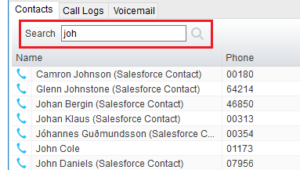

Search results will display each number for a contact as a separate line. Drag or double click the entry to make a call or right click to select a call action from the context menu.
icons represent external numbers or system resources such as hunt groups for which presence information cannot be displayed.

It is also possible to search on department name to list all users of matching departments.
13.3 Contact Search Settings
Preferences for Search can be configured in Settings > Unity Settings > Contact Search. The order of search results can also be changed to display internal extension users first and the “Include department name in search” as shown above, can be toggled.

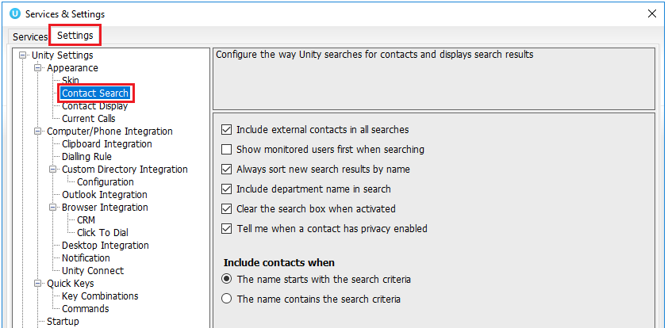
13.3.1 Listing Directories
Right-click the search box in the Contact list to view all directories available in Unity, then select the directory to load those contacts in the list, as below.

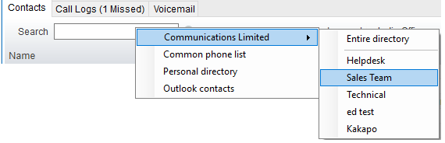
13.4 Configuring Outlook Contacts Preferences
The Outlook directories are both public and private folders and is configurable in Settings > Outlook Integration as below.
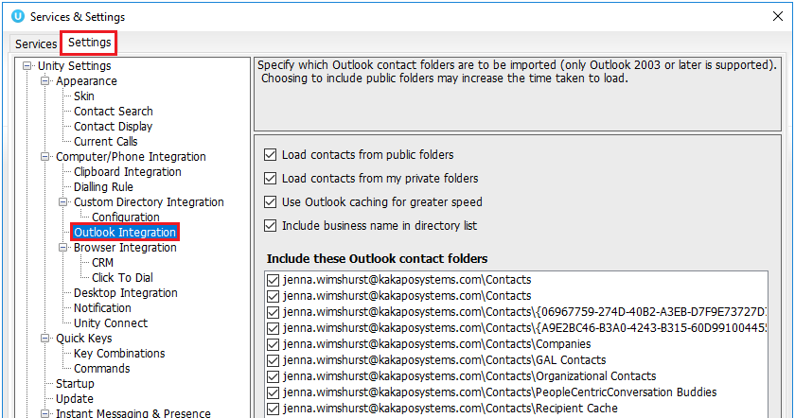
13.5 Third Party Directories
When searching BroadWorks and Outlook directories, Unity will dynamically match entries as keys are typed. For third party LDAP and SQL directories, because these are not loaded into Unity but polled each time a search request is made, search results are not listed until the Supervisor user has entered three characters and hit enter or clicked Search . Unity includes a wizard to connect to third party SQL and LDAP directories. Go to Settings to add, edit and remove custom directories, as shown below.

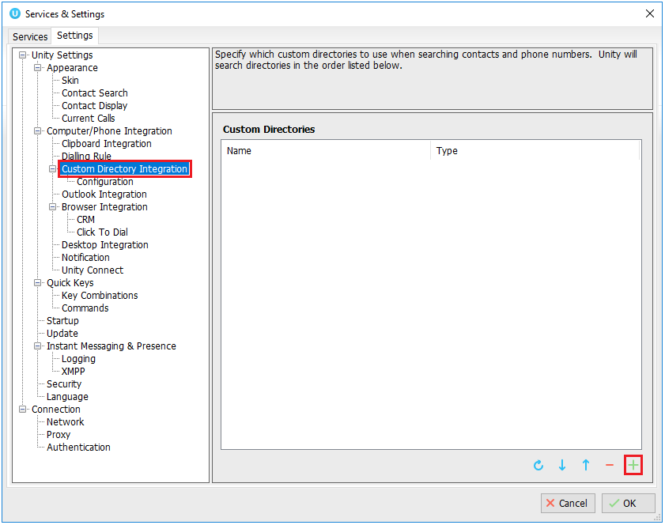
13.6 Desktop Integration
Go into Settings > Settings tab > Desktop Integration, as below.
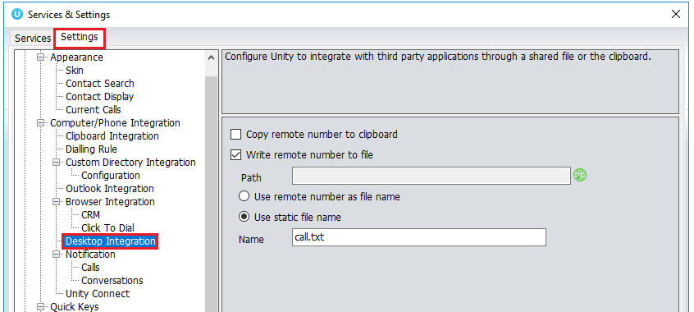

Unity must be configured with the folder location where the file is to be written, you can also specify whether to use the remote number as the filename (for example 02082881248.txt) or to include the remote number in a text file with whatever naming convention you require. Lastly you should instruct Unity when to create the file, for example only when receiving [call center] calls. Please note that Unity will only create the file for an inbound call when the user has answered it.

When you click OK to save, Unity will attempt to create a file called test.txt in the specified folder, then to delete it, which is to test that appropriate folder permissions have been applied. If this fails, Unity will alert the user and the settings will not be saved.

14 Call Logs

The Call Logs tab displays Missed, Received and Dialled Calls with a date and time stamp showing the most recent call at the top. Up to 20 numbers are listed unless the Enhanced Call logs service is assigned to the Supervisor user in BroadWorks. Calls to the Supervisor user DID as well as hunt group and call center calls that have reached the Supervisor user are shown.

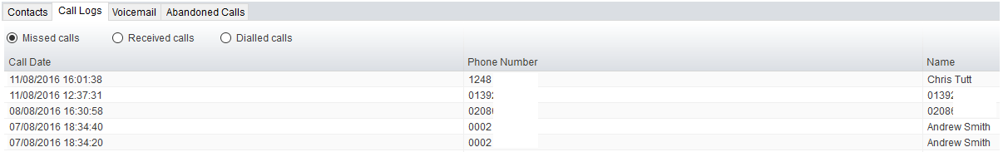

Drag or double click an entry to make a call to that number. Call logs can be exported as a csv file, either individually or together, but clicked the Export button.

15 My Status

The “My Status” link provides an indication of the current status of the user as well as quick access to key services that are regularly modified. Unity will only display the options for the services that have been assigned to the user, available services are CommPilot Express (CPE), Do Not Disturb (DND), Call Forward Always (CFA), Remote Office and Hoteling Guest (for hot-desk environments).
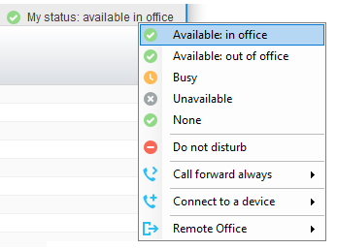

CommPilot profiles are also used to convey presence information to other users within the group or enterprise. As users change their CommPilot Express state, any Unity client that is monitoring that user [through the User Status list] will see their image change, as outlined below.

User State | Description | User Status Image
Available: In Office | I am in the office and available to receive calls. | 
Available: Out Of Office | I am not in the office but am available to take calls
Busy | I am currently busy (short term) | 
Unavailable | I am currently unavailable (longer term)
None | No call routing plan is in use

15.1 Configuring CommPilot Express States
CommPilot Express allows the user to specify how inbound calls are to be handled. Once the four different profiles (above) have been configured in Settings, the profile in use can quickly be changed through the My Status link. Unity can also be configured to automatically apply a CommPilot Express profile when starting or closing, as below.

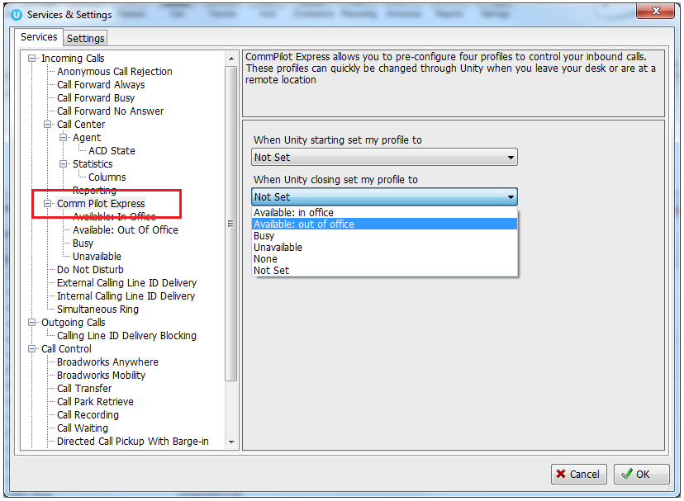
15.1.1 Available: In Office
This is the profile to use when you are working from the desk where you phone is located; it should represent “normal” routing rules.

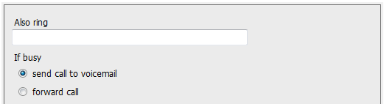
15.1.2 Available: Out Of Office
This is the profile to use when you are away from your desk for an extended period, but still available for receive calls. Examples are when in a meeting or when travelling.

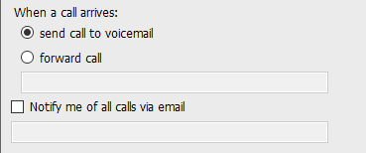
15.1.3 Busy
This is the profile to use when you are temporarily unavailable to take calls, for example when in a meeting where you don’t want to be disturbed.
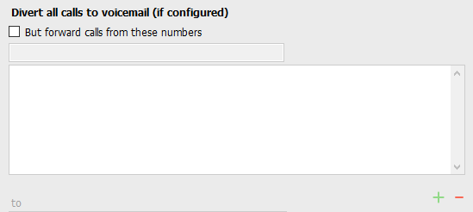
15.1.4 Unavailable
Use this profile when you are away for an extended period of time and not available to take calls, for example when on vacation.

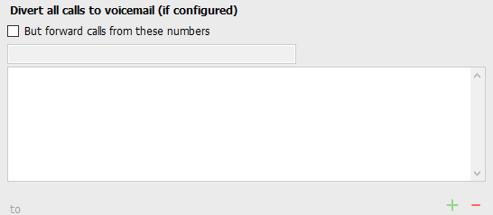

15.2 Do Not Disturb
To activate Do Not Disturb, click on the My Status link and click the menu option. The My Status link will change to indicate the service activation, as will the Unity title bar.

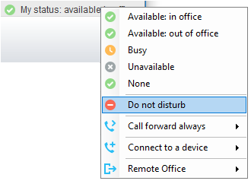

Anyone monitoring the user [in the Contacts list] will also see that they currently have Do Not Disturb activated.

15.3 Call Forward Always
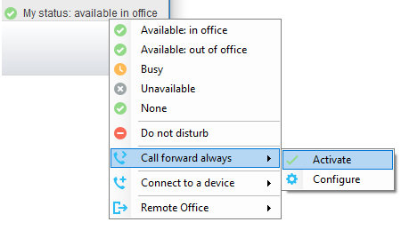

Use the My Status link to quickly activate/deactivate the service, or click configure to go directly to that. service in Settings
15.4 Remote Office
Use the My Status link to quickly activate/deactivate the service, or click configure to go directly to that service in Settings.
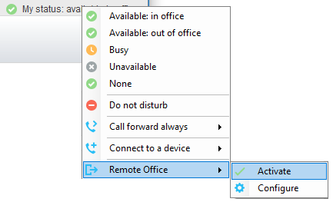

Unity can also be configured to automatically activate and deactivate Remote Office on start-up and shutdown. If Unity is not configured to automatically deactivate when closing a prompt will be presented to the user, as shown below.

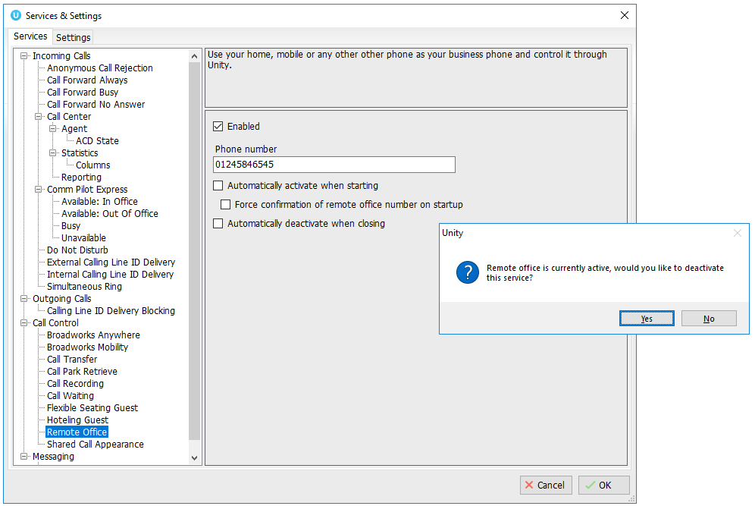
15.5 Hot-Desk and Flexible seating
Hoteling Guest allows the user to connect to a device, typically in a hot-desk and flexible seating environment. To attach the user account to a device, select the device from the menu option below. Please note that only available devices [that aren’t already in use] will be displayed.

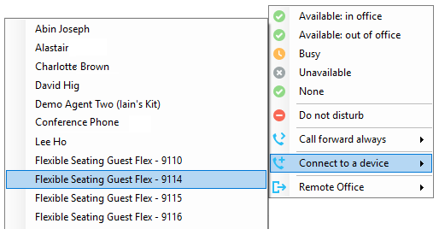

There is no visual notification that the user account is attached to a device, other than if the user clicks in the My Status link, in which case they will see the device is ticked.

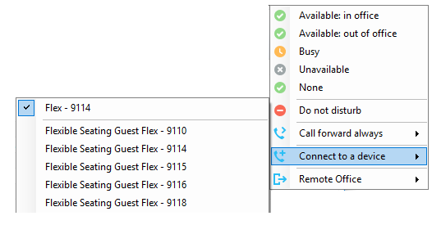

When Unity is closing, it will prompt the user to remove the device attachment.

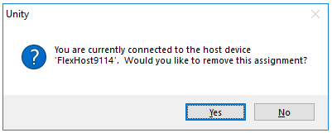

If the user clicks no they will continue to be attached to the device until the association is automatically ceased by the BroadSoft.
15.6 Personal Assistant Service
All Unity clients provide the ability to set the current status for the Personal Assistant service through the “My Status” quick access link, as shown below. This menu option is only shown if the service is assigned to the user in BroadWorks.

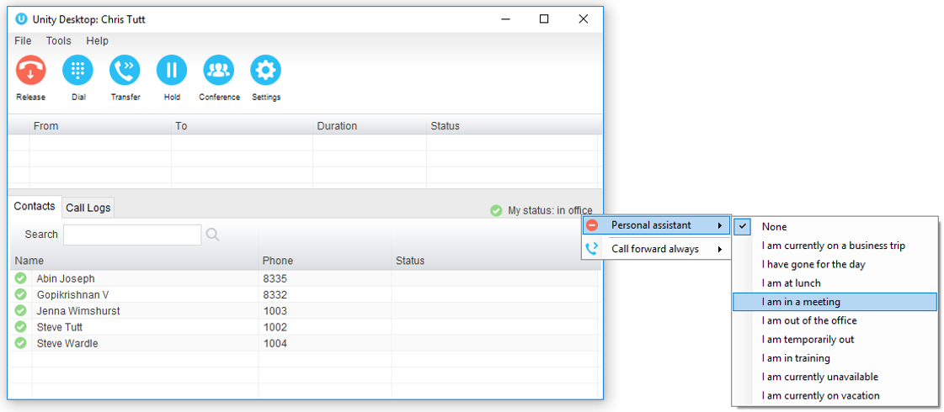

If the user selects a status from the My Status quick link then an expiry date/time will not be configured. If there is a status currently assigned with an expiry date/time then this will be removed. This is for users to quickly set a status “until further notice”.

If a user wants to set an expiry date/time for the status then this can be done through Unity Settings, as shown below. The user can configure all aspects of the service here, including setting the assigned numbers that the status will apply to, and any exclusion numbers that will bypass this service (meaning if there is a status set but a call is received from an exclusion number, then it will be routed to the user rather than caught and processed by the service.)

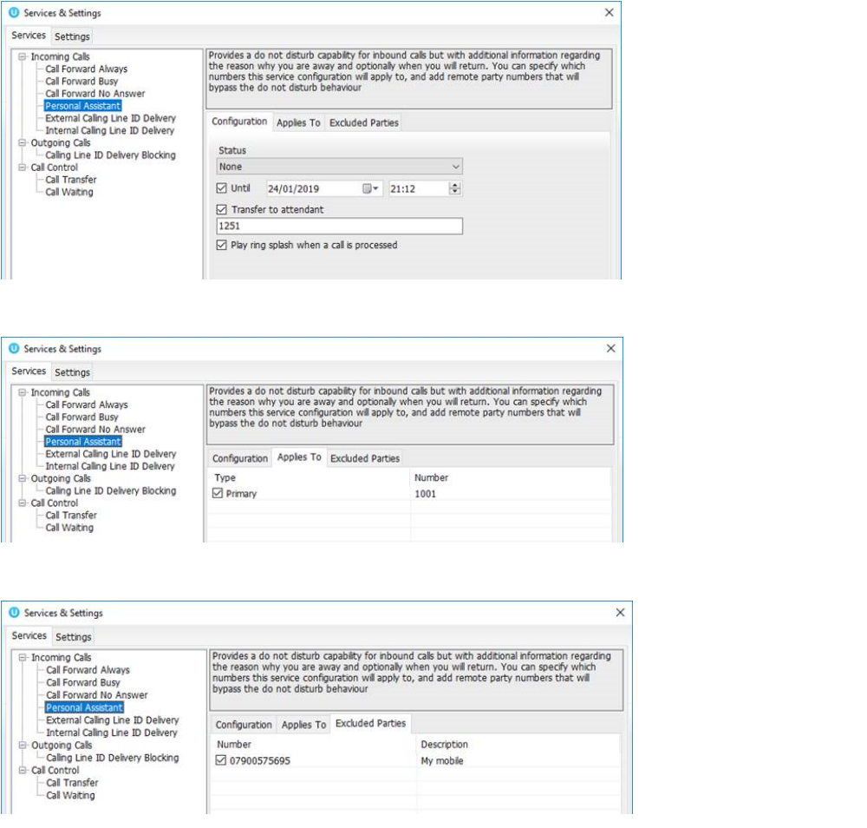

These settings map directly to the service configuration pages in the BroadWorks portal.
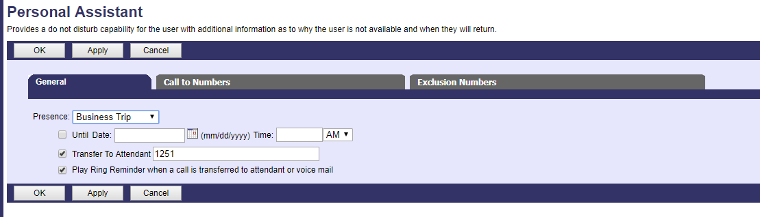

Only Unity Reception clients will show the Personal Assistant status of other users in the group or enterprise, as shown below.
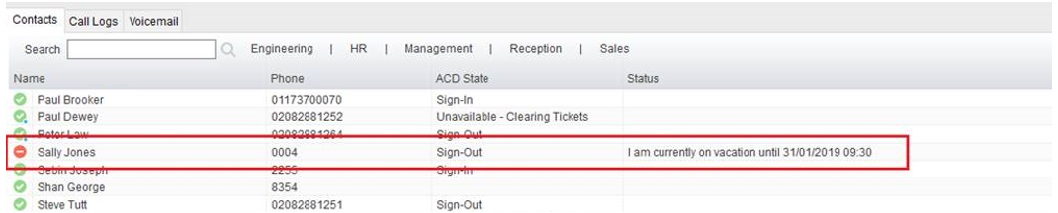
Unity will show the state and the expiry date/time if one was set, the available status messages are:
- I am currently on a business trip
- I have gone for the day
- I am at lunch
- I am in a meeting
- I am out of the office
- I am temporarily out
- I am in training
- I am currently unavailable
- I am currently on vacation

The Do Not Disturb image will always be shown for that user when a Personal Assistant status is set, because this service is an extension of DND.

The Personal Assistant status can only be displayed if the BroadWorks CTI protocol is being used.

