

UNITY AGENT WEB QUICK USER GUIDE
CONTENTS

1 Initial Setup 3
1.1 System Requirements 3
1.1.1 Web Browser Requirements 3
1.2 Call Center Login Details 3
2 Unity Agent Web Interface Overview 5
3 Main Interface Elements 5
3.1 ACD State Buttons 5
3.2 Call Control 5
3.3 Active Call Window 5
3.4 Contacts [Busy Lamp Field] 5
3.5 Call Logs 6
3.6 Voicemail 6
4 Call Center Agent Functionality 6
4.1 Changing ACD State 6
4.1.1 Only Show One ACD Button 7
4.1.2 Assigning Unavailable Codes 7
4.2 Using Personal Wallboard 7
4.2.1 Configuring Statistics Columns in Personal Wallboard 7
4.2.2 Customizing Statistics Label 7
4.2.3 Configuring Alert Thresholds in Personal Wallboard 8
4.3 Joining & Leaving Queues 9
4.4 Standard Escalation 9
4.5 Emergency Escalation 9
5 Call Control 9
5.1 Making a Call 9
5.1.1 Using the Dial Window 9
5.1.2 Using the Contacts Panel 9
5.2 Answer a Call 10
5.3 End a Call 10
5.3.1 Redial 10
5.4 Send Call to Voicemail 10
5.5.1 Announced Transfer 10
5.5.1.1 Warm Transfer 10
5.5.2 Blind Transfer 11
5.5.2.1 Using Contacts Panel Drag and Drop 11
5.5.2.2 Using Transfer Button 11
5.5.2.3 Using Right Click 11
5.6 Call Hold/Retrieve 11
5.6.1 Placing a Call on Hold 12
5.6.2 Retrieving a Held Call 12
5.7 Conference Calling 12
5.8 Starting a Conference Call 12
5.9 Call Recording 12
6 Active Call Window 13
6.1 Window Layout 13
6.2 Calls In Queue 13
7 Drag and Drop 13
8 Contacts Panel [Busy Lamp Field] 14
8.1 Contact Panel Display Options 14
8.1.1 Details View 14
8.1.2 List View 14
8.1.3 Small Icon View 14
8.1.4 Tile View 14
8.2 User Icons 15
8.2.2 Instant Messaging Availability 15
8.3 Managing Monitored Users in the Contacts Panel 15
9 Instant Messaging 15
9.1 Docking the IM Window 15
9.3 Sending an Instant Message 16
9.4 Adding Participants to an Existing IM Session 16
9.5 Logging IM Sessions 16
10 Personal Directory 16
10.1 Add New Entry 16
10.2 Edit Entry 17
10.3 Remove Entry 17
10.4 Dialling Directory Entry 17
11 Contact Search Directories 18
12 Call Logs 18
13 My Status 19
13.1 Call Forward Always 19
13.2 Remote Office 20
13.3 Connect to a Device 20

1 Initial Setup

Unity Agent Web is a web-based application that enhances the Hosted PBX solution to provide call control, directory integration, instant messaging, and service configuration. Featuring an intuitive icon-based interface, Unity provides point and click call control within Google Chrome, Safari for Mac, Microsoft Edge and Internet Explorer. Unity improves workgroup collaboration by bringing users closer to each other and simplifying internal and external communication.
1.1 System Requirements
1.1.1 Web Browser Requirements
Unity will run on the following browsers:
- Google Chrome
- Microsoft Edge
- Safari for Mac
- Internet Explorer

Unity requires an initial configuration in order to communicate with your service provider’s BroadSoft.
The first-time Unity is started you will be prompted to enter the configuration details, as shown below. Unity can then retain the connection and authentication details for later use.
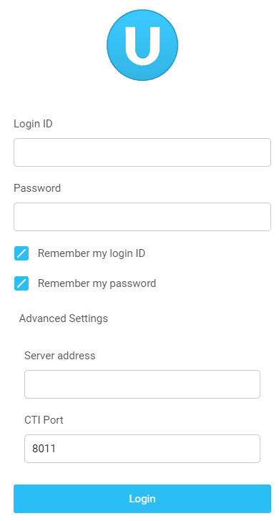

Enter your Login ID and password and the BroadSoft Server Connection as specified by your Service Provider.

Once you have entered your login details click login. Unity will now display a dialogue box “Logging into BroadSoft” as the application opens.
1.2 Call Center Login Details
Once Unity has been restarted it will connect to the host BroadWorks system and populate all the Call Center Instance IDs for the call centers that the agent is a member of, as shown below.
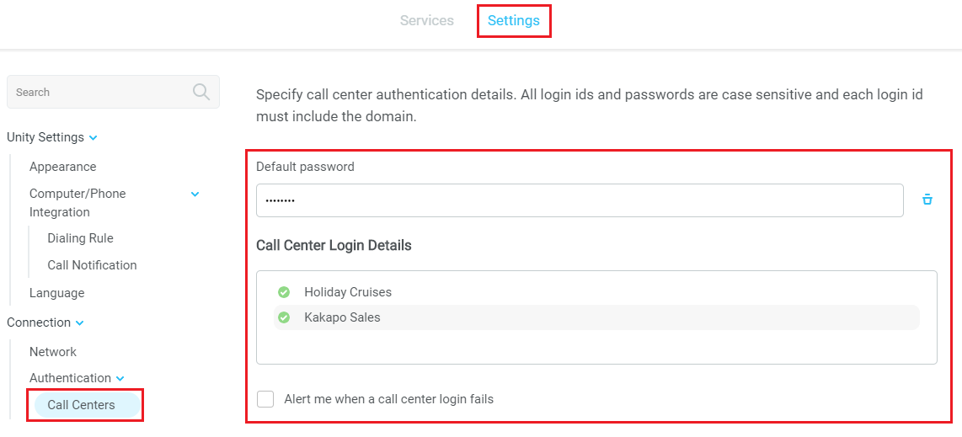

2 Unity Agent Web Interface Overview

Unity is split into six functional areas; ACD Buttons, Call Control buttons, Personal Wallboard, Active Call Window, Contacts [Busy Lamp Field] and Instant Messages. Contacts is a tab that can be toggled to display Call Logs and the Voicemail tab.

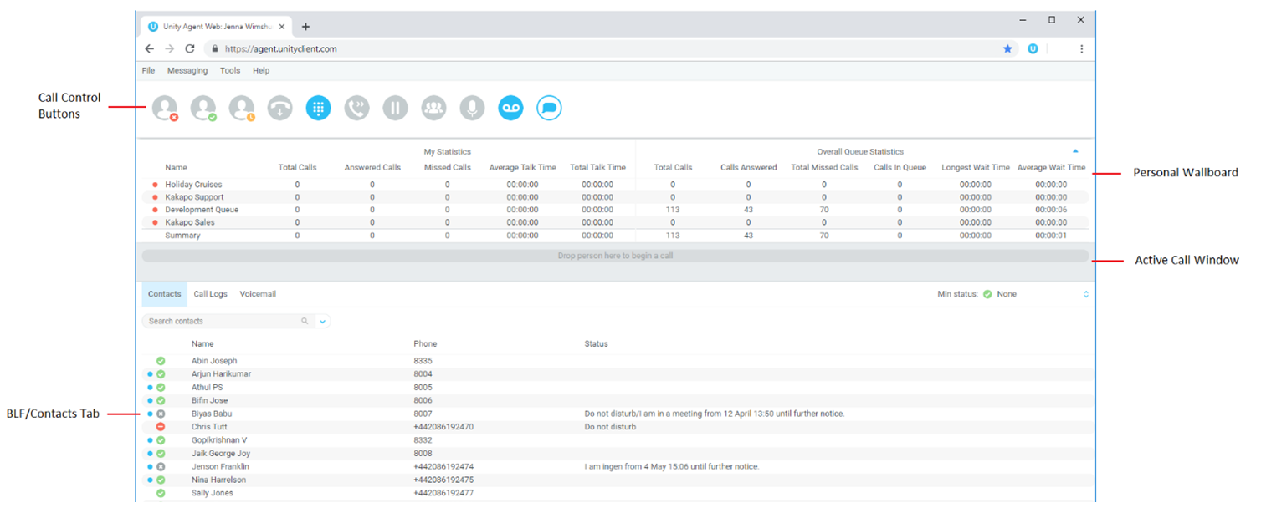
3 Main Interface Elements
3.1 ACD State Buttons
ACD State buttons for setting the agent’s availability to the call center. When clicking “Unavailable” the user will be presented a list of unavailable codes as configured in BroadWorks.
3.2 Call Control
Call Control buttons provide quick access to common telephone handling commands. Only services that are assigned to the user are displayed.
3.3 Active Call Window
This provides a list of all current calls and their state. For example, Ringing, Active or On Hold. The duration of the call is also displayed.
3.4 Contacts [Busy Lamp Field]
This panel will display up to 30 monitored users, displaying their Do Not Disturb [grey], Available [green], Engaged [red] or Ringing [orange] state as icons.
3.5 Call Logs
Toggling the bottom Contacts panel to Call Logs will display Missed Calls, Received Calls and Dialled Calls.
3.6 Voicemail
Clicking into the Voicemail tab will display a list of voice messages with the most recent at the top.

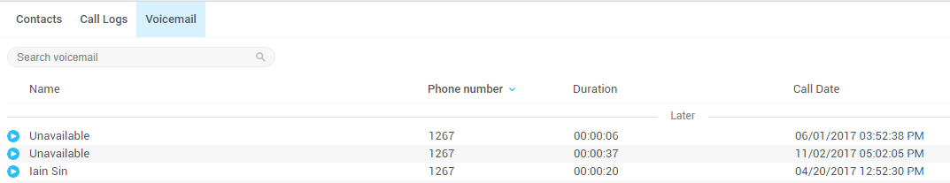

4 Call Center Agent Functionality

Inbound ACD calls will display the call center name, as configured in BroadWorks, in the “To” field. The “From” field will display the incoming CallerID [if not withheld] or the name of the caller if that can be matched from the Directory. Answer the call by lifting the IP phone handset, clicking Answer/Release call control button or double clicking the call in the Active Call Window.
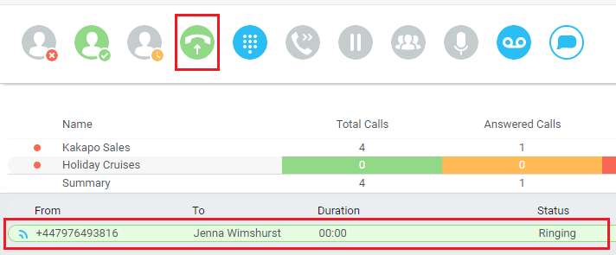

Hang up the IP phone handset or click Release  to end the call.
4.1 Changing ACD State
Clicking Unavailable, Available or Wrap-Up will change your availability for all queues you are a member of.

4.1.1 Only Show One ACD Button
Unity Agent Web can optionally be configured in Settings > Incoming Calls > Call Center > Agent > ACD State to only display one ACD button, which will be the currently selected state.
4.1.2 Assigning Unavailable Codes
When the agent selects unavailable, any unavailable codes that have been configured in BroadWorks will appear. Unavailable Code assignment with one ACD button:

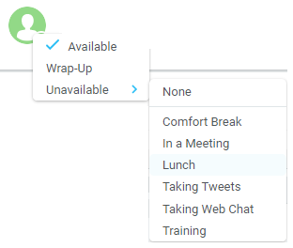
4.2 Using Personal Wallboard
The Personal Wallboard will show current performance metrics for the call centers the agent is assigned to. The stats are broken down by “My Statistics” which shows the agent’s individual performance and “Overall Queue Statistics” which will show the current conditions across the entire call center[s].
4.2.1 Configuring Statistics Columns in Personal Wallboard
The statistics shown in “My Statistics” and “Overall Queue Statistics” panels of the Personal Wallboard are configurable in Settings > Services > Call Center > Statistics > Columnns.
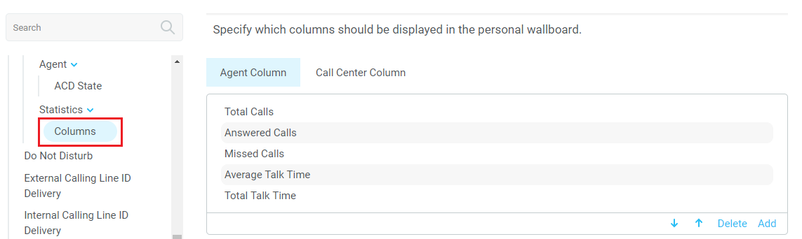
4.2.2 Customizing Statistics Label
Double click any statistic as displayed in the list above. From the below field you are able to customize the statistic label as required.
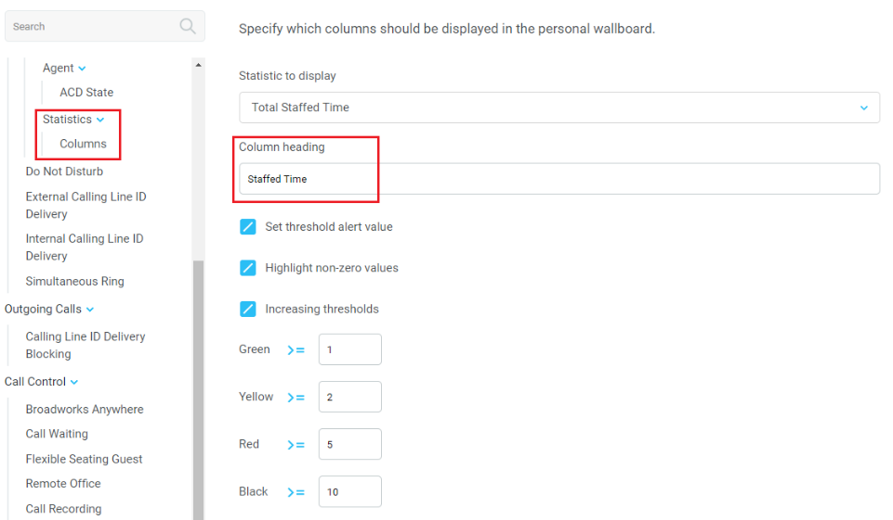
4.2.3 Configuring Alert Thresholds in Personal Wallboard
Double click any Statistic in Settings > Services > Call center > Statistics > Columns and tick “Set threshold alert values”. This will display a table where corresponding values can be configured that will progressively change the statistic background colour greed, yellow, red and black.

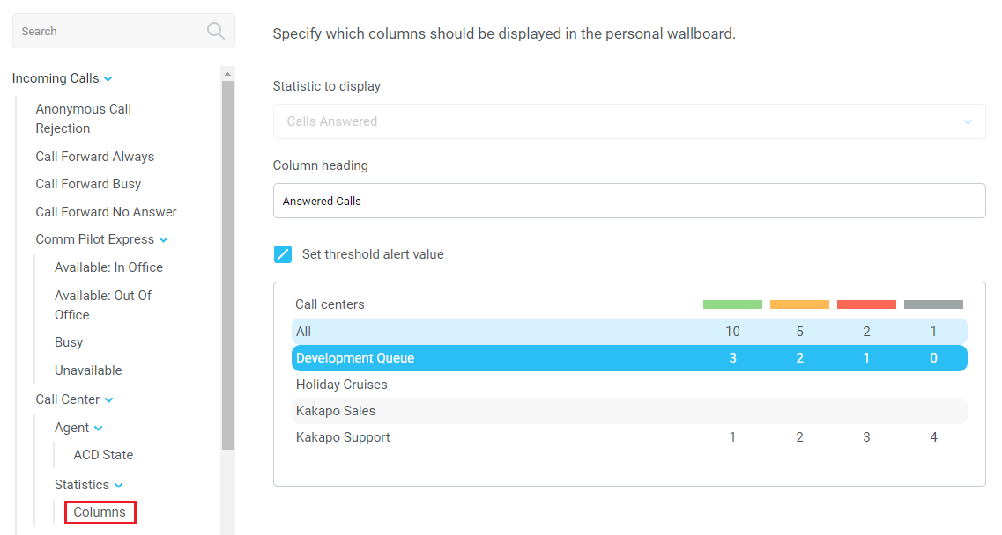

Double click an entry in the list to set overall threshold values or those for a specific call center.
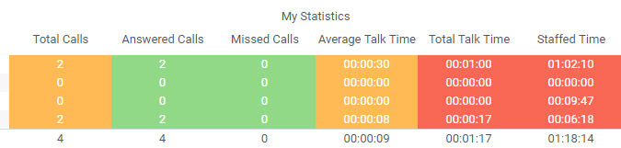
4.3 Joining & Leaving Queues
Right click any queue in the Personal Wallboard to toggle between Join and Leave queue. Queues that you are joined to have a green icon next to them. This is only available if the Agent is allowed to join or leave a call center queue.
4.4 Standard Escalation
Standard escalation is used when the agent needs to be given information or instruction from the supervisor without conferencing in the remote party. Typically, the agent will release the call to the supervisor and replay the information to the remote party.
4.5 Emergency Escalation
Emergency escalation is used to immediately conference a supervisor into the call with the remote party, therefore it relies on either the 3-Way or N-Way Calling user service being assigned to the agent. When performing an emergency escalation, Unity will place any active calls on hold then dial the selected supervisor, or the first supervisor that is available.

5 Call Control

All calls are managed through the call control buttons at the top of the application. These buttons will change depending on the state of the selected call, or the only call if there is only one call in the Active Call Window. For example, the Answer/Release   and Hold/Retrieve  buttons toggle as only one of these options will be valid at any time.
5.1 Making a Call
5.1.1 Using the Dial Window
Click the Dial button  to bring up the Dial dialogue box, as shown below. Using the computer keypad enter the desired number and press Enter or click OK to make the call.
5.1.2 Using the Contacts Panel
Double click a user icon or right click and select “Call extension”
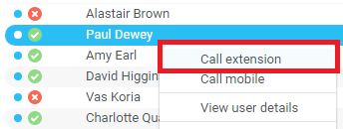
5.2 Answer a Call
When Unity displays an inbound call, click the Answer icon or double click the call in the Active Call Window to answer the call.
5.3 End a Call
Click the Release button  to end the currently selected call. If there are multiple calls in the Active Call Window, make sure you select the right call before clicking Release.
5.3.1 Redial
You can also right-click the Dial button to see a list of the last 10 dialled numbers. Simply click on an entry to dial the party, as shown below.
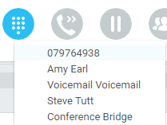
5.4 Send Call to Voicemail
To send an inbound caller directly to your voicemail click the Voicemail button .
5.5.1 Announced Transfer
Receive and answer an inbound call. Make a new call to the desired destination extension or number as described Make a Call above. This will automatically place the first caller on Hold and will open a new call in the Active Call Window. Once the called party answers, click Transfer  and select the context menu option to transfer both calling parties together.

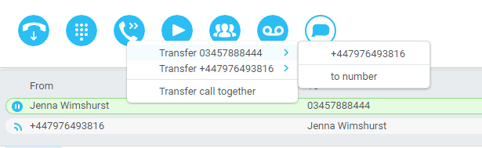

5.5.1.1 Warm Transfer
Unity Agent Web allows you to warm transfer a call by right clicking the user you want to transfer the call to and selecting “warm transfer” from the context menu. This will then put the original caller on hold and dial the selected number. When ready, click the transfer button in the call center control options panel and the two calls will be transferred.
5.5.2 Blind Transfer
5.5.2.1 Using Contacts Panel Drag and Drop
Unity Agent Web can be configured to automatically blind transfer a call by dragging the call from the Active Call Window and dropping it on a user icon or number icon in the Contacts panel, or dropping it onto a call center queue [if agent is configured as an agent with call center queues].
5.5.2.2 Using Transfer Button
Once on a call click the Transfer call control button . In the Transfer window enter the destination and click OK.
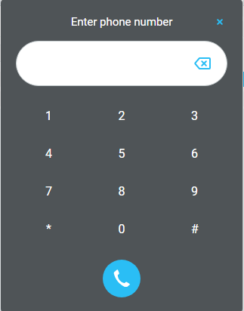
5.5.2.3 Using Right Click
While on an active call right click the recipient icon or number in the Contacts panel or Search. Select “Transfer call to extension” to blind transfer the call.
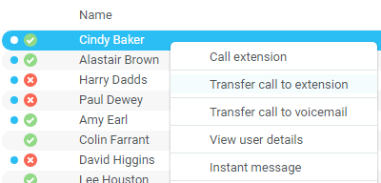
5.6 Call Hold/Retrieve
The Hold/Retrieve  function toggles depending on the status of the currently selected call. Hold is only available for an active call while Retrieve is only a valid option for a call currently on Hold.
5.6.1 Placing a Call on Hold
To place a current active call on Hold, press the red Hold button. The call status will now show as on hold in the Active Call Window and there will be an On Hold icon alongside the call.
5.6.2 Retrieving a Held Call
Click the held call in the Active Call Window to select it. Click the Retrieve button to take the call off hold, you can also double click the call to retrieve it.
5.7 Conference Calling
A conference call can be established with any combination of internal and external numbers. The total number of parties that can be supported is determined by service assignment. The Three-Way Calling user service supports conference calls with two other parties only while the N-Way Calling user service supports conference calls with more participants.
5.8 Starting a Conference Call
You can select two calls in the Active Call Window and click this button to quickly conference everyone together. Once in a conference you can easily select other calls and add them to it, but you must start with a conference with two other calls first. You can use the hold and retrieve buttons to hold the whole conference, and use the release button to drop a caller out of the conference. Please note this feature depends on service assignment so may not always be available.
5.9 Call Recording
You can use this button to manage call recording in two ways. You can right-click on the button to select how to record calls.
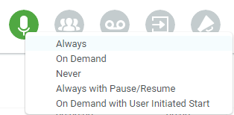

Or left click to start, stop, pause or resume recording the selected call. The button will change to show if the selected call is currently being recorded, or if recording is paused or stopped.
Depending on the call recording option selected you may see a menu when clicking this button, as below.

6 Active Call Window

The Active Call Window gives visual representation of the status of all calls the user receives or is currently managing.
6.1 Window Layout

From – This field will display the incoming CallerID or the name
To – This field displays the name of the user, hunt group or call center
Duration – This displays the total time elapsed since the call was first answered.
Status – This shows the Ringing/Active, on On Hold and recording status of each call.
6.2 Calls In Queue
Agents can optionally see all calls in queue for the Call Centers they are joined to, as shown below. This is configured in Settings>Agent>Display queued call center calls in the list.
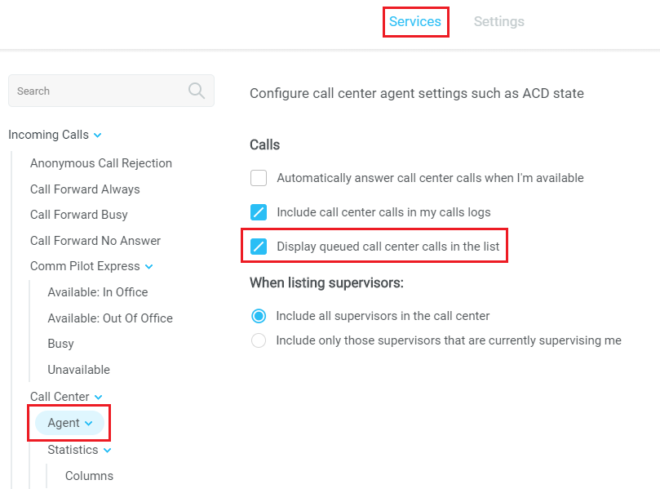
7 Drag and Drop

Drag & drop is an important feature of Unity, it means that in order to perform an action on a call you can simply drag it on top of something. For example, if you want to blind transfer a call to a user then this can be done by simply searching for that user, then dragging the call and dropping it on that user in the contacts list.

You may see some options here depending on what was configured in settings, or Unity can automatically blind transfer the call. Similarly, if you want to perform an announced transfer then simple drag one call on top of the other in the Active Call Window, the calls will be transferred together and be removed from the list.

You can also drag other objects into this list to make a call, for example drag a user from the contacts list into the Active Call Window to call that internal user’s extension or external contact’s number.
8 Contacts Panel [Busy Lamp Field]

The Contacts tab gives a visual indication of the status of users [within the group/enterprise] that are currently being monitoring. A maximum of 30 users can be displayed. Double clicking a monitored user will call them and right clicking will bring up a dynamic options menu.
8.1 Contact Panel Display Options
There are three different views available, as outlined below. Right-click anywhere in the Contacts panel and select Appearance list to change the view.
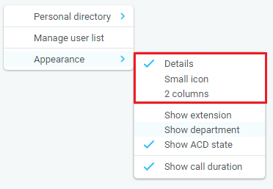
8.1.1 Details View
This view provides by far the greatest amount of detail, but requires more space [although the list can be shortened in which case scrollbars will automatically appear]. This is the recommended view for Agents as it shows the ACD state of up to 30 monitored Agents.
8.1.2 List View
This option will display all users in a list.
8.1.3 Small Icon View
This view combines a simplified look and space reduction.
8.1.4 Tile View
This view is similar to Icon view but uses more white space to provide a cleaner look.
8.2 User Icons
There are four main user icons states shown in the Contacts panel, regardless of the view chosen.
 | Available | The monitored user extension is on hook
 | Ringing | The monitored user extension is ringing
 | Engaged | The user is on the phone
 | Do Not Disturb | The user has selected DND or Unavailable profile
8.2.2 Instant Messaging Availability
Regardless of a user’s Available/Ringing/Engaged/DND state, if they currently have any version of Unity open they will be available for instant messaging. This is shown by the blue dot at bottom right of the user icon.
8.3 Managing Monitored Users in the Contacts Panel
The Contacts panel will display 30 users. In the Contacts panel right click anywhere and click “Manage user list”. This will allow you to choose which users to display.
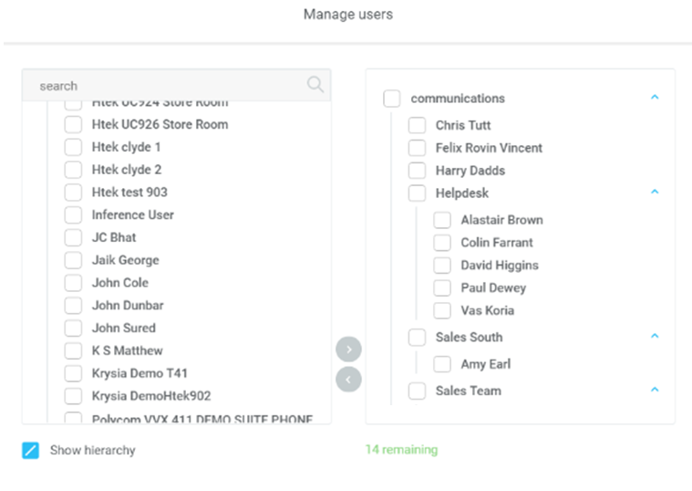

9 Instant Messaging

Instant messages can be sent and received between any Unity app [Reception, Desktop, Agent, or Supervisor]. Messages sent to offline user [those that do not have an instance of Unity open] can be stored and delivered when the recipient next opens Unity.
9.1 Docking the IM Window
Instant Messages can be displayed in the Docked IM Window or as separate dialogue boxes for each individual IM thread. If the docked window is used IMs can be initiated via drag and drop and new IM windows will not pop over other applications.
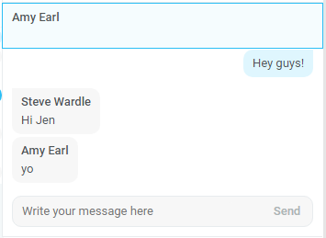
9.3 Sending an Instant Message
Send an instant message either by right clicking a user icon in Contacts panel or Search and selecting “Instant Message” from the drop list, or by dragging a user icon into the docked IM panel.
9.4 Adding Participants to an Existing IM Session
When an IM conversation is in the Docked IM panel you can drag a user icon from the Contacts Panel or Search and drop them on the IM window to add them to the conversation.
9.5 Logging IM Sessions
You will find the Instant Messaging and presence logging options in the Settings tab. Here you
will be able to configure how IMs are saved, what file type they are (CSV or HTML) and where
they are saved.

10 Personal Directory

Personal Directory – Right click in Contacts
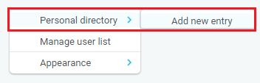
10.1 Add New Entry
Enter the Name and Number and click Ok
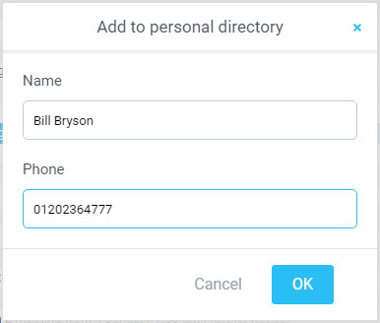
If the number specified is already in the Directory the user will be alerted as below.
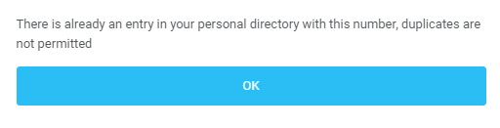
10.2 Edit Entry
Use the Search field in Contacts to locate the entry. You can search by either Name or Number. Right click the Entry and select “Edit”.
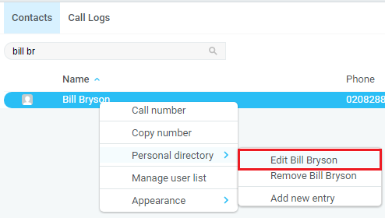
10.3 Remove Entry
Use the Search field in Contacts to locate the entry. You can search by either Name or Number. Right click the Entry and select “Remove”.
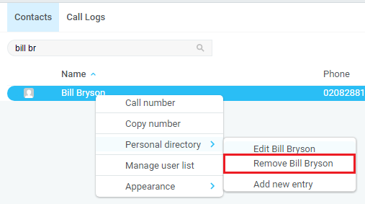
10.4 Dialling Directory Entry
Locate the entry either on the Contacts panel or Search. Drag the entry into the Active Call Window or double click to make a call, or right click the entry and click “Call number”.
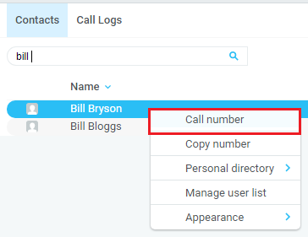

11 Contact Search Directories

The Contact Search field combines all BroadWorks and Outlook Contacts directories to create a central search repository. The BroadWorks directories include the Common Phone List [system speed dials], the receptions user’s own Personal Directory entries, and the Group Directory which includes all the other users in the group as well as hunt groups, auto attendants and call centers. Unity can also integrate with third party LDAP [including Microsoft Active Directory] and SQL directories.
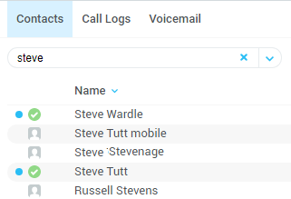

Right click in the search box to select a directory, then click the search button to clear it and see the default list of monitored users.
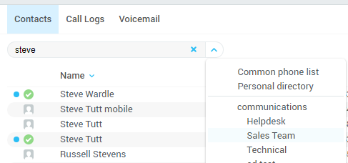

Search results will display each number for a contact as a separate line. Drag or double click the entry to make a call or right click to select a call action from the context menu.
icons represent external numbers or system resources such as hunt groups for which presence information cannot be displayed.

12 Call Logs

The Call Logs tab displays Missed, Received and Dialled Calls with a date and time stamp showing the most recent call at the top. Up to 20 numbers are listed unless the Enhanced Call logs service is assigned to the Agent user in BroadWorks. Calls to the Agent user DID as well as hunt group and call center calls that have reached the Agent user are shown.
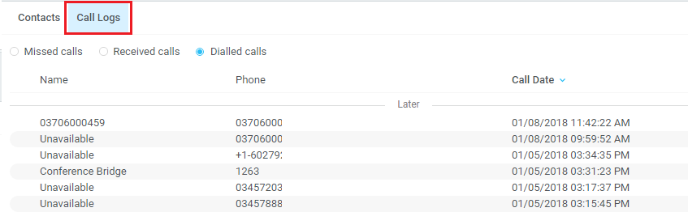

Drag or double click an entry to make a call to that number. Call logs can be exported as a csv file, either individually or together, but clicked the Export button.
13 My Status
The “My Status” link provides an indication of the current status of the user as well as quick access to key services that are regularly modified.
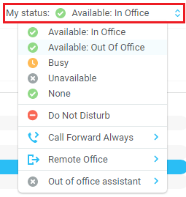

CommPilot profiles are also used to convey presence information to other users within the group or enterprise.
13.1 Call Forward Always
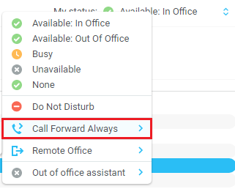
13.2 Remote Office
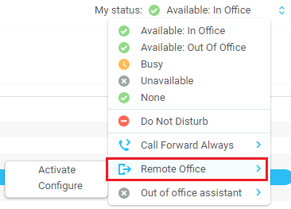
13.3 Connect to a Device
The user can easily select the device to connect to through the My Status link, as shown below.
