

Contact Center Dashboard - User Guide
CONTENTS
1. The Portal 2
2. User Permission Requirements 3
3. Bar charts 4
Bar Chart Behaviour with Today, Week, Month Toggle 4
4. Pie Charts 6
Pie Chart Behaviour with Today, Week, Month Toggle 7
5. Tables 7
Overall Contact Center Level 7
Queue Level 8
Media Stream Level 9
Table Behaviour with Today, Week, Month Toggle 10
6. Queues 10
7. Media Streams 11

The Portal

This document will give you an overview on how to use the Contact Center Dashboard in the Kakapo Portal.
When you are sent your portal login details go to https://portal.unityclient.com/ to login. You will need to have the permission “contact center admin” enabled in order to view and configure the Contact Center Dashboard.
In the portal the end-user customer admins can configure Unity Contact Center and immediately see key statistics in the Contact Center Dashboard.
Key functionality:
- Display headline statistics for the overall Contact Center, Queues or Media Streams and to be able to toggle these by Today, Week, Month 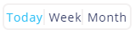
- Easily identify problems, like a Media Stream not working, multiple conversations queued or Missed conversations
- Improve navigation by reducing the clicks required to get to Media Streams
The Dashboard is made up of a bar chart, two pie charts and two tables, as shown below. The tables, charts and statistics will change depending on whether you are viewing the overall Contact Center, an individual Queue or an individual Media Stream.

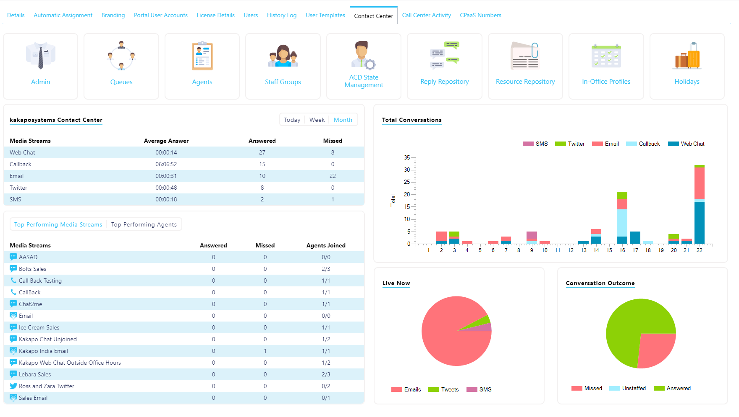

User Permission Requirements

The Dashboards will be visible to any portal user that is configured at the Group or Enterprise as “Is Contact Center Viewer”.
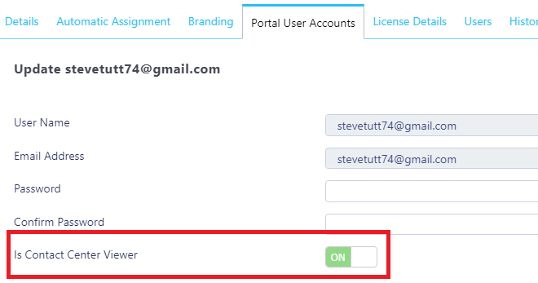

To create Media Streams this permission needs to be set because these are billable actions:
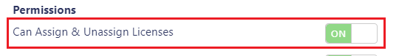

Users need the below settings toggled on in order to create, update and delete objects in the Contact Center, e.g. Staff Groups, Queues, Supervisors etc.
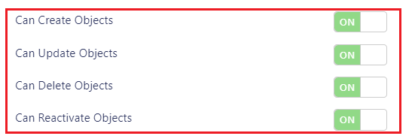

Bar charts
On the top left of the Dashboard is the bar chart which, depending on which level of the hierarchy you are viewing (overall Contact Center, Queue etc), will display the total number of conversations received by type.
If viewed at the individual Media Stream level the bar chart will display the conversations’ outcomes e.g. how many have been missed, answered and unstaffed.
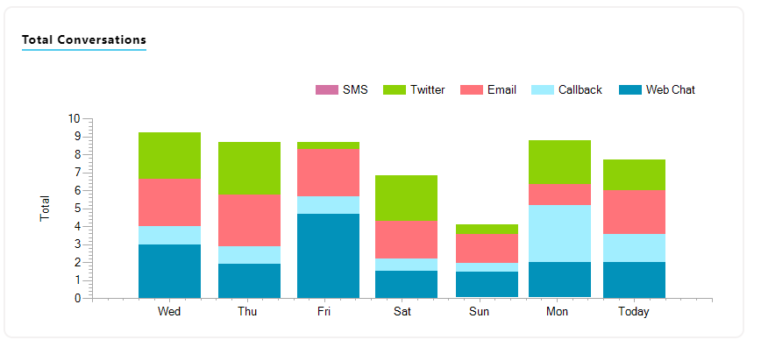
By default, the numbers on the bars will be hidden, but if the user hovers over the bar chart then the numbers for all Media Stream types for all columns are inserted.

Bar Chart Behaviour with Today, Week, Month Toggle

Today – View the number of conversations received today. Configure the start and end time and preferred intervals by clicking the cog and inputting the desired times.
If not specified, the default time will be 9am until 6pm and the default interval will be 30 mins.
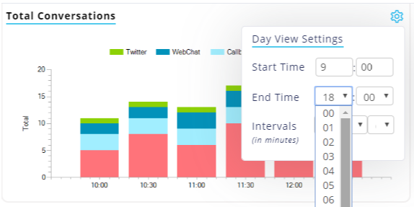

Week – For the week view the bar chart will display 7 bars, with the current day at the far right and the 6 proceeding bars for the days before.
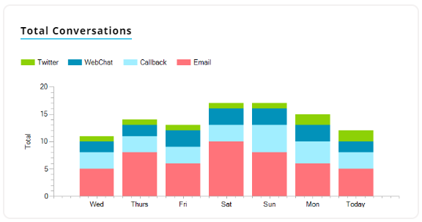

Month – The month view will only show a bar for each day of the current month. So, on the 15th there will be 15 bars, as shown below.
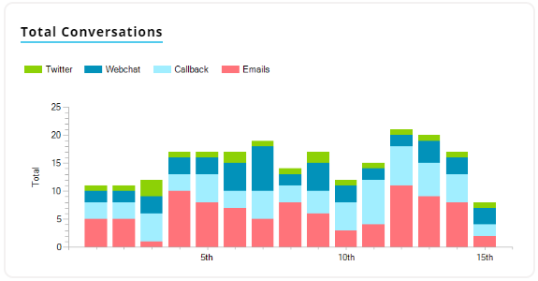
Viewing the bar chart on the 30th day of the month:
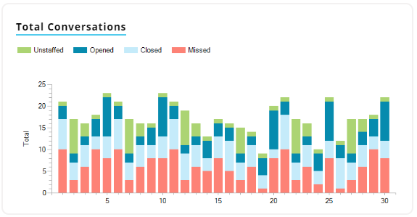

Pie Charts

At the bottom right of the Dashboard there are two pie charts, depending on which level of the hierarchy you are viewing, they will display different statistics.
If viewing the overall Contact Center, Queues or Media Streams the number of conversations by type will be displayed, along with either the number of Agents joined or the outcome of the conversations. E.g. Missed, answered or unstaffed.
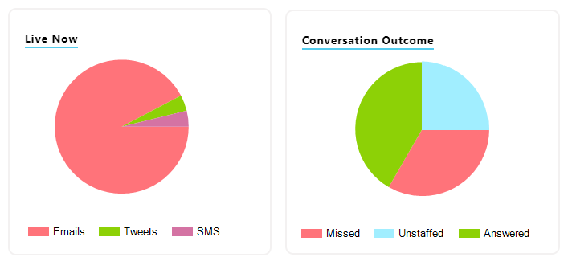

When viewing the Dashboard for an individual Media Stream the pie charts will display the number of conversations currently in progress vs the number of queued conversations and the number of Agents online and joined.
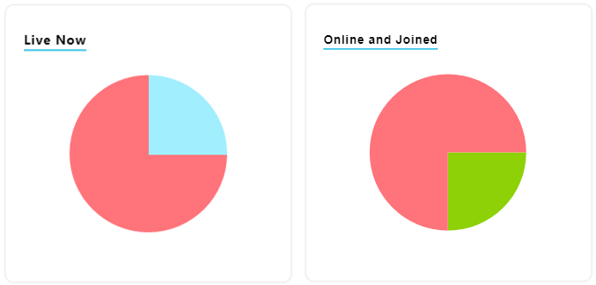

When there are no live conversations, the Live Now pie chart will be greyed out. This will also be the case for the Conversations pie chart is nothing has been received yet.


Pie Chart Behaviour with Today, Week, Month Toggle
The only pie chart that can be toggled to Day, Week and Month is the Conversation Outcome chart as the other pie charts feature live statistics. E.g. Agents Joined and Unjoined.
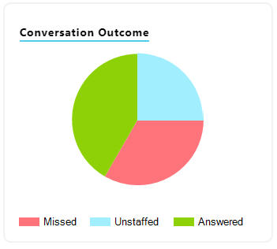

Tables

Please note the “Missed” statistic will show Web Chats that have abandoned and Tweets, Emails and SMS that have exhausted the routing phase(s) for those Media Streams. This distinction is because Web Chat is a real-time communication channel, much like a phone call. If the Web Chat is not answered within the routing phase, then the visitor sees a prompt apologising and the web chat is closed.
If Emails, Tweets and SMS are not answered within the routing phase they will drop into the “Always On Queue”. When this happens, those conversations will be delivered to all users assigned to the Media Stream. In this way it is possible for an Email to be counted as “Missed”, in that it has missed the original routing, but in fact was answered subsequently within the Always On queue.

Overall Contact Center Level
This table will display all the Media Streams in all Queues with the Average Answer and Longest Wait statistics which can be toggled for the Day, Week and Month.
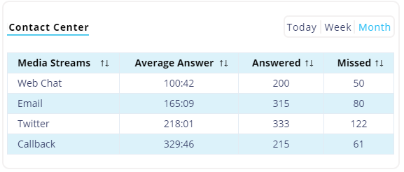
The bottom table displays the top performing Media Streams and Agents across all Queues in the entire Contact Center.
All statistics will change when the Day, Week and Month toggle is changed apart from Agents Joined as it is a live statistic which will only shows what’s happening right now.
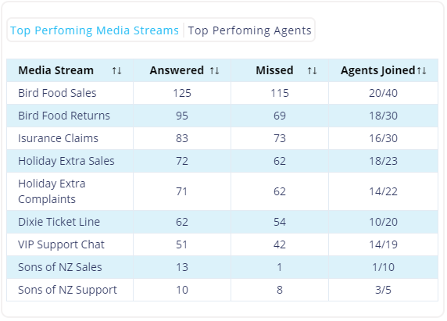
Click the Media Stream name to open the profile for that Media Stream.

Queue Level
This table will display all the Media Streams within this Queue with the Average Answer and Longest Wait statistics which can be toggled for the Day, Week and Month.
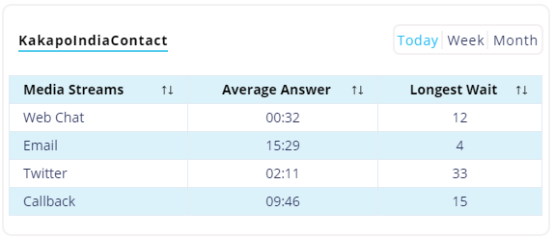

The bottom table will display the top performing Media Streams and Agents in this Queue. The top performing Agents will also show the Join state of the Agents, an Agent with a red dot is not joined to the Queue and the green dot means they are joined to the Queue.
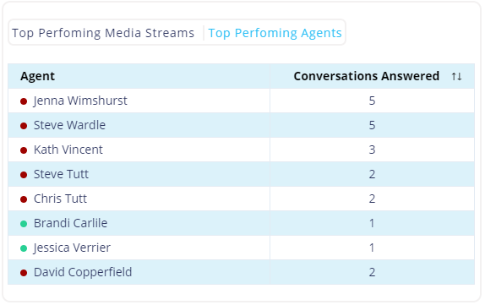

Click the Media Stream name to open the profile for that Media Stream.
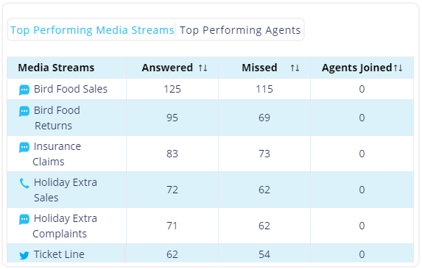

Media Stream Level
This table will display the key statistics for this Media Stream. All statistics will change when the Day, Week and Month toggle is changed, but Agents Joined/Total is a live statistic which will only show what’s happening right now.
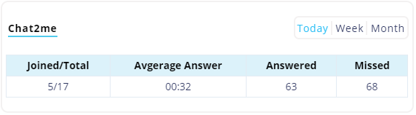
The bottom table displays the top performing Agents for that Media Stream along with the Average Rating statistic if the Media Stream is a Web Chat.
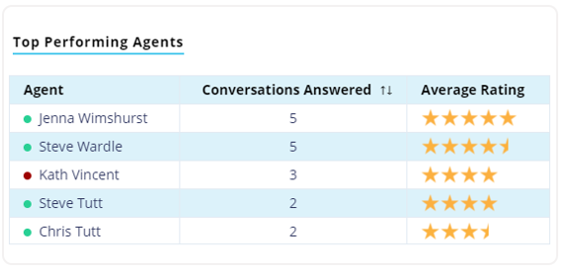

Table Behaviour with Today, Week, Month Toggle

Most statistics and data in the tables will change when the user toggles between Today, Week and Month, however Agents Joined will remain the same as this is a live statistic.

Queues

Click the Queue icon 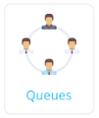 to view all the Queues in the Contact Center:
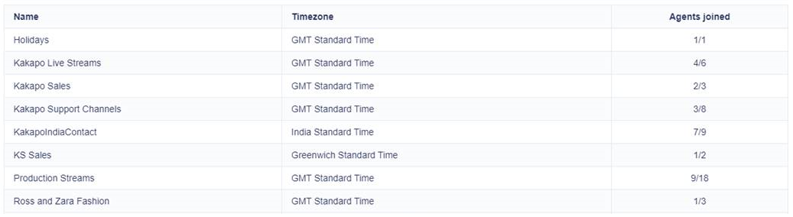

If the Queue text is red then there is a problem and the Queue is not online.
Simply click the Queue to open the Dashboard and settings for that Queue.

Media Streams

Click the Media Streams icon 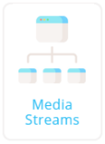 to view all the Media Streams in the current Queue:
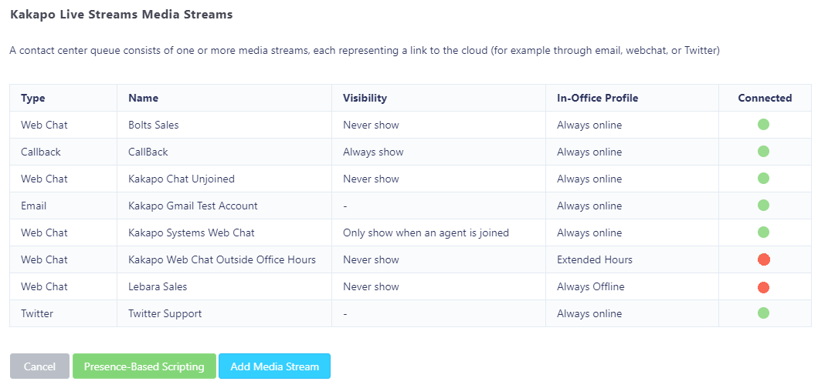
Displayed next to the Media Stream type and name is the visibility of the Media Stream, the In-office Profile and answered and missed statistics.
Connected – This displays whether the Media Stream is active. Active means connected to the Contact Center server, authenticated OK and able to take new conversations.
E.g. A Web Chat that was set to only display after hours will be red during the day. Or if there are no Agents Joined and the Visibility is set to only show when Agents are joined, then it will be red.

