Unity Contact Center - CALLBACK TEMPLATE

 | Requirement | Example | Text
Call Back  Media Stream | Name | Kakapo Systems Call Back Queue
Call Back  Media Stream | Language | English (UK)
Call Back  Media Stream | Media Type | Call Back
Call Back  Media Stream | Time-zone | Dublin, Edinburgh, London
Call Back  Media Stream | In Office Profile | Always Online
Call Back  Media Stream | In Office Profile | Pre-configured In Office Profile
Call Back  Media Stream | Identifier | Callback.Sales@kakaposystems.com
Call Back  Media Stream | Required information | Name | Yes/no
Call Back  Media Stream | Required information | Email | Yes/no
Call Back  Media Stream | Required information | Phone | Yes/no
Call Back  Media Stream | External Reference Label | Please enter your ticket number/account ID
Call Back  Media Stream | Visibility (Select one) | Never Show
Call Back  Media Stream | Visibility (Select one) | Always Show
Call Back  Media Stream | Visibility (Select one) | Only show during office hours
Call Back  Media Stream | Visibility (Select one) | Only show outside of office hours
Call Back  Media Stream | Visibility (Select one) | Only show when agent is joined
Call Back  Media Stream | Visibility (Select one) | Only show when agent is not joined
Call Back  Media Stream | Visibility (Select one) | Only show during office hours when agent is joined
Call Back  Media Stream | Visibility (Select one) | Only show during office hours when agent is not joined
Call Back  Media Stream | Call Back Start Text | Enter your details below and we’ll call you within office hours
Call Back  Media Stream | Call Back End Text | Thanks, your details have been saved, we will call you shortly
Call Back  Media Stream | Branding | Hide Callback when close button clicked | Yes/no
Call Back  Media Stream |  | Unreserved sender name | Media stream name/Queue name
Call Back  Media Stream | Primary colour (Select one) | Light blue
Call Back  Media Stream | Primary colour (Select one) | Blue
Call Back  Media Stream | Primary colour (Select one) | Grey
Call Back  Media Stream | Primary colour (Select one) | Steel
Call Back  Media Stream | Primary colour (Select one) | Lime
Call Back  Media Stream | Primary colour (Select one) | Orange
Call Back  Media Stream | Primary colour (Select one) | Pink
Call Back  Media Stream |  | Hex Color Code | #
Call Back  Media Stream | Start Image (Select one) | 
Call Back  Media Stream | Start Image (Select one) | 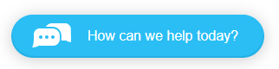
Call Back  Media Stream | Start Image (Select one) | 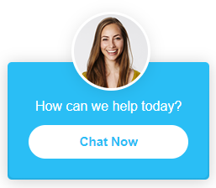
Call Back  Media Stream | Start Image (Select one) | 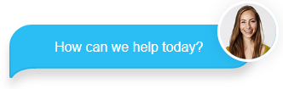
 | Start Image (Select one) | 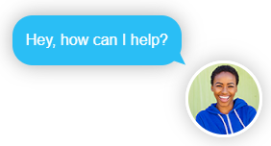
 | Start Image (Select one) | 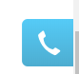
 | Start Image (Select one) | 
 | Select Avatar (if applicable) | 
 |  | 
 |  | 
 |  | 
 |  | 
 |  | 
 |  |  | Please attach custom avatar
 | Invert Start Image |  | Yes/No
 | Callback Window Type | Pop up window or Docked window | Window/Docked
 | Start Text  Button Text  Location  Callback delay | Want us to call you back?
 | Start Text  Button Text  Location  Callback delay | Call Me
 | Start Text  Button Text  Location  Callback delay | Bottom right or left
 | Start Text  Button Text  Location  Callback delay | 5 seconds

CALL BACK Configuration

 | Requirement | Example | Customer Required Text
 | Departments | Use departments to route conversations & Callbacks | Yes/No
 | Agents to include | List all agents to include in this phase. E.g.  Bill.Bryson@company.com  Sally.Wainwright@company.com  Natalie.Maines@company.com  Jack.Donovan@company.com

