UNITY CRM INTEGRATION – Sugar CRM

CONTENTS
1 Overview 1
2 Configuring Sugar CRM Integration 2
3 Unity CRM Functionality 5
3.1 Contact Pop 5
3.2 Contact Search 7
3.3 Call Log Entry 8
3.3.1 Manual Call Log Entry 8
3.3.2 Automatic Call Log Entry 9

1 Overview

Unity seamlessly integrates with Sugar CRM to facilitate contact lookup and “popping” for inbound and outbound calls, searching for CRM contacts within Unity and click to dial both from within Unity and Sugar CRM.

This functionality relies on a CRM Integration license being assigned to the user, as shown below. Please note this license is required in addition to the base license for Unity Desktop, Agent, Supervisor or Reception. All versions of Sugar CRM are supported.

If a CRM Connector license has not previously been assigned to the user, then a trial license will automatically be assigned the first time CRM configuration settings are entered in Unity.

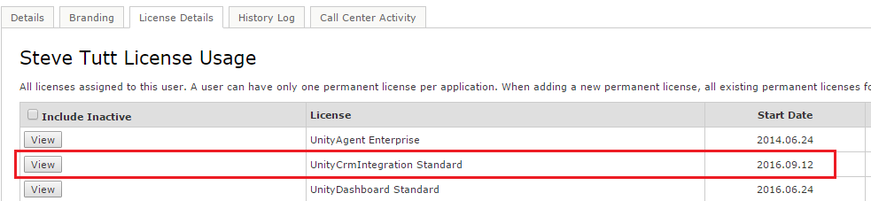

Once this license is assigned and Unity is restarted, the CRM panel will become available in Settings, as shown below.

To configure Unity to integrate with Sugar CRM, simply select the CRM platform from the dropdown list and complete the required fields, as outlined in sections below.

2 Configuring the Sugar CRM portal

In order for Unity to integrate with Sugar CRM, an API Platform must be created in the Sugar CRM instance. Unity uses this to consume the Sugar API so it must be done before configuring Unity clients, but it only needs to be done once per Sugar CRM instance (which will then apply to all users).

When logged in as an administrator, click Admin from the context menu. If you don’t see this menu option then you are not logged in as an administrator.
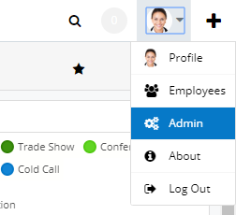

Under Developer Tools, click Configure API Platforms

Add an API platform called “unity” – please note this is all lower case

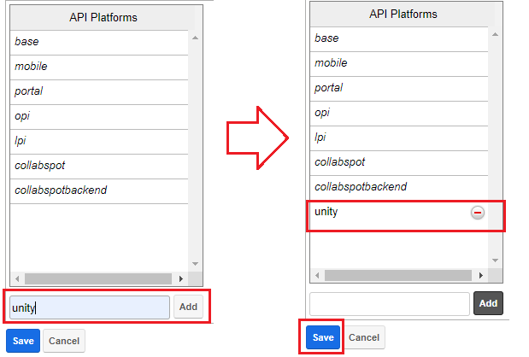

Click Add to add the API to the list, then click Save to update.

3 Configuring Sugar CRM Integration

3.1 Go to Unity Settings>Settings>CRM and then select Sugar from the dropdown list of CRM platforms.
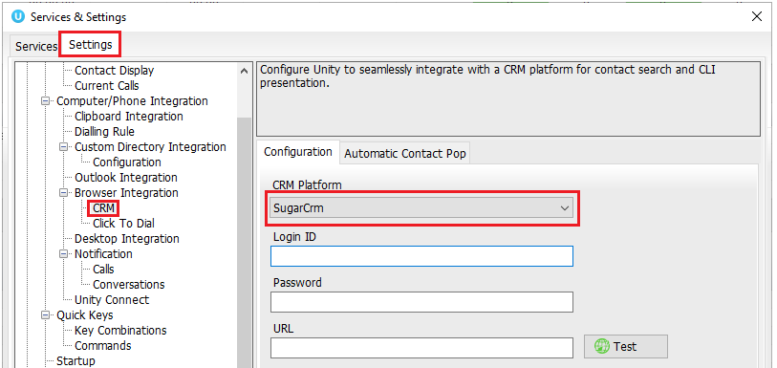

Enter your login ID, password and URL. The URL will be the same that is used to log into the Sugar CRM portal, it must start with https://

Click Test. If the details are correct then you will see the below pop up:

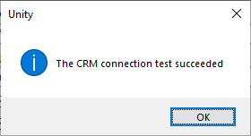

If the details are incorrect then you will see this pop up and will need to enter the correct details to integrate Sugar CRM:
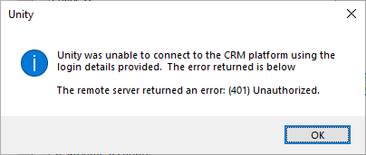

Once the Test has been successfully completed you can choose whether to include contacts, leads and/or accounts from Sugar by selecting the boxes shown below:
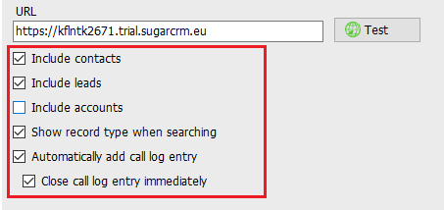

Unity can also include the record type when showing a contact from Sugar, making is easy to identify if a call is from a Contact or Lead.

If the account doesn’t have access to search contacts, leads or accounts (depending on the license type of the user in Sugar CRM) then Unity will automatically uncheck the related setting to ensure it doesn’t continue to search for that entity type.

Unity allows the user to add a call log entry into Sugar for any call, assuming the remote party was found in Sugar. This feature is outlined further below, but you can also configure Unity to automatically add a call log entry if one hasn’t been added manually. This includes both inbound and outbound calls and even calls that were unanswered.

You can also configure Unity to automatically pop the CRM contact when the phone is answered, as shown below.

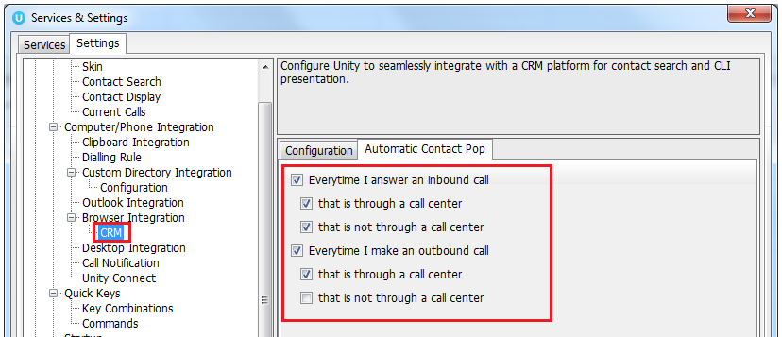

You will be able to test the integration by performing a search for a contact within Unity, you should see Sugar records appear in the list as well as from all other directories. If in doubt you may want to activate the “Show record type when searching” setting in order to distinguish between Sugar records in the search results.

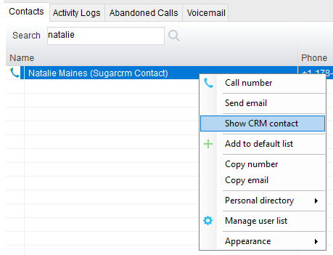

4 Unity CRM Functionality

  - 4.1 Contact Pop
Unity will use Sugar to identify inbound and outbound calls and conversations, including queued call center calls.

At any time, you can search for CRM contacts from within Unity and perform click to dial to make an outbound call to the contact, or display the contact in the CRM platform (this is referred to as “popping” a contact) as shown below.

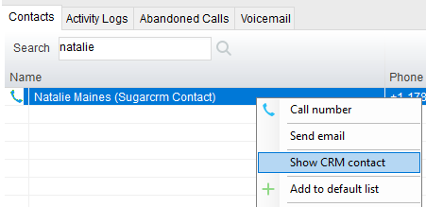

You can also right-click a call to pop the record in Sugar using the default browser, as shown below. This assumes the contact was found in the CRM platform rather than another directory (for example an Outlook contacts folder).

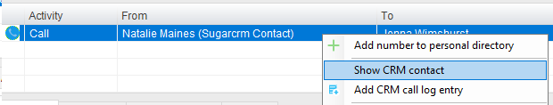

You can also click on the call details “toast” notification popup to pop the contact, as below. Again, this assumes the contact was found in the CRM platform.

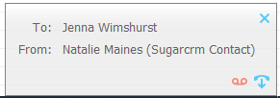

This feature depends on the appropriate Call Notification setting being activated, as shown below.
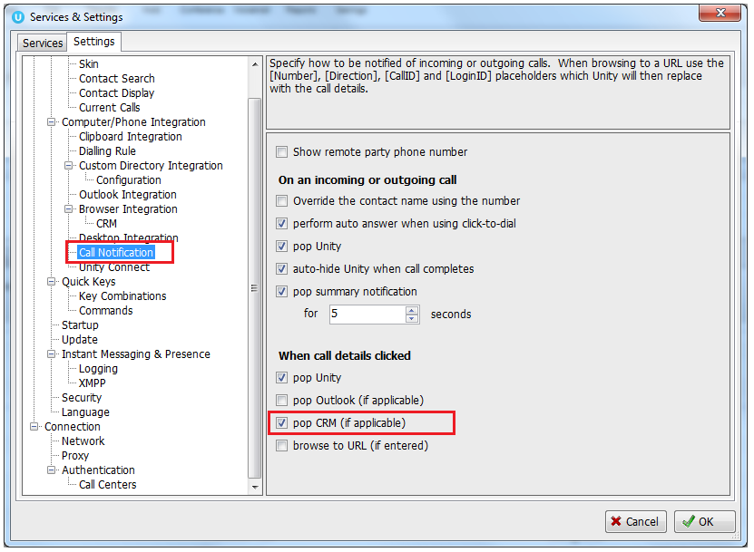

Unity can also be configured to automatically pop the CRM contact when the call is answered, which depends on the Automatic Contact Pop tab settings as shown below.

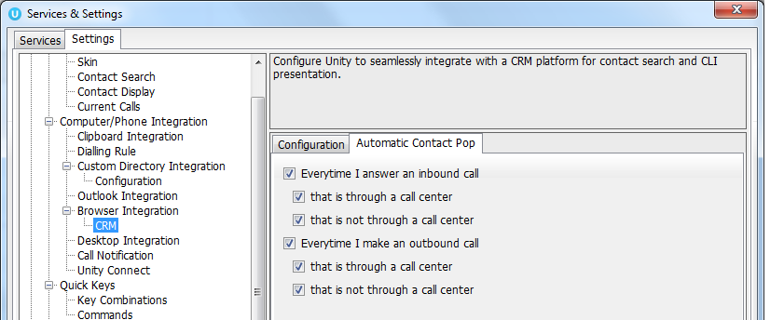

  - 4.2 Contact Search
When you perform a contact search, Unity will check all directories such as the group/enterprise phone list, personal directory and Outlook etc, but it will also search Sugar CRM and return the results. You can search on contact name or company name, simply double click an entry to call that number.

Please note that you will need to type in a minimum of three letters to search for a CRM contact.
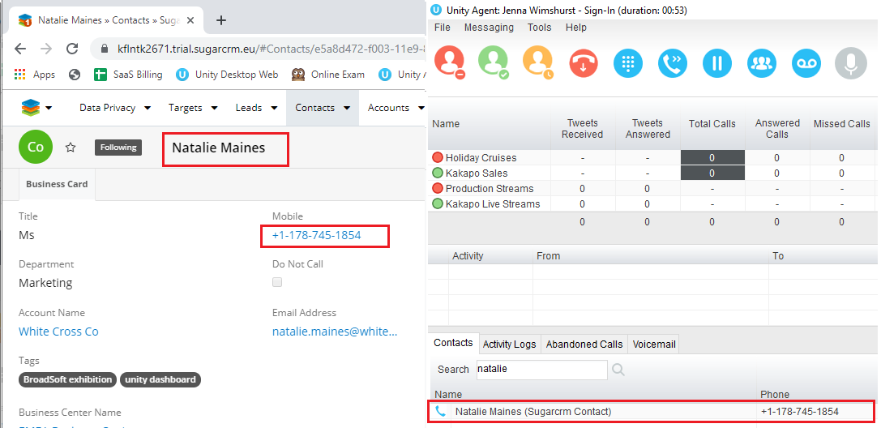

You can also right-click entries to send an email using the default mail program (if there is an email address set for that Contact or Lead in Sugar).

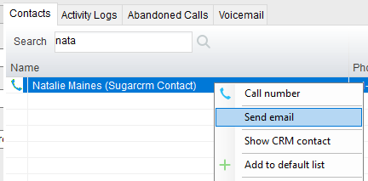
  - 4.3 Call Log Entry
When integrated with Sugar, Unity can add call log entries on behalf of the user, as outlined below.

  - 4.3.1 Manual Call Log Entry
Right-click on a call and select to add a call log entry, as shown below.

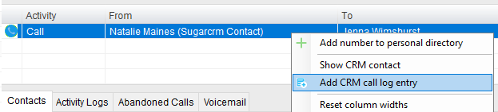

Unity will enter basic details of the call depending on if the call is inbound or outbound.

Remember this call log will be stored in Sugar so an outbound call in Unity is an inbound call in Sugar, because we have called the contact.
You can also add further notes manually, then click OK to save the call log entry.

The call note will be saved against that contact in Sugar, please note that you can specify whether to close the status of the call log task/activity in Sugar or keep it open by ticking the box.
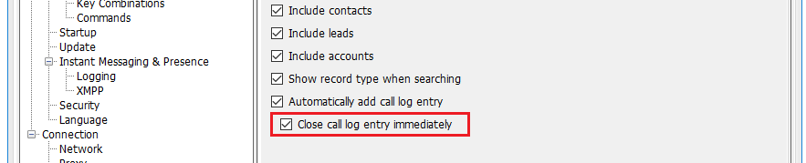

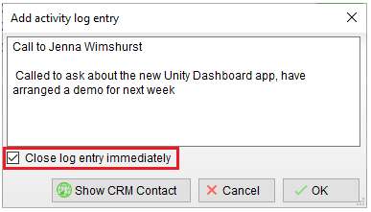

If you click Show CRM Contact or Cancel the call log will not be saved.

You will now see this call log entry in Sugar, as shown below.
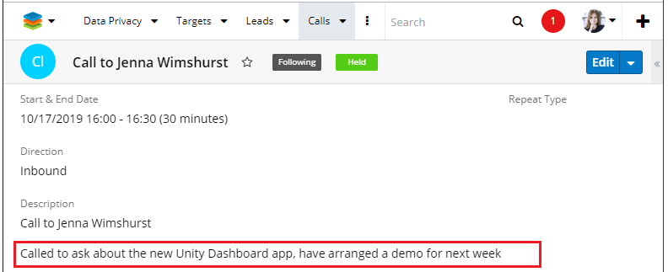

  - 4.3.2 Automatic Call Log Entry
Unity can be configured to automatically add a call log entry for any calls where a call log hasn’t been manually created using the steps above. This feature is activated as shown below.

Unity will automatically add call log entries when the call is released (the same time it is removed from the Active Call List in Unity). Only basic information on the call is presented, based on the direction of the call and the Unity user that made or received the call. Sugar will timestamp the call internally.

This shows an unanswered call from the Sugar contact to the Unity user.
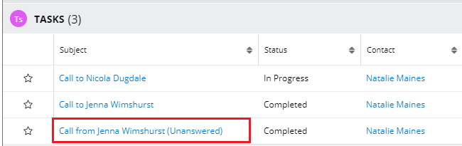

This shows an answered call from the Unity client to the Sugar contact.
