

UNITY MOBILE – SALESFORCE EDITION
Contents
Licensing Info 1
Setting Up 1
Contact Search 2
Adding to Favourites 3
Contact Functionality 3
Call 3
During a Call 4
Send SMS 4
Send Email 5
Call Logs 5
Voicemail 6
View Contact in CRM 6

Licensing Info

In order to integrate the Salesforce Platform with Unity Mobile (on both Android Mobiles and iPhones), users must have the Unity Mobile license and the CRM Connector license assigned to them. For more information, please contact your Unity provider.

Setting Up

To setup Unity Mobile’s CRM configuration go to Settings>CRM:
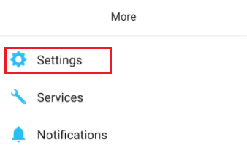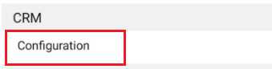

Select the CRM platform.
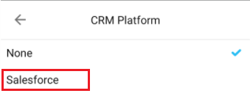

Enter the relevant login details for the CRM platform and slide the toggles to include Contacts, Leads and Accounts as desired.
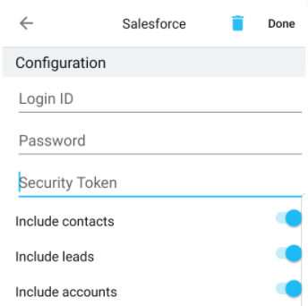

Once complete, click Done.

If the details you’ve entered are incorrect the following error will appear:
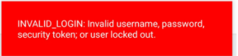

If the details you’ve entered are correct you will be directed back to the CRM platform page and “Joined” will be displayed, as shown below.

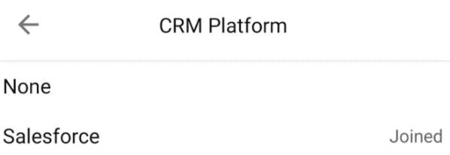

Contact Search

Once the CRM configuration has been completed you will be able to search for the relevant Contacts and Leads in the Contacts tab (depending on which type of Contacts you have included).

Please note: The Contacts and Leads will not be listed in the full list of Contacts as there could be thousands of CRM contacts listed.

To find a Contact simply tap on the search bar and start typing:
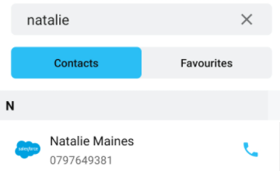

All CRM Contacts will have the CRM icon next to the name.

Adding to Favourites
To add a Contact or Lead to your Favourites simply tap the Contact and then tap the blue star on the top right.

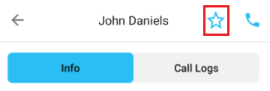

The Contact or Lead will then be permanently listed in your Favourites tab. Simply unselect the star to remove them from your Favourites.

Contact Functionality

Once you have located the Contact or Lead you can either call them directly by tapping the phone icon next to their name in the list, or tap their name in order to open up the Contact information page and call logs.

Call
To make a call either tap the blue phone icon next to the Contact in the list or tap into the Contact page by tapping on the name and then tap the phone icons on the Contact’s information page.
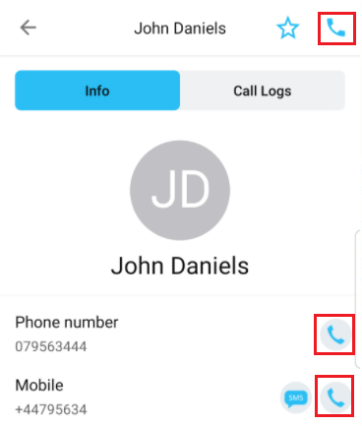

During a Call
During a live call with a CRM Contact or Lead two dots will appear at the bottom indicating that there are more menu options. Simply slide the menu to the left to access the CRM menu options, as shown below.
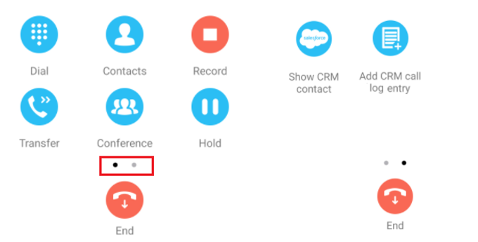
Show CRM Contact: This will open the CRM Contact page in the CRM platform using your mobile device’s native internet browser.

Add to personal directory: This will add the number to your personal directory.
Please note: Any personal directory contact will override a CRM Contact if the phone numbers are the same.

Add CRM call log entry: Add a call log entry to the CRM Contact with the option to manually enter additional information about the call, as shown below.
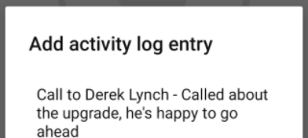

Send SMS
If the Contact or Lead has a mobile/cell number, then the SMS icon will appear. Simply tap the SMS icon to open the native messaging app on your device and send an SMS.
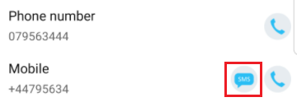

Send Email
If the Contact or Lead has an email address, then the envelope icon will appear. Simply tap the envelope icon to open the native email app on your device and compose an email.

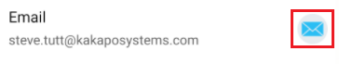

Call Logs
View the call logs for the CRM Contact by opening the Contact and then tapping on the Call Logs tab at the top. You will then be able to see all missed, dialled and received calls from the Contact.
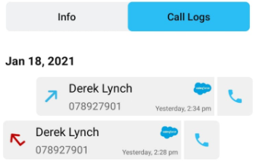
Similarly, if you navigate to the Call Logs tab at the bottom using this icon  you will be able to see that the CRM Contact log entries have the CRM icon next to their name, as shown below.
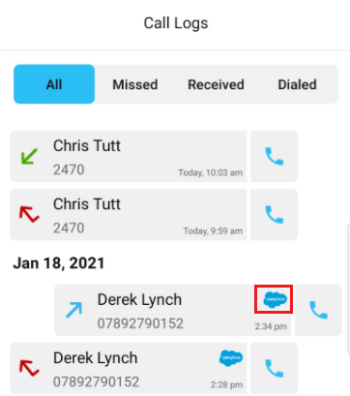

Voicemail
When you receive a voicemail from a CRM Contact or Lead the CRM icon will appear next to the name is the list of Voicemails, as shown below.
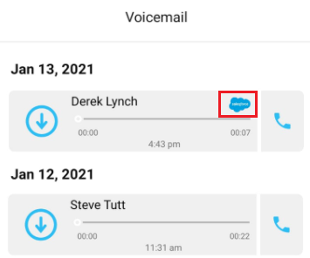

View Contact in CRM
Tap Show CRM Contact to open the CRM Contact page using your device’s native internet browser.
